**一年级语文上册汉语拼音测试卷（五）**

1. 默写六个单韵母。（6分）

|  |  |  |  |  |  |
| --- | --- | --- | --- | --- | --- |
|  |  |  |  |  |  |
|  |  |  |  |  |  |
|  |  |  |  |  |  |

1. 按顺序默写二十三个声母。（23分）

|  |  |  |  |  |  |  |  |  |  |  |  |
| --- | --- | --- | --- | --- | --- | --- | --- | --- | --- | --- | --- |
|  |  |  |  |  |  |  |  |  |  |  |  |
|  |  |  |  |  |  |  |  |  |  |  |  |
|  |  |  |  |  |  |  |  |  |  |  |  |

|  |  |  |  |  |  |  |  |  |  |  |  |
| --- | --- | --- | --- | --- | --- | --- | --- | --- | --- | --- | --- |
|  |  |  |  |  |  |  |  |  |  |  |  |
|  |  |  |  |  |  |  |  |  |  |  |  |
|  |  |  |  |  |  |  |  |  |  |  |  |

1. 按要求分类写下来。（12分）

a g u t m e r ü p i c o

单韵母：

声母：

1. 照样子写音节。（7分）

b—ù→（ bù ） zh—è→( )

x—ǜ→（ ） d—u—ǒ→( )

n—ǚ→（ ） h—u—à→( )

q—ǜ→（ ） z—u—ō→( )

1. 把图与对应的音节连起来。（4分）

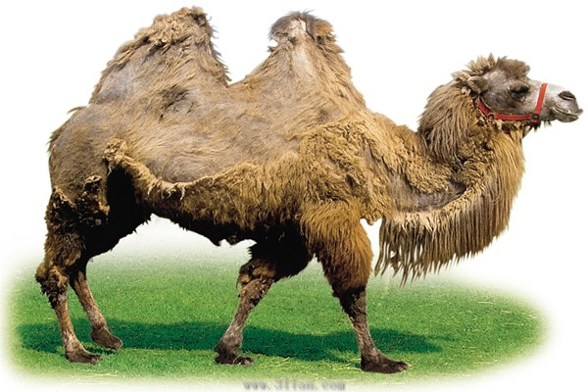 shīzi

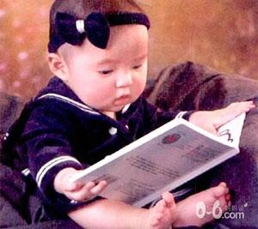 dú shū

AN01124_ shāfā

HH01669_ luò tuo

1. 看图，选择合适的音节写下来。（10分）

shū bàbɑ dàshù guóqí yéye

|  |  |  |  |  |
| --- | --- | --- | --- | --- |
|  |  |  |  |  |
|  |  |  |  |  |
|  |  |  |  |  |

 BD07153_ BS00554_ 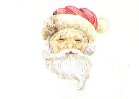

1. 看图，给音节加上合适的声调。（10分）

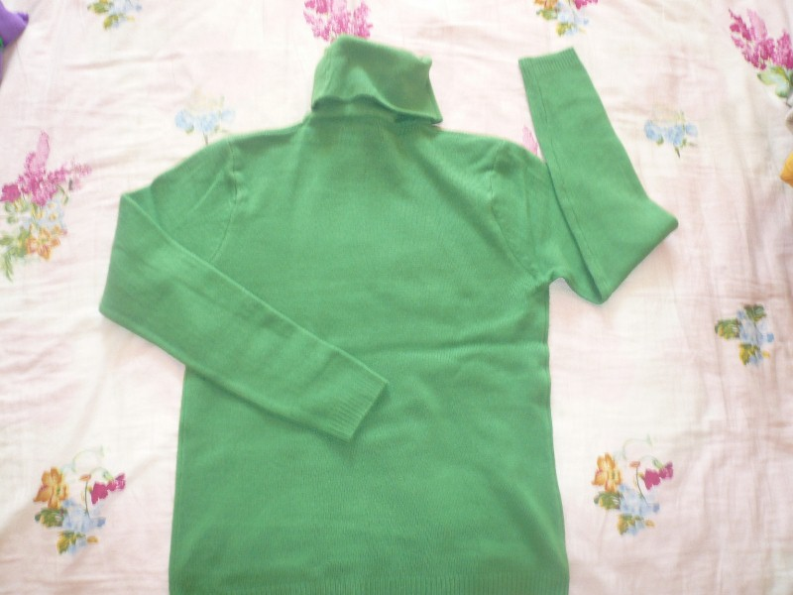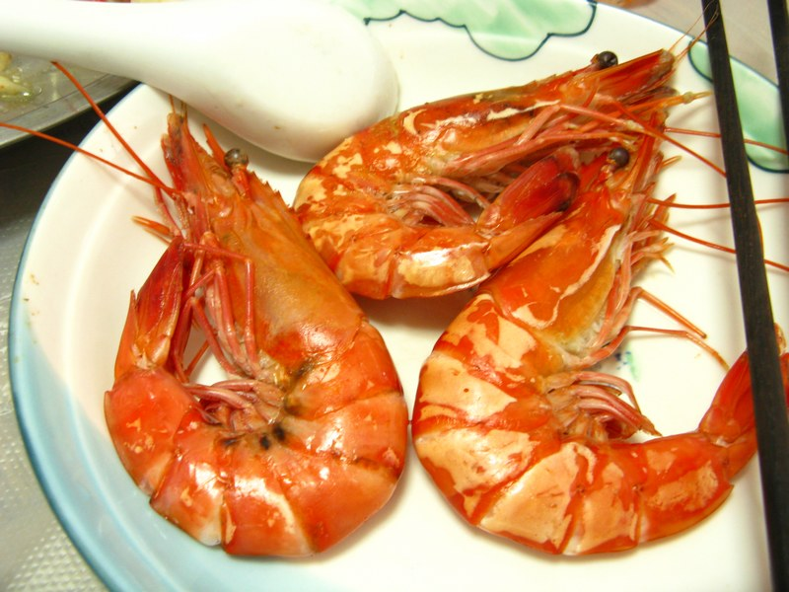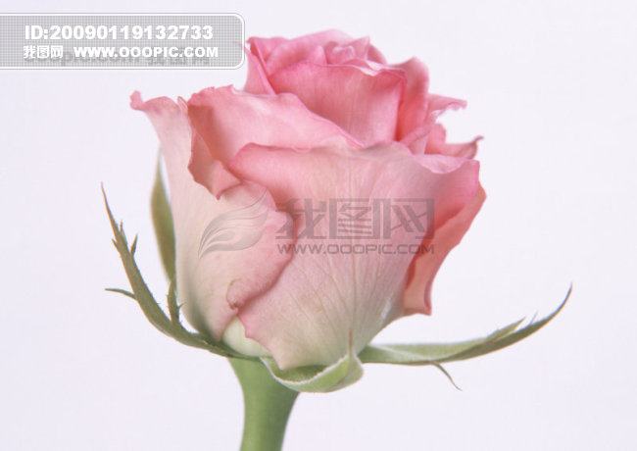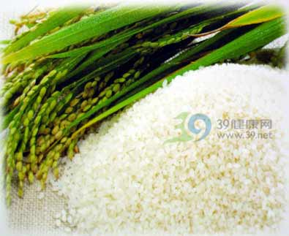

bi yifu da xia hua duo da mi

1. 看图把音节补充完整。（10分）

0046 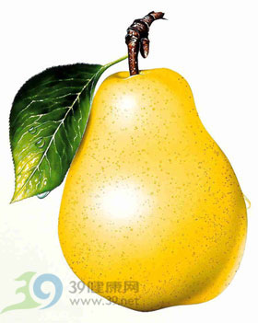  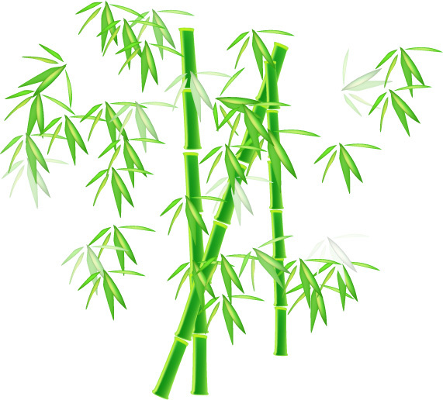

xīg y l ìch zh i

1. 把图与对应的字连起来。（8分）

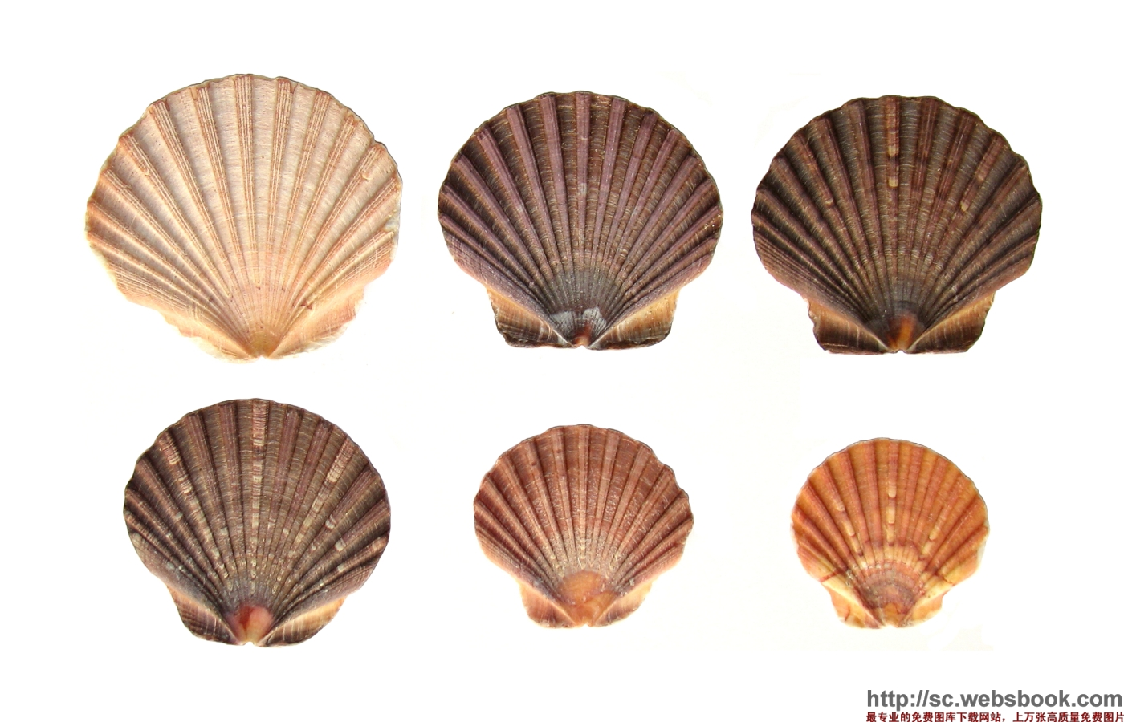 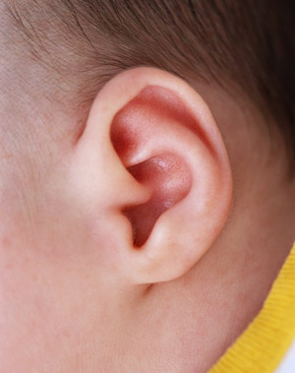 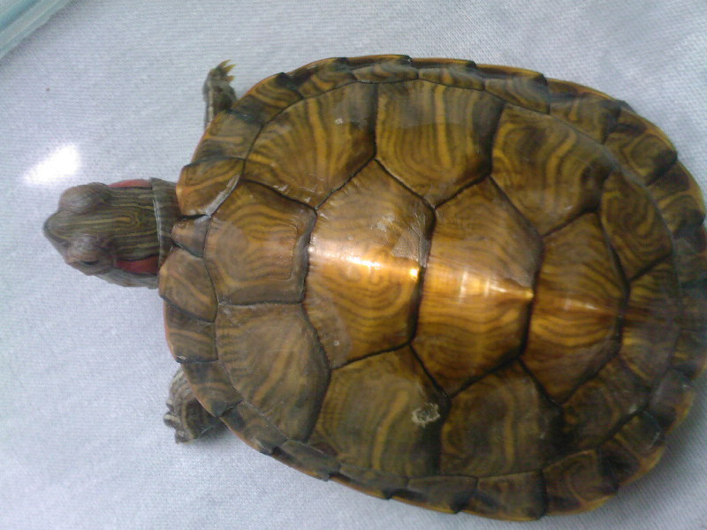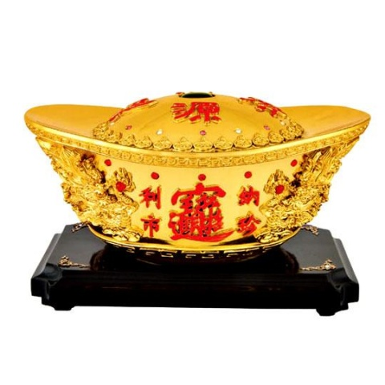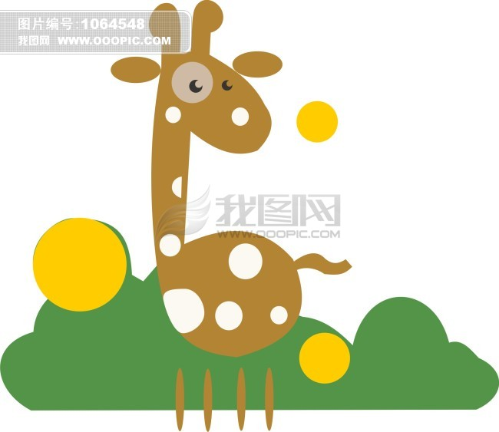 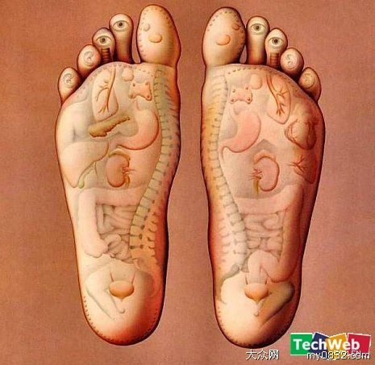 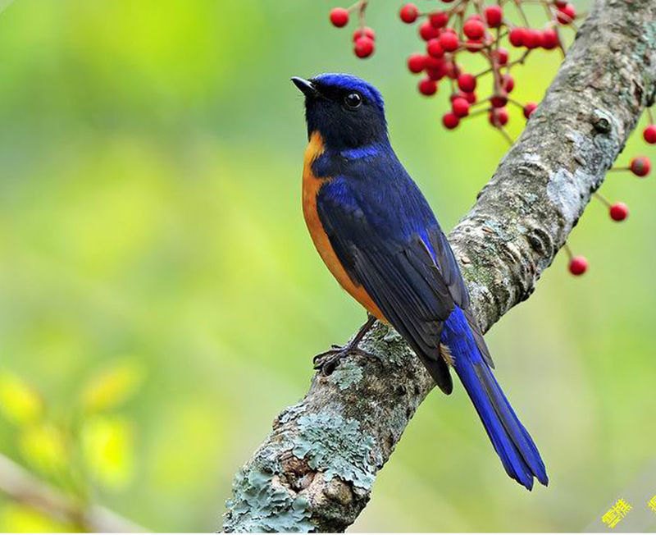 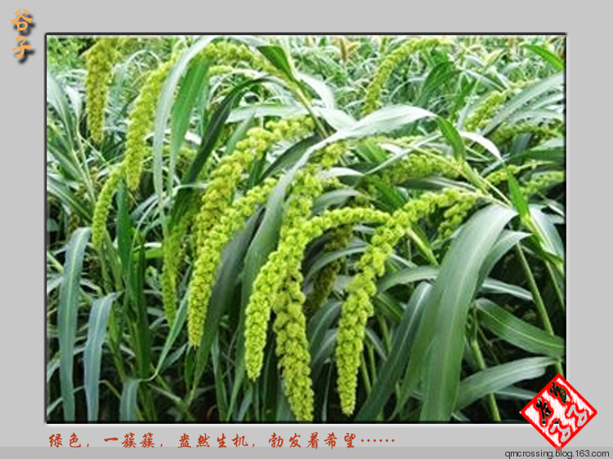

足 金 耳 谷 贝 鸟 龟 鹿

1. 给下面的字选择正确的读音，写下来。（10分）

yú má yá hé tǔ mù pí zhú huǒ shí

|  |  |  |  |  |  |  |  |  |  |
| --- | --- | --- | --- | --- | --- | --- | --- | --- | --- |
|  |  |  |  |  |  |  |  |  |  |
|  |  |  |  |  |  |  |  |  |  |
|  |  |  |  |  |  |  |  |  |  |

土 鱼 火 禾 目 石 竹 皮 牙 麻