专项训练二:句 型
一、读句子. 看图片. 判断图片与句子是否相符. 相符的打“√”. 不相符的打“×”。
( ) 1. —What time is it?
—It's two o'clock.
( ) 2. This is a teacher's desk. 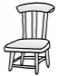
( ) 3. Have some noodles, please. 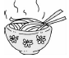
( ) 4. Let's play football. 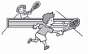
( ) 5. It's time for English class. 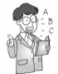
( ) 6. The shirt is beautiful. 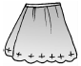
( ) 7. It's sunny today.
( ) 8. —Do you like cucumbers?
—Yes. I do. 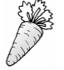
( ) 9. These are my sandals. 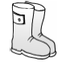
( ) 10. It's time to get up. 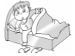
二、图文对对碰。
( ) 1. The T­shirt is 90 yuan. A. 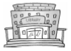
( ) 2. Hold a lamb. B. 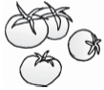
( ) 3. —What's this?
—It's a goat. C. 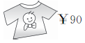
( ) 4. The library is on the first floor. D. 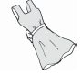
( ) 5. There are four tomatoes. E. 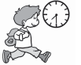
( ) 6. It's windy. F. 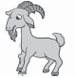
( ) 7. It's time to go to school. G. 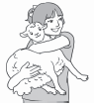
( ) 8. The dress is very pretty. H. 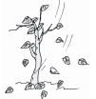
( ) 9. It's cool today. I can wear my jacket. I. 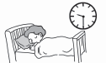
( ) 10. It's 9:30. It's time to go to bed. J. 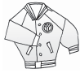
三、单项选择。
( ) 1. —What time is it?
—________
A. Let's go to school. B. It's 8 o'clock. C. Have a good time.
( ) 2. —Where is my shirt?
—________
A. It's yellow. B. They are on the bed. C. It's on the bed.
( ) 3. ________go to the art room.
A. Let's B. I am C. We are
( ) 4. —Whose T-shirt is this?
—________
A. It's me. B. It's my brother's. C. They are Mike's.
( ) 5. —Do you have a computer?
—________
A. Yes, it is. B. Yes, we do. C. Yes, we are.
( ) 6. —What are they?
—________
A. Yes, they are. B. They are jeans. C. They are on the bed.
( ) 7. —Can I wear my new shirt?
—No. ________.
A. you can't B. you are C. you can
( ) 8. —What's the weather like today?
—________
A. It's near the door. B. It's cool. C. It's black and white.
( ) 9. —What colour are your pants?
—________
A. It's blue. B. They are green. C. They is white.
( ) 10. —How much are the shoes?
—________
A. They is 39. B. They are 39 yuan. C. It's 49 yuan.
四、连词成句。
1. is, teacher's, desk, our, This (.)
________________________________________________________________________
2. you. a. have. library. Do (?)
________________________________________________________________________
3. to. time. It's. bed. to. go (.)
________________________________________________________________________
4. for. is. class. time. It. music (.)
________________________________________________________________________
5. colour. it. is. What (?)
________________________________________________________________________
6. How. are. much. your. shoes (?)
________________________________________________________________________
7. are. those. Whose. pants (?)
________________________________________________________________________
8. This. so. farm. big. is (.)
________________________________________________________________________
9. I. them. Can. try. on (?)
________________________________________________________________________
10. What's. weather. like. the. in. New York (?)
________________________________________________________________________
五、按要求改写句子。
1. It's time to go to school. (改为同义句)
It's time________ school.
2. It's 6:00. (对画线部分提问)
________ ________is it?
3. Is that your skirt? (作否定回答)
________. ________ ________.
4. The jacket is sixty__yuan. (对画线部分提问)
________ ________is the jacket?
5. The art room is on_the_first_floor. (对画线部分提问)
________ ________the art room?
6. There are thirteen horses. (对画线部分提问)
________ ________horses are there?
7. It is cold today. (改成一般疑问句)
________ ________cold today?
8. Do you have a new classroom? (作肯定回答)
________. ________ ________.
9. This is an_English_book. (对画线部分提问)
________is this?
10. It's Mary's skirt. (对画线部分提问)
________skirt is it?
六、看图. 补全句子。
1. 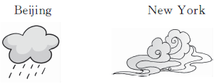
—What's the weather like in Beijing?
—It is________.
—How about New York?
—It is________.
2. —Is that a ________?
—Yes, it is.
3. —________ ________is it?
—It's________ o'clock.
4. —How much is the________?
—It is sixty yuan. 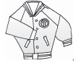
5. —Is this a shirt?
—Yes. ________ ________. 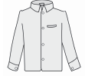
七、根据图表. 仿照例句写句子。
What | colour | Who | Price(价钱)
a dress | red | Amy | 100 yuan
a scarf | blue | May | 70 yuan
shoes | black | Tom | 200 yuan
sunglasses | yellow | Peter | 180 yuan
Amy has a dress.
What colour is it? It's red.
How much is it? It's 100 yuan.
1. ________________has a______________.
______________?________________.
__________________?________________.
2. ________has a pair of________.
__________________?________________.
__________________?________________.
3. ________has a pair of________.
__________________?________________.
__________________?________________.

专项训练二:句 型
一、1. × 2. × 3. √ 4. × 5. √ 6. × 7. √ 8. × 9. × 10. √
二、1. C 2. G 3. F 4. A 5. B 6. H 7. E 8. D 9. J 10. I
三、1. B 2. C 3. A 4. B 5. B 6. B 7. A 8. B 9. B 10. B
四、1. This is our teacher's desk. 2. Do you have a library? 3. It's time to go to bed.
4. It is time for music class. 5. What colour is it? 6. How much are your shoes?
7. Whose pants are those? 8. This farm is so big. 9. Can I try them on?
10. What's the weather like in New York?
五、1. for 2. What time 3. No; it isn't 4. How much 5. Where is 6. How many
7. Is it 8. Yes; I do 9. What 10. Whose
六、1. rainy；cloudy 2. hat 3. What time；twelve 4. jacket 5. it is
七、1. May；scarf
What colour is it；It's blue
How much is it；It's 70 yuan
2. Tom；shoes
What colour are they；They are black
How much are they；They are 200 yuan
3. Peter；sunglasses
What colour are they；They are yellow
How much are they；They are 180 yuan

