专项训练三：完形与阅读
一、完形填空。
(一) (建议用时：5分钟)
Today is__1__the National Day. My family are busy now. Look, I'm__2__the floor. My sister Lily is__3__the flowers. Mum is__4__dinner. My brother is doing his__5__in the bedroom. Dad__6__writing an__7__to Uncle Li. __8__is my younger sister Lucy doing? She__9__ doing__10__homework. She is playing computer games.
( ) 1. A. August 1st B. July 1st C. October 1st
( ) 2. A. swimming B. sweeping C. sleeping
( ) 3. A. eating B. drinking C. watering
( ) 4. A. cooking B. doing C. taking
( ) 5. A. house B. homework C. dishes
( ) 6. A. is B. are C. am
( ) 7. A. card B. letter C. email
( ) 8. A. Where B. What C. When
( ) 9. A. is B. not C. isn't
( ) 10. A. his B. my C. her
(二) (建议用时：6分钟)
There are__1__days on weekends, __2__. __3__Saturdays, I often go to my dancing class__4__the morning and__5__my homework in the afternoon, and I often__6__my mother wash the clothes. On Sundays, I always__7__my grandparents in the morning and read some books in the afternoon. After dinner, I often watch TV__8__my parents. At that time, we can __9__ with each other. We often__10__a good time.
( ) 1. A. one B. two C. three
( ) 2. A. Monday and Tuesday B. Wednesday and Thursday C. Saturday and Sunday
( ) 3. A. On B. At C. In
( ) 4. A. at B. in C. on
( ) 5. A. do B. does C. doing
( ) 6. A. play B. talk C. help
( ) 7. A. say B. talk C. visit
( ) 8. A. and B. with C. or
( ) 9. A. talk B. tell C. say
( ) 10. A. have B. has C. having
(三) (建议用时：6分钟)
It is sunny today. My mother, my father and I go to a park. We like the park very much. It is very big and beautiful. There__1__many trees and flowers in it. Many people like__2__there. Look! An old man is sitting __3__the chair. He__4__a book carefully. Two boys__5__on the ground. __6__mothers are talking__7__each other. Two birds__8__in the sky. The ducks are swimming__9__the river. They are very happy. What is the cat doing? Oh, it is running__10__a mouse.
( ) 1. A. am B. is C. are
( ) 2. A. go B. goes C. to go
( ) 3. A. of B. at C. on
( ) 4. A. is reading B. reading C. read
( ) 5. A. jump B. jumps C. are jumping
( ) 6. A. Their B. Theirs C. They
( ) 7. A. and B. with C. of
( ) 8. A. is flying B. fly C. are flying
( ) 9. A. of B. at C. in
( ) 10. A. after B. in C. under
(四) (建议用时：6分钟)
Hello, boys and girls. My__1__is Zhang Peng. I am a__2__. My favourite__3__is Monday. I often get up__4__6:30 in the morning. I have__5__and bread for breakfast. Then I go to school at 7:10. I do__6__exercises at 7:40 am. I eat lunch at 11:30 at school. In the afternoon, we have art, computer and__7__classes. After school, I play__8__with my friends. In the evening, I eat__9__at 7:00. Then I do my homework. __10__I watch TV. I go to bed at 9:00. This is my day.
( ) 1. A. am B. name C. is
( ) 2. A. teacher B. worker C. student
( ) 3. A. day B. season C. month
( ) 4. A. on B. at C. in
( ) 5. A. supper B. milk C. lunch
( ) 6. A. morning B. afternoon C. evening
( ) 7. A. TV B. PE C. VCD
( ) 8. A. piano B. sports C. the football
( ) 9. A. dinner B. lunch C. breakfast
( ) 10. A. Always B. Sometimes C. Sometime
二、阅读短文, 判断正(T)误(F)。
(一) (建议用时：6分钟)
Today is Sunday. Mike, his sister Amy and his parents are in the park. They are having a picnic. Now, they are busy. Look! Mother is making food for everyone. Father is sleeping on the grass. What about Amy? Amy is singing and dancing with her favourite pet cat. Where's Mike now? Is he reading a book? No, he isn't. Is he swimming in the lake? Oh, no. He's not swimming. He is listening to music. Everyone is having great fun.
( ) 1. There are four people in Mike's family.
( ) 2. Mike's family are having a picnic in the park.
( ) 3. Mike's parents are cooking dinner.
( ) 4. Amy is singing and dancing with Mike.
( ) 5. Mike is reading a book.
(二) (建议用时：6分钟)
I'm Mike. Lucy is my friend. She lives in a small house near a park in London. I am eleven. Lucy is eleven, too. Lucy does not study Chinese. She studies English, maths, science and art. She likes maths very much. She has six lessons every day. Lucy usually looks after her kitten after school. And I usually read storybooks. We usually write emails to each other on Saturdays.
( ) 1. Lucy lives in a small house in Nanjing.
( ) 2. Lucy and Mike are eleven.
( ) 3. Lucy studies English, maths and Chinese at school.
( ) 4. Mike likes maths very much.
( ) 5. Lucy usually reads storybooks after school.
(三) (建议用时：6分钟)
I like summer best. In summer, the weather is very hot, and I can swim in the sea. Spring is beautiful, but in Canada it often rains. And it is hard (很难) to plant flowers in the rain. I love my garden! It is so nice to watch the flowers grow. In autumn, I can pick apples. They are so delicious. I like to watch the leaves fall. Is that why we can call autumn “fall”? It usually snows in winter in Canada. Sometimes it snows in Beijing, too. When it snows, I can ski (滑雪). I love all the seasons. They are all good and I can find many things to do.
( ) 1. I like spring best, because I can fly kites.
( ) 2. Usually it snows in winter in Canada.
( ) 3. I like to watch the leaves fall in fall.
( ) 4. The weather in summer is very hot.
( ) 5. In winter, I can ski when it snows.
(四) (建议用时：7分钟)
Hi, friends! Let me tell you something about the months and seasons. In Harbin, spring is from March to May. Summer is from June to August. Autumn is short. Winter is long in Harbin. It's from November to February of next year. But in Guangzhou, summer is very long. It's from April to October. Spring and autumn are very short. March is spring and November is autumn. Winter is from December to February of next year. And it's not too cold in winter. If you are planning a trip, look at the map first and remember that it may be not the same season where you're going.
( ) 1. In Harbin, autumn is short.
( ) 2. Winter is from November to February of next year in Harbin.
( ) 3. Summer is short in Guangzhou.
( ) 4. It's not too cold in winter in Harbin.
( ) 5. Spring is very short in Guangzhou.
三、阅读短文, 选择正确的答案。
(一) (建议用时：6分钟)
Bob's weekdays (工作日)
Bob | Monday | Tuesday | Wednesday | Thursday | Friday
Get up | 6：50 am | 6：50 am | 6：50 am | 6：50 am | 6：50 am
Have
lessons | 8：00－
11：00 | 8：00－
11：00 | 8：00－
11：00 | 8：00－
11：00 | 8：00－
11：00
Have
lunch
at school | 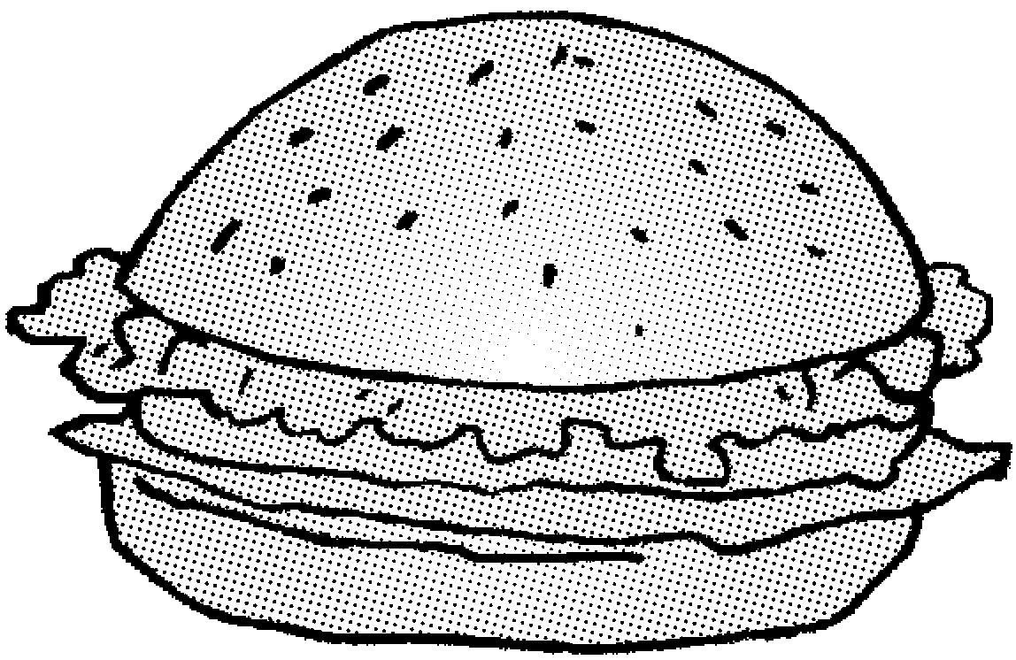 |  | 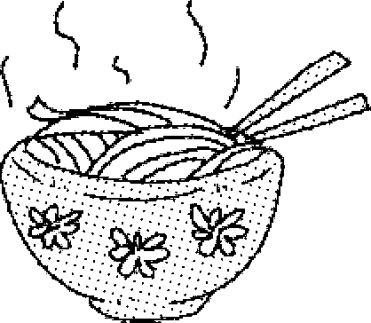 |  | 
After­
school
activities |  |  |  |  | 
In the
evening | Do
homework | Do
homework | Do
homework | Do
homework | watch TV
Go to
bed | 9：40 pm | 9：40 pm | 9：40 pm | 9：40 pm | 10：15 pm
( ) 1. Bob's classes last (持续) __________ in the morning.
A. two hours B. four hours C. three hours
( ) 2. He has __________ for lunch twice a week (一周两次) at school.
A. hamburgers B. rice C. noodles
( ) 3. He plays __________ twice a week after school.
A. ping­pong B. football C. basketball
( ) 4. On weekdays, he usually __________ in the evening.
A. does homework B. watches TV C. plays sports
( ) 5. He goes to bed at __________ on Friday.
A. 9：40 pm B. 8：00 pm C. 10：15 pm
(二) (建议用时：6分钟)
It's Sunday today. It's sunny. I go to a park with my parents. I am playing football with my father. Mother is flying a kite. A boy is flying a kite with his mother, too. There are two students. They are playing games. A girl is jumping on the grass. Two women are watering the flowers.
( ) 1. My father is __________.
A. flying a kite B. playing games C. playing football
( ) 2. __________are flying a kite.
A. My father and I B. My mother and students C. The boy and his mother
( ) 3. Two students are __________.
A. flying a kite B. playing games C. jumping on the grass
( ) 4. __________ are watering the flowers.
A. Two women B. Two students C. A girl
( ) 5. There are __________ people in the park.
A. eight B. nine C. ten
(三) (建议用时：6分钟)
I am Mike. It's Sunday morning. We are busy. Look! My father is washing the car. My mother is washing the clothes. My brother and sister are drawing pictures. John is my best friend. I'm doing homework with him in the study. After lunch, we can go to the library and read some books.
( ) 1. What day is it today?
A. It's Sunday. B. It's sunny. C. It's Saturday.
( )2. Where are John and Mike?
A. In the living room. B. In the study. C. In the kitchen.
( )3. What is Mike's father doing?
A. He is reading a newspaper. B. He is watching TV. C. He is washing the car.
( )4. What are Mike's brother and sister doing?
A. Playing football. B. Watering the flowers. C. Drawing pictures.
( )5. John and Mike can go to the __________ in the afternoon.
A. library B. park C. zoo
(四) (建议用时：6分钟)
My name is Chen Jie. I'm from China. I'm a Chinese girl. I live in a big city. There are four seasons. They are spring, summer, autumn and winter. I like spring best. It's windy and warm. We can fly kites in spring. It's the best time to plant trees, too. I don't like summer. It's too hot. In winter it seldom snows in our city. So it's not very cold. Do you want to be my friend? My QQ number is 2029804631, and my telephone number is 6425075.
( ) 1. How many seasons are there in the city?
A. Two. B. Three. C. Four.
( ) 2. What's the weather like in spring?
A. It's hot. B. It's windy and warm. C. It's cool.
( )3. Which season does Chen Jie like best?
A. Spring. B. Summer. C. Winter.
( )4. What can she do in spring?
A. Skate. B. Make a snowman. C. Fly kites.
( )5. Is it very cold in her city in winter?
A. Yes, it is. B. No, it isn't. C. Yes, she is.

专项训练三：完形与阅读
一、(一)
1. C 点拨：本题考查常识。十月一日是国庆节。
2. B 点拨：本题考查固定搭配。sweep the floor 打扫地板。
3. C 点拨：本题考查固定搭配。water the flowers 浇花。
4. A 点拨：本题考查固定搭配。cook dinner 做饭。
5. B 点拨：本题考查名词辨析。homework家庭作业, 句意为：我弟弟正在卧室做他的家庭作业。
6. A 点拨：本题考查主谓一致。主语Dad为单三形式, 故be动词用is。
7. C 点拨：本题考查不定冠词用法。由空前的不定冠词an可知, 空处应填元音音素开头的单词。
8. B 点拨： 本题考查疑问词的辨析。询问“我的妹妹正在做什么？”, 选疑问词 “what”。
9. C
10. C
(二)
1. B 点拨：本题考查常识。周末有两天。
2. C 点拨：本题考查常识。周末指的是周六和周日。
3. A 点拨：本题考查介词。“在周六”用介词on。
4. B
5. A
6. C 点拨：本题考查动词辨析。句意为：……我经常帮妈妈洗衣服。
7. C 点拨：本题考查动词辨析。visit my grandparents 意为“拜访我的祖父母”。
8. B
9. A 点拨：本题考查词语辨析。talk with sb. 和某人交谈。tell意为“告诉”, say意为“说”, 后面常跟说话内容。本句句意为：那时, 我们可以相互交谈。
10. A
(三)
1. C 点拨：本题考查主谓一致。many trees为复数形式, 谓语动词用are。
2. C 点拨：本题考查非谓语动词。 like to do sth. 意为“喜欢做某事”。
3. C 点拨：本题考查介词辨析。on 意为“在……上”, 句意为：一位老人正坐在椅子上。
4. A 点拨：本题考查时态。句意为：他正在认真地读一本书。用现在进行时表示动作正在发生。
5. C
6. A 点拨：本题考查代词。their形容词性物主代词, 意为“他们的”, 后跟名词。theirs名词性物主代词, 相当于形容词性物主代词＋名词。they主格形式, 作句子的主语。
7. B
8. C
9. C 点拨：本题考查介词辨析。in the river在河里。句意为：鸭子们正在河里游泳。
10. A 点拨：本题考查常识。猫捉老鼠, 在老鼠的后面。
(四)
1. B
2. C
3. A
4. B 点拨：本题考查介词辨析。at用在具体的时刻前。
5. B 点拨：本题考查名词辨析。根据句意, 早餐喝牛奶、吃面包。
6. A 点拨：本题考查固定搭配。根据时间在上午7：40可知是do morning exercises。
7. B
8. B 点拨：本题考查固定搭配, 做运动 play sports。
9. A 点拨：本题考查名词辨析。根据句意可知, 在晚上7：00, 所以吃的是晚饭。
10. B
二、(一)
1. T 点拨：细节理解题。由短文“Mike, his sister Amy and his parents are in the park. ”可知, Mike一家有四口人。
2. T 点拨：细节理解题。由短文“They are having a picnic. ”可知, Mike一家正在公园里野餐。
3. F 点拨：细节理解题。由短文“Mother is making food for everyone. Father is sleeping on the grass. ”可知, 妈妈正在做食物。爸爸正在草地上睡觉。
4. F 点拨：细节理解题。由短文“Amy is singing and dancing with her favourite pet cat. ”可知, Amy正在和她最喜欢的宠物猫唱歌跳舞。
5. F 点拨：细节理解题。由短文“Is he reading a book? No, he isn't. ”及“He is listening to music. ”可知, Mike没有读书, 他正在听音乐。
(二)
1. F 点拨：细节理解题。由短文“She lives in a small house near a park in London. ”可知, Lucy住在伦敦一个公园附近的小房子里, 而不是南京。
2. T 点拨：细节理解题。由短文“I am eleven. Lucy is eleven, too. ”可知, Lucy和Mike都是十一岁。
3. F 点拨：细节理解题。由短文“Lucy does not study Chinese. She studies English, maths, science and art. ”可知, Lucy在学校不学习汉语。她学习英语、数学、科学和美术。
4. F 点拨：细节理解题。由短文“She likes maths very much. ”可知, 是Lucy喜欢数学而不是Mike。
5. F 点拨：细节理解题。由短文“And I usually read storybooks. ”可知, Mike经常读故事书, 而不是Lucy。
(三)
1. F 点拨：细节理解题。由短文“I like summer best. ”可知, 作者最喜欢夏天。
2. T 点拨：细节理解题。由短文“It usually snows in winter in Canada. ”可知, 加拿大的冬天通常下雪。
3. T 点拨：细节理解题。由短文“I like to watch the leaves fall. ”可知, 作者喜欢在秋季看树叶飘落。
4. T 点拨：细节理解题。 由短文“In summer, the weather is very hot. . . ”可知, 在夏天, 天气炎热。
5. T 点拨：细节理解题。由短文“When it snows, I can ski(滑雪). ”可知。
(四)
1. T 点拨：细节理解题。由短文“Autumn is short. ”可知, 哈尔滨的秋天很短。
2. T 点拨：细节理解题。由短文“Winter is long in Harbin. It's from November to February of next year. ”可知, 哈尔滨的冬天很长。从十一月至来年的二月。
3. F 点拨：细节理解题。由短文“But in Guangzhou, summer is very long. ”可知, 广州的夏天很长。
4. F
5. T 点拨：细节理解题。由短文“Spring and autumn are very short. ”可知, 广州的春天和秋天很短。
三、(一)
1. C点拨:细节理解题。由表格“Have lessons 8：00－11：00”可知, 上午的课持续三个小时。
2. B点拨:细节理解题。由图表可知, 在学校一周吃两次米饭。
3. C点拨:细节理解题。由图表可知, 放学后, 他一周打两次篮球。
4. A点拨:细节理解题。看“In the evening”一栏可知, 在晚上, 他通常做作业。
5. C点拨:细节理解题。看表格最后一栏Go to bed可知, 在周五晚上睡觉的时间是10：15。
(二)
1. C 点拨：细节理解题。由短文“I am playing football with my father. ”可知, “我”和爸爸正在踢足球。
2. C 点拨：细节理解题。由短文“A boy is flying a kite with his mother, too. ”可知, 小男孩和他的妈妈正在放风筝。
3. B 点拨：细节理解题。由短文“There are two students. They are playing games. ”可知, 两名学生正在玩游戏。
4. A 点拨：细节理解题。由短文“Two women are watering the flowers. ”可知, 两名妇女正在浇花。
5. C 点拨：细节理解题。短文出现的人物有：I, my parents, a boy and his mother, two students, a girl, two women, 共计10人。
(三)
1. A 点拨：细节理解题。由短文“It's Sunday morning. ”可知, 今天是星期天。
2. B 点拨：细节理解题。由短文“I'm doing homework with him in the study. ”可知, “我”正在和他在书房做作业。
3. C 点拨：细节理解题。由短文“My father is washing the car. ”可知, 父亲正在洗车。
4. C 点拨：细节理解题。由短文“My brother and sister are drawing pictures. ”可知, Mike的弟弟妹妹正在画画。
5. A 点拨：细节理解题。由短文“After lunch, we can go to the library and read some books. ”可知, 午饭后, “我”们去图书馆读书。
(四)
1. C
2. B 点拨：细节理解题。由短文“It's windy and warm. ”可知, 春天的天气多风, 暖和。
3. A 点拨：细节理解题。由短文“I like spring best. ”可知, 作者最喜欢春天。
4. C 点拨：细节理解题。由短文“We can fly kites in spring. ”可知, 在春天可以放风筝。
5. B 点拨：细节理解题。由短文“In winter it seldom snows in our city. So it's not very cold. ”可知, 在冬天, 天气不是很冷。

