**小学六年级英语下册期中考试试题B**

**姓名** **班级** **分数**

**听力部分（30分）**

**一、听句子，选正确答案。（10分）**

1．A．4 hours（小时） B．230 minutes（分钟）

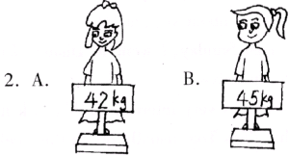

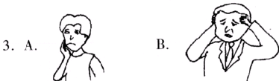

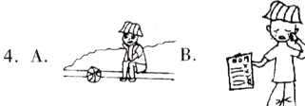

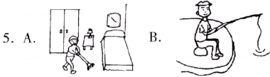

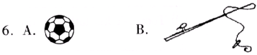

**二、听短文，选择合适的单词填入横线。（5分）**

|  |
| --- |
| heavier big longer fighting bigger lovely |

Look at these two children．The boy is taller than the girl．They are talking about the animals．The elephant are ________．They are ________ and ________ than the horses．The monkeys are playing．Their tails are ________ than the rabbits'．The tigers are big，too．They are ________．They are “angry”．The animals are ________．

**三、听对话，回答问题。（5分）**

1．A．Tom is 160 cm． B．Tom is 168cm．

2．A．Yes，she is． B．No，she isn't．

3．A．He has a sore throat． B．He has a headache．

4．A．She's bored． B．She's happy．

5．A．He went hiking． B．He went fishing．

**四、听对话，判断正（√）误（×）。（6分）**

1．Amy is older than Ann．

2．Ann is shorter than Amy．

3．Amy is stronger than Ann．

4．Amy is twelve．

5．Ann likes reading books．

6．Ann is 164 cm tall．

**五、听短文填空。（8分）**

Tony：Hi，Jenny! It will he Helen' birthday next ________．What gift would you ________ her?

Jenny：I want to buy a ________ for her．She's practising baseball now．

Tony：That's a good ________!

Jenny：I'll put the ball into a beautiful ________ and let her guess．She'll find that's a wonderful present．

Tony：Great! That's very interesting．

Jenny：What's your ________，Tony?

Tony：It's a secret．I can't ________ you now．

Jenny：OK．Let's go to ________ a baseball right away．

Tony：Let's go!

**笔试部分（70分）**

**六、读句子，根据图形填单词。（8分）**

1．Today Mary-missed the bus．She is www.ziyuanku.com

2．What's thewww.ziyuanku.com with you，Kitty?

3．I am not www.ziyuanku.comtoday．I feel tired．

4．www.ziyuanku.comsome medicine and drink hot drinks．

**七、根据图示和表格将下列各句补充完整。（10分）**

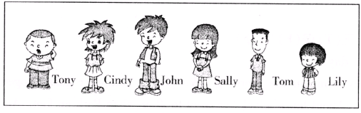

|  |  |  |  |  |  |  |
| --- | --- | --- | --- | --- | --- | --- |
|  | Tony | Cindy | John | Sally | Tom | Lily |
| Date of birth | March 6th，1994 | October  10th，1994 | May 20th，1994 | March 23rd，1994 | June 2nd，I995 | December 5th，1995 |

1．John is the ________ of these children．

2．Sally's hair is the ________ and Cindy's hair is the ________ of the three girls．

3．Tony is the ________ and ________ of these children．

4．Lily is the ________ and ________ of these children．

5．Tom is the ________ and ________ of the three boys．

**八、问答配对。（10分）**

Ⅰ Ⅱ

1．How heavy are you? A．He went to Hong Kong．

2．What did Kathy do yesterday? B．Because I failed the math test．

3．Where did Tom go? C．I'm 48 kg．

4．Did Mary and Jane go swimming? D．She did homework．

5．Why are you so sad? E．No，they didn't．

**九、选词填空。（20分）**

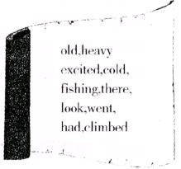

A：How are you，Zhang Jun? You ________ happy．

B：Yes，I ________ to the Yellow Mountain yesterday．

A：What did you do ________?

B．In the morning we ________ the mountain and we ________ a picnic at the foot of the mountain．

A：Did you go ________?

B：Yes．There is a big lake．The fish are very big．We are ________．

A：Did your sister go with you?

B：No，she had a bad ________ and her throat was sore．

A：Then who went with you?

B：My parents and my cousin Tommy．

A：How ________ is he?

B：He is two years older than me．

A：Is he ________?

B：Yes．He is about 60 kg．

A：Wow!

**十、阅读短文，判断正（T）误（F）。（8分）**

Today was a fun day．

John came to my home in the morning．We played computer games together．We read some funny English stories．About ten o'clock，we went to Zhongshan Park on foot．And we fished there．It was very interesting．

We cooked lurch at about 12 o'clock and it was very yummy．Then we cleaned the kitchen．We watched TV after lunch．At 4 o'clock in the afternoon．we went to school and played basketball．

1．They watched TV in the afternoon．

2．They didn't go fishing．

3．They went to the park by bus

4．They cooked lunch and cleaned the kitchen，too．

**十一、读对话，回答下列问题。（10分）**

Jack：Hi，Tom! What do you usually do on the weekend?

Tom：I usually visit my grandparents or old friends．

Jack：Who did you visit last weekend?

Tom：I visited my grandparents last Saturday．

Jack：What did you do for them?

Tom：I washed clothes for them and cleaned their rooms．

Jack：You're very helpful．

Tom：What about you，Jack?

Jack：Last Sunday，I went to Disney World with my parents．We had a good time，but it is expensive．

Tom：That's very interesting．I'll ask my father to go there，too．

1．What does Tom usually do on the weekend?

2．When did Tom visit his grandparents?

3．What did Tom do for them?

4．What did Jack do last Sunday?

5．What will Tom ask his father to do?

**十二、读单词，将它们分类。（4分）**

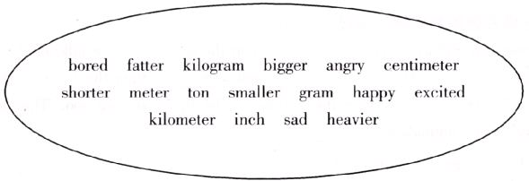

1．__________ 2．__________ 3．__________ 4．__________

**听力材料及参考答案**

Ⅰ．1．Which is longer，4 hours or 230 minutes?

2．Amy is 42 kg．Sarah is 45 kg．Who is heavier?

3．A：What's the matter with Mr. Li?

B．He has a headache．

4．A：How does Zhang Peng feel?

B．He's sad．

5．A：What did you do last weekend，Mingming?

B：I went fishing．

6．A：Did you read a book yesterday afternoon，John?

B：No，I didn't．I played football with my friends．

Ⅱ．Look at these two children．The boy is taller than the girl．They are talking about the animals．The elephant are big．They are bigger and heavier than the horses．The monkeys are playing．Their tails are longer than the rabbits'．The tigers are big，too．They are fighting．They are “angry”．The animals are lovely．

Ⅲ．1．A：I'm 164 cm tall．How tall are you，Tom?

B：I'm 4 cm taller than you．

Q：How tall is Tom?

2．A：How heavy are you，Sarah?

B：I'm 40 kg，my mother is 45 kg．

Q：Is Sarah’s mother 5 kg heavier than her?

3．A：John! It's time to go to school．

B：Mom，I feel sick．My throat is sore．

Q：What's the matter with John?

4．A：What are you doing，Chen Jie?

B：I'm swimming．I'm tired but very happy．

Q：How does Chen Jie feel?

5．A：Did you go fishing last weekend，Mike?

B：No，I didn't．I went hiking with my brother．

Q：What did Mike do last weekend?

Ⅳ．A：Who's that girl，Amy?

B：She's nay younger sister，Ann．

A：How old is she?

B：She is twelve．

A：But she is taller than you．

B：Yes，I'm 160 cm tall．She is 4 cm taller than me．

A：You look stronger than your sister．

B：That's right．I like doing sports，but she likes reading books．

Ⅴ．Tony：Hi，Jenny! It will he Helen' birthday next Sunday．What gift would you give her?

Jenny：I want to buy a baseball for her．She's practising baseball now．

Tony：That’s a good idea!

Jenny：I'll put the ball into a beautiful box and let her guess．She'll find that's a wonderful present．

Tony：Great! That's very interesting．

Jenny：What's your gift，Tony?

Tony：It's a secret．I can't tell you now．

Jenny：OK．Let's go to buy a baseball right away．

Tony：Let’s go!

**参考答案**

Ⅰ．A B B B B A

Ⅱ．big bigger heavier longer fighting lovely

Ⅲ．B A A B A

Ⅳ．√ × √ × √ √

Ⅴ．Sunday give baseball idea box gift tell buy

Ⅵ．1．sad 2．matter 3．well 4．Take

Ⅶ．1．tallest 2．longest，shortest 3．fattest，oldest 4．shortest，youngest 5．thinnest，youngest

Ⅷ．C D A E B

Ⅸ．look went there climbed had fishing excited cold old heavy

Ⅹ．T F F T

Ⅺ．略

Ⅻ．1．bored sad angry happy excited

2．fatter bigger shorter smaller heavier

3．meter kilometer centimeter inch

4．ton gram kilogram