**福建省福州市小学六年级英语下册期中考试试题A**

**姓名** **班级** **分数**

**听力部分（30分）**

**一、听句子，选择图片。（5分）**

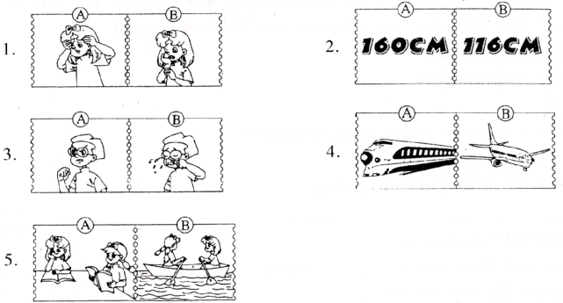

**二、听音，看图，判断正（√）误（×）。（5分）**

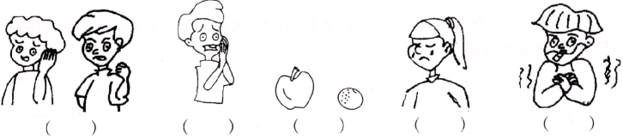

**三、听问句，选答句。（10分）**

1．A．The green dog． B．I like the stronger dog．

2．A．I'm going there by car． B．I feel sick．

3．A．I have a headache． B．I'm thinner than you．

4．A．I played the piano． B．I'm going to play the piano．

5．A．I will go to Hangzhou． B．I went to Canada．

**四、听短文，选答案。（10分）**

1．There're ________ girls in our class．

A．twenty-five B．forty-five C．twenty

2．________ is the tallest in our class．

A．Tom B．Jack C．Peter

3．________ is the heaviest boy in our class．

A．Tom B．Peter C．Jack

4．Mr. Lin is the ________ man in our school．

A．thinnest B．strongest C．tallest

5．Mr. Lin teaches us ________．

A．English B．Chinese C．PE

**笔试部分（70分）**

**五、下列句子均缺少一个单词，请把正确的句子写在横线上。（5分）**

1．The elephant is heavier the horse．

2．What is the matter him?

3．You sad today．

4．I taller than my sister．

**六、理解句子意思填空。（10分）**

1．The hug is bigger than the ant．The ant is ________ than the bug．

2．I am fatter than you．You are ________ than me．

3．You are not sad at all．You are ________．

4．Today I get the full mark in English test．I am very ________．

5．My mother is not well today．She feels ________．

**七、问答配对。（5分）**

Ⅰ Ⅱ

1．How do you feel? A．She has a headache．

2．What's the matter with your mother? B．I wear size 8．

3．How big are your feet? C．I failed the math test．

4．Why are you so sad? D．I am tired．

5．What did Mike do last weekend? E．He visited his grandparents．

**八、句型转换，按要求改写句子，句意不变。（10分）**

1．Does your father like watching TV? （否定回答）

No，________ ________．

2．Tina goes to bed at ten in the evening．（改为否定句）

Tina ________ ________ to bed at ten in the evening．

3．I like playing basketball．（改为一般疑问句）

________ you ________ playing basketball?

4．The little girl is very pretty．（改为感叹句）

________ ________ the little girl is!

________ ________ pretty little girl she is!

**九、补全对话。（5分）**

|  |
| --- |
| A．Is everyone having a good time?  B．Who's that?  C．What will that be?  D．What are they doing now?  E．How do you feel? |

Chen Jie：Hello．_______

Wu Yifan：Hello．This is Wu Yifan speaking．I have a cold．I can't go to your birthday party．

Chen Jie：I'm sorry to hear that．________

Wu Yifan：I have a sore throat．________

Chen Jie：Yes．

Wu Yifan：________

Chen Jie：Sarah is singing．Zhang Peng is playing the piano．John and Amy are playing chess．

Wu Yifan：I want to go，too．

Chen Jie：Don't be sad．we will give you a surprise．

Wu Yifan：Really? ________

Chen Jie：Just wait and see．

**十、看图填空。（5分）**

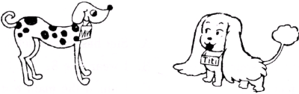

I have two pet dogs．Look at Vivi，she is white with black spots．She's very beautiful．Titi is a short and fat dog，but he is very cute．He is ________ and ________ than Vivi．Vivi's legs are ________ than Titi's．But her head is ________ than Titi's．Titi is one year old．Vivi is two years old．Titi is ________ than Vivi．I love my dogs．

**十一、选用框内单词的适当形式填空。（10分）**

|  |
| --- |
| back be because flower give make old on she train |

Uncle John's birthday is coming．He will be 35 years ________．Dad and Mum ________ going to take me to his house．We are going there by ________．We are leaving ________ Friday evening．And we are coming ________ on Sunday afternoon．The birthday party will be on Saturday．I am going to ________ my dear Uncle John a birthday card．I am ________ it now．I am using my colour pencils to draw some nice ________ on the card．I am going to draw Uncle John's little dog on it，too．________ he likes dogs．The card will be very nice．Mom says ________ brother will like it very much．

**十二、请阅读下面的小文章，然后回答问题。（10分）**

Spring is the warmest and best season of the year．A lot of flowers come out．Some are red，some are pink，some are purple．

Spring is the time to plant trees．Look! Many children are planting trees on both sides of the street．Some are digging holes，some are carrying water，some are watering trees．How hard all these children are working! They are making our motherland more and more beautiful．

根据短文内容，回答下列问题：

1．Which season is the warmest?

________ is．

2．Which season is the hottest season，spring or summer?

Of course ________ is．

3．Many children are planting trees，aren't they?

________________________

4．Why are the children working hard?

Because they want China to be a ________ country．

5．When do people like to plant trees?

They like to plant trees in ________．

**十三、书面表达。（10分）**

今天天气很好，你们全家五人——爷爷、奶奶、爸爸、妈妈和你去东湖公园玩，请用60个左右的单词写一写游玩的过程。

**听力材料及参考答案**

Ⅰ．1．I feel sick．I have a headache．

2．I'm 160 cm tall．

3．Wu Yifan failed the math test，he's sad．

4．I went to Beijing by train．

5．A：Did you go to the park yesterday?

B：No，we read books at home．

Ⅱ．1．Look at Tom．He is so tall．He is the tallest student in his class．He is 178 cm．

2．I am sad that Mr. Lee is not well today．He has a bad cold．

3．I like oranges very much．The orange is small and the apple is much bigger．

4．Mary is not happy today because she is not good at the test．

5．Look at John．He is playing basketball．He is smiling all the time．Today is his birthday．

Ⅲ．1．Which dog is stronger?

2．How do you feel?

3．What's the matter，Lucy?

4．What did you do last Sunday?

5．Where did you go on your holiday?

Ⅳ．There're forty-five students in our class．Twenty-five of us are boys and the others are girls．I am tall．Jack is taller than me，but Jack is shorter than Tom．Tom is the tallest in our class．Peter is the heaviest boy in our class，because he always eats more．Mr. Lin is our PE teacher．He is very tall and strong．He is the strongest man in our school．

**参考答案**

Ⅰ．A A B A A

Ⅱ．× × √ √ ×

Ⅲ．A B A A B

Ⅳ．C A B B C

Ⅴ．1．The elephant is heavier than the horse．

2．What is the matter with him?

3．You are／look sad today．

4．I am taller than my sister．

Ⅵ．1．smaller 2．thinner 3．happy 4．excited/happy 5．sick／ill

Ⅶ．D A B C E

Ⅷ．1．he doesn't 2．doesn't go 3．Do，like 4．How pretty，What a

Ⅸ．B F A D C

Ⅹ．shorter，fatter，longer，smaller，younger

Ⅺ．old，are，train，on，back，give，making，flowers，Because，her

Ⅻ．1．Spring 2．summer 3．Yes，they are 4．beautiful 5．spring

XIII．略