**六年级期中英语检测卷**

**听力部分**

1. **听录音，选出你听到的单词。（10分）**

( )1.A.traffic B.turn C.tell

( )2.A.taxi B.trip C.ship

( )3.A.street B.sled C.space

( )4.A.stop B.go C.wait

( )5.A.No. 57 B.No. 5 C.No. 15

1. **听录音，选出与录音内容相符的图片。（10分）**

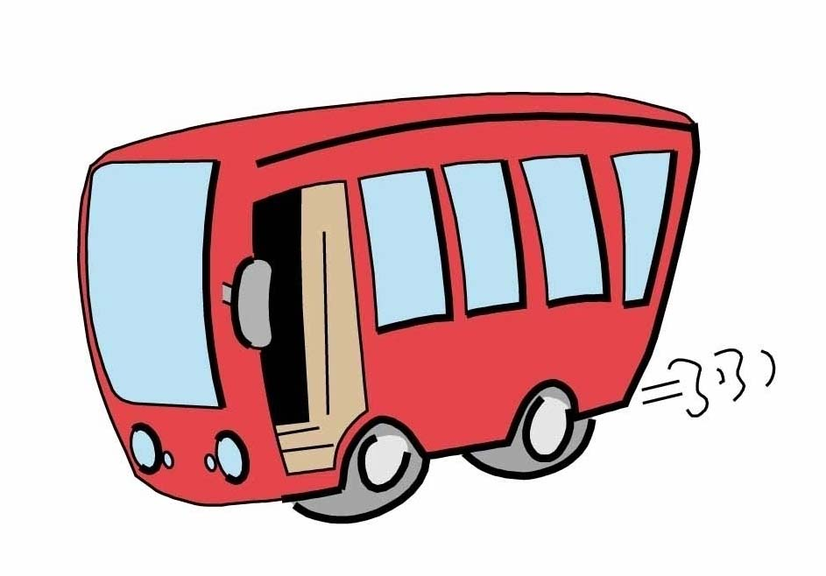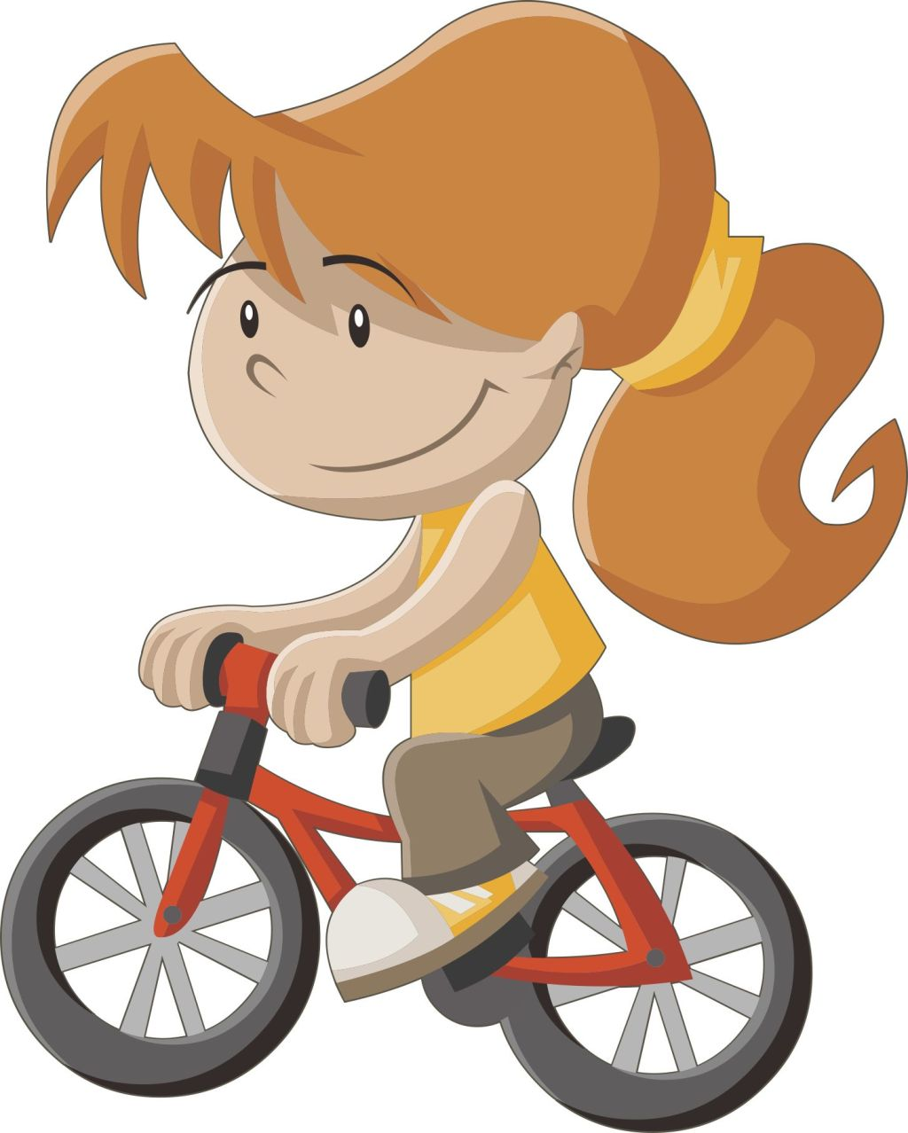( )1.A. B. C.

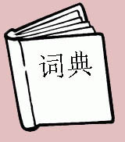

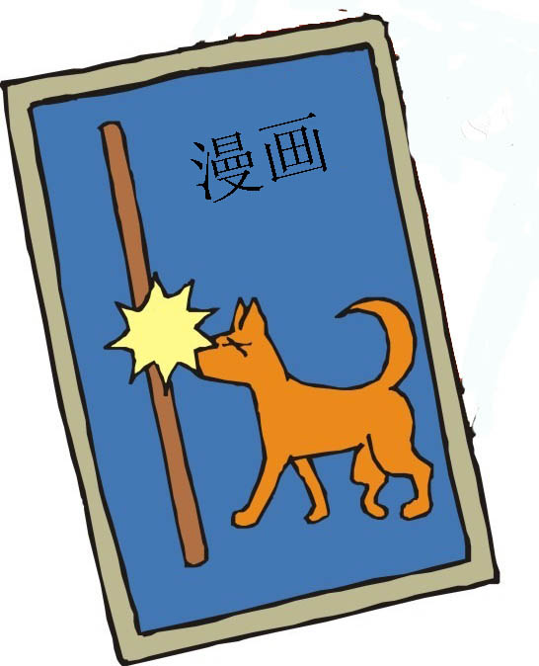( )2.A. B. C.

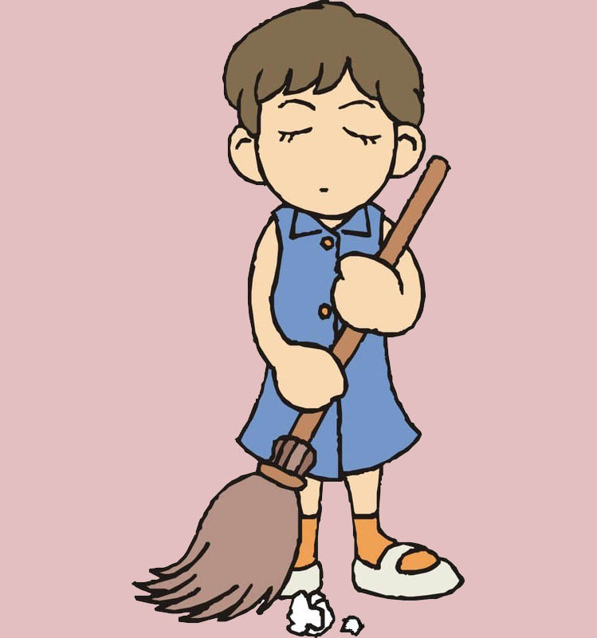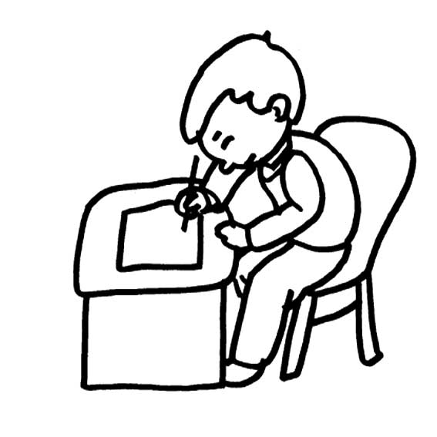( )3.A. B. C.

( )4.A. B. C.



( )5.A. B. C.



1. **听录音，排顺序。（10分）**

（ ）Peter is going to have an English class..

（ ）My mother works near the sea.

（ ）We are going to Beijing next Wednesday.

（ ）My brother goes to work by bus.

（ ）Mike goes to work by car.

1. **听录音，把下列句子补充完整。（10分）**
2. The is behind the science museum.
3. There is a in my city.
4. let’s go and turn left at the bookstore.
5. I usually go to the hospital by .
6. —What are you going to do tonight?

—I’m going to see a .

**笔试部分**

**五、找出下列每组单词中不属于同一类的一项。（10分）**

（ ）1.A.foot B.train C.plane D.subway

（ ）2.A.museum B.post office C.ask D.library

（ ）3.A.how B.must C.what D.where

（ ）4.A.left B.right C.turn D.front

（ ）5.A.dictionary B.postcard C.tonight D.comic book

**六、单项选择。（20分）**

( )1.— can I go to Shanghai? —You can go by plane.

A.What B.Where C.How

( )2.Then turn right the hospital?

A.in B.at C.on

( )3.—I going to take a trip tomorrow.

A.am B.is C.are

( )4.—What they going to do?

A.is B.are C.am

( )5.I am going to buy a dictionary in the .

A.restaurant B.bookstore C.museum

( )6.I must the traffic lights!

A.pay attention B.attention to C.pay attention to

( )7.She’s going to the Great Wall next week.

A.visit B.visits C.visiting

( )8.Please ! The light is yellow now.

A.slow down and stop B.stop and wait C.go

( )9.How do you to the USA from China?

A.gets B.get to C.get

( )10.—How do you go to school? —I often go to school foot.

A.by B.on C.in

**七、连词成句。（注意首字母要大写）（10分）**

1. a, and, red, stop, at, light, wait ( . )
2. coming, bus, the, is ( . )
3. you, where, going, are ( ? )

1. over, park, the, is, there ( . )
2. the, in, of, front, we, cinema, are ( . )

**八、给下列句子选出正确的答语，写在题前括号里。（10分）**

( )1.Where are you going? A.You too..

( )2.How do you come to school? B.I’m going to the library.

( )3.Where is the post office? C.It’s next to the museum.

( )4.Can I help you? D.By bus.

( )5.Have a good time! E.Yes

**九、阅读理解，选择正确的答案，将其编号写在题前的括号里。（10分）**

I’m Jack. I live near our school. So I usually go to school on foot. But sometimes I go by bike.My father works in our school. We go to school together. On the weekend, I often play with my friend, Mike. We usually play ping—pong. Sometimes we play chess. This weekend, I’m going to visit my grandparents. Because it’s my grandma’s birthday.

( )1.Jack usually goes to school .

1. on foot B.by bike C.by bus

( )2.Jack’s father works .

1. next to the school B.near the school C.in the school

( )3.Jack goes to school with .

1. his father B.his friend, Mike C.his mother

( )4.Jack and Mike usually .

1. play football B.play ping—pong C.play chess

( )5.Whose birthday is this weekend?

1. Grandfather’s. B.Grandmother’s . C.Mike’s.

新 课 标 第 一 网

小学六年级英语期中考试试卷答案

听力部分材料

一、**听录音，选出你听到的单词。**

1、traffic，2、taxi，3、sled，4、stop，5 、No.15

二、**听录音，选出与录音内容相符的图片。**

1、 I go to school by bike .

2、 I want to bu a dictionary .

3 、I usually watch TV after school .

4 、I like playing football .

5 、She is an English teacher .

三、**听录音，排顺序。**

1、My mother works near the sea.

2、Peter is going to have an English class.

3、My brother goes to work by bus.

4、Mike goes to work by car.

5、We are going to Beijing next Wednesday.

四、**听录音，把下列句子补充完整。**

1、The post office is behind the science museum.

2、There is a bank in my city.

3、Let’s go straight and turn left at the bookstore.

4、I usually go to the hospital by subway.

5、what are you going to do tonight ? I’m going to see a film.

参 考 答 案

听力部分

一、1~5 AABAC

二、1~5 BACCB

三、21534

四、1、post office ，2、bank ，3、straight ，4、subway， 5、 film

笔试部分

五、1-5 ACBCC

六、1-5 CBABB 6-10 CAABB

七、1.Stop and wait at a red light.

1. Where does your father work? 新
2. Where are you going?
3. My father is a police officer.
4. He should see a doctor.

八、1-5 BDCEA

九、1-5 ACABB