三年级下学期英语期中测试卷

时间：60分钟　满分：100分

|  |  |  |  |  |  |  |  |  |  |  |  |  |  |
| --- | --- | --- | --- | --- | --- | --- | --- | --- | --- | --- | --- | --- | --- |
| 题　号 | 一 | 二 | 三 | 四 | 五 | 六 | 七 | 八 | 九 | 十 | 十一 | 十二 | 总　分 |
| 得　分 |  |  |  |  |  |  |  |  |  |  |  |  |  |



一、听录音, 给单词排顺序, 用①、②、③表示。（每小题2分, 共10分）

1. friend（　　） father（　　） family（　　）

2. girl（　　） grandma（　　） giraffe（　　）

3. today（　　） tall（　　） tail（　　）

4. student（　　） sister（　　） small（　　）

5. China（　　） child（　　） children（　　）

二、听录音, 将下列图片按顺序标号。（共10分）

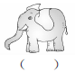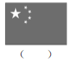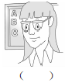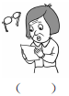

三、听录音, 在与所听内容相符的图片的序号上画“√”。（每小题2分, 共10分）

1. 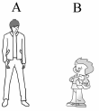　　 2. 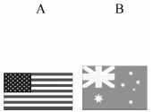　　3. 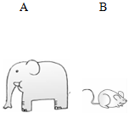

4.　 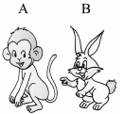　　5. 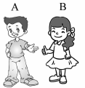

四、听录音, 根据所听句子选择相应的答语。（每小题2分, 共10分）

（　　）1. A. He's from the USA. B. I'm from the UK.

（　　）2. A. OK! B. Thank you.

（　　）3. A. Welcome! B. Nice to meet you, too.

（　　）4. A. He's my father. B. He's my brother.

（　　）5. A. Yes, she is. B. Yes, he is.



五、根据字母a, e, i的发音, 补全单词并连线。（每小题1分, 共5分）

1. d　d　　　2. s　x　　　3. p　n　　　4. m　lk　　　5. c　t

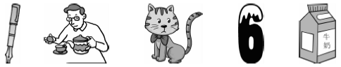

六、替换、添加、去掉一个字母都可以, 使其与后面的汉语意思相符, 并把它们写在四线三格内。（每小题2分, 共10分）

1. 

2. 

3. 

4. 

5. 

七、请将下列单词分类, 将序号填在所属类别的方框里。（每个词1分, 共10分）

1. Australia　　 2. short 　　3. China　　 4. Canada　　 　5. big

6. the USA 7. brother 8. fat 9. sister 10. grandpa

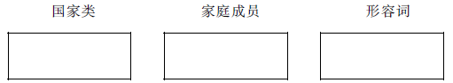

八、我会选。（每小题1分, 共5分）

(　　) 1. This is _______friend.

A. my　　　　　　　B. me　　　　　　　C. I

(　　) 2. I _________a new friend.

A. have B. has C. is

(　　) 3. The elephant has a _______nose and a ________tail.

A. short；long B. short；short C. long；short

(　　) 4. —Where are you from?

—__________.

A. The USA　　　　　B. OK　　　　　　C. Welcome

(　　) 5. —Who's that woman?

—__________.

A. He's my grandfather B. She's my grandmother C. He's my father

九、读句子, 选择符合句意的图片, 并将序号写在括号内。（每小题1分, 共5分）

(　　) 1. 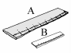I have a short ruler.

(　　) 2. 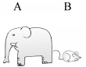Look at the mouse. It's so small！

(　　) 3. 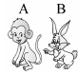The monkey has a long tail.

(　　) 4. 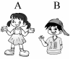This is a boy.

(　　) 5. 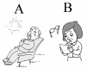He is my grandfather.

十、照例子, 写句子。（每小题2分, 共10分）

例：thin　It's so thin！

1. long ________________________________________________________________________

例：family　This is my family.

2. friend _______________________________________________________________________

例：I china　I'm from China.

3. He Canada ___________________________________________________________________

例：long nose　It has a long nose.

4. small head ___________________________________________________________________

例：he father　Is he your father?

5. she teacher ___________________________________________________________________

十一、看图, 选择框内恰当的句子完成对话, 将序号填在对话框内。（每小题1分, 共5分）

A. Yes, he is. 　　　 B. It has a short tail. 　　 　C. I'm from Canada.

D. She's my mum. E. Nice to meet you.

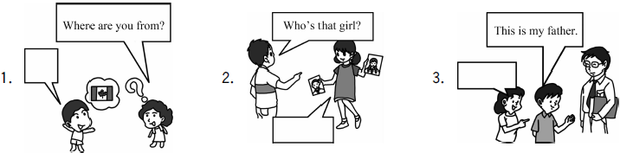

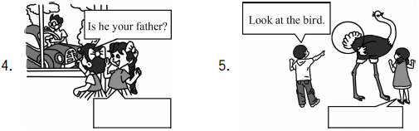

十二、小小阅读家。（每小题2分, 共10分）

Jane White is a girl. She is from the USA. She is a student. Her father is Bill White and her mother is Joan White. Her brother Bob is a student, too. Jane has long hair（头发）. She is tall, but（但是） Bob is short.

(　　) 1. Jane White is from ________.

A. China B. the UK C. the USA

(　　) 2. She is _______.

A. short B. tall C. quiet（安静的）

(　　) 3. Her brother is a _______.

A. student B. teacher C. worker（工人）

(　　) 4. Jane's hair is _______.

A. short B. black C. long

(　　) 5. Bob is _________.

A. tall B. short C. thin

三年级下学期英语期中测试卷

听力材料

一、1. father friend family　2. giraffe girl grandma 3. today tail tall　4. small sister student

5. China children child

二、1. I'm from China. 2. It's an elephant. It has a long nose. 3. She's a teacher.

4. She's my grandma. 5. Mike is from Canada.

三、1. He's tall. 　2. I'm from the USA. 3. It's small. 4. It has long ears. 5. He's my brother.

四、1. Where are you from？　2. Let's play a game. 3. Nice to meet you. 　4. Who's that boy?

5. Is she your sister?

听力答案

一、1. ②①③　2. ②③①　3. ①③②　4. ③②① 5. ①③②

二、2 5 1 3 4

三、1. A　2. A　3. B　4. B　5. A

四、1. B　2. A　3. B　4. B　5. A

笔试答案

五、

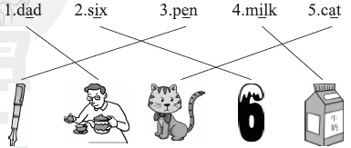

六、

七、国家类：1 3 4 6　家庭成员：7 9 10 形容词：2 5 8

八、1. A　2. A　3. C

4. A [点拨]由问句可知, 询问的是来自于哪里, 应回答地点, 选A。

5. B [点拨]由问句中woman女人可知, 选B。

九、1. B　2. B　3. A　4. B　5. A

十、1. It's so long！　2. This is my friend. 3. He is from Canada. 4. It has a small head.

5. Is she your teacher?

十一、1. C　2. D　3. E　4. A　5. B

十二、1. C　2. B　3. A　4. C　5. B