六年级上学期英语期中测试卷

时间：60分钟　满分：100分

|  |  |  |  |  |  |  |  |  |  |  |  |  |  |
| --- | --- | --- | --- | --- | --- | --- | --- | --- | --- | --- | --- | --- | --- |
| 题　号 | 一 | 二 | 三 | 四 | 五 | 六 | 七 | 八 | 九 | 十 | 十一 | 十二 | 总　分 |
| 得　分 |  |  |  |  |  |  |  |  |  |  |  |  |  |

第一部分 听力 (30分)

一、听录音，选择正确的图片。(5分)

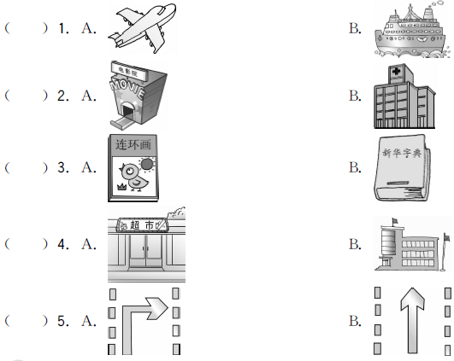

二、听录音，给下面的句子排序。(5分)

(　　) Sometimes I come to school by bus.

(　　) The cinema is next to an Italian restaurant.

(　　) In the USA people on bikes must wear a helmet.

(　　) In China, people drive on the right side.

(　　) I'm going to see a film tomorrow.

三、听录音，选择正确的答语。(10分)

(　　) 1. A. I'm going to Jinan on Sunday. B. She is going to Jinan.

C. He's going to Jinan by bus.

(　　) 2. A. I get there on foot. B. It's not far from here.

C. My school is next to the bank.

(　　) 3. A. I want to buy some books. B. I'm going to the bookstore.

C. Turn left at the traffic lights. You can see it on your right.

(　　) 4. A. We are going there next weekend. B. We go there on foot.

C. Go straight and then you can see it.

(　　) 5. A. They work in a post office.

B. They are going to visit my grandparents.

C. They can take the No. 4 bus to go there.

四、听录音，连线。(10分)

1. Sarah A. visits her grandparents a. by subway

2. Chen Jie B. goes to the supermarket b. by bike

3. Amy C. goes to the nature park c. on foot

4. Mike D. goes to the bookstore d. by car

5. Wu Yifan E. goes to the cinema e. by bus

第二部分　笔试(70分))

五、语音归类。(10分)

science　office　hospital　left　right　street　get　feature

bus　subway　visit　trip　tonight　dictionary　together

1./aɪ/_________________________________________________________________

2./ɪ/__________________________________________________________________

3./e/_________________________________________________________________

4./iː/_________________________________________________________________

5./ʌ/_________________________________________________________________

六、为下列句子配上合适的图片。(5分)

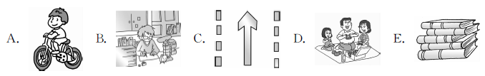(　　) 1. I have to do my homework first.

(　　) 2. We are going to have a picnic next weekend.

(　　) 3. You can go to the post office by bike.

(　　) 4. I'm going to the bookstore to buy some comic books.

(　　) 5. Go straight，and you can see the supermarket.

七、单项选择。(5分)

(　　) 1. ________. Where is the supermarket?

A. Sorry B. Hello C. Excuse me

(　　) 2. We usually go to the park ________.

A. by feet B. on foot C. by a car

(　　) 3. I ________ the Great Wall tomorrow.

A. visit B. am going to visit C. am visit

(　　) 4. The traffic light is green now. We can ________.

A. wait B. stop C. go

(　　) 5. I'm going to buy a book ________ animals.

A. to B. of C. about

八、用所给词的正确形式填空。(5分)

1. I'm going to ________ (swim) with my friend this afternoon.

2. Grandma ____________ (wash) clothes tomorrow.

3. Don't ________ (talk) in class.

4. Why not ________ (buy) a dictionary for him?

5. I'm going to look for some beautiful________ (leaf).

九、补全对话。(5分)

**A:** Excuse me, I'm new here. I want to go to the post office. 1. ________

**B:** It's near the bookstore.

**A:** 2. ________

**B:** Yes, it is.

**A:** 3. ________

**B:** You can go by the No. 302 bus. Get off at the hospital，and then turn left. You can see it. 4. ________

**A:** I'm going to buy a postcard and send it to my cousin. 5. ________

**B:** You're welcome.

A. Where is it? B. How can I get there?

C. Thank you very much. D. Is it far from here?

E. What are you going to do there?

十、想一想，写一写。(10分)

森林卫士招聘会开始了，小黄狗第一个报名并拿到了试卷，可是下面的题目可把它难坏了。同学们，快来帮忙吧！

1. What does this sign mean(意思是)? 

It means “____________”.

2. Can he drive on the left side in China? 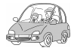

____________________________

3. Where are you going to work if you become(变成)a postman? 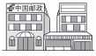

____________________________

4. What should you do when you see the red light? 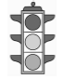

I should ________.

5. 用英语写出图中车辆的名称

____________________________　 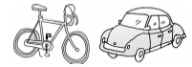

十一、按要求完成下列各题。(10分)

1. The restaurant is next to the hospital. (对画线部分提问)

________ ________ the restaurant?

2. I'm going to see a film this evening. (对画线部分提问)

________ are you going to ________ this evening?

3. Miss Zhang often comes to school by bike. (对画线部分提问)

________ ________ Miss Zhang often come to school?

4. Go at a red light. (改成否定句)

________ ________ at a red light.

5. We can go to the museum on foot. (写出同义句)

We can ________ ________ the museum.

十二、阅读理解。(10分)

Tomorrow is Sunday. Wang Jie isn't going to school. He is going to get up early. In the morning，he is going to visit a science museum. He's going there by subway. He's going to have lunch in McDonald's. In the afternoon，he is going to play football with his friends. At about 3：30，he is going home to do homework. Then he is going to clean his bedroom. He's going to cook dinner for his father and mother in the evening.

(　　) 1. —What day is it today?

—It is ________.

A. Sunday　　　　　　B. Saturday　　　　　　C. Monday

(　　) 2. What is Wang Jie going to do on Sunday morning?

A. He is going to visit a science museum.

B. He is going to visit his grandparents.

C. He is going to the bookstore.

(　　) 3. Wang Jie is going to have lunch ________.

A. in McDonald's B. at school C. at home

(　　) 4. Wang Jie is going to the science museum ________.

A. by car B. by subway C. by bus

(　　) 5. What is he going to do after he finishes his homework?

A. He is going to clean his bedroom.

B. He is going to play football with his friends.

C. He's going to cook dinner for his grandparents.

十三、小作文。(10分)

周末就要来了，请写一写你和你的家人的周末计划吧。

_____________________________________________________________________

_____________________________________________________________________

_____________________________________________________________________

_____________________________________________________________________

_____________________________________________________________________

_____________________________________________________________________

听力材料：

一、1. I go to Nanjing by plane.

2. I am going to the cinema this evening.

3. I want to buy a dictionary.

4. We are going to the supermarket this weekend.

5. Go straight and you will see the bank on your left.

二、1. In China, people drive on the right side.

2. In the USA people on bikes must wear a helmet.

3. Sometimes I come to school by bus.

4. I'm going to see a film tomorrow.

5. The cinema is next to an Italian restaurant.

三、1. Where is she going?

2. How do you get there?

3. How can I get to the bookstore?

4. When are you going to the Great Wall?

5. What are your parents going to do?

四、　　My friends are so busy this weekend. Sarah is going to the bookstore. It's not far from her home. She can go there on foot. Chen Jie is going to the cinema by bus. Amy is going to visit her grandparents with her parents. They are going there by car. Mike is going to the supermarket by bike. He wants to buy some fruits. And Wu Yifan is going to the nature park by subway.

答案：

一、1. A　2. A　3. B　4. A　5. B

二、3　5　2　1　4

三、1. B　2. A　3. C　4. A　5. B

四、1. D­c　2. E­e　3. A­d 4. B­b　5. C­a

五、1. /aɪ/ science，right，tonight

2. /ɪ/ office，hospital，visit，trip，dictionary

3. /e/ left，get，together

4. /iː/ street，feature

5. /ʌ/ bus，subway

六、1. B　2. D　3. A　4. E　5. C

七、1. C　2. B　3. B　4. C　5. C

八、1. swim

2. is going to wash/will wash　点拨：由tomorrow可知，该句用一般将来时。

3. talk　点拨：祈使句的否定形式是Don't＋动词原形. . . 。

4. buy　点拨：由“Why＋not＋动词原形”可知这里填buy的原形。

5. leaves　点拨：由句中的some 可知应使用leaf的复数形式leaves。

九、1. A　2. D　3. B　4. E　5. C

十、1. turn right

2. No，he can't.

3. I am going to work in a post office.

4. stop

5. bike；car

十一、1. Where is 　2. What；do　3. How does 4. Don't go　5. walk to

十二、1. B　点拨：细节理解题。由“Tomorrow is Sunday. ”可知，明天是星期天，今天是星期六。

2. A　点拨：细节理解题。由“In the morning，he is going to visit a science museum. ”可知，在星期天的上午王杰将去参观科学博物馆。

3. A　点拨：细节理解题。由“He's going to have lunch in McDonald's. ”可知，王杰将在麦当劳吃午餐。

4. B　点拨：细节理解题。由“He's going there by subway. ”可知，王杰将乘地铁去科学博物馆。

5. A　点拨：细节理解题。由“Then he is going to clean his bedroom. ”可知，王杰在做完作业后要打扫他的卧室。

十三、范文：

The weekend is coming！I'm going to the bookstore on Saturday. I want to buy a dictionary. My mother is going to visit my grandparents on Sunday. My father is going to take a trip with his friends on Saturday. I think we will be very happy.