# 小学六年级英语期末检测题11

考 号

|  |
| --- |
| 乡镇__________________ 学校_____________________ 班级____________ 姓名____________ 座号__________  **………………………………密………………………………….封……………………….线…………………………………………………………………………..** |

|  |  |  |  |  |  |  |  |  |  |  |  |  |  |
| --- | --- | --- | --- | --- | --- | --- | --- | --- | --- | --- | --- | --- | --- |
| 题 次 | 一 | 二 | 三 | 四 | 五 | 六 | 七 | 八 | 九 | 十 | 十一 | 十二 | 总评 |
| 记 分 |  |  |  |  |  |  |  |  |  |  |  |  |  |

A. 听力部分 (30分)

一、听音，选出你听到的内容，并写出其字母编号。（5分）

( ) 1. A. big B. bag C. bigger

( ) 2. A. her B. hurt C. hair

( ) 3. A. head B. leg C. hand

( ) 4. A. tall B. tail C. tired

( ) 5. A. play basketball B. plays basketball C. played basketball

**二、**根据你所听到的内容, 选择相符合的一项，并将其填在括号内。(7分)

（ ） 1. A. 146cm tall B. 164cm tall C. 164cm long

（ ） 2. A.15 B. 50 C.55

（ ） 3. A. bike B. by C. bought

（ ） 4. A. wash B. catch C. watch

（ ） 5. A. play B. plant C. plane

（ ） 6. A. actor B. actress C. artist

（ ）7. A. October B. November C. December

三、听录音，在每组图片中打🗸选择A或B。(8分)

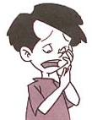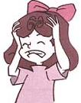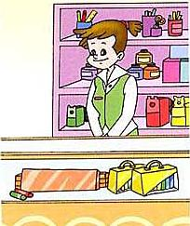  **1.**  **2.**

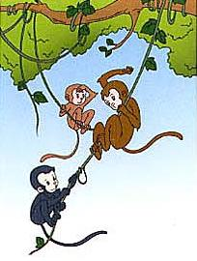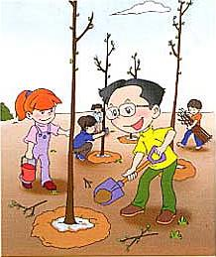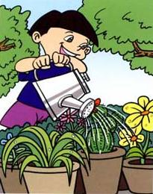 **A B A B**



**3. 4.**

**A B A B**

四、听读句子，写出句子中所缺的单词。（5分）

1. Mary is __________ and __________.

2. He had a ___________yesterday.

3. Zhang Peng is __________ than me.

4. I __________ a new magazine for my brother yesterday.

五**、听一段短文，判断对错，对的打√，错的打×。**(5分)

( ) 1. Tom lives in China.

( ) 2. Tom’s father is a policeman.

( ) 3. Tom’s mother is a teacher.

( ) 4. Tom is a student.

( ) 5. Tom went to school by bus yesterday .

B**.**笔试部分（70分）

六、看图片，找单词或短语，把图片序号填写在词语前括号里。（15分）

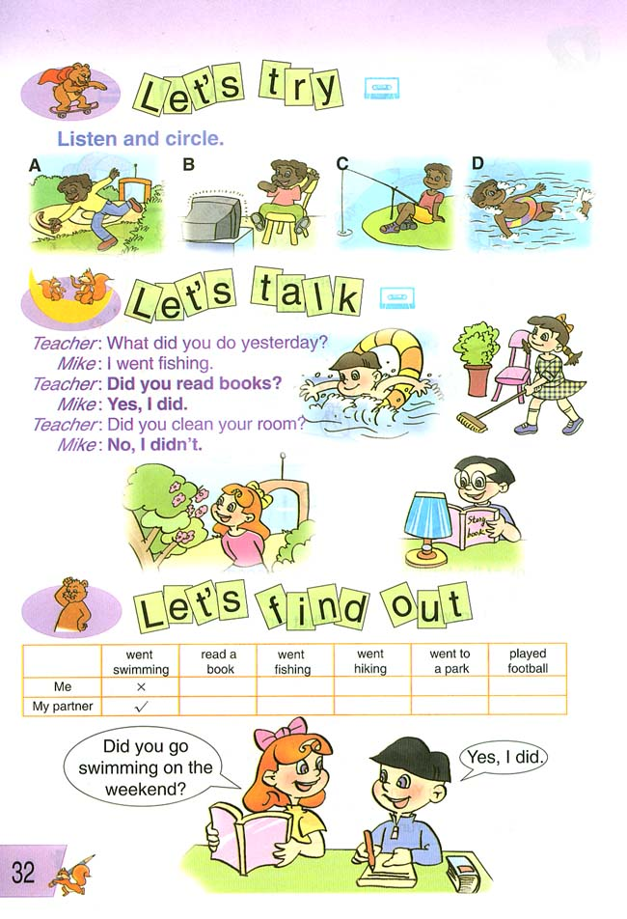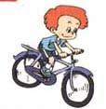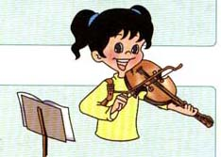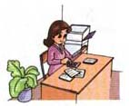

1. 2. 3. 4. 5.

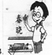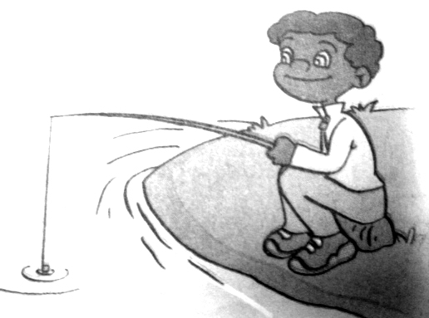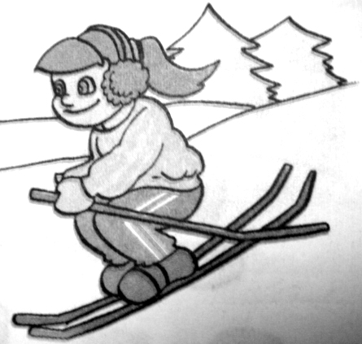

6. 7. 8. 9. 10.

( ) go skiing ( ) play the violin ( )swimming ( ) reading

( ) go fishing ( ) go ice-skating ( )clean the room

( ) riding a bike ( ) Chinese teacher ( ) accountant

七、找出不同类的词，将其编号填在左边括号内。（10分）

( ) 1. A. tell B . say C . cook D . father

( ) 2. A . pear B . apple C . flower D . banana

( ) 3. A. bike B. bus C. black D.ship

( ) 4. A. bread B . milk C . table D . egg

( ) 5. A. one B . two C . first D . four

八、选择填空，把其编号填在左边括号内。（10分）

( ) 1. Who’s the lady ______ blue ?

  A. in                  B. at            C. with

( ) 2. Thank you for .

A. come B. comes C. coming

( ) 3. I’m going to the park________ my friend.

A. with B. to C. for

( ) 4. How big are your feet? _________ .

A. I wear Size 17. B. I’m bigger than you. C. I’m 17 bigger.

( ) 5. . I want _______ a map of China .

A. buy          B. is buying   C. to buy

( ) 6. Every one must know the traffic .

A. rules B. policeman C. books

( ) 7. What you this weekend?

A. are, doing B. did, do C. are, going to do

( ) 8. your aunt work in a factory?

A. Is B. Does C. Do

( ) 9. Green light means “ ”.

A. Stop B. Go C. Wait

( ) 10. My parents often tell me ______ China .

      A. about           B. from         C. for

九、连词成句。(10分)

1. where  on   you   go  your  holiday  did**(?)**

__________________________________________________

2. you    much    am    than    I    taller(**.**)

__________________________________________________

3. He by to goes work subway(**.**)

__________________________________________________

4. the  do  you  what on  weekend  do usually (**?**)

__________________________________________________

5. visit  I’m   tomorrow my   going  grandparents  to(**.**)

__________________________________________________

十、在Ⅱ栏中找出Ⅰ栏的正确答案，将其字母编号填入括号内。（5分）

**（Ⅰ） （Ⅱ）**

( ) 1. What time is it now? A. It comes from the vapour in the river.

( ) 2.Where does she work? B. You can take the bus.

( ) 3. What are you going to do? C. It's about a quarter to eight.

( ) 4. How can I get there? D. She works in a car company.

( ) 5. Where does the cloud come from? E. I’m going to the park.

十一、阅读短文，然后判断后面的句子是否符合短文内容，打“√”或“×”。（10分）

It was Saturday. Tom stayed at home alone(单独地). His parents went to visit his grandparents in another city. He did his homework and read books. After lunch, he watched TV and played basketball on the playground with Jack. He felt very tired. In the evening, his parents came back and brought him some presents. They were a schoolbag and a basketball. Tom felt very excited!

( ) 1. Tom didn’t visit his grandparents.

( ) 2. Tom read books in the afternoon.

( ) 3. Tom felt tired after reading books.

( ) 4. Tom’s parents bought a new schoolbag for him.

( ) 5. Tom was happy in the evening.

十二、作文：(六十词左右)（10分）

Last weekend

假设上个周末你去了公园游玩，请你以“Last weekend”为题，写写你去的

地点、时间，用了什么交通工具，游玩了什么，心情怎么样等。

________________________________________________________________________

________________________________________________________________________

________________________________________________________________________

________________________________________________________________________

________________________________________________________________________

小学六年级英语期末检测题参考

一、听音，选出你听到的内容，并写出其字母编号。（5分）

1. My bag is smaller than yours. 2. I hurt my finger.

3. What’s the matter with your head? 4. Were you tired last week?

5. Uncle John plays basketball every day.

(B B A C B) http://w w w.xkb 1. com

二、根据你所听到的内容, 选择相符合的一项，并将其填在括号内。(7分)

1. Tom is 164cm tall.

2. You can take the No. 50 bus to the hospital.

3.I bought some presents for my friends

4.Can you wash the clothes?

5.Can you plant trees?

6. My aunt is an actress.

7. My birthday is in December.

(B B C A B B C)

三、听录音，在每组图片中打√选择A或B。(8分)

1、How does he feel? He has a toothache.

2、My aunt is a salesperson.

3、What are you going to do this weekend? I’m going to plant trees.

4、What are they doing? They’re swinging.

(B B B A)

四、听读句子，写出句子中所缺的单词。（5分）

1. Mary is 45kg and 161cm.

2. He had a headache yesterday..

3. Zhang Peng is heavier than me.

4. I bought a new magazine for my brother yesterday.

五、听一段短文，判断对错，对的打√，错的打×。(5分)

Tom is my new pen pal . He lives in Beijing. His father works in a hospital. He helps sick people. His mother works in a shop. She sells books there. Tom studies in a school. He usually goes to school on foot. But he went to school by bike yesterday. Because his father bought a new bike for him.

（√ ×　× √　×）

六、看图片，找单词或短语，把图片序号填写在词语前括号里。（15分）

6 5 3 1 7 10 9 4 8 2

七、找出不同类的词，将其编号填在左边括号内。（10分）

D C C C C

八、选择填空，把其编号填在左边括号内。（10分）

A C A A C A C B B A

九、连词成句。(10分)

1.Where did you go on  your  holiday ?

2. I  am much  taller than you .

3. He goes to work by subway.

4. What do you usually do on the  weekend?

5. I’m going to visit my  grandparents tomorrow .

十、在Ⅱ栏中找出Ⅰ栏的正确答案，将其字母编号填入括号内。（5分）

C D E B A

十一、阅读短文，然后判断后面的句子是否符合短文内容，打“√”或“×”。（10分）

1.√ 2.× 3.× 4.√ 5.√

十二、作文：(六十词左右)（10分）答案略。