期末检测卷

时间: 60分钟　满分: 100分

第一部分　听力(40分)

一、听录音，圈出你所听到的字母或字母组合。(5分)

二、听录音，选出与你听到的内容相符的图片。(5分)

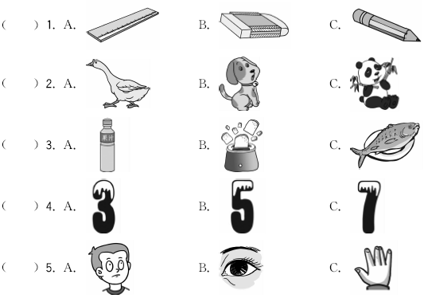

三、听录音，根据你所听到的顺序，在括号中用数字1、2、3……标出。(5分)

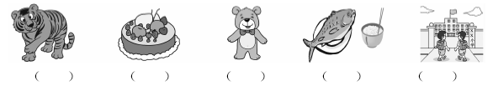

四、听录音，选出你所听到的句子。(5分)

(　　) 1. A. My name's John. B. My name's Jack.

(　　) 2. A. I see black. B. Colour it black.

(　　) 3. A. Let's go to the zoo. B. Let's make a puppet.

(　　) 4. A. What's this? B. What's that?

(　　) 5. A. Here you are. B. Have some bread.

五、听录音，下列图片与你所听到的内容一致的画，不一致的画。(10分)

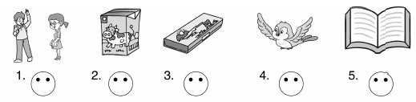

六、听录音，选择正确的答语。(10分)

(　　) 1. A. Nice to meet you, too. B. Good afternoon.

(　　) 2. A. It's blue. B. It's a tiger.

(　　) 3. A. Very well, thanks. B. Me too.

(　　) 4. A. This is Mike. B. My name's Mike.

(　　) 5. A. I'm six years old. B. You're welcome.

　　　　　　　　　　　　第二部分　笔试(60分)

七、写出下列字母的相邻字母的大小写。(5分)

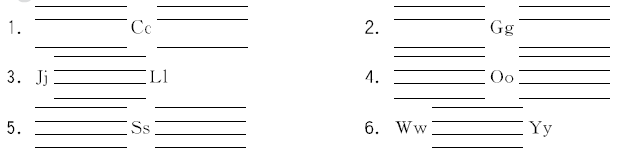八、看图，找单词，选择对应的序号。(5分)

1. mouth　　2. cat　　3. foot　　　　4. bag　　5. fish

6. ruler 7. pen 8. pencil box 9. juice 10. elephant

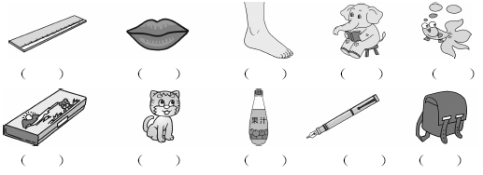九、单项选择，将正确的序号填在括号内。(10分)

(　　) 1. —What's your name?

—________

A. My name is Wu Yifan. B. It's a pen. C. Nice to meet you.

(　　) 2. —How are you? —________

A . Fine, thank you. B. I'm ten. C. Good morning.

(　　) 3. —What's this? —It's________ elephant.

A. a B. an C. /

(　　) 4. —How old are you? —________

A. It's a dog. B. I am nine. C. Happy birthday!

(　　) 5. —How many candles? —________

A. Six. B. I am five. C. I have a pen.

十、情景选择。(10分)

(　　) 1. Mike认识了一位新朋友，他应该怎样介绍自己呢？

A. My name's Mike. B. How are you? C. Nice to meet you, too.

(　　) 2. 早上在校门口你遇到你的同学，你应该说：

A. Good afternoon. B. Good evening. C. Good morning.

(　　) 3. 当你把一样东西给对方时，可以说：

A. How are you? B. Here you are. C. Here are you.

(　　) 4. 当你想请别人喝牛奶时，你应该说：

A. I'd like some milk. B. Have some milk. C. Show me the milk.

(　　) 5. 当你的朋友祝你生日快乐时，你应该如何回答？

A. I'm OK. B. Me too. C. Thank you.

十一、根据图片和情景，选择正确选项。(10分)

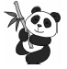(　　) 1. —What color is it?

—It's________.

A. yellow and white　　 B. black and white　 　C. blue and green

(　　) 2. —I have________.

—Me too.

A. a crayon B. a book C. an eraser

(　　) 3. —I'm hungry, Mom.

—Would you like some________?

A. milk B. rice C. bread

(　　) 4. —What's that?

—It's________.

A. a pig B. a monkey C. a tiger

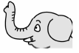(　　) 5. —Look at my________.

—OK.

A. foot B. body C. nose

十二、根据对话，选择正确的句子。(10分)

**Sarah:** Happy birthday, Mike!

**Mike:** Thank you, Sarah. 1. ________

**Mum:** Nice to meet you, Sarah.

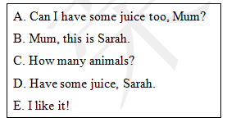**Sarah:** Nice to meet you, too.

**Mum:** 2. ________

**Sarah:** Thank you.

**Mike:** 3. ________

**Mum:** Sure, here you are.

**Mike:** Look, Sarah! I have a zoo!

**Sarah:** Cool! 4. ________

**Mike:** 9.

**Sarah:** Wow, 5. ________

十三、阅读短文，根据短文内容选择正确答案。(10分)

Hello, my name's Kate. I'm nine years old. I like red and white. I like juice and bread. Look, this is my friend (朋友) Lily. Lily is red and blue. She is lovely (可爱的). Haha, she is a bird. I like her very much.

(　　) 1. Kate is ________ years old.

A. 8 B. 9 C. 10

(　　) 2. Kate likes ________.

A. milk and bread B. juice and rice C. juice and bread

(　　) 3. Kate's friend is ________.

A. Lily B. black C. a cat

(　　) 4. Lily is ________.

A. red and white B. blue and black C. red and blue

(　　) 5. Lily is a ________.

A. dog B. bird C. panda

期末检测卷

听力材料：

一、1. E　2. G　3. S　4. gd　5. kn

二、1. I have a ruler.

2. I see a panda in the zoo.

3. Can you drink some juice?

4. Mike is five years old.

5. Look at the eye.

三、1. This is a bear.

2. I can see a tiger.

3. Let's go to school.

4. Happy birthday.

5. Have some fish and rice.

四、1. **M:** My name's Jack.

2. Colour it black.

3. Let's go to the zoo.

4. What's that?

5. Here you are.

五、1. **M:** Good morning, Miss White.

2. Would you like some milk?

3. I have a pencil.

4. Look at the bird.

5. I have a book.

六、1. Nice to meet you.

2. What's this?

3. I have an eraser.

4. What's your name?

5. How old are you?

答案：

一、1. E　2. G　3. S　4. gd　5. kn

二、1. A　2. C　3. A　4. B　5. B

三、2 4 1 5 3

四、1. B　2. B　3. A　4. B　5. A

五、1.  　2. 　3.  　4.  　5. 

六、1. A　2. B　3. B　4. B　5. A

七、

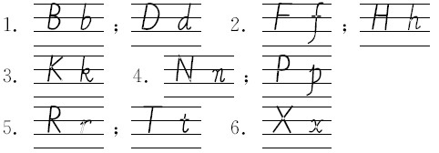

八、

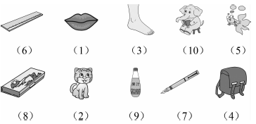

九、1. A

2. A　点拨：问句句意为“你好吗？”A项“很好，谢谢你。”B项“我10岁。”C项“早上好。”故选A。

3. B　点拨：elephant是以元音音素开头的单词，故前面用an。

4. B　点拨：问句句意为“你几岁了？”A项“它是一只狗。”B项“我9岁。”C项“生日快乐！”故选B。

5. A　点拨：问句句意：有多少根蜡烛？A项“6根。”B项“我5岁。”C项“我有一支钢笔。”故选A。

十、1. A　2. C　3. B　4. B　5. C

十一、1. B　2. A　3. C　4. B　5. C

十二、1. B　2. D　3. A　4. C　5. E

十三、1. B　2. C　3. A　4. C　5. B