**第一学期英语学科四年级期末检测卷**

1．读一读，选一选。

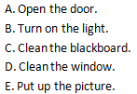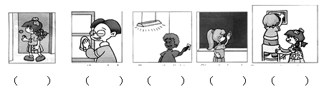

2．找出不同类的单词。

（1）A red B. doctor C. yellow

（2）A. uncle B. basketball C. aunt

（3）A. spoon B. father C. mother

（4）A. fork B. bowl C. light

（5）A. her B. his C. parents

（6）A bathroom B. kitchen C. sofa

（7）A. candy B. floor C. wall

（8）A. friendly B. quiet C. hat

（9）A. key B. driver C. cook

（10）A. baby B. football C. basketball

3．请找出每个句子的答语，并将其字母代号填在前面的括号里。

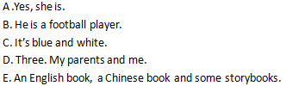

（ ）What’s your uncle’s job?

（ ）What’s in your schoolbag?

（ ）What colour is it?

（ ）How many people are there in your family？

（ ）Is she in the study?

4．将单词与图片连线。

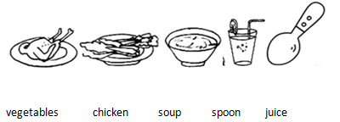

5．_______is in the classroom?

A. How B. What C. How many

6．Is it in your desk? —

A. Yes, it isn’t. B. Yes, it is. C. Yes, they are.

7． some noodles? —Yes, please.

A. What would you like

B. Would you like

C. What do you like

8．Is she in the living room? —

A. Yes, she is. B. No, he isn’t. C. Yes, he is.

9．Are they near the phone? —

A. Yes, they are.

B. Yes, it is.

C. No, they are.

10．My grandparents are________.

A. farmers B. farmer C. teacher

11．Can I a knife and a fork? —Yes, please.

A. has B. is C. have

12．What’s his name?

A .His name is Zhang Peng.

B. He is tall C. She’s Amy.

13．Let ____ clean the board.

A. me B. to C. go

14．I have a good friend. He _____ glasses and his shoes are blue.

A. has B. have C. are

15．读一读，判断正“√”误“×”。

（1）My mother is a teacher.

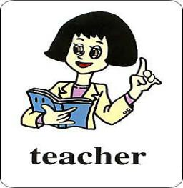

（2）She has short hair.

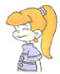

（3）I have two Chinese books.

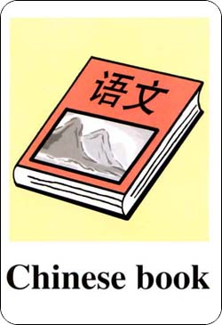

（4）The boy is short and thin.

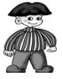

（5）Look! This is my study. It’s nice.

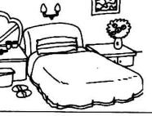

16．认真阅读文章，并判断“√”错“×”。

This is my family. My grandparents are farmers. My mother is a teacher. My father is a doctor. My aunt is a nurse. She has long hair. My brother and I are good students. This is my family. My family is happy.

（1）My father is a doctor.

（2）My grandmother is a farmer.

（3）My grandfather is a driver.

（4）My mother is a cook.

（5）My aunt is a teacher.

17．根据图画提示选择合适的单词填空，一空一词，注意书写规范。

|  |
| --- |
| study computer shoes sofa rice |

（1）A: What would you like for dinner?

I’d like some

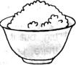

（2）Where is the ?

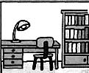

（3）These are my , they’re green.

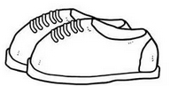

（4）I have a new .



（5）The is in the living room.

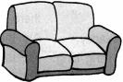

18．读一读，字母发音相同的打“√”不同的“×”。

（1）face cake

（2）rose dog

（3）cute mum

（4）bike rice

（5）he she

（6）cat make

19．找出下列句子的反义词。写在括号里。

（1）He is tall. She is short . （ ） （ ）

（2）Mike is strong . Mary is thin . （ ） （ ）

（3）She has small nose and big eyes . （ ） （ ）

（4）The boy and the girl are friends . （ ） （ ）

（5）Zhang Peng has black hair, but his grandpa’s hair is white. （ ） （ ）

20．给下列句子排序。

（ ）What colour is it?

（ ）Excuse me. I lost my schoolbag.

（ ）An English book, two toys and a notebook.

（ ）It’s yellow and black.

（ ）Here it is.

（ ）Thank you so much.

（ ）OK. What’s in it?

**参考答案**

1．A D B C E

【解析】

2．（1）B （2）B （3）B （4）B （5）A （6）C （7）C （8）C （9）A （10）A

【解析】

3．B D C E A

【解析】

4．

【解析】

5．B

【解析】

6．B

【解析】

7．B

【解析】

8．A

【解析】

9．A

【解析】

10．A

【解析】

11．C

【解析】

12．A

【解析】

13．A

【解析】

14．A

【解析】

15．（1） √ （2） × （3） √ （4） × （5）×

【解析】

16．

【解析】

17．rice study shoes computer sofa

【解析】

18．√ × × √ √ ×

【解析】

19．（1）tall short （2）strong thin （3）small big （4）boy girl （5）black white

【解析】

20．

【解析】