**人教PEP四年级英语上册期末测试卷**

1．选出你所听到的单词。（10%）

（1）A.bread B.red C.brown

（2）A.chair B.where C.sure

（3）A.beef B.fish C.farmer

（4）A.people B.pencil C.pass

（5）A.milk B.music C.mouse

（6）A.science B.Chinese C.English

（7）A.she B.shelf C.short

（8）A.math B.man C.many

（9）A.bathroom B.bedroom C.classroom

（10）A.twenty B.thirty C.fifty

2．听音判断图的正确与否。（10%）

（1）

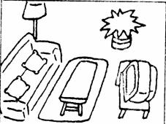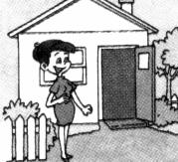

（2）

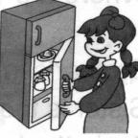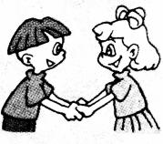

（3）

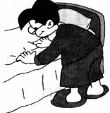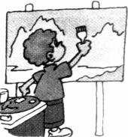

（4）

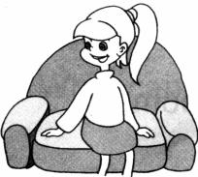

（5）

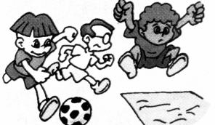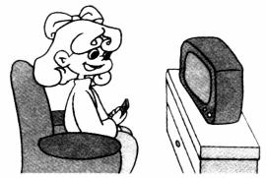

3．听句子选单词。（10%）

（1）A.door B.board C.floor

（2）A.teacher B.picture C.finger

（3）A.short B.sport C.strong

（4）A.forty B.thirty C.twenty

（5）A.wall B.ball C.tall

4．根据读音，完成下列句子，每空一词。（10%）

（1）Welcome to my .

（2）Amy’s is a .

（3）I have an uncle. He’s a .

（4）My parents are s .

5．听录音，选出你所听到句子的答语。（10%）

（1）A. He’s a teacher.

B. Yes, she is.

C. Yes, she’s my teacher.

（2）A. My name is Tom.

B. Her name is Sarah.

C .This is Sarah.

（3）A. No, they aren’t.

B. Yes, they aren’t.

C. No, they are.

（4）A. It’s a schoolbag.

B. Some books and pens.

C. It’s red.

（5）A. There are 9.

B. They’re in the room.

C. They are 9.

6．How many ________ can you see?

A. apple B. cats C. dog

7．Give me ________ pens.

A. two B. an C. a

8．Can I ___________ some noodles, please?

A. like B. has C. have

9．Let ________ clean the blackboard.

A. I B. me C. our

10．What’s ________ name? His name is Zhang Peng.

A. his B. her C. your

11．What colour is your English book?

A. 9 B. It’s big. C. It’s yellow.

12．Do you like sports?

A. Yes, I don’t. B. Yes, I do. C. No, I do.

13．What would you like for lunch?

A. Yes, I like.

B. I’d like some chicken.

C. I don’t like rice.

14．What can you see in my room?

A. I can see a bed.

B. It’s nice.

C. I have two windows.

15．Where are the keys?

A. It’s on the desk.

B. they’re on the table.

C. They’re on the table.

16．找出下列单词不同类的单词。 （10% ）

（1）A. rice B. soup C. light D. bread

（2）A. thin B. long C. short D. sports

（3）A. thirty B. pencil C. twenty D. fifty

（4）A. bedroom B.door C. wall D. window

（5）A. spoon B. water C. plate D. fork

17．将问句的编号写在相应答句前面的括号里。（5%）

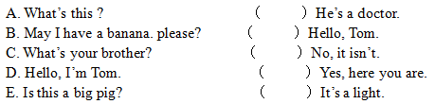

18．阅读理解。（10%）

Look at my family photo. This is my father. He’s a teacher. He’s tall. He likes

sports. This is my mother. She’s a teacher, too. She likes reading. This is my

brother. He’s a baseball player. He’s strong. I love my family.

（1）My parents are teachers.

（2）My father likes sports.

（3）My brother likes music.

（4）My brother is tall and strong.

（5）There are four people in my family.

**参考答案**

1．（1）A（2）C（3）B（4）A（5）B（6）B（7）A（8）C（9）A（10）B

【解析】

【听力材料】

（1）bread

（2）sure

（3）fish

（4）people

（5）music

（6）Chinese

（7）she

（8）many

（9）bathroom

（10）thirty

2．

【解析】

【听力材料】

（1）It’s my bedroom. （×）Welcome to my home. （√）

（2）Open the door. （×）Make friends. （√）

（3）Make the bed. （√）Clean the picture. （×）

（4）Set the table. （√）Sit on the chair. （×）

（5）Do sports. （√）Watch TV. （√）

3．

【解析】

【听力材料】

（1）Sweep the floor.

（2）Put up the picture.

（3）He is strong, too.

（4）How much is it? It is thirty yuan.

（5）My brother has a big ball.

4．

【解析】

【听力材料】

（1）Welcome to my （home）.

（2）Amy’s （brother）is a （doctor）.

（3）I have an uncle. He’s a （farmer ）.

（4）My parents are （teacher）s .

5．

【解析】

【听力材料】

（1）What’s your father?

（2）What’s her name?

（3）Are they nurses?

（4）What colour is your eraser?

（5）Where are the girls?

6．

【解析】

7．

【解析】

8．

【解析】

9．

【解析】

10．

【解析】

11．

【解析】

12．

【解析】

13．

【解析】

14．

【解析】

15．

【解析】

16．

【解析】

17．

【解析】

18．

【解析】