**小学英语（PEP）六年级上册期末测试卷**

**班级_________  姓名________________  学号________ 得分_________**

一、看图写单词，开头字母已给出。（10分）

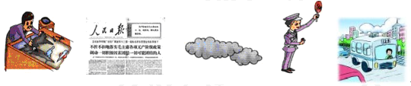

1. a_______ 2. n________ 3. c_______ 4. p________ 5. b_______

二、找出不同类的单词（10分）

1. A. actor B. father C. teacher D. cleaner

2. A. cloud B. rain C. sun D. seed

3. A. classroom B. bookstore C. salesperson D. shoe store

4. A. bus B. foot C. plane D. subway

5. A. east B. west C. straight D. south

三、看图片，选出相应的单词或短语（10分）

1. 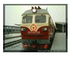 A. plane B. train

2.  A. traffic lights B. traffic rule

3.  A. policeman B. engineer

4. 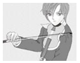 A. ride a bike B. play the violin

5. 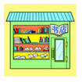 A. post office B. bookstore

四、单项选择（20分）

1. How do you go to school?

A. I go to school on foot.

B. The school is next to the hospital.

C. I am going to the cinema.

2. What is your hobby?

A. I like making kites.

B. She goes to work by bus.

C. Next to the hospital.

3. Turn left at the cinema, then __________. It’s on the left.

A. our school B. go straight C. green light

4. at the red light.

A. Stop B. Go C. Wait

5. Excuse me. Where is the cinema?

A. I am a cleaner.

B. Next to the bookstore.

C. I am going outside.

6. Tom’s mother teaches English. What does his mother do?

A. She is a policewoman.

B. She is a teacher.

C. She goes to work by car.

7. When does she go to school?

A. She works in Beijing.

B. She goes to school at 7:30.

C. Yes, she does.

8. What are you going to do this afternoon?

A. Yes, he does.

B. I am going to play football.

C. He likes collecting stamps.

9. Does your pen pal live in Shanghai?

A. I like diving. B. He is tall and strong. C. Yes, he does.

10. Where are you going this afternoon?

A. Next to the shoe store.

B. I’m going to the bookstore.

C. He is going to visit grandparents.

五、选择与图片相符的句子，并将图片的字母标号填到相对应的句子前面的括号内。（10分）

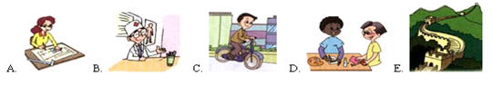

( ) 1. My father goes to work by bike every day.

( ) 2. I’m going to make a card for Sarah.

( ) 3. He helps sick people.

( ) 4. Let’s go to the Great Wall this weekend.

( ) 5. My aunt is an engineer. She works in a car company.

六、仔细阅读下列五篇小短文，将短文的内容与图片对应起来，并将每题的序号填入方框下。（10分）

1. He likes helping people. He goes to work by motorcycle. He helps make our city a safe place to live and work in.

2. He works in a *bank*. He helps the bank use their money well. He likes working with number and he is good at computer.

3. She likes drawing pictures. She works in a car factory. She often goes to work by car.

4. She works in a hospital. She often helps sick people.

5. He works in a street. He cleans streets and he works hard.

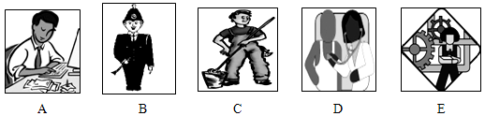

七**、**看图，完成对话**。**（10分）

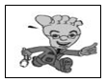

1. —How do you usually go to school?

—I usually go to school ________ ________.

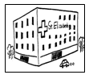

2. —Where does your father work?

—He ________ in a ________.

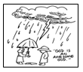

3. —Where does the rain come from?

—It comes from ________ ________.

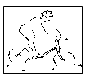

4. —What is your hobby?

—I like ________ the ________.

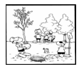

5. —What are you going to do this weekend?

—We are going to ________ ________.

八、阅读理解（10分）

Mike: Excuse me. Can you tell me where Nature Park is?

Man: Yes, it’s beside the school.

Mike: How can I get there?

Man: You can take a bus. You can walk there, too.

Mike: I’m new here. Where can I find the right bus?

Man: This way, please. You can see it.

Mike: Is it over there?

Man: Yes, it’s over there.

Mike: Thank you very much.

Man: You’re welcome.

选择填空 ( 6分)

1. Mike doesn’t know the way to ______.

A. a school B. his new house C. a park

2. Which of the following is NOT right?

A. Mike is new in the city.

B. Mike meets a friend on his way.

C. A man tells Mike the right way.

3. “You’re welcome” means _______.

A. 不用谢 B. 欢迎再来 C. 慢走

从对话中找出适当的词以其正确形式填空。（4分）

4. I can see a chair ___________ the door.

5. My father _____________ me to the park every Sunday.

**【试题答案】**

一、1. artist 2. newspaper 3. cloud 4. policeman 5. bus

二、1. B 2. D 3. C 4. B 5. C

三、1. B 2. A 3. A 4. B 5. B

四、1. A 2. A 3. B 4. A 5. B 6. B 7. B 8. B 9. C 10. B

五、1. C 2. D 3. B 4. E 5. A

六、1. B 2. A 3. E 4. D 5. C

七、1. on foot 2. works, hospital 3. the cloud 4. riding, bike 5. plant trees

八、1. C 2. B 3. A 4. beside 5. takes