**人教PEP四年级英语上册期末复习卷1**

1．听音，选单词（每题2分，共12分）

（1）A. letter B. little

（2）A. Mexico B. Mexican

（3）A. America B. American

（4）A. India B. Indian

（5）A. England B. English

（6）A. apple B. April

2．听句子，看图,标号（每题2分，共10分）

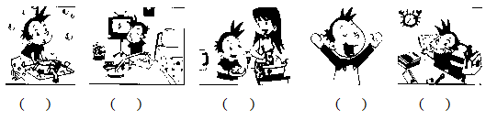

3．听音，选词,补全短文（每空1分，共8分）



Lingling usually _______ up at 6:30 on Mondays. But she didn’t

______ up at 6:30 yesterday. She usually ______ to school. But she didn’t ______ to school yesterday. She usually ______ English and Maths. But she didn’t ______ these things yesterday. Yesterday was National Day! Lingling _______ TV and _______ with her toys.

4．按顺序,用书写体填空（每空1分，共10分）

Aa B___ Cc D___ Ee Ff ___g Hh I___ Jj K___

L___ Mm Nn Oo Pp Q___ Rr Ss Tt ___u V___ Ww Xx ____y Zz

5．看图，连线（每题2分，共10分）

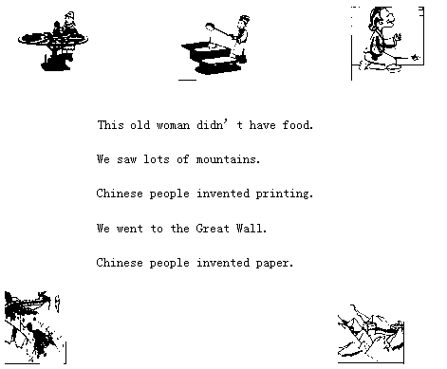

6．过去式与原形连线（每题1分，共10分）

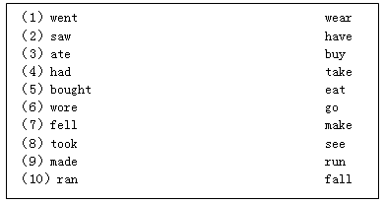

7．问句与答句连线（每题2分，共10分）

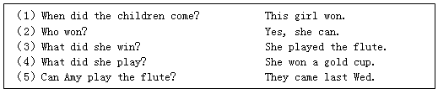

8．连词成句（每题2分，共10分）

（1）Did / thing / see / you / scary / a / ?

（2）make / He / didn’t / biscuits / .

（3）time/ good / We / had / a / .

（4）printed / I / newspaper / this / .

（5）does / she / Where / live / ?

**参考答案**

1．A A B B A B

【解析】

【听力材料】

（1）letter

（2）Mexico

（3）American

（4）Indian

（5）England

（6）April

2．（3） （1） （4） （5） （2）

【解析】

【听力材料】

（1）Yesterday, I cleaned my room.

（2）I finished my homework.

（3）I washed my trousers.

（4）I helped my mum.

（5）I was very happy.

3．gets get walks walk learns learn watched played

【解析】

【听力材料】

Lingling usually gets up at 6:30 on Mondays. But she didn’t get up at 6:30 yesterday. She usually walks to school. But she didn’t walk to school yesterday. She usually learns English and Maths. But she didn’t learn these things yesterday. Yesterday was National Day! Lingling watched TV and played with her toys.

4．

【解析】

5．

【解析】

6．

【解析】

7．

【解析】

8．（1）Did you see a scary thing?

（2）He didn’t make biscuits.

（3）We had a good time.

（4）I printed this newspaper.

（5）Where does she live?

【解析】