**人教PEP四年级英语上册期末测试卷二**

1．Listen and number.（请根据听到的内容为下列图片排序）10’

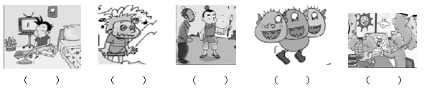

2．Listen and tick （听音找出相应的图片，并在括号里画√表示）10’

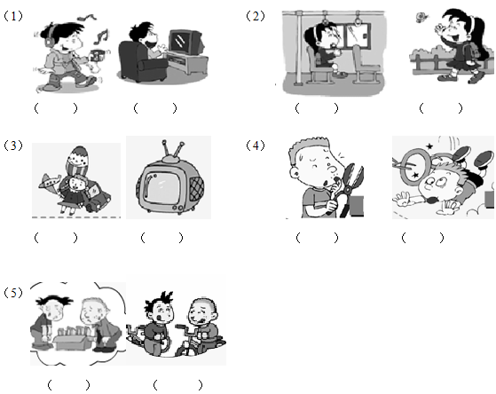

3．Listen and match （请根据听到的内容将人物与相应图片连线）10’

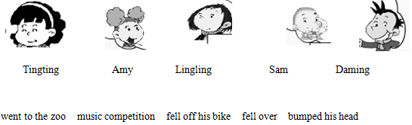

4．Listen and fill in the blanks （请根据听到的内容填上缺少的单词）10’

（1）The magic paintbrush didn’t __________ gold. It _________ a snake.

（2）Did you _________ your toy? No, I didn’t.

（3）_________ did they come? They ________ last Wednesday.

（4）What __________ to you? I _________ my ____________.

（5）We __________ a watermelon. Sam ________ the watermelon on his bike.

5．Listen and put the words in the right order（听音连词成句）12’

（1）did / where / you / go



（2）were / three / children / there



（3）you / did / see / a / scary / thing



（4）hungry / we / were / and / thirsty



（5）did / what / eat / yesterday / you



（6）is / the/ what / matter



6．Read and match. （读一读，连一连）8’

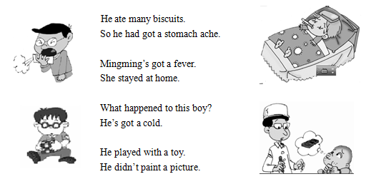

7．Yesterday Sam and I went ______ a bike ride.

A. for B. of

8．What did you see? I ________ lions and tigers.

A. see B. saw

9．Did they _________ for the music competition? Yes, they did.

A. come B. came

10．How many children _________ in your class? There were thirty-five.

A. are there B. were there

11．Yesterday _______ cold. I ________ warm clothes.

A. is …wear B. was… wore

12．Read, choose and write. （读一读，选择单词补全句子）12’



Ma Liang was a good boy, he had a _______________. It was ___________. He __________ people with the paintbrush. An old woman didn’t have ___________. So Ma Liang ___________ food. It was real. The old woman was ____________.

13．Read and draw√或×.（读一读，判断对错）10’

Yesterday was a holiday. The children didn’t go to school. Tom went to the Great Wall. He saw lots of mountains. Sam went ice-skating. He fell over, but he didn’t hurt. Peter stayed at home and helped his mum. Lingling stayed at home, too. Because she’s got a stomach ache. She took some medicine. She’s sad.

（1）The children didn’t go to school yesterday.

（2）Tom went to the Great Wall.

（3）Sam fell over and hurt his knee.

（4）Peter stayed at home. Because he’s got a stomach ache.

（5）Lingling’s got a toothache. But she helped her mum.

**参考答案**

1．

【解析】

【听力材料】

There was a monster. It had three heads.

Look, this girl won a gold cup.

Ma Liang has got a magic paintbrush.

The boy bumped his head.

The boy cleaned his room yesterday.

2．

【解析】

【听力材料】

（1）He didn’t listen to music. He watched TV.

（2）This girl walked to school.

（3）She played with his toys yesterday.

（4）What happened to this boy? He fell off his bike.

（5）We went for a bike.

3．

【解析】

【听力材料】

Yesterday, Amy went to the zoo. Lingling fell over. But she didn’t hurt. Sam fell off his bike. He hurt his knee. Daming fell on the watermelon. He bumped his head. Our new friend Tingting came to China for the music competition. She won a gold cup.

4．

【解析】

【听力材料】

（1）The magic paintbrush didn’t make gold. It made a snake.

（2）Did you break your toy? No, I didn’t.

（3）When did they come? They came last Wednesday.

（4）What happened to you? I cut my finger.

（5）We bought a watermelon. Sam put the watermelon on his bike.

5．

【解析】

【听力材料】

（1）Where did you go?

（2）There were three children.

（3）Did you see a scary thing?

（4）We were hungry and thirty.

（5）What did you eat yesterday?

（6）What’s the matter?

6．

【解析】

7．

【解析】

8．

【解析】

9．

【解析】

10．

【解析】

11．

【解析】

12．

【解析】

13．

【解析】