**人教版六年级上册英语期末试卷4**

听力部分（40分）

一、听音，判断。与录音内容相符的在括号内打√，与录音内容不符的在括号内打×。10分

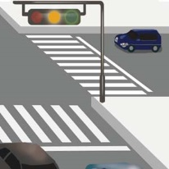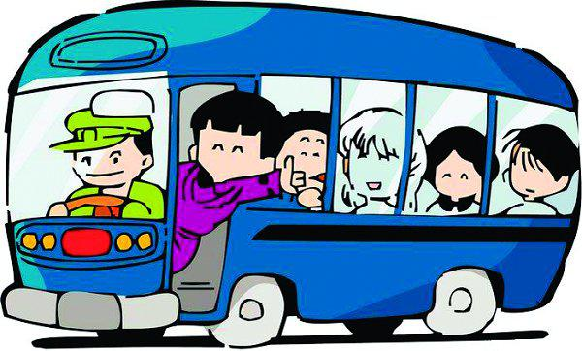 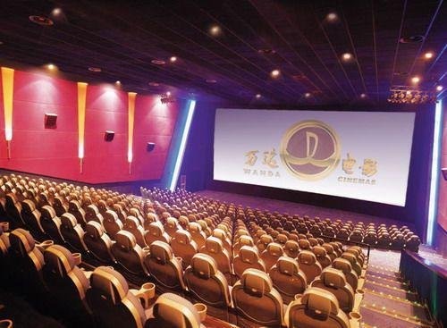 

1.（   ）       2.（    ）         3.（   ）   学科网(www.zxxk.com)--教育资源门户，提供试卷、教案、课件、论文、素材及各类教学资源下载，还有大量而丰富的教学相关资讯！  4. （   ）       5.（   ）

（   ）6. Tim is my new pen pal. He lives in Beijing.

（   ）7. My father is a coach.

（   ）8. My cousin Jack likes playing football and swimming.

（   ）9. The woman is going to buy a dictionary.

（   ）10. Turn left at the traffic lig学科网(www.zxxk.com)--教育资源门户，提供试卷、教案、课件、论文、素材及各类教学资源下载，还有大量而丰富的教学相关资讯！hts. [来源:Z&xx&k.Com]

二、听音，选词。选择听到的单词或句子，将正确答案的序号写在题前括号内。10分

( ) 1. A. hiking B. swimming C. singing

( ) 2. A. show B. snow C. now

( ) 3. A. pen pal B. pencil C. plane

( ) 4. A. play sports B. play football C. play basketball

( ) 5. A. Canberra B. country C. Chinese

( ) 6. A. hungry B. angry C. afraid

( ) 7.A.policeman B. policewoman C. police officer

( ) 8. A. coach B. sports reporter C.P.E teacher

( ) 9. A. live B. lives C. living

( )10. A. No.57 B. No.75 C. No.51

三、听音，选句。根据听到的问句选择答句，将正确答案的学科网(www.zxxk.com)--教育资源门户，提供试卷、教案、课件、论文、素材及各类教学资源下载，还有大量而丰富的教学相关资讯！序号写在题前括号内。10分

( ) 1学科网(www.zxxk.com)--教育资源门户，提供试卷、教案、课件、论文、素材及各类教学资源下载，还有大量而丰富的教学相关资讯！. A. He goes to work by car. B. He works in a school.

( ) 2. A. He likes diving. B. She likes riding a bike.

( ) 3. A.I’m gong there tonight. B. I’m going by ship.

( ) 4. A. He is worried. B. They are very happy.

( ) 5. A. You can go by No.18 bus. B. I go to school by bike.

四、听音，排序。根据听到的句子顺序，将正确的序号写在题前括号内。10分

( ) What are you going to do in your lesson? 新课 标 第 一 网

( ) What are you going to do?

( ) I’m going to have an art lesson.

( ) Sounds great!

( ) Have a good time!

( ) We’re going to draw some pictures in Renmin Park.

( ) I’m going to see a film tomorrow.

( ) You, too. I have to do my homework now.

( ) Bye.

( ) OK. Bye.

笔试部分（60分）

一、选一选。选出不同类的单词或词组，将序号写到括号里。10分

( ) 1. A. foot B. train C. plane D. subway

( ) 2. A. newspaper B. bookstore C. magazine D. comic book

( ) 3. A. police officer B. father C. pilot D. worker

( ) 4. A. angry B. sad C. happy D. wear

( ) 5. A. teaches B. tomatoes C. watches D. reads

( ) 6. A. afraid B. angry C. sad D. trip

( ) 7 .A. sing B. hiking C. fishing D. reading

( ) 8. A. wear B. where C. what D. how

( ) 9. A. park B. grass C. flower D. tree

( )10.A. tomorrow B.morning C. afternoon D. evening

[新 课 标 第 一 网](http://www.xkb1.com/)

二、补一补。根据上下文或汉语意思，写出单词。10分

Cherry __________(live) in New Zealand. She likes singing and _________ word __________ (填字游戏). Her father is a ____________(商人). He ________(go) to work by ___________(地铁). Her mother is a ________ ________学科网(www.zxxk.com)--教育资源门户，提供试卷、教案、课件、论文、素材及各类教学资源下载，还有大量而丰富的教学相关资讯！(工人). She likes ___学科网(www.zxxk.com)--教育资源门户，提供试卷、教案、课件、论文、素材及各类教学资源下载，还有大量而丰富的教学相关资讯！_____(play) the violin. Cherry has a __________(幸福的) family.

三、写一写。把下列单词连词成句。（注意书写格式、标点和大小写）10分

1. does, what, he, do (?)

______________________________学科网(www.zxxk.com)--教育资源门户，提供试卷、教案、课件、论文、素材及各类教学资源下载，还有大量而丰富的教学相关资讯！____________________学科网(www.zxxk.com)--教育资源门户，提供试卷、教案、课件、论文、素材及各类教学资源下载，还有大量而丰富的教学相关资讯！___________________

1. don’t, at, red, go, the, light (!)

_____________________________________________________________________

1. bookstore, left, turn, at, the (.)

_____________________学科网(www.zxxk.com)--教育资源门户，提供试卷、教案、课件、论文、素材及各类教学资源下载，还有大量而丰富的教学相关资讯！_____________学科网(www.zxxk.com)--教育资源门户，提供试卷、教案、课件、论文、素材及各类教学资源下载，还有大量而丰富的教学相关资讯！___________________________________

1. he, see, doctor, this, morning, a, should (.)新 课 标 第 一 网

_____________________________________________________________________

1. going, Renmin Park, are, to, we, draw, pictures, some, in

__________________________________________________学科网(www.zxxk.com)--教育资源门户，提供试卷、教案、课件、论文、素材及各类教学资源下载，还有大量而丰富的教学相关资讯！___________________

四、配一配。请从B栏中选出与A栏相配的句子。将序号写在A栏的题前括号内。10分

A B[来源:学+科+网Z+X+X+K]

( )1. Where does Tom work? A. He is angyr.

( )2. What are you going to do tomorrow? B. Yes, she does.

( )3. How do you go to work? C. He works at a sea.[来源:学*科*网]

( )4. Does she like going hiking? D. He likes fishing.

( )5. What does your father do? E. You should do more exercise.

( )6. How does he feel? F. I’m going to see a film.

( )7. What’s your dad’s hobby? G. Hooray!

( )8. How can I get to the cinema? H. I go to work by bike

( )9. What should I do? I. He’s a fish man.

( )10. Let’s go to the nature park. J. Go straight, then turn left.

五、选一选。在对话框内选出匹配的句子，将序号填在横线上，使对话意思完整。10分

A. Don’t worry. B. You should see a doctor. C. What’s wrong?

D. Where does he work? E. I’ll visit Doctor Ma this afternoon. F. Great!

[来源:Zxxk.Com]

Mr Li: Good morning, Mr Su.

Mr Su: Good morning, Mr Li. You look unhappy.___________

Mr Li: I’m ill. I have a headache.

Mr Su: I’m sorry to hear that.____________________

Mr Li: Yes . _______________________

Mr Su: ____________________________

Mr Li: He works in Peace Hospital.

Mr Su: That’s good._____________ You will be better soon.

Mr Li: Thank you .Bye!

Mr Su: Bye!

六、读一读。阅读短文，判断正误，在句子后面的括号里打上√或×。10分

Hello, I’m Bob. There are 5 people in my family. I’m a coach. I like playing sports. I go to work by bike, because it’s good exercise. My father is a police officer. He goes to work by car.He likes singing. My mother is a head teacher. She likes listening to music. She often goes to work by subway. But sometimes she goes to by taxi. My sister Jenny likes dancing. She is a factory worker. She goes to work by bus. My brother Ben is a pilot. He goes to work by sub学科网(www.zxxk.com)--教育资源门户，提供试卷、教案、课件、论文、素材及各类教学资源下载，还有大量而丰富的教学相关资讯！way. He likes doing word puzzles. Our family is big and happy.

( ) 1. There are 3 people in Bob’s family.

( ) 2. Bob’s father is a head teacher.

( ) 3. Bod’s sister goes to work by bus.

( ) 4. Bob’s mother often goes to work by taxi.

( ) 5. Bob’s brother is a pilot.

[来源:学.科.网Z.X.X.K]

**答案**

听力部分：

一、听音，判断。与录音内容相符的在括号内打√，与录音内容不符的在括号内打×。10分

1. I often go to school by bus.

2. Slow down and 学科网(www.zxxk.com)--教育资源门户，提供试卷、教案、课件、论文、素材及各类教学资源下载，还有大量而丰富的教学相关资讯！wait at the yellow light.

3. Amy is going to see a film this evening.

4. Sarah is ill. She should go to the hospital. [新|课 | 标|第 | 一| 网](http://www.xkb1.com/)

5. Mr Jones is a businessman.

6. Tim is my new pen pal. He lives in Canberra.

7. My father is a coach.

8. My cousin Jack likes playing football and swimming.

9. The woman is going to buy a word book.

10. Turn left at the traffic lights.

√×√√× √√××√

二、听音，选词。选择听到的单词或句子，将正确答案的序号写在题前括号内。10分

1. Sarah likes swimming. 2. 1. There is a kite show on the playground.

3. I have a pen pal. 4. I often play football.

5. She studies Chinese. 6. My mom is angry.

7. He is a police officer. 8. His brother is a P.E. teacher.

9. He lives in Sydney. 10. Take the No. 57 bus.

B A A B C B B C B A

三、听音，选句。根据听到的问句选择答句，将正确答案的序号写在题前括号内。10分

1. Where does he work? 2. What’s her hobby?

3. When are you going there? 4. How does he feel?

5. How do you go to school?

BBAAB

四、听音，排序。根据听到的句子顺序，将正确的序号写在题前括号内。10分

Mike: What are you going to do?

Sarah: I’m going to have an art lesson.

Mike: What are you going to do in your lesson?

Sarah: We’re going to draw some pictures in Renmin Park.

Mike: Sounds great! I’m going t学科网(www.zxxk.com)--教育资源门户，提供试卷、教案、课件、论文、素材及各类教学资源下载，还有大量而丰富的教学相关资讯！o see a film tomorrow.

Sarah: Have a good time!

Mike: You, too. I have to do my homework now. Bye.

Sarah: OK. Bye.

3,1,2,5,7,4,6,8,9,10

笔试部分（60分）

一、选一选。选出不同类的单词或词组，将序号写到括号里。10分

ABBDB DAAAA

1. 补一补。根据上下文或汉语意思，写出单词。10分

lives, doing puzzles, businessman,goes subway, factory worker, playing, happy

三、写一写。把下列单词连词成句。（注意书写格式、标点和大小写）10分

1. What does he do? 2. Don’t go at the red light.

3. Turn left at the bookstore. 4. He should see a doctor this morning.

5. We are going to draw some pictures in Renmin Park.

四、配一配。请从B栏中选出与A栏相配的句子。学科网(www.zxxk.com)--教育资源门户，提供试卷、教案、课件、论文、素材及各类教学资源下载，还有大量而丰富的教学相关资讯！将序号写在A栏的题前括号内。10分

C F H B I A D J E G

五、选一选。在对话框内选出匹配的句子，将序号填在横线上，使对话意思完整。10分

C B E D A

六、读一读。阅读短文，判断正误，在句子后面的括号里打上√或×。10分

××√×√