**人教PEP六年级英语第二学期复习卷**

1．听录音，在符合录音内容的图片下面的字母上画一圆圈。（10分）

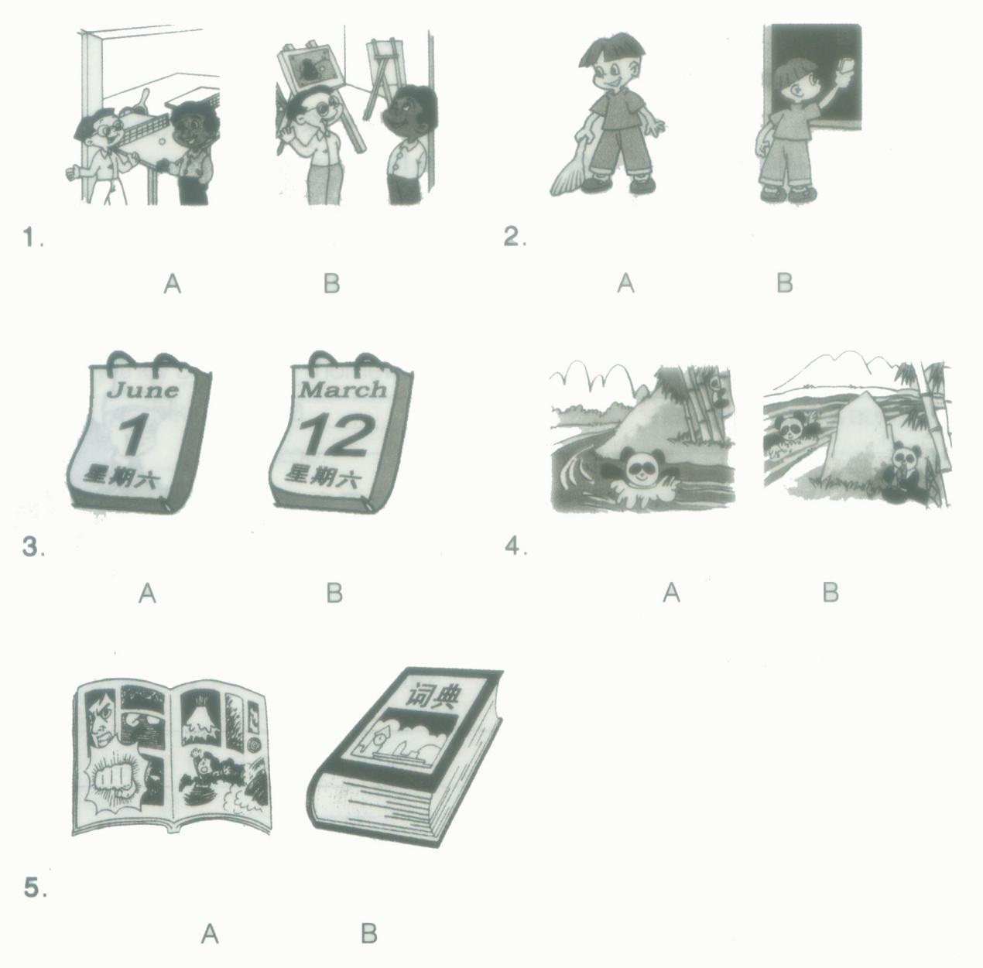

2．听录音，判断下面各张图片是否与内容相符，符合的在该图片下面的括号里打“√”，不符的打“×”。（10分）

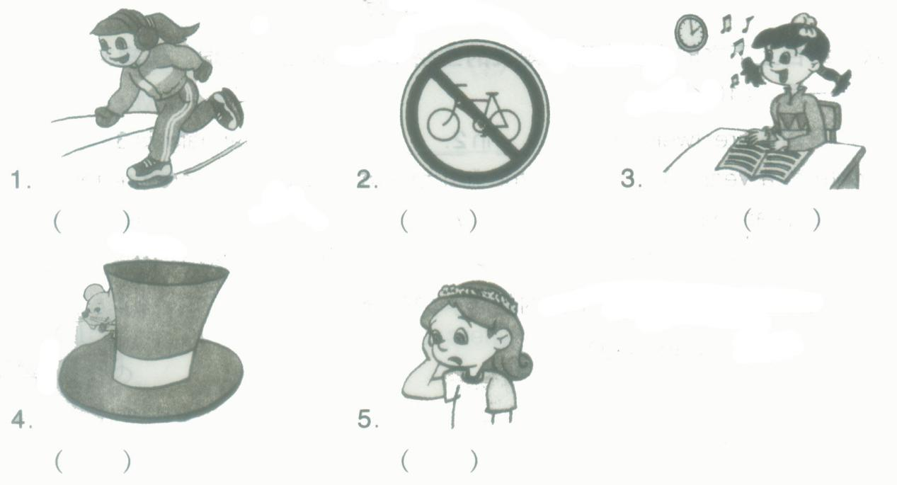

3．根据录音内容，在句子的空格中填上单词，将句子补充完整。每空一词。（10分）

（1）Chen jie is a__________ ________________.

（2）If you don’t __________well , it’s easy to have a _____________.

（3）I like_________ pictures and _______________ games.

（4）We ___________fans and a ____________in the supermarket.

（5）There __________a kite show on____________.

4．根据对话内容，选出问题的答案，并将该答案的字母符号填在题前的括号里。（10分）

（1）A .It’s Friday.

B. It’s Saturday.

C. It’s Thursday.

（2）A. Yes, he did.

B. No, he didn’t.

C. She’s 150kg.

（3）A. She’s 50kg.

B. She’s 15kg.

C. She’s 150kg.

（4）A. Yes, he did.

B. No, he didn’t.

C. Yes, he is.

（5）A. A student.

B. A singer.

C. An artist.

5．听录音，按听到的内容顺序给下面的图片编号。（10分）

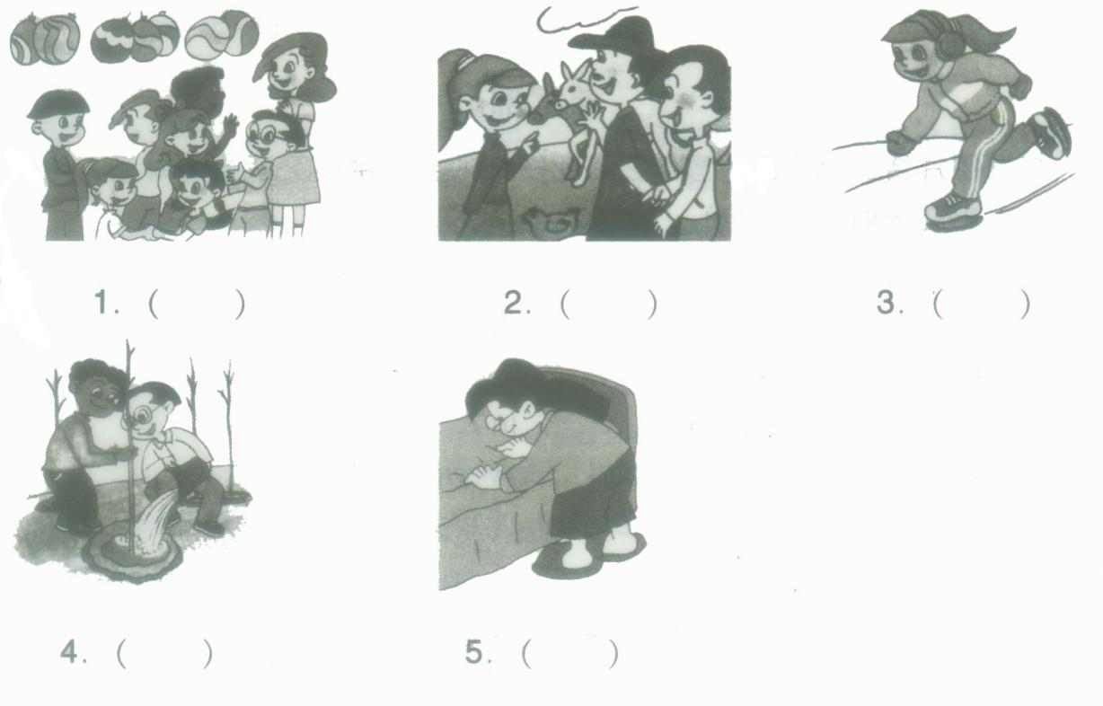

6．选择正确的词填空。（10分）



Mike and John are good _______.Mike is 164cm tall. He is 4cm________than John, and______.

John is 14. Mike is only 12. Mike is_______. Usually they _________homework together on Sundays. Last ________, they_________hiking and ________.They________happy. Next weekend, they’re_______to the zoo.

7．根据所给的图片回答下面的问题。（10分）

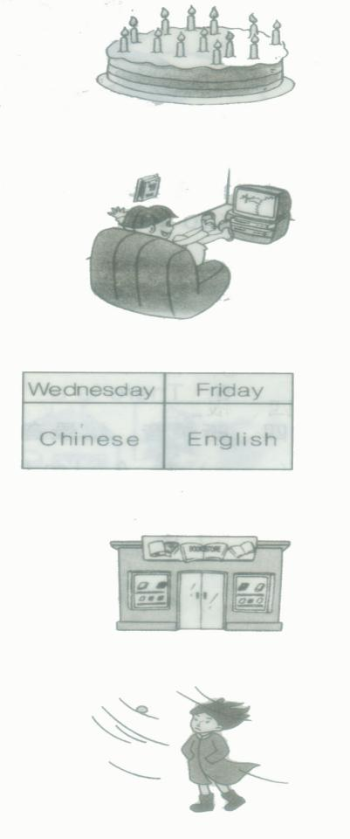

（1）How old are you ?

_______________________________________________

（2）What did you do last night?

_______________________________________________

（3）When do you have English class?

_______________________________________________

（4）Where are you going?

________________________________________________

（5）What’s the weather like?

_________________________________________________

8．看图说话，说说上个周末这些同学做了什么事情。五句话以上。（10分）

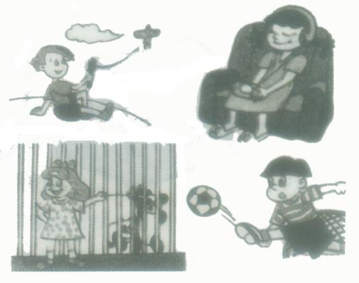

9．补全对话。 （10分）

A: This is a photo of my family.

B: _____________________________________

A: He’s my father.

B: He looks strict.________________________________

A: He’s a principal of a primary school.

___________________________________________

B: My father is an accountant.

A:______________________________________________

B: He works in a company. This pretty woman must be your mother.

______________________________________________

A: Yes, she teaches English.

10．阅读，根据短文判断下面的句子是否正确，正确的在句子前面的括号里打“ √”，不正确的打“×”。（10分）

We have summer, fall., winter, and spring in a year. People can plant trees and go hiking in spring. It’s warm. In summer, people often swim in the sea or lake. They like to work in cool place(地方). When it’s fall, the leaves fall down. We can pick apples. It usually snows in the north in China. Children like winter. They can roll(滚动) a snowball, make a snowman, ski and skate. They feel happy in winter.

（1）We have four seasons in a year.

（2）People like go swimming in spring.

（3）People like to work in cool place in summer.

（4）It usually rains a lot in the north in winter.

（5）Children like winter very much.

**参考答案**

1．1B 2B 3B 4A 5A

【解析】

【听力材料】

1A: Where are they?

B: They are in the art room.

2A: What is Zheng Peng doing?

B: He is cleaning the board.

3It’s Tree-Plant Day today.

4I can see two pandas. One is swimming. Another is climbing trees.

5I am going to buy a magazine this afternoon.

2．1× 2√ 3× 4× 5√

【解析】

【听力材料】

1I went skiing.

2You can’t ride your bike here.

3I have P.E. class at 2:00p.m.

4The mouse is under the hat.

5Mary has a headache.

【答案】（1）Quiet,girl （2）sleep, headache （3）drawing, playing（4）bought,present （5）is, Saturday

【解析】

【听力材料】

（1）Chen Jie is a quiet girl.

（2）If you don’t sleep well, it’s easy to have a headache.

（3）I like drawing pictures and playing games.

（4）We bought fans and a present in the supermarket.

（5）There is a kite show on Saturday.

4．（1）C（2）B（3）A（4）B（5）B

【解析】

【听力材料】

（1）A: What day is it today?

B: It’s Friday. It’s rainy yesterday.

Question: What is the day yesterday?

（2）A: Did you go swimming on the weekend?

B: No, but I cleaned my room at home.

Question: Did the boy go swimming on the weekend?

（3）A: How heavy are you?

B: I am 50kg.

Question: How heavy is the woman?

（4）A: When do you usually get up?

B: I usually get up at 6:30. But not today.

Question: Did the boy get up at 6:30 today?

（5）My grandma is a singer. My grandpa is an artist. I am a student.

Question: What does the girl’s grandma do?

5．1E 2A 3D 4B 5C

【解析】

【听力材料】

1They are in the farm.

2We can plant trees in spring.

3Make the bed after you get up.

4We skate in winter.

5Say goodbye at the farewell party。

6．（1）friends （2）shorts （3）thinner （4）younger （5）do （6）Sunday （7）went （8）swimming （9）were （10）going

【解析】

7．（1）I’m 13 years old.

（2）I watched TV.

（3）I have English class on Friday.

（4）I’m going to the bookstore.

（5）It’s windy.

【解析】

8．

【解析】

9．（1）Who’s the man?

（2）What does he work ?

（3）What does your father do?/What about your father?

（4）Where does he work ?

（5）Does she teach English?

【解析】

10．（1）√（2）×（3）√（4）×（5）√

【解析】