六年级上学期英语期末测试卷

时间: 60分钟　满分: 100分

|  |  |  |  |  |  |  |  |  |  |  |  |  |  |
| --- | --- | --- | --- | --- | --- | --- | --- | --- | --- | --- | --- | --- | --- |
| 题　号 | 一 | 二 | 三 | 四 | 五 | 六 | 七 | 八 | 九 | 十 | 十一 | 十二 | 总　分 |
| 得　分 |  |  |  |  |  |  |  |  |  |  |  |  |  |

第一部分　听力(30分)

一、听录音，选择正确的图片。(5分)

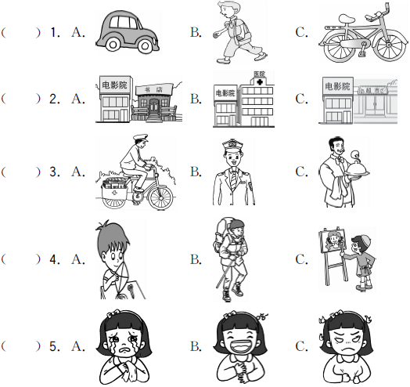

二、听录音，根据对话内容选择正确的答案。(5分)

(　　) 1. —What does Mike's uncle do? —He is a ________.

A. cook　　　　　B. worker　　　　 C. businessman

(　　) 2. John goes to school ________.

A. by bus B. by bike C. on foot

(　　) 3. —What's Sarah's hobby? —________.

A. Swimming B. Dancing C. Singing

(　　) 4. —Where is the bus stop? —________.

A. Go straight on, and you can see it on your right

B. Go straight on, and then turn right

C. Go straight on, and you can see it on your left

(　　) 5. —Where is the pen pal from?

—He is from ________.

A. Australia B. the USA C. China

三、听录音，选择恰当的答语。(10分)

(　　) 1. A. It's next to the hospital. 　　B. It's big and new.

C. You can go there on foot.

(　　) 2. A. He is a pilot. B. He likes drawing pictures.

C. He is drawing pictures.

(　　) 3. A. She goes to school by bus. B. He goes to the park on foot.

C. I go to work by car.

(　　) 4. A. By subway. 　　　　　　B. This weekend. 　　C. The scientist.

(　　) 5. A. I'm going to the cinema. B. He's a cleaner. C. I feel angry.

四、听短文，判断正(T)误(F)。(10分)

(　　) 1. Mike is a policeman.

(　　) 2. He goes to work by car.

(　　) 3. He likes drawing pictures on the weekend.

(　　) 4. Mike works in a supermarket.

(　　) 5. He is going to the bookstore this weekend.

第二部分　笔试(70分)

五、从Ⅱ栏中选出Ⅰ栏单词的汉语意思，将序号填入括号中。(10分)

　　　 Ⅰ　　　　　　　　　　　　Ⅱ

(　　) 1. Straight A. 地铁

(　　) 2. Tomorrow B. 担心

(　　) 3. Train C. 成直线地

(　　) 4. Wait D. 右边

(　　) 5. Library E. 字典

(　　) 6. Subway F. 脚

(　　) 7. Dictionary G. 图书馆

(　　) 8. Worry H. 明天

(　　) 9. Foot I. 火车

(　　) 10. Right J. 等待

六、看图片，完成句子。(10分)

1. The cinema is ________ ________ the hospital. 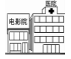

2. ________ ________ at the traffic lights. 

3. My friend likes ________ ________. 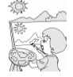

4. I am going to buy a ________ ________ tomorrow. 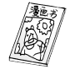

5. He is ill. He should ________ ________ ________. 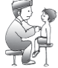

七、单项选择我最棒！(5分)

(　　) 1. What should you ________ then?

A. do B. does C. doing

(　　) 2. —Where does your pen pal live?

—________

A. No, he lives in the country. B. He lives in the USA.

C. He likes swimming.

(　　) 3. All of them are afraid ________ the dog.

A. at B. of C. in

(　　) 4. My brother is ________ university student. He has ________ art class every

week.

A. an; a B. an; an C. a; an

(　　) 5. —________ can I go to Australia?

—You can go there by plane.

A. What B. Where C. How

八、(N)用所给单词的适当形式填空。(10分)

1. Let's ________ (play) basketball this weekend.

2. Mr Black ________ (teach) us English.

3. The dog ________________ (chase) a rabbit now.

4. Jim works very hard and ________ (stay) healthy.

5. Don't ________ (draw) on the wall.

九、根据中文提示补全句子。(10分)

1. You should ________ ________ ________(做更多的锻炼).

2. They want to be________ ________(工厂工人).

3. We ________ ________ ________ ________ ________(将去爬山) tomorrow.

4. Do you like ________ ________(堆雪人)?

5. My mother ________ ________(洗衣服) every day.

十、读一读，选择正确的答语。(5分)

(　　) 1. What do you want to be?

(　　) 2. Why are the mice bad?

(　　) 3. What's wrong with your brother?

(　　) 4. How does Oliver feel?

(　　) 5. Do you want to be a teacher?

A. Yes, I do. B. He feels angry. C. Because they hurt people.

D. He's ill. E. I want to be a pilot.

十一、阅读短文，回答下列问题。(10分)

It is Saturday，Zhang Lei wants to go to the park with his friend, but he gets up late. He puts on his clothes quickly and doesn't have breakfast. He rides his bike very quickly. At the crossing，the red light is on，but he doesn't stop. A policeman stops him and says，“Please get off your bike. Didn't you see the red light?”

“Yes, I did. But I didn't see you,” says Zhang Lei.

1. When does Zhang Lei go to the park?

___________________________________________________________________

2. How does Zhang Lei go to the park?

_____________________________________________________________________

3. What light is on at the crossing?

_____________________________________________________________________

4. Does Zhang Lei see the red light?

_____________________________________________________________________

5. Why doesn't he stop when he sees the red light?

_____________________________________________________________________

十二、书面表达。(10分)

你在网上新结识了一位叫Mary的笔友。请根据她发给你的有关信息，向你的同学作简要介绍。(不少于50词)

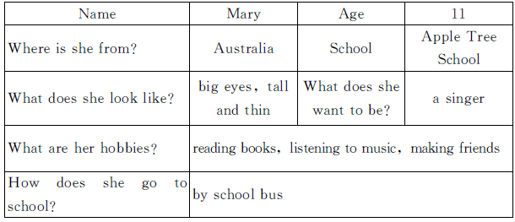_____________________________________________________________________

_____________________________________________________________________

_____________________________________________________________________

_____________________________________________________________________

_____________________________________________________________________

_____________________________________________________________________

_____________________________________________________________________

听力材料：

一、1. **M:** I go to school on foot.

2. The cinema is near the bookstore.

3. My father is a police officer. He likes helping people.

4. **M**: I'm going to go hiking tomorrow.

5. **W:** I'm happy，because I am going to take a trip.

二、1. **W:** Hello，Mike！Who's he?

**M:** He's my uncle.

**W:** What does your uncle do?

**M:** He's a worker.

2. **W:** How do you go to school，John?

**M:** I go to school by bike.

3. **M:** What's your hobby，Sarah?

**W:** I like dancing.

4. **M:** Where is the bus stop?

**W:** Go straight on，and you can see it on your left.

5. **M:** Is your pen pal from China?

**W:** No，he isn't. He is from Australia.

三、1. Where's the nature park?

2. What does Lee do?

3. How does Amy go to school?

4. When are you going there?

5. How do you feel?

四、　　Mike is a head teacher. He's tall and strong. He works in a university. He is very busy. He can speak English and Chinese. He goes to work by car. On the weekend，he likes drawing pictures. He is going to the supermarket with friends this weekend.

答案：

一、1. B　2. A　3. B　4. B　5. B

二、1. B　2. B　3. B　4. C　5. A

三、1. A　2. A　3. A　4. B　5. C

四、1. F　2. T　3. T　4. F　5. F

五、1. C　2. H　3. I　4. J　5. G　6. A　7. E　8. B　9. F　10. D

六、1. next to　2. Turn right　3. drawing pictures　4. comic book　5. see a doctor

七、1. A

2. B　点拨：Where对地点提问，其答语也应用地点来回答。

3. B　点拨：be afraid of“害怕……”，固定搭配。

4. C　点拨：university以辅音音素开头，冠词用a，art以元音音素开头，冠词用an。

5. C

八、1. play　2. teaches　3. is chasing 4. stays　5. draw

九、1. do more exercise

2. factory workers

3. are going to climb mountains

4. making snowmen

5. washes clothes

十、1. E　2. C　3. D　4. B　5. A

十一、1. On Saturday.

2. By bike.

3. The red light.

4. Yes，he does.

5. Because he doesn't see the policeman.

十二、范文：

Mary is my new pen pal. She is eleven years old. She is from Australia. She studies in Apple Tree School. She has big eyes. She is tall and thin. She likes reading books and listening to music. She also likes making friends. She often goes to school by school bus. She wants to be a singer one day.