三年级下学期英语期末测试卷(**A**卷)

时间：60分钟　满分：100分

|  |  |  |  |  |  |  |  |  |  |  |  |  |  |
| --- | --- | --- | --- | --- | --- | --- | --- | --- | --- | --- | --- | --- | --- |
| 题　号 | 一 | 二 | 三 | 四 | 五 | 六 | 七 | 八 | 九 | 十 | 十一 | 十二 | 总　分 |
| 得　分 |  |  |  |  |  |  |  |  |  |  |  |  |  |



一、听录音, 用数字①, ②, ③给单词排序。(每小题2分, 共10分)

1. boat(　　) box(　　) buy(　　)

2. fifteen(　　) friend(　　) fruit(　　)

3. giraffe(　　) girl(　　) grape(　　)

4. short(　　) sister(　　) student(　　)

5. tail(　　) tall(　　) toy(　　)

二、听录音, 选择与所听内容相符的图片。(每小题2分, 共10分)

(　　) 1. A.  B.  C. 

(　　) 2. A.  B. 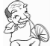 C. 

(　　) 3. A. 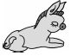 B. 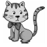 C. 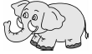

(　　) 4. A. 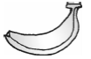 B. 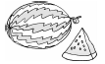 C. 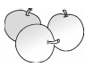

(　　) 5. A. 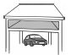 B. 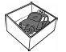 C. 

三、听录音, 判断图片与所听内容是()否()相符。(每小题2分, 共10分)

1. 　2. 　3. 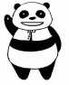　4. 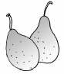　5. 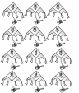

    

四、听问句, 选择正确的答语。(每小题2分, 共10分)

(　　) 1. A. Yes, she is. B. Yes, he is. C. Yes, it is.

(　　) 2. A. Thank you! B. Wow, so beautiful! C. Welcome.

(　　) 3. A. Silly me! B. Me too. C. Me, neither.

(　　) 4. A. I see twelve. B. I have sixteen. C. I'm eleven.

(　　) 5. A. No, it isn't. B. No, I don't. C. No, she isn't.



五、把下列单词中的画线字母换成另外一个字母, 使改写后的单词与后面的汉语相符, 并书写在四线格内。(每小题1分, 共5分)

1. 

2. 

3. 

4. 

5. 

六、给下列单词分类(只填序号)。(共5分)

①pear　　　②brother　　　③grandmother　　　④seventeen　　⑤sister

⑥grape ⑦orange ⑧father ⑨fifteen ⑩twelve

1. three：________________________________________________________________________

2. apple：_______________________________________________________________________

3. mum：_______________________________________________________________________

七、根据图片, 选单词完成句子。(每小题1分, 共5分)

twelve　small　map　long　family

1. The monkey has a ________ tail. 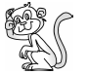

2. This is my ________. 

3. I have ________ crayons. 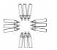

4. Look！The bird is ________. 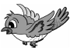

5. The ________ is on the desk. 

八、读一读, 选一选。(每小题2分, 共10分)

(　　) 1. The giraffe is tall and the small cat is ________.

A. tall B. big C. short

(　　) 2. Look ________that man. He's tall.

A. on B. at C. in

(　　) 3. ________ you like bananas?

A. Is B. Are C. Do

(　　) 4. —Is it on the book?

—________.

A. No, it isn't B. Yes, it does C. No, it is

(　　) 5. —________is that?

—It's a toy car.

A. Where B. How C. What

九、看图, 判断下列句子的正(√)误(×)。(每小题2分, 共10分)

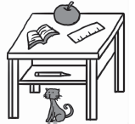

(　　) 1. The cat is on the desk.

(　　) 2. The apple is on the desk.

(　　) 3. The pencil is in the desk.

(　　) 4. The book is under the desk.

(　　) 5. The ruler is in the desk.

十、看图, 选择正确的句子完成对话, 把选出的序号写在对话框里。(每小题1分, 共5分)

A. Wow！It's so tall. B. It's under your book. C. Do you like watermelons?

D. I see five. 　 E. Who's that boy? Is he your brother?

1. 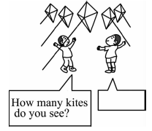　　　 2. 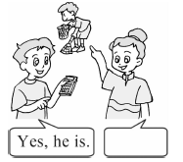

3. 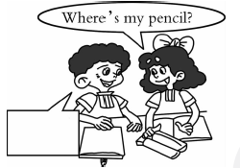　4. 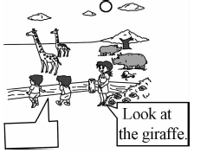

5. 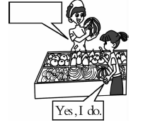

十一、小小书写家(根据图画提示, 从方框中选择恰当的单词完成短文)。(每小题2分, 共10分)

student　Canada　teacher　monkey　apples

This is my father. He is a 1. ________ 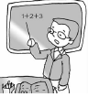. He likes 2. ________ . This is my friend John. He is my father's 3. ________ . He is from 4. ________ . His favorite(最喜欢的)animal is the 5. ________ . He likes pears. He has a new cap.

十二、阅读短文, 选择正确答案。(每小题2分, 共10分)

Hello, I'm Beibei. I'm a panda. I'm from China. Look！This is my family. The man is my dad. He's tall and fat. He has a black and white body. The boy is my brother. He has a black and white body, too. The woman is my mum. She has big eyes. She's very beautiful. Who's that girl？Oh, right！That is my sister, Jingjing. Welcome to my home.

(　　) 1. Beibei is a ________ from China.

A. monkey B. giraffe C. panda

(　　) 2. Beibei's father is ________.

A. tall and fat B. tall and thin C. short and thin

(　　) 3. Beibei's mother has ________.

A. small eyes B. big eyes C. big ears

(　　) 4. Jingjing is Beibei's ________.

A. brother B. sister C. mother

(　　) 5. The family has ________ members(成员).

A. three B. four C. five

三年级下学期英语期末测试卷(**A**卷)

听力材料

一、1. box buy boat

2. fruit fifteen friend

3. grape girl giraffe

4. short student sister

5. tall toy tail

二、1. I'm from China.

2. Look！This is my grandfather.

3. It's big. It has a long nose.

4. I like watermelons.

5. The car is under the desk.

三、1. I'm from China.

2. This is my grandmother.

3. It has a long tail.

4. I like pears.

5. I see 20 kites.

四、1. Is he your father？

2. Look at my new kite!

3. I don't like grapes.

4. How many books do you have?

5. Is it on your desk?

听力答案

一、1. ③①②　2. ②③①　3. ③②①　4. ①③② 5. ③①②

二、1. A　2. B　3. C　4. B　5. A

三、1. 　2. 　3. 　4. 　5. 

四、1. B　2. B　3. C　4. B　5. A

笔试答案

五、

 

六、1. ④⑨⑩　2. ①⑥⑦　3. ②③⑤⑧

七、1. long　2. family　3. twelve　4. small　5. map

八、1. C　 [点拨] tall “高的”, 对应词为short “矮的”。

2. B　 [点拨] look at. . . “看……”, 为固定短语。　3. C

4. A [点拨] 由Is it开头的一般疑问句, 肯定回答为“Yes, it is. ”, 否定回答为“No, it isn't. ”。

5. C [点拨] 由答句可知问的“那是什么？”, 故选C。

九、1. ×　2. √　3. √　4. ×　5. ×

十、1. D　2. E　3. B　4. A　5. C

十一、1. teacher　2. apples　3. student 4. Canada　5. monkey

十二、1. C　2. A　3. B　4. B　5. C