专项训练一：词 汇
一、判断下列单词与图片是否相符, 相符的打“√”, 不相符的打“×”。
1.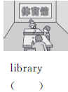 2.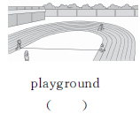3.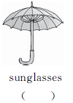4.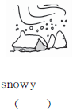
5.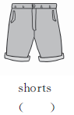 6.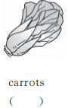 7. 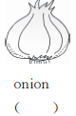 8. 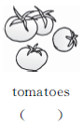
9. 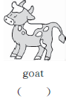10. 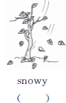 11. 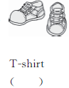 12. 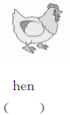
二、给下列图片找到相应的单词。
1. A. skirt B. jacket C. dress D. sweater
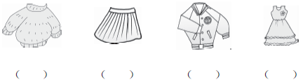
2. A. windy B. cloudy C. rainy D. sunny
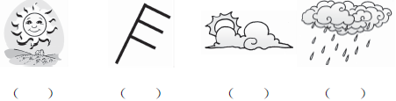
3. A. teachers' office B. art room C. music room D. library
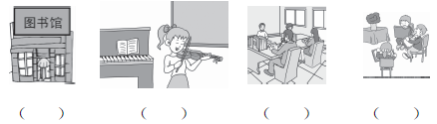
4. A. tomatoes B. potatoes C. onions D. carrots
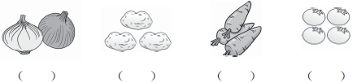
三、把下列单词或短语分类。(填序号即可)
①jacket ②PE ③pear ④English class ⑤music class ⑥dress
⑦horse ⑧cloudy ⑨sunny ⑩peach ⑪apple ⑫pants
⑬rainy ⑭hen ⑮sheep ⑯shorts ⑰goat ⑱watermelon ⑲snowy ⑳Chinese class
1. Fruit(水果)：____________________
2. Animal(动物)：____________________
3. Clothes(衣服)：____________________
4. Weather(天气)：____________________
5. Class(课程)：____________________
四、仿照例子完成下列各题。
第一组：cow cows
tomato__________, dress__________, sheep__________, potato__________
第二组：man woman
this__________, those__________
第三组：fat thin
hot__________, cheap__________, big__________, short__________
第四组：they're they are
let's__________, who's__________, what's__________
第五组：three third(第三)
one__________, two__________
第六组：brother brother's
John__________, your__________, Mike__________
五、改变单词中的一个字母, 使它变成一个关于动物名称的单词。
1. how→________ 2. big→________
3. fat→________ 4. pen→________
5. coat→________ 6. lamp→________
7. house→________ 8. pear→________
六、英汉对对碰选一选。
( ) 1. go to the playground A. 音乐教室
( ) 2. teachers' office B. 英语课
( ) 3. music room C. 天气预报
( ) 4. art room D. 穿上
( ) 5. English class E. 去上学
( ) 6. have breakfast F. 体育课
( ) 7. just a minute G. 多少
( ) 8. get up H. 起床
( ) 9. go to school I. 教师办公室
( ) 10. go to bed J. 多少钱
( ) 11. weather report K. 刚好合适
( ) 12. computer room L. 稍等一会儿
( ) 13. PE class M. 为什么
( ) 14. what for N. 计算机房
( ) 15. how much O. 美术教室
( ) 16. how many P. 脱下
( ) 17. what about Q. 吃早饭
( ) 18. just right R. 怎么样
( ) 19. put on S. 上床睡觉
( ) 20. take off T. 去操场
七、单项选择。
( ) 1. Do you have lunch________ school?
A. under B. at C. on
( ) 2. It's________ in Moscow. You should(应该)wear a coat.
A. warm B. cold C. hot
( ) 3. It's________. We can't play football on the playground.
A. rainy B. sunny C. warm
( ) 4. —How many________ are there? —Twelve.
A. sheep B. a sheep C. two sheep
( ) 5. —________are the shorts? —Sixty yuan.
A. How many B. How much C. How old
( ) 6. The coat is________ expensive.
A. to B. too C. two
( ) 7. Look________ the blackboard.
A. in B. at C. of
( ) 8. —It's hot. What do you want to wear?
—I want to wear a ________.
A. dress B. sweater C. coat
( ) 9. —What's the weather like today?
—It's ________.
A. rainy B. sun C. cloud
( ) 10. —Is this________ T-shirt, Tom?
—Yes, it is.
A. him B. you C. your
八、根据图片完成句子。
1. —Are these your________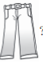? —Yes, ________ ________.
2. It's ________. I can wear my________. 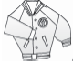
3. I see five________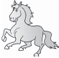, eight________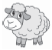, two________ and three________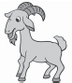.
4. It's 9：00. It's time for________ class 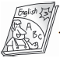.
5. The________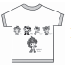 looks like a “T”.

专项训练一：词 汇
一、1. × 2. √ 3. × 4. √ 5. √ 6. × 7. √ 8. √ 9. × 10. × 11. × 12. √
二、1. D A B C 2. D A B C 3. D C A B 4. C B D A
三、1. ③ ⑩ ⑪ ⑱ 2. ⑦ ⑭ ⑮ ⑰ 3. ① ⑥ ⑫ ⑯ 4. ⑧ ⑨ ⑬ ⑲
5. ② ④ ⑤ ⑳
四、第一组：tomatoes；dresses；sheep；potatoes
第二组：that；these
第三组：cold；expensive；small；long/tall
第四组：let us；who is；what is
第五组：first；second
第六组：John's；yours；Mike's
五、1. cow 2. pig 3. cat 4. hen 5. goat 6. lamb 7. horse 8. bear
六、1. T, 2. I, 3. A, 4. O, 5. B, 6. Q, 7. L, 8. H, 9. E, 10. S, 11. C, 12. N, 13. F, 14. M, 15. J, 16. G, 17. R, 18. K, 19. D, 20. P
七、1. B, 2. B, 3. A, 4. A, 5. B, 6. B, 7. B, 8. A, 9. A, 10. C
八、1. jeans; they are 2. rainy; jacket 3. horses；sheep；hens；goats 4. English 5. T-shirt

