专项训练一：词 汇
一、读一读，判断下列各组中单词画线部分发音是(T)否(F)一致。
( ) 1. A. face B. make
( ) 2. A. big B. five
( ) 3. A. nose B. hot
( ) 4. A. milk B. big
( ) 5. A. duck B. up
( ) 6. A. bed B. she
二、读一读，选出画线部分与其他两项发音不同的一项。
( ) 1. A. cake B. map C. name
( ) 2. A. kite B. like C. pig
( ) 3. A. lost B. rose C. box
( ) 4. A. cute B. excuse C. fun
( ) 5. A. get B. we C. be
三、将左右两边的单词连线，使它们组成新的单词。
1. school A. book
2. story B. bag
3. bed C. board
4. black D. ball
5. basket E. room
四、看图，补全单词。
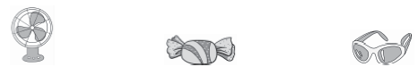
1. f________ 2. c________y 3. g________s
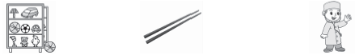
4. t________s 5. c________s 6. d________r

五、选出与所给单词或短语相符的图片。
( ) 1. turn on the light A. 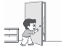 B. 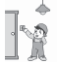
( ) 2. beef A. 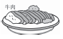 B. 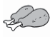
( ) 3. strong A. 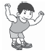 B. 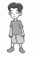
( ) 4. go to the bathroom A. 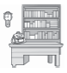 B. 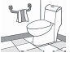
( ) 5. noodles A. 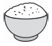 B. 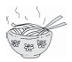
六、根据图片及首字母提示，写词语补全句子。
1. There is a p________ on the wall. 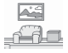
2. I have a C________ b________. 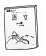
3. The girl is my friend. She has long h________. 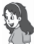
4. There is a TV in the l________ r________. 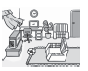
5. —What would you like? 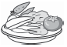
—I'd like some v________, please.
6. He's a f________. 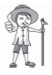
七、选出与画线部分单词属于同一类的一项。
( ) 1. Open the door, please.
A. cute B. hair C. window
( ) 2. I have an English book in my schoolbag.
A. maths book B. ruler C. key
( ) 3. He's tall and strong.
A. thin B. friendly C. blue
( ) 4. He has many books in his study.
A. behind B. bedroom C. book
( ) 5. My aunt is a driver.
A. cook B. doctor C. uncle
八、将下列词语归类。
blackboard teacher's desk fridge notebook aunt English book uncle
storybook fork strong sofa spoon cousin thin bowl tall phone
classroom schoolbag short knife table parents
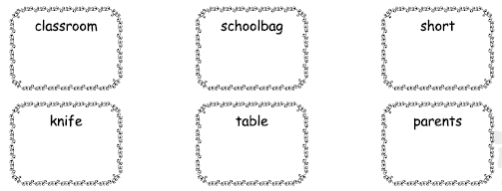
九、读一读，选一选。
( ) 1. We can see it in a room. We can talk to our friend with it. It's a ________.
A. phone B. sofa C. table
( ) 2. We can see him in a hospital(医院). When we are not well, we go to see him. He is a ________.
A. student B. brother C. doctor
( ) 3. It's a kind of(一种)food. We use a spoon to have it. It's ________.
A. beef B. soup C. water
( ) 4. We put them on our feet. We often have two. They are ________.
A. hair B. glasses C. shoes
( ) 5. It's a room. There are many books in it. We can read books and do our homework in it. It's a ________.
A. bedroom B. study C. kitchen
( ) 6. He is my aunt's baby. He is my ________.
A. cousin B. brother C. sister
( ) 7. It looks like a TV. We can play on it. We can listen to music on it. We can do our homework on it. It's a ________.
A. phone B. fan C. computer
( ) 8. It's in a classroom. The teacher puts his books on it. It's a ________.
A. teacher's desk B. light C. window
( ) 9. It's black. The teachers write(写字) on it. It's a ________.
A. picture B. blackboard C. wall
( ) 10. We put it on our head. It's a ________.
A. hat B. job C. puppy
十、选择正确的单词完成句子。
( ) 1. She has long (A. hair B. hairs). She is cute.
( ) 2. He has blue (A. glass B. glasses).
( ) 3. I'd like some (A. vegetable B. vegetables), please.
( ) 4. My new (A. shoes B. shoe) are blue.
( ) 5. Would you like some (A. noodle B. noodles)?
( ) 6. How many (A. man B. people)are there in your family?
十一、根据图片提示选择单词或短语，完成短文。
TV parents kitchen nurse sofa fridge
tall and strong quiet and friendly bed driver
I'm a boy. Welcome to my home and meet my family. They are my 1. ________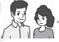. My dad is a 2. ________ 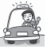. He is 3. ________ 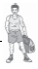. My mum is a 4. ________ 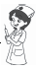 . She is 5. ________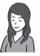 . We have a new 6. ________ and a new 7. ________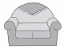 in the living room. And we have a new 8. ________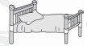 in the bedroom and a new 9. ________ 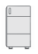 in the 10. ________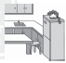 .
专项训练一：词 汇
一、1. T 2. F 3. F 4. T 5. T 6. F
二、1. B 2. C 3. B 4. C 5. A
三、1. B 2. A 3. E 4. C 5. D
四、1. fan 2. candy 3. glasses 4. toys 5. chopsticks 6. doctor
五、1. B 2. A 3. A 4. B 5. B
六、1. picture 2. Chinese book 3. hair
4. living room 5. vegetables 6. farmer
七、1. C 2. A 3. A 4. B 5. C
八、classroom: blackboard teacher's desk
schoolbag: notebook English book storybook
short: strong thin tall
knife: fork spoon bowl
table: fridge sofa phone
parents: aunt uncle cousin
九、1. A 点拨：关键点在第二句，我们可以用它与朋友交谈，所以应为“电话”。
2. C 点拨：能在医院里看到的，身体不好时要去看的，当然是“医生”。
3. B
4. C 点拨：脚上穿的当然是“鞋”。
5. B 点拨：有很多书的房间应该是“书房”。
6. A 点拨：阿姨家的孩子，是自己的“同辈表亲”。
7. C 点拨：像电视，又能用来玩的，当然是“计算机”了。
8. A 点拨：教室里老师放书的地方，应该是“讲台”。
9. B 点拨：黑色的，老师在上面写字，应该是“黑板”。
10. A 点拨：戴头上的应该是“帽子”。
十、1. A 点拨：hair是不可数名词，没有复数形式。
2. B
3. B 点拨：some后的可数名词要用复数形式。
4. A 点拨：shoes是复数名词。
5. B 6. B
十一、1. parents 2. driver 3. tall and strong
4. nurse 5. quiet and friendly 6. TV
7. sofa 8. bed 9. fridge 10. kitchen

