Unit 2综合能力测评

(40分钟　100分) 开始计时: ________

　Part 1 Speaking说（25%）

一、跟读下面的单词和短语。(10分)

1. Friday 2. Sunday 3. Monday 4. Wednesday

5. Tuesday 6. Saturday 7. Thursday 8. wash my clothes

9. on the weekend　 10. do homework

二、跟读下列句子。(5分)

1. What do you have on Thursdays?

2. I have maths, English and music.

3. Do you often read books in this park?

4. You should play sports every day.

5. I don't have art on Wednesdays.

三、跟读对话。(10分)

1. —Who's your science teacher?

—Mr Wu.

2. —What do you have on Tuesdays?

—We have Chinese, science and PE.

3. —What's that? —It's a storybook.

4. —Do you often play ping­pong on the weekend?

—Yes, I do.

5. —Do you often clean your room on Friday?

—No, I don't. I often draw pictures.

Part 2 Listening听(25%)

一、听录音，将图片按其顺序标出。(5分)



(　　) (　　) (　　) (　　) (　　)

二、听录音，选出与图片意思相符的正确选项。(5分)

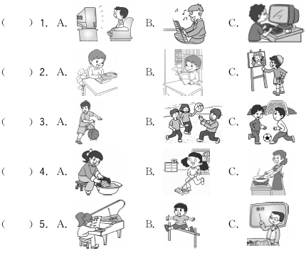

三、听录音，选出你所听到的句子。(5分)

(　　) 1. A. What do you have on Thursdays?

B. What do you often do on the weekend?

C. What do you do on Tuesdays?

(　　) 2. A. We have maths and PE on Mondays.

B. We have music and PE on Mondays.

C. We have art and music on Mondays.

(　　) 3. A. Do you often play football?

B. Do you often play games?

C. Do you often play sports?

(　　) 4. A. I have a cooking class with your grandma.

B. I have a basketball class with your brother.

C. I have a volleyball class with my friends.

(　　) 5. A. Do you often read storybooks on weekends?

B. Do you often do your homework on weekends?

C. Do you often clean your room on weekends?

四、听录音，根据你所听到的对话内容，将下面的内容配对连线。(10分)

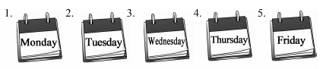

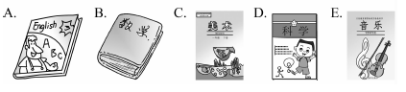

Part 3 Reading and Writing读和写(50%)

一、圈出每个句子中含有与例词画线部分相同读音的单词。(5分)

1. Please read after the teacher.

2. I'd like to eat some bread, some beef and some tea.

3. I go to meet my friend, but I can't see him.

二、将下列单词归类。(6分)

Monday　play　 do　　Thursday　read　　English

watch music Tuesday 　PE science Friday

Wednesday ________ ________ ________ ________

wash ________ ________ ________ ________

Maths ________ ________ ________ ________

三、根据图片m容，判断下列句子正(T)误(F)。(8分)

(　　) 1. I often wash my clothes. 

(　　) 2. We have music on Mondays. 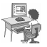

(　　) 3. She often plays the pipa on the weekend. 

(　　) 4. I often play football on Fridays. 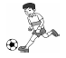

四、从II栏中找出I栏句子的相应答语。(5分)

　　　　　　　　I

(　　) 1. Who's your science teacher?

(　　) 2. What do they have on Wednesdays?

(　　) 3. Is it Monday?

(　　) 4. Do you often play ping­pong on the weekend?

(　　) 5. What do you often do on the weekend?

　　　　　　　II

A. They have Chinese, maths and science.

B. I often draw pictures in the park.

C. Yes, it is.

D. Mr. Brown.

E. Yes, I do.

五、看图，完成句子。(6分)

1. I often________________ on Saturdays. 

2. Tom often________________ on Sundays. 

3. I often________________ on the weekend. 

六、阅读短文，选择正确的答案。(10分)

Miss Chen is an art teacher in a school. She has her classes on Mondays, Wednesdays, Thursdays and Fridays. So she has lunch at school these days. On Tuesday she can have lunch at home. She often listens to music on Saturdays. She sings very well. On Sundays she often plays the *pipa* in the park.

1. Miss Chen is a(n) ________ teacher.

A. music B. art C. science

2. Miss Chen has her classes ________ times(次数) a week.

A. six B. five C. four

3. Miss Chen can have lunch at home on ________.

A. Monday B. Tuesday C. Friday

4. Miss Chen often ________ on Saturdays.

A. listens to music B. cleans her room C. plays the *pipa*

5. Miss Chen often goes to the ________ on Sundays.

A. shop B. park C. market

七、根据图表中的信息，用英语写一篇小短文。(10分)

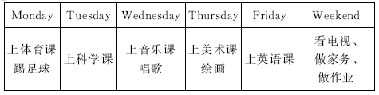

要求：不少于5句话。

参考句型：I often…on…

_____________________________________________________________________

_____________________________________________________________________

_____________________________________________________________________

_____________________________________________________________________

_____________________________________________________________________

_____________________________________________________________________

_____________________________________________________________________



Unit 2综合能力测评

Part 2　Listening

听力材料：

一、1. Sunday　2. Monday　3. Friday 4. Thursday　5. Tuesday

二、1. **M:** I like to watch TV.

2. He often reads books in the evening.

3. **M:** I often play football on the weekend.

4. My sister washes her clothes on Saturdays.

5. We have Chinese on Wednesdays.

三、1. What do you often do on the weekend?

2. We have maths and PE on Mondays.

3. Do you often play sports?

4. I have a cooking class with your grandma.

5. Do you often read storybooks on weekends?

四、1. —What do you have on Mondays?

—I have art.

2. —What do you have on Tuesdays?

—I have music.

3. —What do you have on Wednesdays?

—I have science.

4. —What do you have on Thursdays?

—I have English.

5. —What do you have on Fridays?

—I have maths.

答案：

一、3　2　1　4　5

二、1. A　2. B　3. C　4. A　5. C

三、1. B　2. A　3. C　4. A　5. A

四、

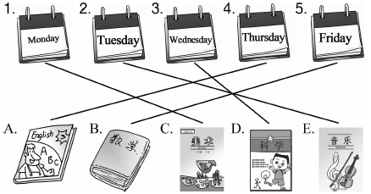

Part 3　Reading and Writing

一、1. read; teacher　2. beef; tea　3. see

二、Wednesday: Monday; Thursday; Tuesday; Friday

Wash: play; do; read; watch

Maths: English; music; PE; science

三、1. T　2. F　3. F　4. T

四、1. D　2. A　3. C　4. E　5. B

五、1. do homework　2. watches TV 3. clean my / the room

六、1. B　2. C　3. B　4. A　5. B

七、范文：

I have P. E. on Mondays and I often play football. On Tuesdays, I have science. I have music on Wednesdays. I can learn singing. On Thursdays, I have art. I like drawing very much. On Fridays, I have English. On weekends, I often watch TV and do my homework. Sometimes I wash my clothes and clean my room.