Unit 1综合能力测评

时间：40分钟　满分：100分

|  |  |  |  |  |  |  |  |  |  |  |  |  |  |
| --- | --- | --- | --- | --- | --- | --- | --- | --- | --- | --- | --- | --- | --- |
|  | Speaking（25%分） | | | Listening  （25%分） | | | Vocabulary and Grammar（30%分） | | | | Reading and Writing  (20%) | | 总分 |
| 题号 | 一 | 二 | 三 | 一 | 二 | 三 | 一 | 二 | 三 | 四 | 一 | 二 |  |
| 得分 |  |  |  |  |  |  |  |  |  |  |  |  |  |

**Speaking说(25%)**

一、跟读下列单词或句子。(10分)

1. classroom　　2. window　　3. picture　　4. door

5. computer 6. wall 7. floor 8. fan

9. What's in the classroom?

10. Let's clean the windows.

二、跟读下列对话。(10分)

1. —Where is the blackboard？—It is on the wall.

2. —Let's clean the classroom！—OK.

3. —Let me help you. —Thank you.

4. —What is this？—It's a computer.

5. —Is your classroom new？—Yes，it is.

三、跟读下面的对话。(5分)

A：Let's clean the classroom!

B：OK.

A：Let me clean the teacher's desk.

B：Let me clean the windows.

A：Let me help you.

B：Thank you.

 **Listening听(25%)**

一、听录音，选出你所听到单词的汉语意思。(5分)

(　　) 1. A. 门　 B. 墙 C. 地板

(　　) 2. A. 这里 B. 那里 C. 哪里

(　　) 3. A. 电灯 B. 喜欢 C. 对的

(　　) 4. A. 在附近 B. 图片 C. 打开

(　　) 5. A. 走 B. 新的 C. 你

二、听录音，标序号。(5分)

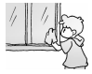 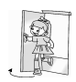 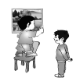

(　　)　　　　 (　　)　　　　　 (　　)

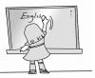 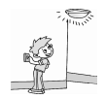

　(　　)　　　　　　　　　(　　)

三、听录音，选择正确的答语。(5分)

(　　) 1. A. OK. B. Thank you.

(　　) 2. A. It's big. B. Six lights，a blackboard.

(　　) 3. A. It's green. B. Yes, it is.

(　　) 4. A. It's near the door. B. It's a door.

(　　) 5. A. Nice to meet you. B. My name is Mike.

四、听录音，把图片与颜色连起来。(10分)

  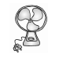  

orange　　　white　　　yellow　　　blue　　　green

**Vocabulary and Grammar**

**词汇与语法(30%)**

一、火眼金睛选不同。(5分)

(　　) 1. A. desk B. chair C. light

(　　) 2. A. computer B. fan C. picture

(　　) 3. A. floor B. open C. clean

(　　) 4. A. yellow B. door C. green

(　　) 5. A. under B. near C. kite

二、看一看，选一选。(5分)

1. The (picture/fan) is good. 

2. The(cake/face) is on the plate(盘子). 

3. Let's clean the(window/light). 

4. Let me clean the(door/fan). 

5. The bag is on the(desk/chair). 

三、单项选择。(10分)

(　　) 1. Turn ________the light.

A. from B. on C. of

(　　) 2. I ________a new computer.

A. have B. are C. has

(　　) 3. — is this？—It's a blackboard.

A. Who B. Where C. What

(　　) 4. Let me ________the desks.

A. cleans B. clean C. to clean

(　　) 5. — Where's the kite？— ________

A. It's near the door.

B. It is a desk.

C. It's so big.

(　　) 6. Look ________ my new picture.

A. of B. at C. in

(　　) 7. I can see many ________ and chairs.

A. desk B. desk's C. desks

(　　) 8. ________ near the computer.

A. It's B. It C. Its

(　　) 9. This is our classroom. The windows ________ blue.

A. are B. is C. be

(　　) 10. —Look at my new bag.

— ________

A. Wow! It's very nice.

B. Thank you.

C. Sorry.

四、选择与句子相对应的图片。(10分)

　　 　 

　　A　　　　　　　B　　　　　　 　C

 

　　　　　 　D　　　　　　　 E

(　　) 1. Let me clean the teacher's desk.

(　　) 2. Let's clean the classroom.

(　　) 3. Close the book.

(　　) 4. Please close the window.

(　　) 5. The picture is on the wall.

**Reading and Writing**

**读和写(20%)**

一、连词成句。(10分)

1. 



2. 



3. 



4. 



5. 



二、读短文，将颜色词的标号填入相应的括号中，将物品词的标号填在相应的 中。(10分)

|  |
| --- |
| A. brown　B. yellow　C. orange　D. blue　E. fan　F. desk  G. computer　H. light　I. teacher's desk　J. blackboard |

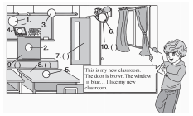

This is my new classroom. It's big. The door is brown. The window is blue. The blackboard is on the wall. The orange teacher's desk is in front of(在……前面) the blackboard. The new computer and books are on it. The fan is near the window. It is blue. We have nineteen chairs and twenty desks. They are yellow. I like my new classroom.

**Part 2**

听力材料：

一、1. door 　 2. where 　3. light 4. picture 　 5. new

二、1. Open the door.

2. Clean the blackboard.

3. Clean the windows.

4. Turn on the light.

5. Put up the picture.

三、1. Let's clean the classroom.

2. What's in the classroom?

3. What colour is the floor?

4. Where's your seat?

5. This is my friend，Mike.

四、1. This is a yellow computer.

2. The door is green.

3. It's an orange fan.

4. It's a blue desk.

5. I have a white cat.

答案：

一、1—5　A C A B B

二、3－1－5－2－4

三、1—5　A B A A A

四、

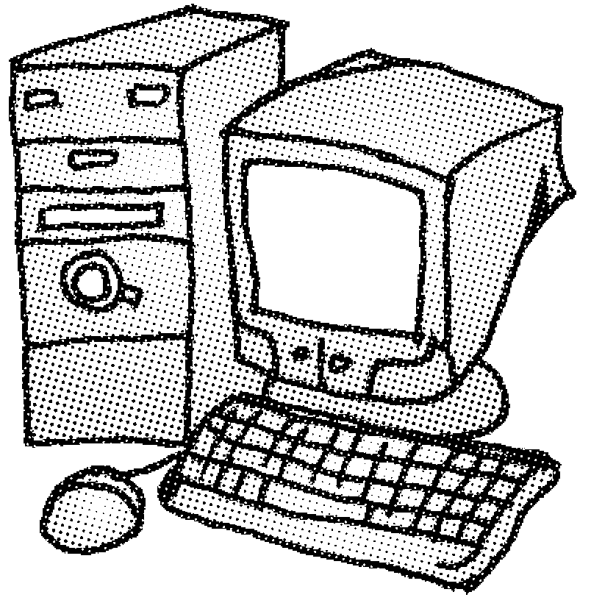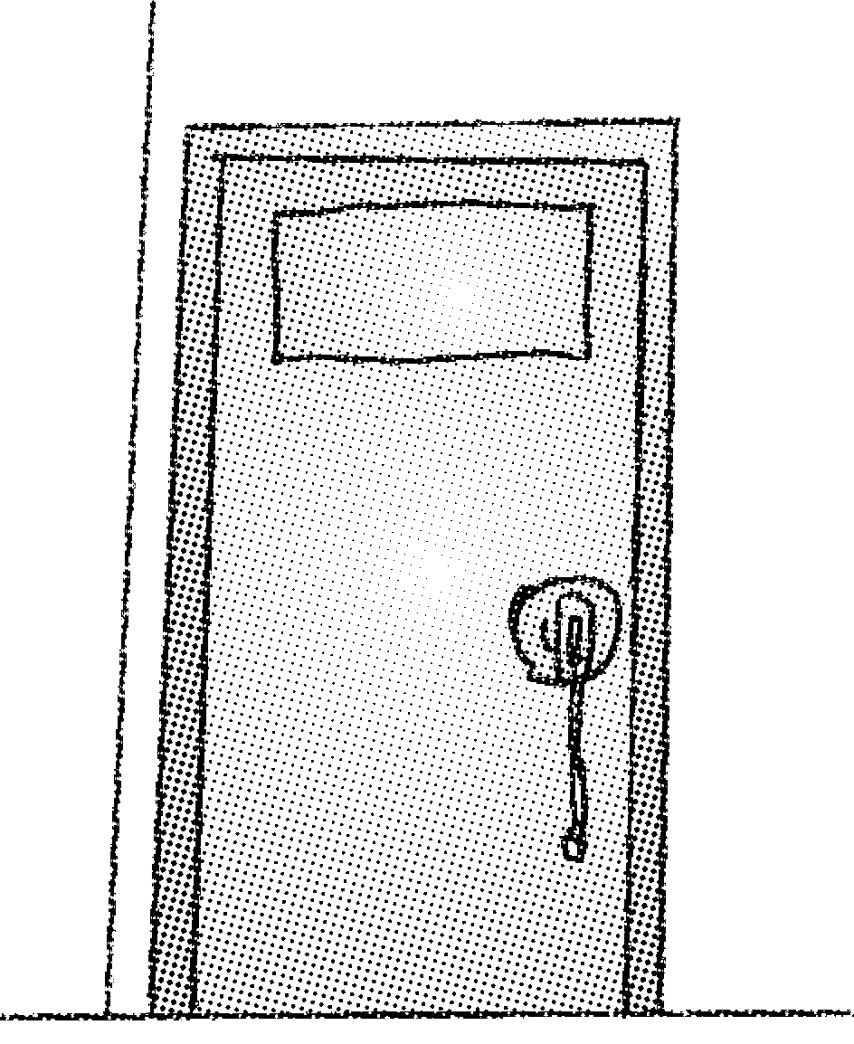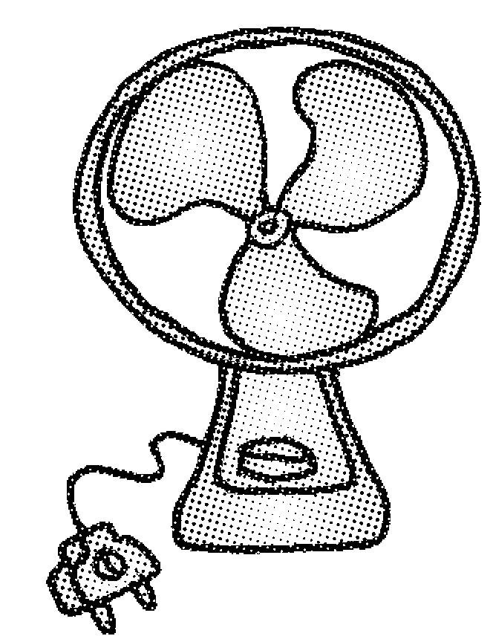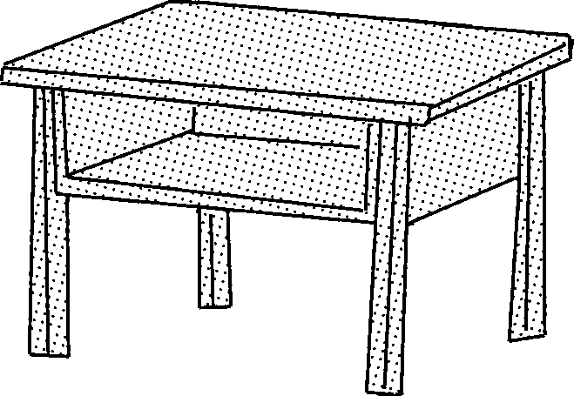 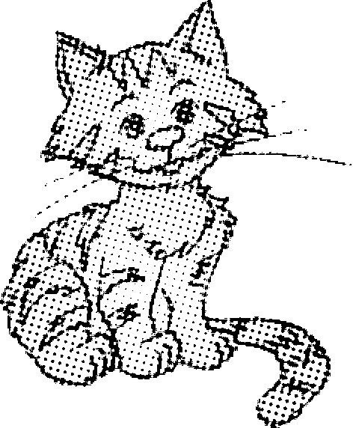

yellow　　 green　 orange　　　 blue　 　 white

**Part 3**

一、1—5　C C A B C

、1—5　C C A B C

二、1. picture 2. cake 3. window 4. door 5. chair

三、1. B　点拨：turn on打开，为固定搭配。

2. A

3. C　点拨：blackboard是“黑板”，对物品提问要用what。

4. B　点拨：let me后跟动词原形，表示“让我……”。

5. A　点拨：问句是询问风筝在哪儿，回答应是地点，故选A“它在门附近。”

6. B　点拨：look at表示“看”。

7. C　点拨：many后接可数名词的复数形式。desk的复数形式为desks。

8. A　点拨：it's它是；it它；its它的。

9. A　点拨：windows是复数，be动词应用are。

10. A

四、1—5　E A B C D

**Part 4**

一、1. Where is the window?

2. It is near the chair.

3. The door is green.

4. Let me clean the classroom.

5. Put up the picture.

二、1. J　2. I　3. H　4. G　5. F

6. E　7. A　8. B　9. C　10. D