Unit 4过关检测卷

(40分钟　100分) 开始计时: ________

　第一部分　听力(40分)

一、听录音, 选出所听到的单词。(每小题2分, 共10分)

(　　) 1. A. box B. boy C. toy

(　　) 2. A. cap B. cat C. car

(　　) 3. A. book B. boat C. ball

(　　) 4. A. map B. cap C. pen

(　　) 5. A. behind B. find C. hide

二、听录音, 选出与所听句子相符的图片。(每小题2分, 共10分)

(　　) 1. 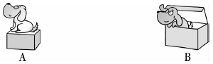

(　　) 2. 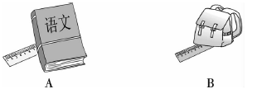

(　　) 3. 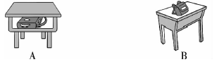

(　　) 4. 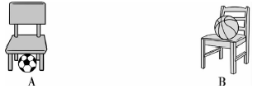

(　　) 5. 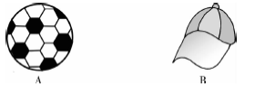

三、听录音, 判断所听内容与图片是否相符, 相符的在图片下的括号内打“√”, 不相符的打“×”。(每小题2分, 共10分)

1.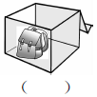2. 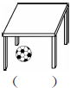3. 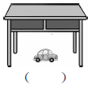4. 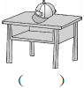5. 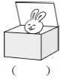

四、听录音, 选出与人物所对应的图片, 并将序号填入题前括号内。(每小题2分, 共10分)

(　　) 1. 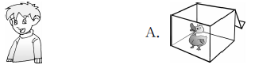

(　　) 2. 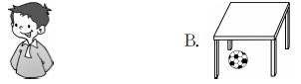

(　　) 3. 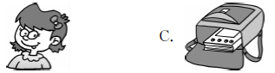

(　　) 4. 

(　　) 5. 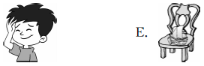

第二部分　笔试(60分)

五、看图, 将单词和相应的图片连线。(每小题1分, 共5分)

1. cap　　　 2. car　　 　3. boat　　 　4. desk　　 　5. chair

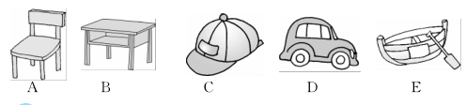

六、我会选。(每小题2分, 共10分)

(　　) 1. Let's ________home.

A. to go B. go C. go to

(　　) 2. —Mom, ________is my pen?

—It's in the pencil box.

A. where B. what C. who

(　　) 3. —Where is my book?

—It's ________your bag.

A. in the B. on C. under the

(　　) 4. —Is the cat under the bed?

—________.

A. Yes, it is B. No, it is C. Yes, it isn't

(　　) 5. —Where are you, Li Ming?

—I'm ________you.

A. in B. at C. behind

七、图文搭配。(找出与图片相对应的句子, 把序号写在图片下面的括号里)(每小题2分, 共10分)

1. 2. 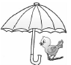3. 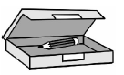4. 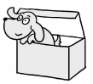5. 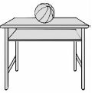

( ) ( ) ( ) ( ) ( )

A. The bird is under the umbrella(雨伞). B. The dog is in the box.

C. The panda is in the cap. D. The ball is on the desk.

E. The pencil is in the pencil box.

八、看图, 选择相应的单词, 并将序号写在括号内。(每小题1分, 共5分)

(　　) 1. Where is the ________? 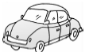

A. car　　　　　 　　B. boat

(　　) 2. Look, the car is ________ the chair. 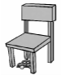

A. on B. under

(　　) 3. It's ________ the box. 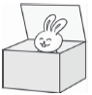

A. on B. in

(　　) 4. —Where is my ruler? 

—It's ________ the book.

A. on　　　　　 　　 B. in

(　　) 5. My toy plane (飞机) is ________ the desk. 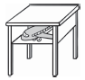

A. on　　 　　　　　B. in

九、读一读, 圈出与图片对应的句子。(每小题2分, 共10分)

1. 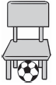 2. 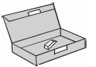

A. The ball is under the chair. A. The eraser is in the pencil box.

B. The ball is on the chair. B. The ruler is in the pencil box.

3. 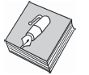 4. 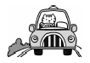

A. The book is on the pen. A. The cat is on the car.

B. The pen is on the book. B. The cat is in the car.

5. 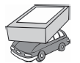

A. The car is under the box.

B. The car is on the box.

十、找朋友。(从第Ⅱ栏中找出第Ⅰ栏每个句子的答语, 把序号写在题前括号里)(每小题2分, 共10分)

　　 Ⅰ　　　　　　　　　　　Ⅱ

(　　) 1. Are you ready? 　 　　 A. He is Mike.

(　　) 2. Where is my eraser? B. It's in the book.

(　　) 3. Where are you from? C. I'm from America.

(　　) 4. Who is that boy? D. Yes, it is.

(　　) 5. Is it under the box? E. Yes!

十一、阅读短文, 根据短文内容, 将物品下的序号填入相应的圈内。(每空2分, 共10分)

Look at the picture(图画). I have a ruler. It's in the boat. I have a ball. It's under the desk. And I have a car. It's in the bag. Where's my kite(风筝)? Oh, it's on the desk. What's on the chair? It's a cap.

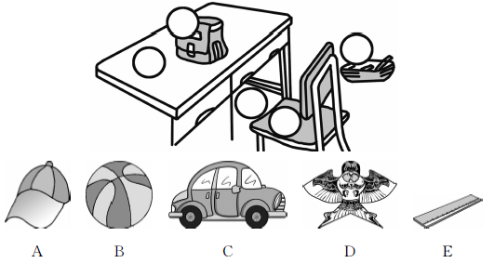

结束时间: ________

Unit 1过关检测卷

听力材料:

一、1. toy　2. cap　3. boat 4. map　5. behind

二、1. The dog is in the box.

2. The ruler is under the book.

3. The bag is on the desk.

4. The ball is under the chair.

5. This is a ball.

三、1. M：Hi, Liu Yun. Where's your cat?

W：It's under the bag.

2. Look！My ball is under the desk.

3. M：Where's my car, Sarah?

W：It's on your desk.

4. Look at my cap. It's on the chair.

5. Oh, it's a lovely duck. It's in the box.

四、1. M：Hi, I'm Mike. My ball is under the desk.

2. M：My name is John. My cap is on the desk.

3. W：Hello, I'm Sarah. I have a new boat. It's on the chair.

4. W：I'm Amy. I have a duck in the box.

5. M：I'm David. My book is in the bag.

答案:

一、1. C　2. A　3. B　4. A　5. A

二、1. B　2. A　3. B　4. A　5. A

三、1. ×　2. √　3. ×　4. ×　5. ×

四、1. B　2. D　3. E　4. A　5. C

五、1. C　2. D　3. E　4. B　5. A

六、1. B　点拨：Let's后面的动词要用原形, go home“回家”是固定搭配, 故选B。

2. A　点拨：由答语“It's in the pencil box. ”可知是提问地点, 故选A。

3. B　4. A　5. C

七、1. C　2. A　3. E　4. B　5. D

八、1. A　2. B　3. B　4. B　5. B

九、1. A　2. A　3. B　4. B　5. A

十、1. E　2. B　3. C　4. A　5. D

十一、

