Unit 1　过关检测卷

(40分钟　100分) 开始计时：________

第一部分　听力(30分)

一、听录音，选出你所听到的单词或短语。(每小题1分，共10分)

(　　) 1. A. garden B. girl C. great

(　　) 2. A. music B. art C. big

(　　) 3. A. there B. this C. lunch

(　　) 4. A. dinner B. under C. after

(　　) 5. A. please B. picture C. play

(　　) 6. A. your B. floor C. you

(　　) 7. A. lunch B. that C. next

(　　) 8. A. school B. room C. full

(　　) 9. A. teacher B. sister C. computer

(　　) 10. A. watch TV B. read books C. water flowers

二、听录音，判断你所听到的内容与图片是否相符，相符的写“√”，不符的写“×”。(每小题1分，共5分)

1. 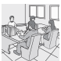　　2. 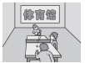　　3. 

(　　) 　　 (　　) 　　 　(　　)

4. 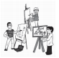 　5. 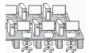

　　　(　　) 　　　　 　(　　)

三、听录音，完成下列句子。(每小题1分，共5分)

(　　) 1. Where is the________?

A. garden B. canteen C. classroom

(　　) 2. We have a new ________ room.

A. computer B. art C. music

(　　) 3. ________ is your library.

A. That B. This C. There

(　　) 4. She's in the________.

A. school B. gym C. music room

(　　) 5. How many ________ are there in your school?

A. teachers B. students C. books

四、听录音，根据你听到的句子选择正确的答语。(每小题2分，共 10分)

(　　) 1. A. It's on the second floor. B. It's the music room.

(　　) 2. A. Yes, I am. B. Yes, it is.

(　　) 3. A. Thirty­eight. B. 45 *yuan*.

(　　) 4. A. Yes, we does. B. Yes, we do.

(　　) 5. A. Thank you. B. You're welcome.

　第二部分　笔试(70分)

一、选出每组单词中画线部分读音与众不同的一项。(每小题1分，共5分)

(　　) 1. A. teacher B. tiger C. girl

(　　) 2. A. student B. computer C. number

(　　) 3. A. garden B. library C. art

(　　) 4. A. next B. second C. we

(　　) 5. A. thirty B. after C. ruler

二、读一读，选一选。(每小题1分，共5分)

A. school　　　B. garden　　　C. art room D. computer room

E. teachers' office

(　　) 1.  (　　) 2.  (　　) 3. 

(　　) 4. 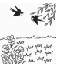 (　　) 5. 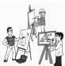

三、单项选择。(每小题1分，共10分)

(　　) 1. Go to the ________ and borrow(借) a book.

A. gym B. garden C. library

(　　) 2. —Is that the music room?

—________

A. I like it. B. No, it isn't. C. It's a computer.

(　　) 3. The gym is ________ the playground.

A. next to B. next C. under

(　　) 4. The teachers' office is ________ floor.

A. the first B. first C. on the first

(　　) 5. We have ________ art room.

A. / B. a C. an

(　　) 6. Welcome ________ Beijing!

A. at B. to C. for

(　　) 7. —Do you have a playground in your school?

—________.

A. Yes, it is B. Yes, we do C. Yes, I am

(　　) 8. —Wow! Your school is big and nice. 　—________.

A. No, it isn't B. Thank you C. Right

(　　) 9. There are ________ classrooms.

A. first B. two C. second

(　　) 10. —________teachers are there in your school?

—Fifty.

A. How B. How many C. Where

四、连词成句。(读一读，把下列灯笼排好队) (每小题2分，共 10分)

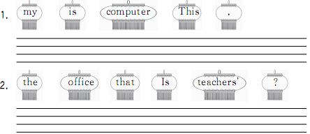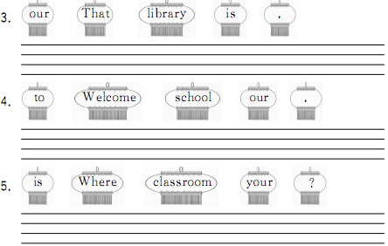

五、句子配对。(选答语) (每小题2分，共10分)

(　　) 1. Where is the gym?

(　　) 2. Do you have a music room?

(　　) 3. How many students are there in your class?

(　　) 4. Is this the second floor?

(　　) 5. Is that your classroom?

A. Forty­five. B. It's on the first floor. C. Yes, we do.

D. No, it's our art room. E. Yes, it is.

六、情景应用。(每小题2分，共10分)

(　　) 1. 当你指着远处告诉别人那是一个操场时，你可以说：

A. This is a playground. B. That is a playground.

(　　) 2. 有一位新生问“Where is the music room?”，你告诉他“它在二楼。”可以说：

A. It's on the first floor. B. It's on the second floor.

(　　) 3. 当你想告诉妈妈“我们有体育馆。”时，可以说：

A. I have a gym. B. We have a gym.

(　　) 4. 你想问“这是计算机教室吗？”，可以说：

A. Is this the computer room? B. Is that the computer room?

(　　) 5. 赞美朋友的学校时，可以说：

A. Your school is cool! B. All right.

七、我是交际小能手。(根据情景补全对话) (每小题2分，共10分)

**A:** Excuse me. Is this the 1. __________________ (教师的) office?

**B:** No，it 2. ________.

**A:** 3. ________is it?

**B:** It's on the first floor. This 4. ________, please.

**A:** 5. ________you.

**B:** Not at all.

八、快乐阅读。(每小题2分，共10分)

Hello! My name is Wan Jun. Welcome to our school. Our school is very big. We have a beautiful garden, a big playground, a clean canteen(餐厅) and a quiet library. My classroom is on the second floor. There are nineteen girls and twenty­one boys in my class. My favourite(最喜爱的) subject(科目) is art. We study and play in our school. We love our school.

(　　) 1. Wan Jun's school is________.

A. big B. small C. old

(　　) 2. —Do they have a library?

—________.

A. Yes, they do B. No, they don't

C. Sorry, we don't know

(　　) 3. —Where is Wan Jun's classroom?

—________.

A. It's on the first floor B. It's on the third floor

C. It's on the second floor

(　　) 4. —How many students are there in Wan Jun's class?

—________.

A. 39 B. 40 C. 41

(　　) 5. —What's Wan Jun's favourite(最喜爱的) subject?

—________.

A. Art B. Music C. Math

结束时间：________

Unit 1过关检测卷

听力材料：

一、1. garden　2. art　3. lunch　4. under　5. play

6. your　7. that　8. school　9. teacher 10. water flowers

二、1. This is the teachers' office.

2. They are in the cinema.

3. Let's go to the playground.

4. They draw in the art room.

5. We sing in the music room.

三、1. Where is the garden?

2. We have a new art room.

3. That is your library.

4. She's in the gym.

5. How many students are there in your school?

四、1. Where's the art room?

2. Is this the teachers' office?

3. How many computers in your school?

4. Do you have a gym?

5. Your classroom is nice and clean.

听力部分

一、1. A　2. B　3. C　4. B　5. C　6. A　7. B　8. A 9. A　10. C

二、1. √　2. ×　3. √　4. √　5. ×

三、1. A　2. B　3. A　4. B　5. B

四、1. A　2. B　3. A　4. B　5. A

笔试部分

一、1. C　点拨：teacher，tiger中er都发短音/ə/，而girl中ir发/ɜː/，故选C。

2. C　点拨：A、B两项中u都发/juː/，而C项中u发/ʌ/。故选C。

3. B　点拨：A、C两项中ar都发/ɑː/，而B项不同，故选B。

4. C　点拨：A、B两项中e都发/e/，而C项中e发/i(ː) /，故选C。

5. A　点拨：B、C两项中er都发/ə/，而A项中ir发/ɜː/，故选A。

二、1—E　2—A　3—D　4—B　5—C

三、1. C

2. B

3. A　点拨：句意应是“体育馆紧挨着操场。”表达“在……近旁”的短语就是next to。

4. C

5. C　点拨：art是以元音音素开头的单词，故前面的冠词用an。

6. B

7. B

8. B　点拨：当别人赞美或夸奖你或与你有关的东西时要感谢对方。

9. B

10. B

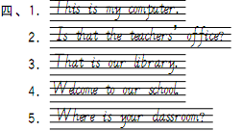

五、1. B　2. C　3. A　4. E　5. D

六、1. B

2. B

3. B　点拨：当主语是第一人称时，表达“有”用have。主语是“我们”we，故选B。

4. A

5. A

七、1. teachers'　2. isn't　3. Where　4. way　5. Thank

八、1. A

2. A

3. C

4. B　点拨：由文中There are nineteen girls and twenty­one boys in my class. 可知答案选B。

5. A