Unit 6综合能力测评
(40分钟 100分)
INCLUDEPICTURE "../../../../../../课件文件下册/典中点/六年级/word/ZB.tif" \* MERGEFORMAT 开始计时: ________
Part 1 Speaking说（25%）
一、跟读下列单词和短语。(10分)
1. angry 2. Afraid 3. Sad 4. worried
5. happy 6. Wear 7. chase 8. see a doctor
9. take a deep breath 10. count to ten
二、跟读下列句子。(5分)
1. The cat is angry with them.
2. The cat is ill. Sarah is sad.
3. Sarah and the cat are worried.
4. You should do more exercise.
5. You should take a deep breath and count to ten.
三、跟读下列对话。(10分)
A: Hi, Nick. How are you?
B: I'm ill.
A: What's wrong?
B: My fingers hurt.
A: Does your hand hurt?
B: Yes. My left hand hurts, too. What should I do?
A: You should see a doctor.
B: Thank you.
A: You're welcome.
Part 2 Listening听（25%）
一、听录音，选出与你所听内容相符的图片。(5分)
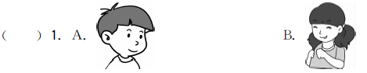
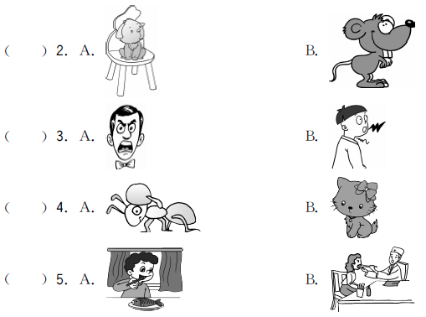
二、听录音，给下面的句子排序。(5分)
( ) The cat is a police officer.
( ) You should see a doctor.
( ) You should take a deep breath.
( ) We should always be nice to each other.
( ) The cat is chasing a mouse now!
三、听录音，选择恰当的答语。(5分)
( ) 1. A. I'm making popcorn. B. I feel happy.
C. Do more exercise.
( ) 2. A. He feels angry.
B. He should wear warm clothes.
C. You should see a doctor.
( ) 3. A. My mother is ill.
B. Let's go to the hospital.
C. We can go next time.
( ) 4. A. Don't be angry. B. Going to the zoo.
C. He feels sad.
( ) 5. A. I'm afraid of the mice.
B. Because I'm going to take a trip tomorrow.
C. It's about a cartoon.
四、听录音，在相应的栏中打“√”。(10分)
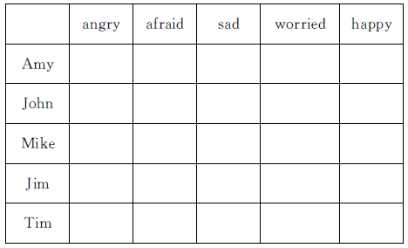
Part 3 Vocabulary and Grammar词汇与语法(30%)
一、把单词宝宝放到合适的位置，使句子完整、通顺。(5分)
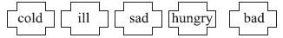
1. I'm ________. I want to eat something.
2. I'm ________. I want to wear more clothes.
3. My father feels _______. He should see a doctor.
4. The weather is ________. We can't take a trip.
5. Lily is ________. She failed the math test.

二、单项选择我最棒！(10分)
( ) 1. John is ________ angry.
A. little B. few C. a little
( ) 2. —________ does Bill feel?
—He feels worried.
A. What B. How C. Where
( ) 3. What's the matter ________ you?
A. to B. with C. of
( ) 4. ________ worry，little Tom. I'll go with you.
A. Don't B. Doesn't C. Are
( ) 5. —Sarah feels cold. What should she do?
—________
A. She should take a deep breath. B. She should go swimming.
C. She should wear warm clothes.
三、读一读，选一选。(10分)
( ) 1. The cat is talking with a mouse now!
( ) 2. He should do more exercise.
( ) 3. Jim is sitting on the grass.
( ) 4. Let's go to the cinema.
( ) 5. They are going to school.
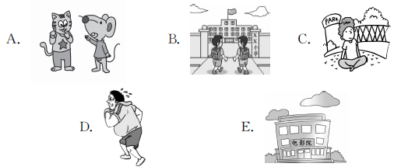
四、(N)用所给单词的适当形式填空。(5分)
1. He must ________ (get) to school early.
2. Do you have ________ (some) popcorn?
3. What are you going to ________ (take)?
4. Your cat ____________ (play) with a mouse now!
5. I will ________ (travel) by ship.
Part 4 Reading and Writing读和写(20%)
一、读短文，判断正(T)误(F)。(10分) (建议用时：6分钟)
Tom is a little boy. He is four. Today his mother takes him to see his grandma. His grandma's home is very far，so they go there by bus. There are only twenty people on the bus. They are all sitting on their seats. Tom is very happy. He runs on the bus. His mother asks him，“Why are you running？” “Because I miss(想念) my grandma so much that I want the bus to go faster. ” Tom answers.
( ) 1. Tom and his mother go to see a doctor.
( ) 2. His grandma's home is near，so they usually walk there.
( ) 3. The bus is crowded(拥挤的).
( ) 4. Tom is running on the bus，so his mother is angry with him.
( ) 5. Tom wants to see his grandma as soon as possible(尽快).
二、小作文。(10分)
根据提示写一篇小作文。
提示：Sarah感冒了，今天没有去上学。她很难过。她应该去看医生，多喝开水，穿厚衣服。她希望早日康复去上学。
_____________________________________________________________________
_____________________________________________________________________
_____________________________________________________________________
____________________________________________________________________________________________________________________________________________________________________________________________________________________________________________________________________________________
Part 2 Listening
听力材料：
一、1. happy 2. mouse 3. angry 4. ant 5. see a doctor
二、1. You should take a deep breath.
2. The cat is chasing a mouse now!
3. The cat is a police officer.
4. You should see a doctor.
5. We should always be nice to each other.
三、1. What are you doing，Lucy?
2. What should John do?
3. What's wrong?
4. How does Sam feel?
5. Why are you happy?
四、 Look at my friends！They are different. Amy is sad today. She failed in her English test. John is angry，because the dog broke his window. Mike is worried. His father is ill in bed. Jim is happy. He is going to take a trip tomorrow morning. Tim is afraid. He sees a mouse. How interesting!
答案：
一、1. B 2. B 3. A 4. A 5. B
二、3 4 1 5 2
三、1. A 2. B 3. A 4. C 5. B
四、
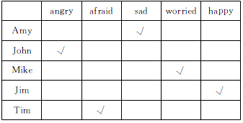
Part 3 Vocabulary and Grammar
一、1. hungry 2. cold 3. ill 4. bad 5. sad
二、1. C 2. B
3. B 点拨：What's the matter with you？你怎么了？
4. A 5. C
三、1. A 2. D 3. C 4. E 5. B
四、1. get 2. any 3. take 4. is playing 5. travel
Part 4 Reading and Writing
一、1. F 2. F 3. F 4. F 5. T
二、范文：
Sarah is not feeling well today. She has a bad cold. She is very sad. She doesn't go to school today. She should go to see a doctor, and she should drink more hot water and wear warm clothes. She hopes she can be better soon. And she wants to go to school as soon as possible.

