Unit 6综合能力测评

(40分钟　100分) 开始计时: ________

　Part 1 Speaking说（25%）

一、跟读单词。(10分)

1. forest 2. river 3. lake 4. mountain 5. tree

6. hill 7. bridge 8. building 9. village 10. house

二、跟读句子。(5分)

1. There is a river in the nature park.

2. There are some trees in the forest.

3. Are there any houses in the village?

4. Are there any buildings in the city?

5. Look! There is a big white bird in the sky.

三、跟读对话。(10分)

1. —Is there a river in the park?

—Yes, there is.

2. —I'm hungry. Is there a restaurant beside the lake?

—No, there isn't. Look! I have some food. Let's share.

3. **A:** The nature park is so quiet!

**B:** Yes, Zhang Peng. There aren't many people.

**A:** Are there any tall buildings in the nature park?

**B:** No, there aren't.

**A:** Are there any animals?

**B:** Yes, there are.

Part 2　Listening听(25%)

一、听录音，选择相应的图片。(5分)

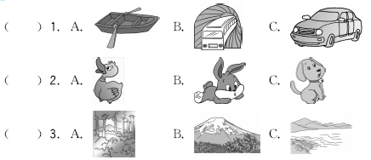

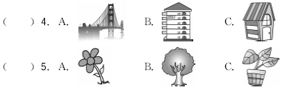

二、听录音，将下列图片排序。(5分)

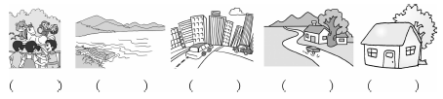

三、听录音，判断下列句子与所听内容是(√)否(×)相符。(5分)

(　　) 1. There are some ducks in the park.

(　　) 2. There is a river in front of the mountain.

(　　) 3. Let's go to the forest.

(　　) 4. There are many houses in the nature park.

(　　) 5. There is a restaurant beside the lake.

四、听录音，选出你所听到的句子的正确答语。(5分)

(　　) 1. A. Yes, there is. B. Yes, it does. C. Yes, it is.

(　　) 2. A. No, they aren't B. No, there aren't. C. No, there isn't.

(　　) 3. A. They are cats. B. They are in the tree. C. There are cats.

(　　) 4. A. They're five yuan. B. There are fish. C. I can see five.

(　　) 5. A. Yes, there is. B. A pen. C. It's in my hand.

五、听录音，选择你所听到的单词或短语完成短文。(5分)

A. houses　B. ducks　C. river　D. In front of　E. behind

Look! This is my village. There is a nature park beside my village. There are some 1. ________ in the nature park. You can see a big forest 2. ________the village. There is a big lake in the forest. On the lake, you can see some 3. ________. In the lake, you can see some fish. 4. ________ the village, there is a 5. ________. A bridge is over the river.

Part 3 Reading and Writing读和写(50%)

一、根据句意及中文提示完成句子。(5分)

1. There is a ________(森林) near my village.

2. There are many ________(高山) around the city.

3. There are two big ________(树) near the river.

4. I want to live in a new ________(房子).

5. There is a ________(桥) over the lake.

二、单项选择。(5分)

(　　) 1. ________there any flowers in the nature park?

A. Am B. Is C. Are

(　　) 2. There aren't ________ ducks on the lake.

A. some B. a C. any

(　　) 3. There are small houses ________ the village.

A. at B. in C. on

(　　) 4. —________ are the trees? —They are near the river.

A. How B. Where C. What

(　　) 5. Do you want to ________ on the lake in the park with me tomorrow?

A. go boating B. go biking C. go shopping

三、、读句子，选择正确的图片。(5分)

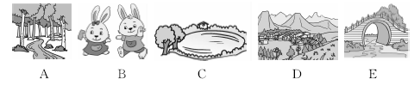

(　　) 1. There is a lake beside the house.

(　　) 2. There is a bridge over the river.

(　　) 3. There are many trees in the nature park.

(　　) 4. There are many mountains around the village.

(　　) 5. There are some rabbits in the forest.

四、选择合适的答语。(5分)

(　　) 1. Are there any tall buildings in the village?

(　　) 2. Where are the cows?

(　　) 3. How many people are there in your family?

(　　) 4. What's in the forest?

(　　) 5. Is there any juice in the bottle?

A. There are five. B. Yes, there is.

C. They are on the farm. D. No, there aren't.

E. There are many trees and animals.

五、看图，写出问句或答句。(10分)

1. —Are there three people in the car?

—________________________________________

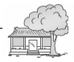

2. —________________________________________

—It's behind the tree.

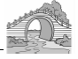

3. —What's over the river?

—________________________________________

4. —________________________________________

—Yes，there is.

5. —What can you see in the nature park?

—________________________________________

六、阅读理解。(10分)

There is a big nature park. In the park there is a forest and some mountains. On the mountains there are some flowers. There are many trees, too. There are two rivers in the park. What can you see in the rivers? Wow, there are many fish in the rivers. But we can't fish(钓鱼) or swim there. However, there are some boats. We can go boating. What a nice park!

根据短文内容，选择正确的答案。

(　　) 1. The nature park is ________.

A. small B. big C. quiet

(　　) 2. There are flowers and many ________ on the mountains.

A. trees B. houses C. villages

(　　) 3. There are ________ rivers in the park.

A. 4 B. 3

(　　) 4. We can ________ in the park.

A. go swimming B. go fishing C. go boating

(　　) 5. Are there any fish in the rivers?

A. I don't know. B. Yes, there are. C. No, there aren't.

七、看图写作文。(10分)

用there is或there are来描述右图。

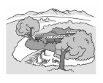____________________________ _

_______________________________ _

___________________________________

___________________________________

___________________________________

___________________________________



Unit 6综合能力测评

Part 2　Listening

听力材料：

一、1. Can you see a boat on the lake?

2. The rabbit is lovely.

3. The mountains are around the lake.

4. My family live in a house.

5. Many birds are in the tree.

二、1. There is a river in front of the house.

2. There are many buildings in the city.

3. There is a lake on the mountain.

4. There is a big tree behind the house.

5. They can see some animals.

三、1. There are some flowers in the park.

2. There is a village in front of the mountain.

3. Let's go to the forest.

4. There are many houses near the nature park.

5. There is a restaurant beside the lake.

四、1. Is there a new student in your class?

2. Are there any plants in your house?

3. Where are the cats?

4. How many fish can you see?

5. What's in your hand?

五、 Look! This is my village. There is a nature park beside my village. There are some houses in the nature park. You can see a big forest behind the village. There is a big lake in the forest. On the lake, you can see some ducks. In the lake, you can see some fish. In front of the village, there is a river. A bridge is over the river.

答案：

一、1. A　2. B　3. C　4. C　5. B

二、5　3　2　1　4

三、1. ×　2. ×　3. √　4. ×　5. √

四、1. A　2. B　3. B　4. C　5. B

五、1. A　2. E　3. B　4. D　5. C

Part 3　Reading and Writing

一、1. forest　2. mountains　3. trees　4. house　5. bridge

二、1. C　点拨：flowers为复数，be动词用are。

2. C　点拨：ducks为复数，可排除B。否定句中表示“一些”用any。

3. B　点拨：in the village在村子里。

4. B

5. A　点拨：in the park在公园里，由on the lake可知只有go boating符合语境。

三、1. C　2. E　3. A　4. D　5. B

四、1. D　2. C　3. A　4. E　5. B

五、1. No, there aren't.

2. Where is the house?

3. There is a bridge.

4. Is there a tree between the two houses?

5. I can see a hill (in the nature park).

六、1. B　2. A　3. C　4. C　5. B

七、范文：

Look at the picture. This is a small village. There are many trees around the village. There are some houses in the village. There is a river in front of the village. And there are two fish in the river. There are many mountains behind the village.