Unit 4过关检测卷

(40分钟　100分) 开始计时: ________

　第一部分　听力(30分)

一、听录音，选择相应的图片。(5分)

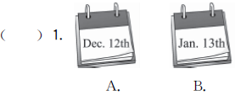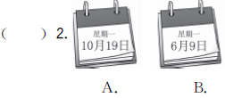

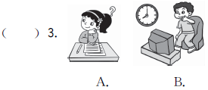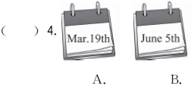

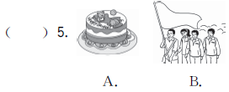

二、听录音，给下面的句子排序。(5分)

(　　) There are some special days in May.

(　　) The English test is on November 2nd.

(　　) The sports meet is on April 4th.

(　　) Miss White's birthday is on August 10th.

(　　) The kittens' eyes are open on April 16th.

三、听录音，判断下列句子与所听内容是(T)否(F)一致。(10分)

(　　) 1. The kittens are five days old.

(　　) 2. The kittens can play with a ball.

(　　) 3. I will cook noodles for my mum on her birthday.

(　　) 4. My cousin's birthday is on Mid­Autumn Day.

(　　) 5. We usually have a school trip in September.

四、听录音，在相应的月份段内打“√”。(10分)

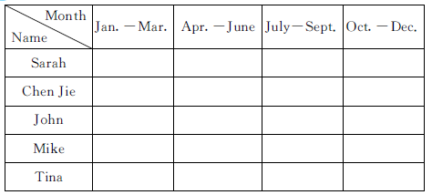

第二部分　笔试(70分)

五、火眼金睛圈不同。圈出不同类的一项。(5分)

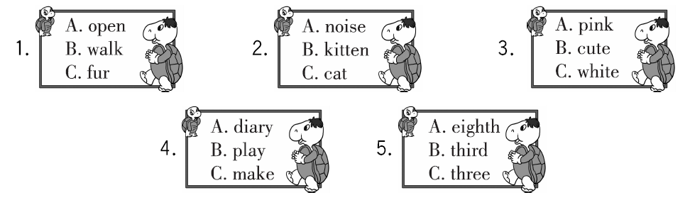

六、读句子，选择适当的单词填空。(5分)

1. He's ______________ () a birthday cake.

2. When is ______________ () friend's birthday?

3. China's National Day is ____________ () October.

4. When is Lily's____________ (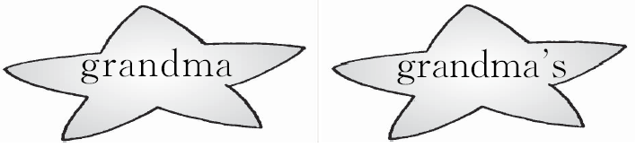) birthday?

5. There are ____________ () people in my family.

七、情景选择。(10分)

(　　) 1. 你想知道奶奶什么时候过生日，怎么询问?

A. When is your birthday? B. When is Grandma's birthday?

C. Grandpa's birthday is in June.

(　　) 2. 想用英语表达小猫们有白色的皮毛，怎么说?

A. They can walk now. B. They can play C. They have white fur.

(　　) 3. 你的生日在三月十二日，怎么用英语表达?

A. My birthday is on March 12th. B. My birthday is on April 26th.

C. It's on October 12th.

(　　) 4. 朋友问你愚人节在什么时候，你怎么回答?

A. It's on May 1st. B. It's on June 2nd. C. It's on April 1st.

(　　) 5. 怎么用英语表达“中国面条很美味。”?

A. I like Chinese food. B. Chinese noodles are delicious.

C. I don't like Chinese noodles.

八、(N) 根据可爱的蓝精灵们的对话，你知道今天是星期几吗？(10分)

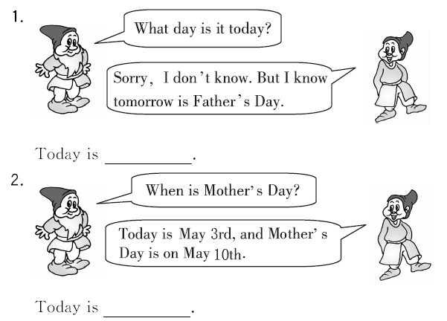

九、小山羊采蘑菇，选一选正确的答语。(10分)

 (　　)1. When is your father's birthday?

 (　　)2. Happy birthday, Mum!

 (　　)3. What do you usually do on your birthday?

 (　　)4. Let's watch TV together!

 (　　)5. When is Children's Day?

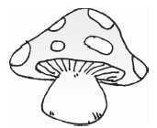A. I usually eat a birthday cake with my family.

 B. Great!

C. Thank you.

D. It's on March 6th.

E. It's on June 1st.

十、(N) 根据汉语提示完成句子。(10分)

1. 当它们饿的时候，它们会发出噪音。

They __________ __________ when they are hungry.

2. 它们是粉红色的，因为它们很小。

They are pink __________ they are very __________.

3. 运动会在什么时候？

When is the__________ __________?

4. 我的生日在4月12日。

My birthday is on __________ __________.

5. 你将为你的妈妈做什么？

__________ __________ you __________for your mother?

十一、连词成句。(10分)

1. a, cake, eat, will, also, family, my, birthday (. )

_______________________________________________________________________

2. 5th, year, this, on, is, it, April (. )

_______________________________________________________________________

3. Day, is, when, National, China's (？)

_______________________________________________________________________

4. can, now, kittens, the, walk (. )

_______________________________________________________________________

5. your, do, what, for, will, you, mum (？)

_______________________________________________________________________

十二、 阅读短文，回答问题。(10分)

 (建议用时：6分钟)

I'm Mary. I'm keeping my diary. Today is April 5th. It's my birthday. It's windy and warm. I get up at 6：20. After breakfast, I visit my grandparents. And then I climb mountains with my friends. In the afternoon, I watch TV and go shopping with my parents. My father and I like summer best, because we can swim. My mother likes spring best, because she likes to climb mountains. We are happy today.

1. When is Mary's birthday?

_______________________________________________________________________

2. What's the weather like today?

_______________________________________________________________________

3. What's Mary's favourite season?

_______________________________________________________________________

4. What does Mary do in the afternoon?

_______________________________________________________________________

5. Why does Mary's mother like spring?

_______________________________________________________________________

结束时间: ________

Unit 4过关检测卷

听力材料：

一、1. January the thirteenth　 2. October the nineteenth 3. maths test　 4. June the fifth

5. school trip

二、1. The kittens' eyes are open on April 16th.

2. The sports meet is on April 4th.

3. Miss White's birthday is on August 10th.

4. There are some special days in May.

5. The English test is on November 2nd.

三、1. The kittens are one month old.

2. The kittens can play with a ball.

3. I will make a birthday card for my mum on her birthday.

4. My cousin's birthday is on Mid­Autumn Day.

5. We usually have a school trip in September.

四、1. Sarah's birthday is on February 3rd.

2. Chen Jie's birthday is on November 11th.

3. John's birthday is on May 12th.

4. Mike's birthday is on August 1st.

5. Tina's birthday is on February 22nd.

答案：

一、1. B　2. A　3. A　4. B　5. B

二、4 5 2 3 1

三、1. F　2. T　3. F　4. T　5. T

四、

|  |  |  |  |  |
| --- | --- | --- | --- | --- |
| Month  Name | Jan. －Mar. | Apr. －June | July－Sept. | Oct. －Dec. |
| Sarah | √ |  |  |  |
| Chen Jie |  |  |  | √ |
| John |  | √ |  |  |
| Mike |  |  | √ |  |
| Tina | √ |  |  |  |

五、1. C　2. A　3. B　4. A　5. C

六、1. making　2. your　3. in　4. grandma's　5. nine

七、1. B　2. C　3. A　4. C　5. B

八、1. Saturday　2. Sunday

九、1. D　2. C　3. A　4. B　5. E

十、1. make noises　2. because; young　3. sports meet　4. April 12th　5. What will; do

十一、1. My family will also eat a birthday cake.

2. It is on April 5th this year.

3. When is China's National Day?

4. The kittens can walk now.

5. What will you do for your mum?

十二、1. It's on April 5th.

2. It's windy and warm.

3. Summer.

4. She watches TV and goes shopping with her parents.

5. Because she likes to climb mountains.