Unit 4综合能力测评

(40分钟　100分) 开始计时: ________

Part 1 Speaking说（25%）

一、跟读下面的词或短语。(10分)

1. dance 2. cook 3. swim 4. party 5. wonderful

6. learn 7. want 8. draw cartoons 9. play basketball

10. speak English

二、跟读下面的句子。(5分)

1. We'll have an English party next Tuesday.

2. What can you do for the party?

3. I have an English class at 3 o'clock.

4. Let's play ping­pong together.

5. I can sing and dance.

三、、跟读下面的对话。(10分)

**Mr Ma:** Good morning, children. Today we'll learn some kung fu.

**Children:** Cool!

**Mr Ma:** Can you do any kung fu, John?

**John:** Yes, I can.

**Mr Ma:** Wonderful! Can you do any kung fu, Oliver?

**Oliver:** No, I can't.

**Mr Ma**: No problem. I can help you.

Part 2 Listening听(25%)

一、听录音，根据你所听到的内容选出相应的图片。(5分)

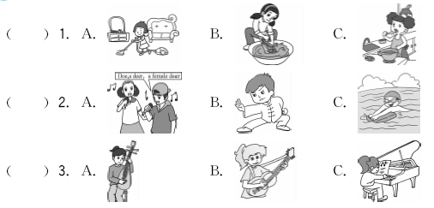

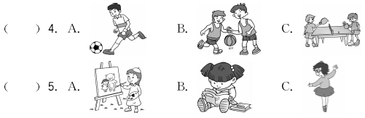

二、听录音，选出你所听到的句子。(5分)

(　　) 1. A. I can speak English. 　B. I can read English books.

C. I can sing English songs.

(　　) 2. A. Do you want a new basketball?

B. Do you like playing basketball?

C. Do you want to play basketball?

(　　) 3. A. I'm friendly. 　 B. I'm helpful. 　 C. I'm funny.

(　　) 4. A. Can she play ping­pong?

B. Can she play the pipa?

C. Can she play the piano?

(　　) 5. A. They can't play the erhu.

B. They can't do any kung fu.

C. They can't draw cartoons.

三、听录音，选择恰当的应答语。(5分)

(　　) 1. A. I can dance. B. I like ping­pong. C. I often watch TV.

(　　) 2. A. Yes, I am. B. Yes, I can. C. Yes, I do.

(　　) 3. A. That's all right. B. No, it's OK. C. Thank you.

(　　) 4. A. Yes, we will. B. Yes, there will. C. Yes, we can.

(　　) 5. A. I will do kung fu. B. I am Amy. C. I will go to the party.

四、听录音，选择适当的选项完成表格。(5分)

A. play the pipa 　B. dance　　　　 C. do kung fu

D. draw cartoons E. sing English songs



五、听录音，完成短文中所缺的单词。(5分)

Hello! My name is Chen Jie. I'm a 1. ________ girl. I often do housework at home. I can 2. ________ and clean the house. I have a brother. He can 3. ________ clothes. We often help our parents. On weekends, I go to the club to learn to play the 4. ________, and my brother goes to play 5. ________ with his friends. We're very happy.

Part 3 Reading and Writing读和写(50%)

一、判断下列每组单词画线部分读音是(√)否(×)相同。(5分)

(　　) 1. A. look B. good C. food

(　　) 2. A. dance B. any C. at

(　　) 3. A. send B. fresh C. every

(　　) 4. A. sing B. ice C. delicious

(　　) 5. A. wonderful B. Monday C. often

二、根据图片和首字母提示完成句中所缺单词。(5分)

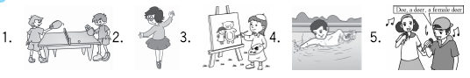1. 1. I often play p________ with Tom after school.

2. Lucy is a cute girl. She can sing and d________.

3. Can you draw c________?

4. My brother likes sports. He can s________.

5. Li Hong can sing English s________.

三、从方框中选择合适的词完成句子或对话。(5分)

any　speak　but　want　learn

1. I'm thirsty. I ________ some water.

2. —Can you see ________ pictures on the wall? —Yes, I can.

3. Robin can ________ Chinese and English.

4. —Let's ________ a new song today. —Great.

5. I can play basketball ________ I can't swim.

四、单项选择。(5分)

(　　) 1. Send me an email________lucy@urfriend.cn.

A. at B. about C. /

(　　) 2. —Can you draw cartoons? —No, I ________.

A. can B. can't C. don't

(　　) 3. Wang Yifan can play ________ piano.

A. a B. / C. the

(　　) 4. She can do________ kung fu.

A. some B. a C. any

(　　) 5. —I can't sing English songs.

—________. I can help you.

A. No problem B. Yes, please C. You're welcome

五、根据提示，将下列句子重新排列，组成一段对话。(5分)

(　　 ) We'll have an English party next Tuesday!

(　　 ) Wonderful! How about you, John?

(　　 ) Thank you, John.

(　　 ) What can you do for the party, children?

( 3 ) I can sing English songs.

(　　 ) I can do some kung fu!

六、连词成句。(5分)

1. any　Can　do　you　kung fu　(?)

_____________________________________________________________________

2. *pipa*　play　the　can't　I　(. )

_____________________________________________________________________

3. friendly　is　Mike　and　funny　(. )

_____________________________________________________________________

4. a　Do　friend　new　you　want　(?)

_____________________________________________________________________

5. football　can　play　She　(. )

_____________________________________________________________________

七、阅读理解。(10分)

I'm Kate. I can sing English songs and dance. I can't play the pipa or draw cartoons. She's Lily. She can play the pipa and cook. She can't swim. He's Henry. He can play basketball and sing English songs. He can't dance. We are all good friends.

(　　) 1. Kate can ________.

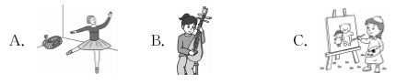

(　　) 2. Lily can ________.

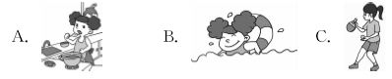

(　　) 3. ________can play basketball.

A. Kate B. Lily C. Henry

(　　) 4. ________can sing English songs.

A. Kate and Lily B. Lily and Henry C. Kate and Henry

(　　) 5. ________can play the *pipa* and cook.

A. Kate B. Lily C. Henry

八、假设你是Tom，根据表格中的内容写一写自己会做和不会做的事情。(10分)

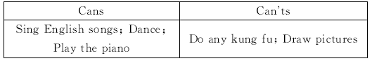　　 I'm Tom. I'm 11 years old. I can ________________________________________________________________________________________________________________________________________________

________________________________________ ________________________________________ ________________________________________ ________________________________________



Unit 4综合能力测评

Part 2　Listening

听力材料：

一、1. Sarah can cook.

2. Jon can sing English songs.

3. Mary can play the piano.

4. Mike can play basketball.

5. The little girl can draw cartoons.

二、1. I can speak English.

2. Do you want a new basketball?

3. I'm funny.

4. Can she play the pipa?

5. They can't do any kung fu.

三、1. What can you do for the party?

2. Can you play basketball?

3. You sing really well.

4. Will you have a party next Monday?

5. I will sing for the party. How about you?

四、We'll have an English party next Sunday. Lily can dance. Tom can do kung fu. Amy can sing English songs. Jim can draw cartoons. Mary can play the pipa.

五、**W:** Hello! My name is Chen Jie. I'm a helpful girl. I often do housework at home. I can cook and clean the house. I have a brother. He can wash clothes. We often help our parents. On weekends, I go to the club to learn to play the piano, and my brother goes to play basketball with his friends. We're very happy.

答案：

一、1. C　2. A　3. C　4. B　5. A

二、1. A　2. A　3. C　4. B　5. B

三、1. A　2. B　3. C　4. A　5. A

四、

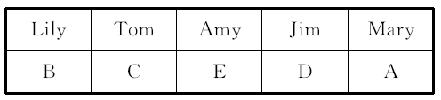

五、1. helpful　2. cook　3. wash　4. piano　5. basketball

Part 3　Reading and Writing

一、1. ×　2. ×　3. √　4. ×　5. ×

二、1. ping­pong　2. dance　3. cartoons

4. swim　5. songs

三、1. want　2. any　3. speak　4. learn　5. but

四、1. A

2. B　点拨：情态动词can的一般疑问句，否定回答为“No, sb. can't. ”。

3. C　点拨：“弹钢琴”为play the piano。

4. A　5. A

五、1　4　6　2　3　5

六、1. Can you do any kung fu?

2. I can't play the *pipa*.

3. Mike is friendly and funny.

4. Do you want a new friend?

5. She can play football.

七、1. A　2. A　3. C　4. C　5. B

八、范文：

I'm Tom. I'm 11 years old. I can sing English songs. I can dance. I can play the piano. But I can't do any kung fu. I can't draw pictures.