Unit 1过关检测卷

(40分钟　100分) 开始计时: ________

　第一部分　听力(30分)

一、听录音，给下面的图片排序。(5分)

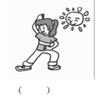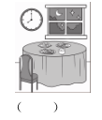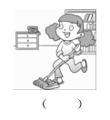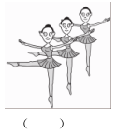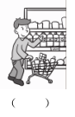

二、听录音，选一选正确的时间。(5分)

(　　) 1. 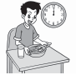 　 A. 10:30 a. m.

(　　) 2. 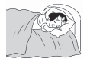 B. 7:30 a. m.

(　　) 3. 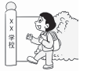 C. 9:00 p. m.

(　　) 4. 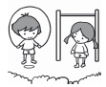 D. 12:00 a. m.

(　　) 5.  E. 9:00 a. m.

三、听录音，判断下列句子与所听内容是(T)否(F)相符。(10分)

(　　) 1. I often play football with my friends.

(　　) 2. Kate sometimes goes shopping with her mum on the weekend.

(　　) 3. I am always very busy on Wednesdays.

(　　) 4. Tina always gets up late in the morning.

(　　) 5. I need a robot to help me clean the room.

四、听录音，选择恰当的应答语。(10分)

(　　) 1. A. At 7 o'clock.

B. You are busy!

C. That's too late.

(　　) 2. A. I usually clean my room.

B. You need a robot to help you.

C. Because my mother worked last night.

(　　) 3. A. I often go shopping.

B. That sounds like a lot of fun.

C. I am so busy.

(　　) 4. A. Yes, it is.

B. No, it isn't.

C. Yes, I do.

(　　) 5. A. She finishes class in the morning.

B. She is in the playground.

C. She often plays ping­pong with her friends.

　　　第二部分　笔试(70分)

五、用你喜欢的颜色给不同类的单词涂色。(5分)

1. 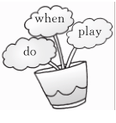 2. 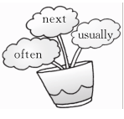3. 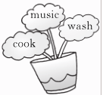

4. 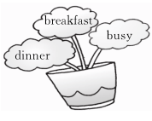5. 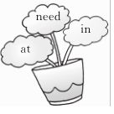

六、根据句意及首字母或汉语提示写单词。(5分)

1. I often eat b__________ at 7:30.

2. My father always goes for a w__________ after dinner.

3. Tom usually takes a __________ (舞蹈) class on the weekend.

4. —Do you like playing s__________?

—Yes, I do.

5. My mother often goes __________ (购物) in the afternoon.

七、单项选择我最棒！(5分)

(　　) 1. Let's __________ football together next weekend.

A. will play B. play C. playing

(　　) 2. —__________ do you do housework?

—I do housework at 4:00 pm.

A. What B. Who C. When

(　　) 3. He __________ goes shopping on Sunday.

A. is B. usually C. do

(　　) 4. I sometimes __________ at 6:00 am.

A. have B. goes shopping C. get up

(　　) 5. I always do morning exercises __________ the morning.

A. at B. in C. of

八、(N) 小熊熊空间更新了状态，你能根据提示用一句话概括出它的主要活动吗?(5分)



I usually __________ __________ __________ (上英语课)on Thursdays.

I usually __________ __________ (进行体育运动)with my friends on Tuesdays.

I usually __________ __________ __________ (打扫我的房间)on Saturdays.

I usually __________ __________ (打乒乓球)with Mr Monkey on Friday.

I usually __________ __________ __________ ________ (去散步)with my friends after dinner.

九、(N) 走迷宫。(10分)

同学们都在一起谈论周末常干什么，问到John时，他笑着拿出一张迷宫图说:“只有找出完整的句子，才能知道答案。”聪明的你知道John周末做什么吗?(用所给单词组成完整的句子)

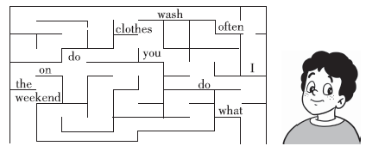

十、连词成句。(10分)

1. work, when, you, go, do, to (?)

_____________________________________________________________________

2. eat, you, do, when, dinner (?)

_____________________________________________________________________

3. watch, I, about, TV, 4:00, at (. )

_____________________________________________________________________

4. do, at, I, exercises, 8:30, morning, usually (. )

_____________________________________________________________________

5. in, when, you, morning, do, the, finish, class (?)

_____________________________________________________________________

十一、读一读，选一选，补全对话。(10分)

Mary: Hi, Jack! When do you get up?

Jack: 1. __________What about you?

Mary: At 6:30. When do you start class?

Jack: 2. __________When do you eat lunch?

Mary: Usually at 11:30. 3. __________

Jack: I often watch TV and read books. What about you?

Mary: 4. __________

Jack: That sounds like a lot of fun.

Mary: Yes. 5. __________

Jack: Great!

A. What do you do on the weekend? B. We always start class at 8 o'clock.

C. I usually get up at 6:40. 　D. I often play sports with my friends.

E. Let's play sports together next weekend.

十二、阅读短文，判断正(T)误(F)。(10分) (建议用时:6分钟)

This is Zhang Peng's day. He usually gets up at 6:00 in the morning. Then he does morning exercises at 6:20. He often eats breakfast at 7:00. Then he goes to school at 7:30. He has English, Chinese and maths class in the morning. He usually has music, art, PE and science class in the afternoon. He often plays sports after school. Sometimes he plays football. He goes home at 5:00. Then he watches TV. Sometimes he reads books. He does his homework at 7:00. He usually goes to bed at 9:00 in the evening.

(　　) 1. Zhang Peng eats breakfast at 7:30.

(　　) 2. Zhang Peng has English, Chinese and maths class in the morning.

(　　) 3. Usually Zhang Peng has Chinese class in the afternoon.

(　　) 4. Zhang Peng often does his homework at 7:00 pm.

(　　) 5. After school, Zhang Peng often plays sports.

十三小练笔。(10分)

以“My weekend”为题写一篇小作文，介绍平时你是怎样过周末的。

要求: 1. 条理清晰，语法正确。　2. 书写规范、认真。　3. 词数不少于50。

My weekend

_______________________________________________________________________________

_______________________________________________________________________________

_____________________________________________________________________________________________________________________________________________________________________________________________________________________________________________

结束时间: ________

Unit 1过关检测卷

听力材料:

一、1. go shopping　 2. clean the room　 3. have dinner 4. do morning exercises

5. take a dancing class

二、1. Bob has lunch at 12:00 a. m.

2. Mary goes to bed at 9:00 p. m.

3. Lei Lei goes to school at 7:30 a. m.

4. We have PE class at 10:30 a. m.

5. Linda reads some books at 9:00 a. m.

三、1. I often play ping­pong with my friends.

2. Kate sometimes goes shopping with her mum on the weekend.

3. I am always very busy on Thursdays.

4. Tina always gets up late in the morning.

5. I need a robot to help me wash the clothes.

四、1. When do you get up?

2. Why are you shopping today?

3. What do you do on Fridays?

4. Do you often play sports?

5. Where is Sarah?

答案:

一、4 3 2 5 1

二、1. D　2. C　3. B　4. A　5. E

三、1. F　2. T　3. F　4. T　5. F

四、1. A　2. C　3. A　4. C　5. B

五、1. when　2. next　3. music　4. busy　5. need

六、1. breakfast　2. walk　3. dancing　4. sports　5. shopping

七、1. B　点拨:Let's. . . 是提建议句型，意为“咱们……吧。”后面跟动词原形。

2. C　3. B　4. C　5. B

八、take English classes; play sports; clean my room; play ping­pong; go for a walk

九、—What do you do on the weekend?

—I often wash clothes.

十、1. When do you go to work?

2. When do you eat dinner?

3. I watch TV at about 4:00.

4. I usually do morning exercises at 8:30.

5. When do you finish class in the morning?

十一、1. C　2. B　3. A　4. D　5. E

十二、1. F　点拨:细节理解题。由短文中“He often eats breakfast at 7:00. ”可知，张朋在七点钟吃早饭。

2. T　点拨:细节理解题。由短文中“He has English, Chinese and maths class in the morning. ”可知，张朋在上午上英语、语文和数学课。

3. F　点拨:细节理解题。由短文中“He usually has music, art, PE and science class in the afternoon. ”可知，张朋下午上音乐课、美术课、体育课和科学课，没有语文课。

4. T　点拨:细节理解题。由短文中“He does his homework at 7:00. ”可知，张朋在下午七点钟做作业。

5. T　点拨:细节理解题。由短文中“He often plays sports after school. ”可知，张朋在放学后经常进行体育运动。

十三、One possible version:

My weekend

I often have a busy weekend. I usually get up at 7:00 am. On Saturdays, I do my homework from 9:00 to 11:00. In the afternoon I clean my room and wash clothes. I watch TV and read some books in the evening. On Sunday morning, I often take a dancing class. In the afternoon, I play sports with my brother. We have a lot of fun together.

I have nice weekends.