Unit 3综合能力测评

时间：40分钟　满分：100分

　Part1 Speaking说(15%)

一、跟读下列单词和短语。(5分)

1. went 2. fish 3. rode 4. hurt

5. ate 6. took 7. bought 8. gift

9. went camping 10. took pictures

二、跟读下面的句子。(5分)

1. I fell off my bike last Saturday and hurt my foot.

2. It looks like a mule.

3. We went to Sanya by plane.

4. I took lots of pictures，and I also went swimming.

5. We dressed up and made a funny play.

三、跟读下列对话。(5分)

**A**：Where did you go over your holiday?

**B**：I went to Guilin.

**A**：When did you come back?

**B**：Yesterday. Because my grandpa was ill.

**A**：I am sorry to hear that. How did you come back?

**B**：I came back by train.

Part2　Listening听(30%)

一、听录音，给下列图片用数字标号。(5分)

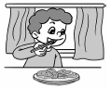  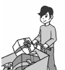 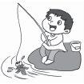 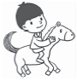

(　　) (　　) (　　) (　　) (　　)

二、听录音，圈出你所听到的单词。(5分)

1. I rode a (horse/bike) yesterday.

2. Andy hurt his (leg/foot).

3. Did you go to (Turpan/Harbin)?

4. Amy went (swimming/fishing) last weekend.

5. I ate some (fresh/delicious) food over the holiday.

三、听录音，给问句选择正确的答语。(10分)

A. I fell off my bike and hurt my foot.

B. I went to Sydney. 　　　　　C. We went by train.

D. It was good. E. He bought some gifts.

1. ________ 2. ________ 3. ________

4. ________ 5. ________

四、听录音，补全短文。(10分)

Last Sunday, I1. _____________________ with my family. We 2. ____________ in the lake. At noon, we 3. _________ near the lake. In the afternoon, we 4. ________ home. I fell off my bike and 5. ____________. It was a bad day but also a good day!

Part3 Vocabulary and Grammar

词汇与语法(35%)

一、选择合适的单词补全句子。(5分)

1. Amy ________(rides, rode) a horse last weekend.

2. ________(What, Where) did you go?

3. They won't be ready ________(till, to) August.

4. Can I see your pictures________________(sometime, sometimes)?

5. It ________(look, looks) like a duck.

二、读对话，选出与其意思相符的图片。(5分)

(　　) 1. —What happened？—I hurt my leg.

(　　) 2. —Where did you go over the winter holiday?

—We went to Sanya.

(　　) 3. —What did you do yesterday?

—I ate fresh food.

(　　) 4. —Who did you go to Beijing with?

—My mum.

(　　) 5. —Did you go to Shanghai by plane?

—No, we went to Shanghai by train.

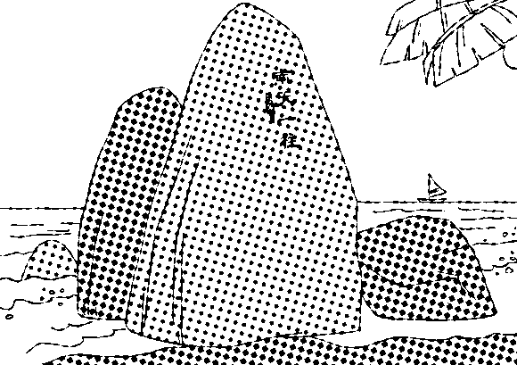 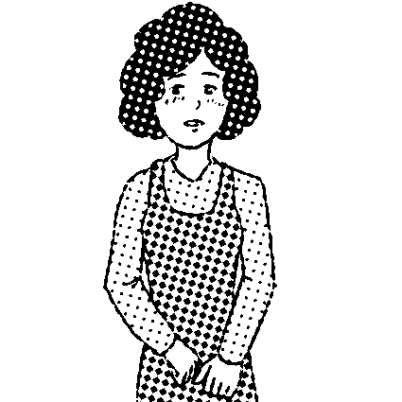 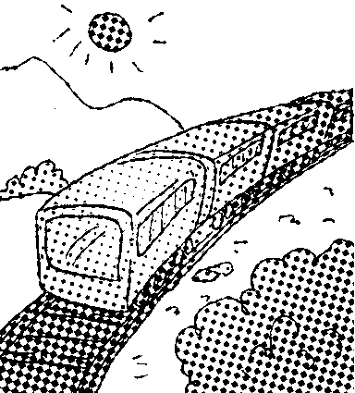 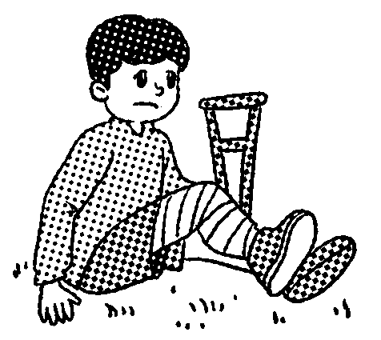 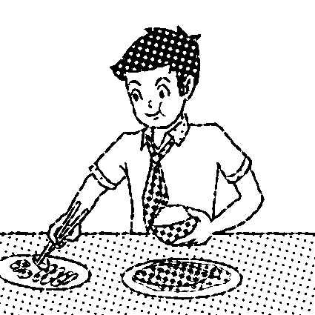

A B C D E

三、单项选择。(10分)

(　　) 1. She went swimming ________.

A. tomorrow　　 B. next day 　　 C. yesterday morning

(　　) 2. I ________ and ________ yesterday.

A. sang；dance B. sang；danced C. sing；danced

(　　) 3. —Where did you ________?

—I went to a park.

A. did B. do C. go

(　　) 4. — ________ did you go there?

—I went by bicycle.

A. How B. What C. Where

(　　) 5. —Hainan is far from here. How did you go there?

— ________

A. By foot. B. On subway. C. By plane.

四、完形填空。(5分)

Yesterday __1__ a sunny day. In the morning, we __2__ a bike for three people. Max sat in a basket on the front of the bike. That was fun. We __3__ pictures of the beautiful countryside. We bought some __4__ and __5__ some delicious food. We were all happy.

(　　) 1. A. was　　　　 B. were　　　　 C. is

(　　) 2. A. ride B. rode C. rides

(　　) 3. A. take B. take C. took

(　　) 4. A. gift B. gifts C. a gift

(　　) 5. A. ate B. eat C. eating

五、选择合适的句子补全对话。(10分)

**Ann**：1. ________

**Oliver**：I went to a park with my parents.

**Ann**：What did you do there?

**Oliver**：2. ________

**Ann**：3. ________

**Oliver**：Yes, Max sat in a basket on the front of the bike. He was very excited.

**Ann**：Did you do anything else?

**Oliver**：4. ________ 5. ________

**Ann**：It was great. I went to Tibet. It was so beautiful. I took lots of pictures.

A. Did Max go with you?

B. How was your holiday?

C. Where did you go over your holiday?

D. Yes, we ate good food and bought some gifts.

E. We rode a bike for three people.

Part4 Reading and Writing

读和写(20%)

一、阅读短文，回答问题。(10分) (建议用时：8分钟)

My name is Tim. I am twelve years old. I like singing. I am from Xi'an. My friend and I had a long holiday last month. We went on a trip. I went to Hangzhou with my parents by plane. We saw the West Lake. John is my brother. He is one year older than me. He went to Beijing by train. He visited the Summer Palace. Alice is my pen pal. She is from Canada. She lives in Chengdu now. She went to Hong Kong by plane. She ate good food and bought some beautiful clothes. Jim is one of my classmates. He went to Huangshan Mountain by train. He climbed the mountain. Jim and Alice are one year younger than me. We are going to a new middle school in September.

1. What did Tim do last month?

__________________________________________________________________

2. How old is John?

__________________________________________________________________

3. Did Alice go to Hong Kong by train?

__________________________________________________________________

4. What did Alice do in Hong Kong?

__________________________________________________________________

5. Where did Jim go?

__________________________________________________________________

二、根据图片提示，和大家说说你的假期生活吧！不少于6句话。(10分)

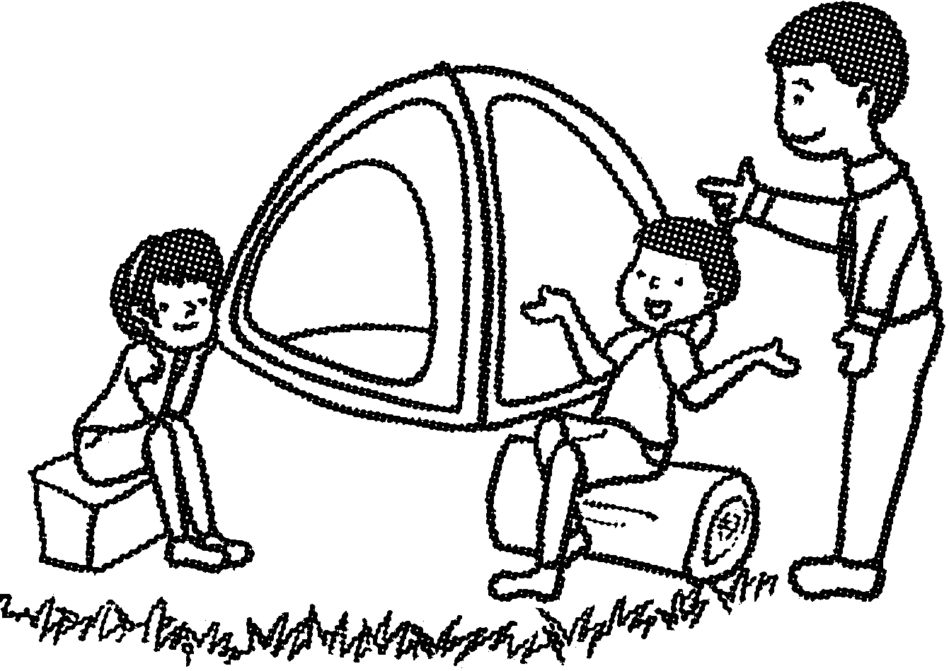　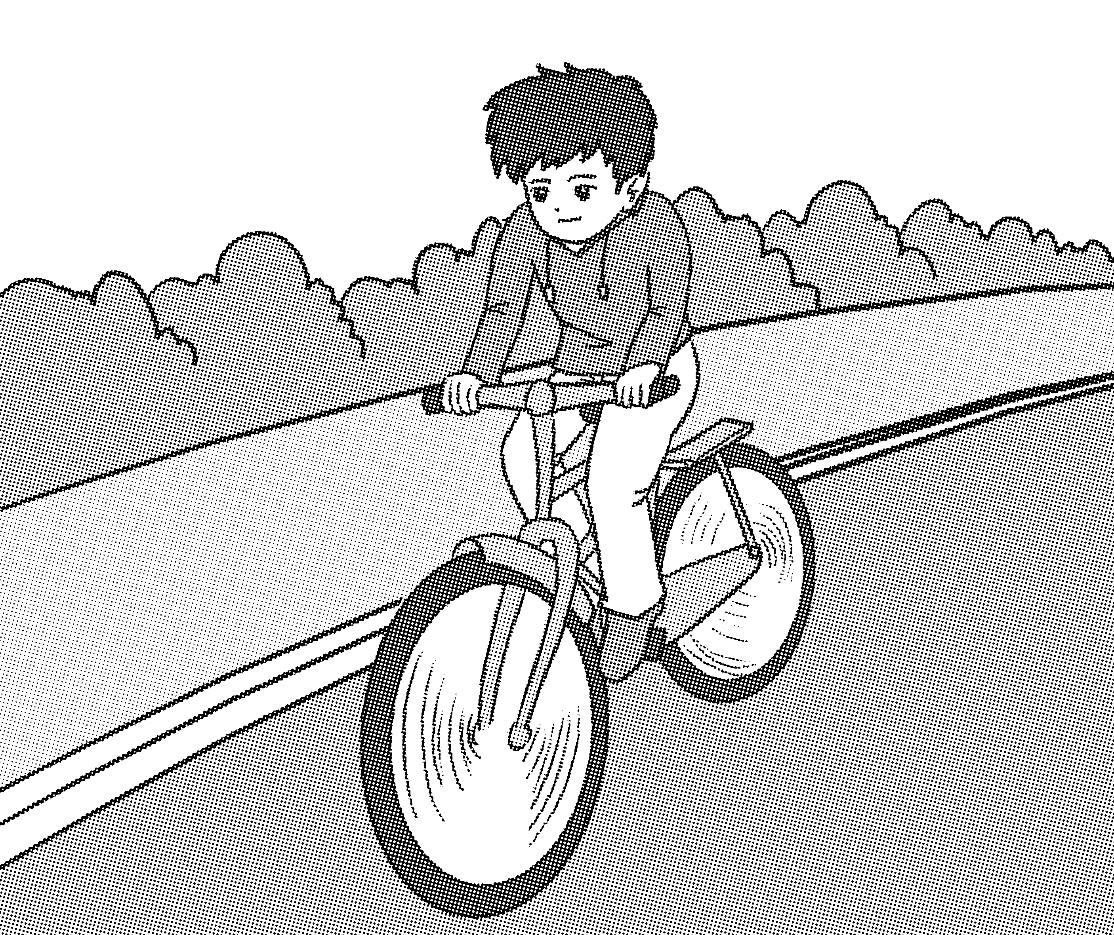　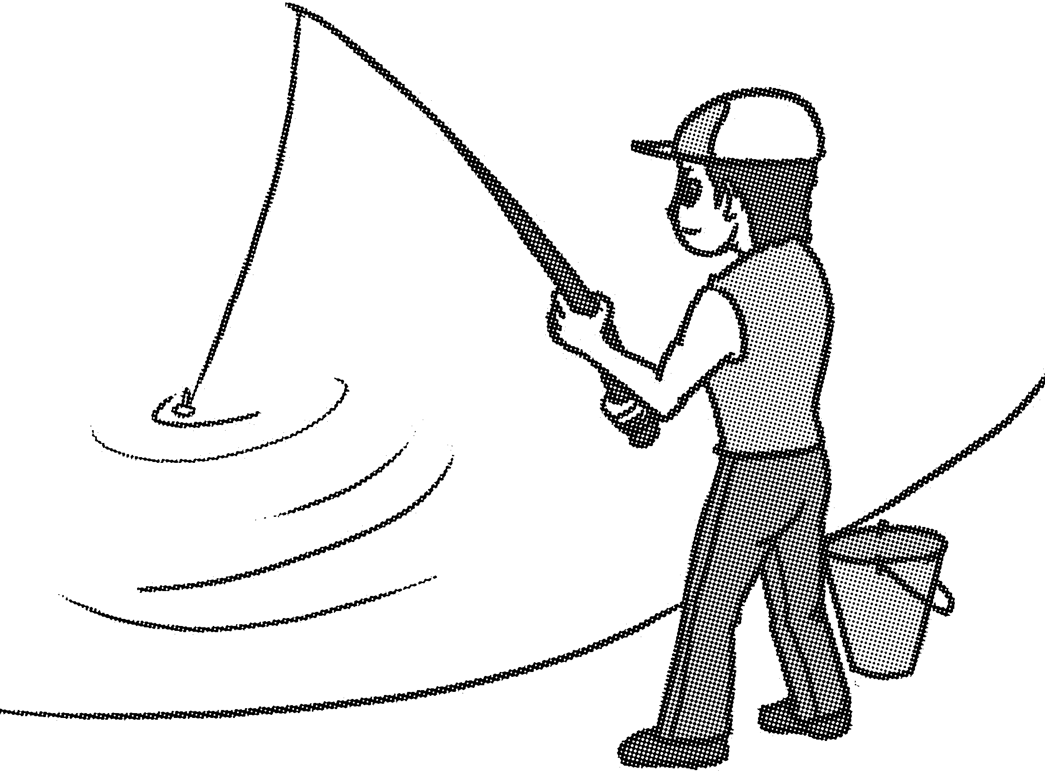　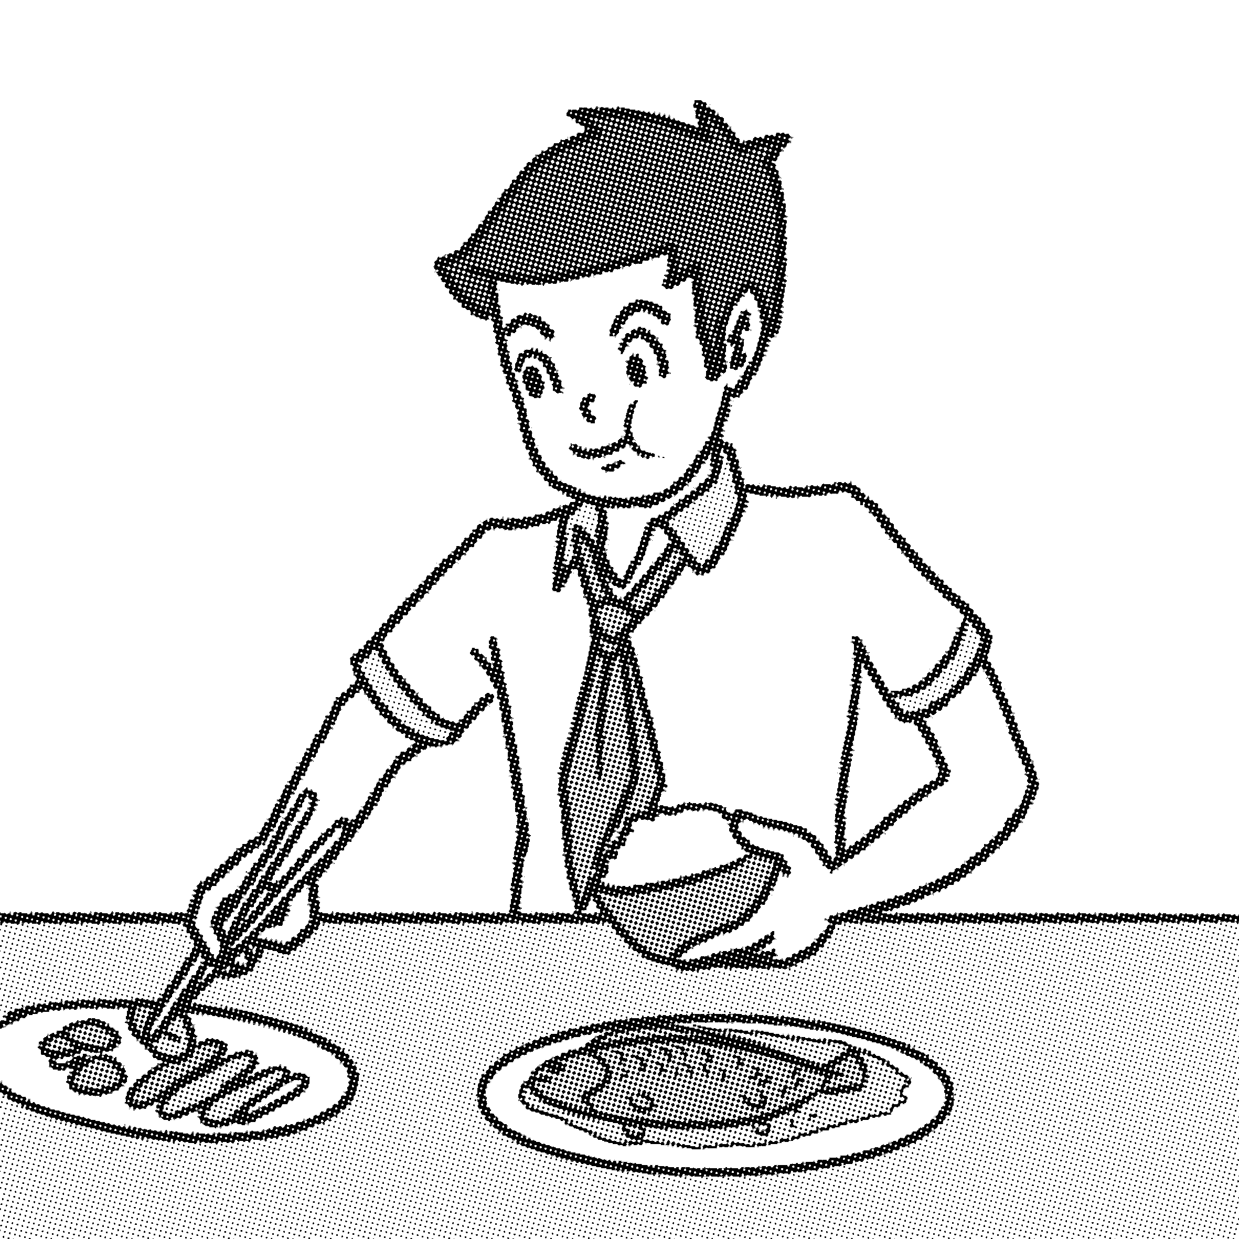　 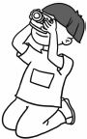

**My holiday**

I had a good time with my friends on my holiday. _________________________

_____________________________________________________________________

_____________________________________________________________________

_____________________________________________________________________

_____________________________________________________________________

Unit 3综合能力测评

Part 2　Listening 听

听力材料：

一、1. bought gifts

2. rode a horse

3. took pictures

4. ate fresh food

5. went fishing

二、1. I rode a horse yesterday.

2. Andy hurt his foot.

3. Did you go to Harbin?

4. Amy went swimming last weekend.

5. I ate some fresh food over the holiday.

三、1. How did you go to Shanghai?

2. Where did you go over your holiday?

3. What did John do last weekend?

4. How was your summer holiday?

5. What happened?

四、 Last Sunday, I went camping with my family. We went swimming in the lake. At noon, we ate fresh food near the lake. In the afternoon, we rode bikes home. I fell off my bike and hurt my foot. It was a bad day but also a good day!

答案：

一、4　3　1　5　2

二、1. horse　2. foot　3. Harbin 4. swimming　5. fresh

三、1. C　2. B　3. E　4. D　5. A

四、1. went camping　2. went swimming　3. ate fresh food

4. rode bikes 5. hurt my foot

Part 3　Vocabulary and Grammar

词汇与语法

一、1. rode　2. Where　3. till　4. sometime　5. looks

二、1. D　2. A　3. E　4. B　5. C

三、1. C　2. B　3. C　4. A　5. C

四、1. A　2. B　3. C　4. B　5. A

五、1. C　2. E　3. A　4. D　5. B

Part 4　Reading and Writing读和写

一、1. He went to Hangzhou and saw the West Lake.

2. He is 13 years old.

3. No, she went to Hong Kong by plane.

4. She ate good food and bought some beautiful clothes.

5. He went to Huangshan Mountain.

二、范文：

**My holiday**

I had a good time with my friends on my holiday. On Saturday we went camping and went fishing. On Sunday we went to the park. We rode a bike for three people in the park. We ate good food. And we took pictures near the lake. We were all happy. Tomorrow I'll go to school.