Unit 5综合能力测评

(40分钟　100分) 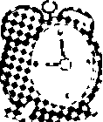开始计时: ________

　Part 1 Speaking说（25%）

一、跟读下面的单词或短语。(10分)

1. clock 2. plant 3. bottle 4. bike

5. photo 6. between 7. above 8. beside

9. behind 10. in front of

二、跟读下面的句子。(5分)

1. There is a big bed.

2. There are so many pictures here.

3. My father can draw very well.

4. What a nice photo!

5. What's in the room?

三、跟读下面的对话。(10分)

1. **A:** Where is the ball?

**B:** It's in front of the dog.

2. **A:** Where are the plants?

**B:** They are on the desk.

3. **A:** This is my room. There is a bed, a desk and. . .

**B:** Wow. Your room is really nice!

**A:** Thanks.

**B:** There is a computer on the desk. And there are so many pictures above the bed.

Part 2 Listening听(25%)

一、听录音，选出与你所听到的内容相符的图片。(5分)

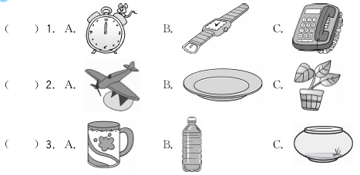

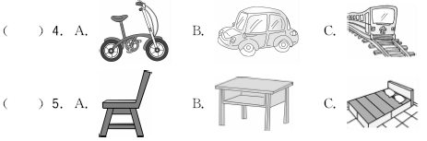

二、听录音，根据你所听到的内容，在方框中标出1、2、3……的顺序。(5分)

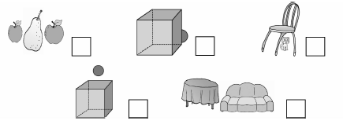

三、听录音，判断下列句子与你所听到的内容是(√)否(×)相符。(5分)

(　　) 1. There are some flowers in the room.

(　　) 2. There is a big tree in front of the house.

(　　) 3. The boy is between his parents.

(　　) 4. You can see some plants on the table.

(　　) 5. There is a mouse in the box.

四、听录音，选出你所听到的句子的正确答案。(5分)

(　　) 1. A. There is a bed. B. I have a bed. C. It's a bed.

(　　) 2. A. It's a photo. B. It's on the wall. C. I like the picture.

(　　) 3. A. I can play the erhu. B. There are some flowers.

C. I can see many flowers.

(　　) 4. A. There are two. B. You can see two. C. They're plates.

(　　) 5. A. Yes, they are. B. No, I don't. C. Yes, there are.

五、听录音，补全下面的短文。(5分)

My name is Peter. I have a big house. There is a garden 1. ________ the house. There are many vegetables 2. ________ the garden. There is a tree 3. ________ my house. There is a dog 4. ________ the tree. There are many plants 5. ________________ the house.

Part 3 Reading and Writing读和写(50%)

一、选出每组单词中不同类的一项。(5分)

(　　) 1. A. room B. desk C. chair

(　　) 2. A. clock B. watch C. plants

(　　) 3. A. garden B. water C. park

(　　) 4. A. house B. tree C. flower

(　　) 5. A. above B. photo C. behind

二、根据汉语提示完成句子。(5分)

1. Look at the ________(钟). It's time for class.

2. Do you often go to school by ________(自行车)?

3. There are two ________(相片) on the wall.

4. There is a balloon________(在……中间) us.

5. There are many trees ________(在……后面) the school.

三、读句子，选择正确的图片。(5分)

(　　) 1. The computer is on the desk.

(　　) 2. There is a tree in front of the house.

(　　) 3. The ball is above the dog.

(　　) 4. There is a plant in the room.

(　　) 5. There is a water bottle in my room.

    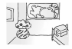

A B C D E

四、单项选择。(5分)

(　　) 1. There ________ so many pictures in the room.

A. is B. are C. am

(　　) 2. —________is the desk?

—It's beside the bed.

A. What B. Who C. Where

(　　) 3. I just moved________ a new house.

A. into B. between C. above

(　　) 4. My mother can draw very ________.

A. good B. well C. wonderful

(　　) 5. Come on! We're late________ school.

A. to B. from C. for

五、仿写句子。(10分)

例句：The ball is behind the door.

There is a ball behind the door.

1. The desk is behind the plant.

_____________________________________________________________________

2. The sofa is in the living room.

_____________________________________________________________________

3. Many flowers are in front of the house.

_____________________________________________________________________

4. Some photos are above the bed.

_____________________________________________________________________

5. The computer is on the desk in my bedroom.

_____________________________________________________________________

六、阅读短文，判断下列句子的正(T)误(F)。(10分)

Hi, I'm Jim. Welcome to my home. This is my living room. There are so many pictures here. My father can draw very well. There are many plants here too. They are my grandmother's plants. There is a big table in the middle of the living room. It's green. There are four chairs beside the table. They are yellow. There is a blue ball under the table.

(　　) 1. This is Jim's living room.

(　　) 2. There are many pictures and plants in the living room.

(　　) 3. The table is yellow.

(　　) 4. There are five chairs in the living room.

(　　) 5. The blue ball is under the table.

七、看图写作文。(10分)

假设这是你的卧室，请你用本单元所学的知识来描述一下。不少于5句话。

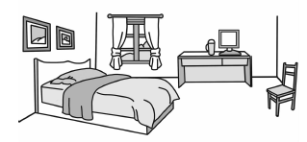

_____________________________________________________________________

_____________________________________________________________________

_____________________________________________________________________

_____________________________________________________________________

_____________________________________________________________________

_____________________________________________________________________



Unit 5综合能力测评

Part 2　Listening

听力材料：

一、1. There is a clock on the desk.

2. The plant is in the garden.

3. Would you like a bottle of water?

4. I often go to school by bike.

5. There is a bed in the room.

二、1. There is a ball behind the box.

2. The table is beside the sofa.

3. The pear is between two apples.

4. The ball is above the box.

5. There is a cat under the chair.

三、1. There are some pictures in the room.

2. There is a big tree behind the house.

3. The boy is between his parents.

4. You can see some plants on the table.

5. There is a mouse on the box.

四、1. What's in your bedroom?

2. Where's your picture?

3. What can you see?

4. How many plates are there?

5. Are there any fish?

五、**M:** My name is Peter. I have a big house. There is a garden behind the house. There are many vegetables in the garden. There is a tree beside my house. There is a dog under the tree. There are many plants in front of the house.

答案：

一、1. A　2. C　3. B　4. A　5. C

二、3　1　5　4　2

三、1. ×　2. ×　3. √　4. √　5. ×

四、1. A　2. B　3. C　4. A　5. C

五、1. behind　2. in　3. beside　4. under 5. in front of

Part 3　Reading and Writing

一、1. A　2. C　3. B　4. A　5. B

二、1. clock　2. bike　3. photos　4. between　5. behind

三、1. B　2. D　3. A　4. E　5. C

四、1. B　点拨：此句为there be句型。pictures为复数，故be动词用are。

2. C　点拨：提问位置，用疑问词where。

3. A　4. B

5. C　点拨：be late for school上学迟到。

五、1. There is a desk behind the plant.

2. There is a sofa in the living room.

3. There are many flowers in front of the house.

4. There are some photos above the bed.

5. There is a computer on the desk in my bedroom.

六、1. T　2. T　3. F　4. F　5. T

七、 This is my bedroom. There is a bed in it. There are two pictures on the wall. There is a desk and a chair. On the desk, there is a computer. There is a water bottle beside the computer. I like my bedroom .