Unit 4达标测试卷(A卷)

时间：40分钟　满分：100分

|  |  |  |  |  |  |  |  |  |  |  |  |  |  |
| --- | --- | --- | --- | --- | --- | --- | --- | --- | --- | --- | --- | --- | --- |
| 题　号 | 一 | 二 | 三 | 四 | 五 | 六 | 七 | 八 | 九 | 十 | 十一 | 十二 | 总　分 |
| 得　分 |  |  |  |  |  |  |  |  |  |  |  |  |  |



一、听录音, 标序号。(共10分)

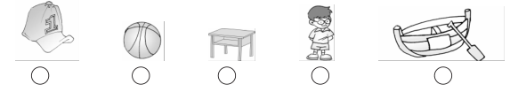

二、听录音, 选择正确的图片。(每小题2分, 共10分)

(　　) 1. A. 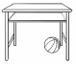 B. 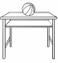

(　　) 2. A.  B. 

(　　) 3. A.  B. 

(　　) 4. A  B. 

(　　) 5. A. 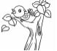 B. 

三、听录音, 判断所听内容与句意是否相符, 相符的在括号内画, 不相符的画 。(每小题2分, 共10分)

( ) 1. Look! The duck is in the bag.

( ) 2. Put your leg under your chair.

( ) 3. Drive a car.

( ) 4. Read a book.

( ) 5. Row a boat.

四、听对话, 连线。(每小题2分, 共10分)

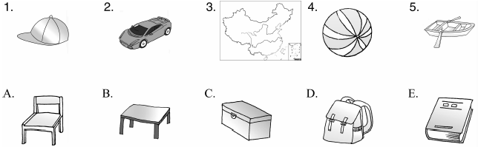



五、看图, 将单词和相应的图片连线。(每小题1分, 共5分)

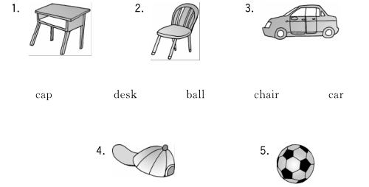

六、单项选择。(每小题1分, 共5分)

(　　) 1. —Where is my toy box？—________

A. It’s in the desk. 　 　B. Here you are. 　 　C. Thank you.

(　　) 2. —Let’s go to the zoo. —________

A. OK. B. Goodbye. C. Thanks.

(　　) 3. —Is it on the desk? —________

A. No, it isn’t. B. Yes, it isn’t. C. No, it is.

(　　) 4. —Where is your ________? —It's in my pencil box.

A. cap B. chair C. pen

(　　) 5. —Where ________your bags？—Under the table.

A. is B. are C. am

七、读句子, 选择正确的图片。(每小题2分, 共10分)

(　　) 1. My kite is under the tree(树) .

A. 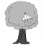 B. 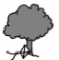

(　　) 2. Your bag is in the desk.

A.  B. 

(　　) 3. My brother's ball is on the chair.

A.  B. 

(　　) 4. My pencil is in the box.

A.  B. 

(　　) 5. Put the car in the box.

A.  B. 

八、看图, 根据图片选择合适的短语补全下列对话, 将其序号填在横线上。(每小题1分, 共5分)

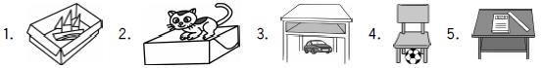

A. on the desk　B. under the desk　C. in the box　D. on the box　E. under the chair 1. A：Where is my boat? B：It’s ________.

2. A：Where is the cat? B：It’s ________.

3. A：Where is your car? B：Let me see. Oh, it’s ________.

4. A：Where is the ball? B：It’s ________.

5. A：Where is my ruler? B：It’s ________.

九、根据情境选择恰当的答句。(每小题2分, 共10分)

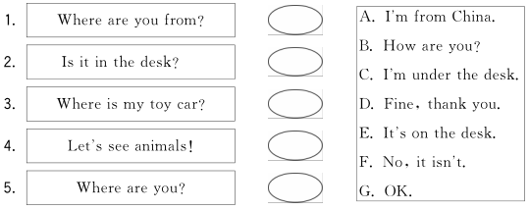

十、情景交际。(每小题1分, 共5分)

(　　) 1. 当你问钢笔是不是在桌子里时, 你应说：

A. Do you have a pen? B. Is your pen in the desk? C. Where is your pen?

(　　) 2. 你找不到你的书包了, 去问妈妈, 你应说：

A. Where is my ruler, Mum? B. I can’t find my pen. C. Mum, where is my bag?

(　　) 3. 当别人猜某物在某个地方, 你觉得是个不错的猜测, 你应说：

A. Sure. Here you are. B. Thank you. C. Good guess.

(　　) 4. 某物在铅笔盒里, 应说：

A. It is on the pencil box. B. It is in the pencil box. C. It is under the pencil box.

(　　) 5. 当你想和汤姆一起回家时, 你应说：

A. Let’s go to bed. B. Welcome back home. C. Let's go home.

十一、连词成句(只填序号) 。(每小题2分, 共10分)

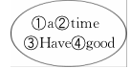1. ________ ________ ________ ________!

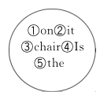2. ________ ________ ________ ________ ________?

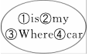3. ________ ________ ________ ________?

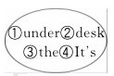4. ________ ________ ________ ________.

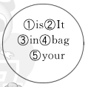5. ________ ________ ________ ________ ________.

十二、根据短文内容, 将物品下的序号填入相应的圈内。(每小题2分, 共10分)

Look at the picture(图画) . I have a pen. It’s in the boat. I have a ball. It’s under the desk. And I have a car. It’s in the bag. My cap is on the chair. Where’s my kite(风筝) ? Oh, it’s on the desk.

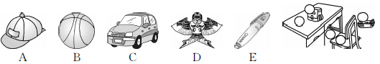

Unit 4达标测试卷(A卷)

听力材料：

一、1. This is a boat. 2. This is a ball. 3. This is a boy. 4. This is a cap. 5. This is my desk.

二、1. The ball is under the desk.

2. The dog is on the box.

3. The pen is under the bag.

4. The cat is on the chair.

5. The book is in the desk.

三、1. Look！The duck is on the box.

2. Put your foot under your chair.

3. Drive a car.

4. Read a map.

5. Row a boat.

四、1. M：Where is my cap? W：It's on the desk.

2. M：Where is my toy car? W：It's in the box.

3. M：Where is my map? W：It's on the book.

4. M：Where is my ball? W：It's on the bag.

5. M：Where is my boat? W：It's under the chair.

**Keys**：

一、4 2 5 3 1

二、1. A　2. A　3. A　4. B　5. B

三、1.  　2. 　  3. 　4.  5. 

四、1—B　2—C　3—E　4—D　5—A

笔试答案

五、1—desk　2—chair　3—car　4—cap　5—ball

六、1. A点拨:问句询问的是哪里, 回答的应该是地点, 故选A。

2. A

3. A点拨:由Is it开头的一般疑问句, 肯定回答用“Yes, it is. ”, 否定回答用“No, it isn't. ”。

4. C点拨：三个选项中只有pen“钢笔”可以放在文具盒里, 帽子和椅子都不可以, 故选C。

5. B点拨：由your bags可知要用复数形式, 故选B。

七、1. B　2. A　3. B　4. B　5. A

八、1. C　2. D　3. B　4. E　5. A

九、1. A　2. F　3. E　4. G　5. C

十、1. B　2. C　3. C　4. B　5. C

十一、1. ③①④②　2. ④②①⑤③ 3. ③①②④　4. ④①③②　5. ②①③⑤④

十二、