Unit 4达标测试卷

时间：40分钟　满分：100分



一、听录音，选出你所听到的选项。(10分)

(　　) 1. A. Mm B. Nn C. Ll

(　　) 2. A. Gg B. Jj C. Kk

(　　) 3. A. bird B. bag C. blue

(　　) 4. A. mouth B. monkey C. mum

(　　) 5. A. egg B. elephant C. ice cream

二、听录音，选出你所听到的句子。(10分)

(　　) 1. A. Look at my bear. B. Look at my ear.

(　　) 2. A. It's a pig. B. It's big.

(　　) 3. A. I have a duck. B. I like a duck.

(　　) 4. A. What's that? B. What's this?

(　　) 5. A. Act like a dog. B. Act like a duck.

三、听录音，根据每个人所喜欢的动物，在表格相应位置打“√”。(10分)

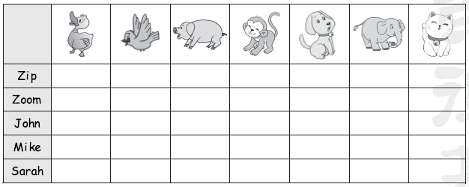四、听录音，判断答语与所听内容是(T)否(F)对应。(10分)

(　　) 1. It's a monkey.

(　　) 2. No, it's a panda.

(　　) 3. OK!

(　　) 4. How are you?

(　　) 5. Me, too.



五、写出下列字母的相邻字母的大写或小写形式。(8分)

1. ____m__ 2. ____j____ 3. ____l____ 4. ____i____

5. ____K___ 6. ____ ____N 7. H____ ___ 8. L________

六、选出与画线单词同类的选项，将序号写在括号中。(5分)

(　　) 1. What's this?

A. that B. an C. long

(　　) 2. It's a pig.

A. leg B. milk C. duck

(　　) 3. Look at the jeep.

A. cool B. in C. dog

(　　) 4. Act like a bird.

A. leg B. nose C. make

(　　) 5. It is big.

A. fat B. kite C. noodles

七、给下列单词分类，将序号写在横线上。(12分)

A. fat　　B. wave　　C. act　　D. big　　E. nice　　F. fine

G. I　 H. long　 I. look　 J. jump　 K. it 　 L. follow

1. funny_______________________________________________________

2. make_______________________________________________________

3. you________________________________________________________

八、看图，根据句意补全单词。(5分)

1. I like the ____ o________ey. 

2. Look! A ________t. 

3. The b____r____ is blue! 

4. This is a p________da. 

5. Follow the ____o____. 

九、单项选择。(5分)

(　　) 1. Follow ______.

A. me B. I C. my

(　　) 2. ______ the monkey.

A. Looks B. Look C. Look at

(　　) 3. —What's that?

—______

A. It's a dog. B. I'm fine. C. I see a dog.

(　　) 4. —Look! A duck.

—______

A. Sorry. B. Cool! I like it. C. It's a duck.

(　　) 5. —It's a panda. I like it.

—______

A. No. B. Bye. C. Me, too.

十、判断句子与图片是(√)否(×)相符。(5分)

(　　) 1. Quack, quack! This is a duck. 

(　　) 2. Act like a tiger. 

(　　) 3. Let's go to the zoo. 

(　　) 4. Look at the pig. It is fat. 

(　　) 5. The bear is on the truck. 

十一、连词成句，将序号写在横线上。(10分)

1. ①Act　②an　③like　④elephant

_____________________________________________________________.

2. ①like　②dogs　③I

_____________________________________________________________.

3. ① It's　②bear　③ a

_____________________________________________________________.

4. ① this　②What　③ is

____________________________________________________________?

5. ①at　②the　③cat 　④Look

_____________________________________________________________.

十二、给下列句子排序。(5分)

　　　　　A. A cat?　　　　　　　　　B. Wow, it's funny! I like it!

C. No! It's a panda. D. Thanks.

E. What's that? F. Guess!

______　　__F__　　______　　______　　______　　______

十三、读一读，将人物与对应的图片连线。(5分)

Hello, I'm Sarah. I have a bear. It's brown. It has (有) black eyes.

Hello, I'm Wu Yifan. I have an elephant. It's big. It has a long nose.

Hello, I'm John. I have a tiger. It's a funny tiger.

Hello, I'm Mike. I have a monkey. It is in the bag.

Hello, I'm Amy. I have a pig. It's very fat.

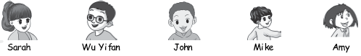

Unit 4达标测试卷

听力材料：

一、1. Nn　2. Jj　3. bird　4. monkey　5. ice cream

二、1. Look at my bear!

2. It's a pig.

3. I like a duck.

4. What's this?

5. Act like a dog.

三、1. I'm Zip. I like a cat.

2. I'm Zoom. I like a pig.

3. I'm John. I like a bird and a dog.

4. I'm Mike. I like a duck and a monkey.

5. I'm Sarah. I like an elephant.

四、1. What's that?

2. This is a panda.

3. Act like a tiger.

4. How are you, Mr Cat?

5. I like the bear.

答案：

一、1. B　2. B　3. A　4. B　5. C

二、1. A　2. A　3. B　4. B　5. A

三、

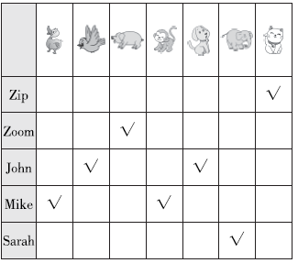

四、1. T　2. F　3. T　4. F　5. T

五、1. l　n　2. i　k　3. k　m　4. h　j

5. J　L　6. L　M　7. I　J　8. M　N

六、1. A　2. C　3. B　4. C　5. A

七、1. A　D　E　F　H

2. B　C　I　J　L

3. G　K

八、1. m；n；k　2. c；a　3. i；d 4. a；n　5. d；g

九、1. A

2. C 点拨：look at 是固定搭配，翻译为“看……”，当表达“看某物”时，look后要加上at。

3. A 　4. B　5. C

十、1. √

2. × 点拨：like是介词，翻译为“像……一样”。

3. √　4. × 　5. √

十一、1. ①　③　②　④

2. ③　①　②

3. ①　③　②

4. ②　③　①

5. ④　①　②　③

十二、E　F　A　C　B　D

十三、

