Unit 1达标测试卷(A卷)

时间：40分钟　满分：100分

|  |  |  |  |  |  |  |  |  |  |  |  |  |
| --- | --- | --- | --- | --- | --- | --- | --- | --- | --- | --- | --- | --- |
| 题　号 | 一 | 二 | 三 | 四 | 五 | 六 | 七 | 八 | 九 | 十 | 十一 | 总　分 |
| 得　分 |  |  |  |  |  |  |  |  |  |  |  |  |



一、听录音，选出你所听到的单词或短语。(5分)

(　　) 1. A. teacher's desk B. teachers' office C. teachers

(　　) 2. A. way B. library C. hungry

(　　) 3. A. first B. ruler C. sister

(　　) 4. A. computer room B. music room C. art room

(　　) 5. A. wall B. floor C. four

二、听录音，判断下列图片与你所听内容是() 否() 一致。(5分)

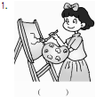 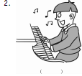 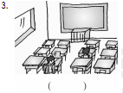

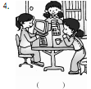 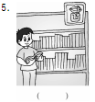

三、听录音，给下面的句子排序。(10分)

(　　) It's the computer room.

(　　) Do you have an art room?

(　　) It's on the second floor.

(　　) It's the teachers' office.

(　　) This is my classroom.

四、听录音，选择正确的选项填空。(10分)

1. The ________ is on the first floor.

2. Let's go to the ________.

3. Do you have a ________?

4. It's the ________.

5. This is our ________.

A. classroom B. teachers' office C. playground

D. library E. computer room

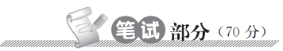

五、朗读句子，从中找出含有与例词画线部分相同读音的单词。(10分)

1. I have a ruler.

2. The computer room is on the second floor.

3. What would you like for dinner?

4. My father is strong.

5. John is a teacher.

river　________　________　________　________　________

六、单词宝宝失窃了，快帮黑猫警长把罪犯抓捕归案，让丢失的字母完璧归赵吧！(10分)

1. f____rst　2. s____cond　3. lib____ary　4. c____mputer　5. m____sic

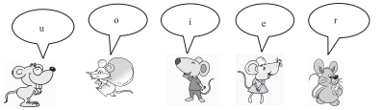

A. 　 B. 　 C. 　 D. 　 E.

1. ________　2. ________　3. ________　4. ________　5. ________

七、选词填空。小老虎当司机，把单词宝宝送回家。(10分)

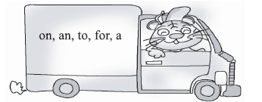

1. The teachers' office is next ________ the library.

2. Do you have ________ art room?

3. I have ________ computer room.

4. It's time ________ lunch.

5. It is ________ the first floor.

八、小兔子采蘑菇。单项选择我最棒！(10分)

(　　) 1. Is that the ________ office？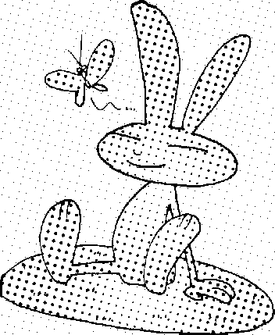

teacher teachers teachers'

(　　) 2. Welcome ________ our school. 

at to 　　　 in

(　　) 3. We ________ books in the library. 

eat 　　　 play 　　　 read

(　　) 4. —________ is your classroom? 

—It's on the second floor.

Where 　　　What 　　　 Who

(　　) 5. This ________ the computer room. 

am 　　　 is 　　　 are

九、小小解说家。给下面的图片配音。(10分)

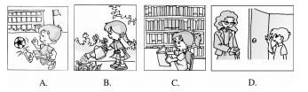

(　　) 1. Go to the library. Read a book.

(　　) 2. Go to the teachers' office. Say hello.

(　　) 3. Go to the playground. Play football.

(　　) 4. Go to the garden. Water the flowers.

十、情景交际。(10分)

(　　) 1. 欢迎朋友来你们学校参观时，你应该说：

A. Welcome to our school. B. It is the school.

(　　) 2. 当你为别人引路时，你应该说：

A. It is on the first floor. B. This way，please.

(　　) 3. 当别人赞美你的学校时，你应该说：

A. No, you're wrong. B. Thank you.

(　　) 4. 图书管理员告诉同学们要保持安静时，她可以说：

A. Be quiet in the library. B. Don't eat in the library.

(　　) 5. 当你想知道教师办公室在哪里时，你应该说：

A. Do you have a teachers' office? B. Where's the teachers' office?

十一、（新型题）Amy在向同学们作介绍**，**你知道下面哪幅图片是Amy介绍的地方吗？根据他们的对话**，**选一选。(10分)

(　　) 1. **Mary:** Is this a desk?

**Amy:** Yes，it is.

**Linda:** What's on it?

**Amy:** Let's go and have a look.

**Mike:** Is this a TV?

**Amy:** No, it's a computer.

**Zhang Peng:** Oh, so many computers!

(　　) 2. **Amy:** This is my school.

**Linda:** Is that the playground?

**Amy:** Yes, it is.

**Mary:** Let's go to the playground.

**Mike:** Let's play football.

**Zhang Peng:** Great！

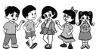

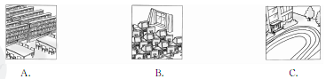

Unit 1 达标测试卷(A卷)

听力材料：

一、1. teachers' office　2. library　3. first 4. art room　5. floor

二、1. Linda is in the art room.

2. Mike is in the computer room.

3. This is our classroom.

4. Go to the playground. Play football.

5. Go to the library. Read a book.

三、1. Do you have an art room?

2. This is my classroom.

3. It's the computer room.

4. It's on the second floor.

5. It's the teachers' office.

四、1. The library is on the first floor.

2. Let's go to the playground.

3. Do you have a computer room?

4. It's the teachers' office.

5. This is our classroom.

Keys：

一、1. B　2. B　3. A　4. C　5. B

二、1. 　2. 　3.  4. 　5. 

三、3 1 4 5 2

四、1. D　2. C　3. E　4. B　5. A

五、ruler　computer　dinner　father　teacher

六、1. C　2. D　3. E　4. B　5. A

七、1. to　2. an　3. a　4. for　5. on

八、1. C,[点拨] 本题考查名词所有格。teachers' office“教师办公室”。以“s”结尾的名词后加“'”表示“……的”。

2. B 3. C

4. A,[点拨] 本题考查疑问词的辨析。由答语句意“它在二楼。”可知，问句是对地点提问。对地点提问用疑问副词where。

5. B

九、1. C　2. D　3. A　4. B

十、1. A　2. B　3. B　4. A　5. B

十一、1. B,[点拨] 根据对话中出现的“so many computers”，可以推断是computer room, 即计算机房。

2. C,[点拨] 根据对话中出现的“Let's go to the playground. ”，可以推断是操场。