Unit 4达标测试卷(A卷)

时间：40分钟　满分：100分

|  |  |  |  |  |  |  |  |  |  |  |  |  |
| --- | --- | --- | --- | --- | --- | --- | --- | --- | --- | --- | --- | --- |
| 题　号 | 一 | 二 | 三 | 四 | 五 | 六 | 七 | 八 | 九 | 十 | 十一 | 总　分 |
| 得　分 |  |  |  |  |  |  |  |  |  |  |  |  |



一、 听录音，选出你所听到的单词。(5分)

(　　) 1. A. house B. horse C. nice

(　　) 2. A. eat B. art C. get

(　　) 3. A. London B. hen C. garden

(　　) 4. A. these B. class C. those

(　　) 5. A. careful B. animal C. girl

二、听录音，判断下列图片与你所听内容是(T) 否(F) 一致。(5分)

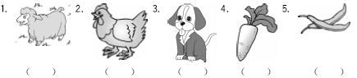

三、听录音，给下面的句子排序。(10分)

(　　) They are hens. I like them.

(　　) They love carrots.

(　　) Those green beans are over there.

(　　) This is a vegetable garden.

(　　) These sheep are so cute.

四、听录音，选择小朋友们喜欢的动物。(10分)

(　　) 1. Mike A. 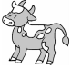

(　　) 2. John B. 

(　　) 3. Linda C. 

(　　) 4. Mary D. 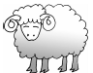

(　　) 5. Sarah E. 

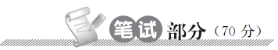

五、看一看，连一连。小火车就要出发了，快帮单词宝宝登火车吧。(10分)

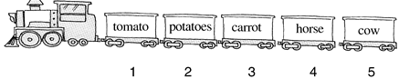

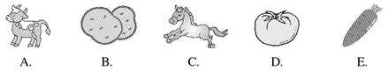

六、快来给我做裁判，同类的标，不同类的标。(10分)

(　　) 1. 

(　　) 2. 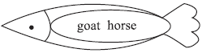

(　　) 3. 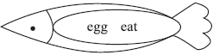

(　　) 4. 

(　　) 5. 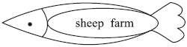

七、选词填空。帮小鸟将信封放到合适的房子里。(10分)

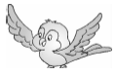



1. I can see a lot ________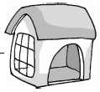 animals.

2. Look ________ the green beans.

3. These sheep are ________ cute.

4. I can see some hens. What ________ you?

5. There are many vegetables ________ the farm.

八、单项选择我最棒！(10分)

(　　) 1. —How ________ cows are there?

—Eight.

A. many B. old C. much

(　　) 2. —________ these hens?

—Yes, they are.

A. Am B. Is C. Are

(　　) 3. Ride a ________.

A. hen B. horse C. duck

(　　) 4. The farm is ________ big.

A. much B. so C. many

(　　) 5. I see five ________.

A. a sheep B. sheeps C. sheep

九、对号入座，找出下列句子正确的应答语。(10分)

A. I have a lot of animals. B. No，they aren't.

C. They are goats. D. Seventeen.

(　　) 1. What are these?

(　　) 2. Are they sheep?

(　　) 3. How many horses do you have?

(　　) 4. What do you have?

十、阅读短文，判断对(√)错(×)。(10分)

My grandpa has a farm. The farm is so big. Let's have a look! There are twelve horses, thirteen cows and forty hens. My grandpa likes tomatoes very much. There are many tomatoes on the farm. Look! They are red. They are very beautiful. It's a sunny day on the farm today.

(　　) 1. My grandpa has a big farm.

(　　) 2. There are thirteen horses.

(　　) 3. The tomatoes are green.

(　　) 4. My grandpa likes tomatoes very much.

(　　) 5. It's rainy on the farm today.

十一、(新型题) 仔细想一想，然后选择正确的答案。(10分)

亮亮周末去放羊，贪玩的他，只顾着捉蝴蝶，而忘了看管羊儿，回家后，发现少了一只sheep，你能帮他找回丢失的羊吗？

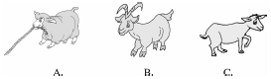

答案：________________________________________________________________________

Unit 4 达标测试卷(A卷)

听力材料：

一、 1. horse　2. eat　3. garden 4. those　5. animal

二、1. sheep　2. hen　3. horse 4. green beans　5. tomato

三、1. This is a vegetable garden.

2. They are hens. I like them.

3. They love carrots.

4. These sheep are so cute.

5. Those green beans are over there.

四、There are many animals at the farm. They are so cute. Mike likes goats. John likes cows. Linda likes hens. Mary likes horses. Sarah likes sheep.

Keys：

一、1. B　2. A　3. C　4. C　5. B

二、1. T　2. T　3. F　4. F　5. F

三、2 3 5 1 4

四、1. E　2. A　3. C　4. B　5. D

五、1. D　2. B　3. E　4. C　5. A

六、1. 　2. 　3.  4. 　5. 

七、1. C　2. A　3. E　4. B　5. D

八、1. A,[点拨] How many用来提问可数名词数量的多少；How old用来提问年龄；How much用来提问不可数名词数量的多少或物品的价钱。由答语句意“八头。”可知，提问的是可数名词数量的多少。

2. C,[点拨] 此题考查be动词的用法。当主语为复数时，be动词用are；当主语为单数时，be动词用is；当主语为I时，be动词用am。

3. B,[点拨] ride a horse 意为“骑马”。

4. B

5. C,[点拨] 五只绵羊，sheep用复数形式，sheep的复数形式为sheep。

九、1. C　2. B　3. D　4. A

十、1. √,[点拨] 细节理解题。由短文中“The farm is so big. ”可知，农场很大。

2. ×,[点拨] 细节理解题。由短文中“There are twelve horses. . . ”可知，农场有12匹马。

3. ×

4. √,[点拨] 由短文中“My grandpa likes tomatoes very much. ”可知爷爷非常喜欢西红柿。

5. ×,[点拨] 细节理解题。由短文中“It's a sunny day on the farm today. ”可知，今天农场的天气很晴朗。

十一、A