Unit 4达标测试卷

时间：40分钟　满分：100分



一、听录音，选出你所听到的单词。(5分)

(　　) 1. A. cute B. duck C. cat

(　　) 2. A. use B. excuse C. up

(　　) 3. A. book B. up C. fat

(　　) 4. A. much B. use C. juice

(　　) 5. A. them B. their C. three

二、听录音，根据所听内容将图片序号写入相应的括号内。(5分)

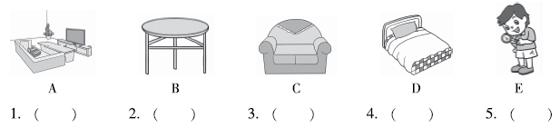三、听录音，判断下列图片与所听内容是(T)否(F)相符。(10分)

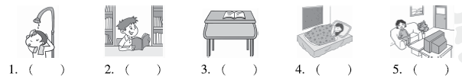四、听录音，为所听句子选择正确的答语。(10分)

(　　) 1. A. Yes, she is. B. Yes, it is.

(　　) 2. A. Yes, she is. B. Yes, it is.

(　　) 3. A. It's in the desk. B. A pencil box.

(　　) 4. A. No, they aren't. B. No, she isn't.

(　　) 5. A. Yes, he is. B. No, she isn't.

五、听短文，根据听到的内容判断正(T)误(F)。(10分)

(　　) 1. Tim has a cat.

(　　) 2. Tim is cute and friendly.

(　　) 3. Tim can't find his pen.

(　　) 4. Tim is in the living room.

(　　) 5. Tim is in the kitchen.



六、读一读，选出画线部分字母发音不同的单词。(5分)

(　　) 1. A. cute B. fun C. use

(　　) 2. A. bus B. excuse C. tube

(　　) 3. A. but B. student C. up

(　　) 4. A. much B. mum C. mule

(　　) 5. A. cut B. us C. pupil

七、给下列图片选择相应的词语，将其序号填写到图片前的括号里。(5分)

(　　) 1. 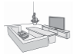 A. telephone

(　　) 2. 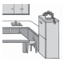 B. bathroom

(　　) 3.  C. bed

(　　) 4. 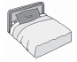 D. living room

(　　) 5. 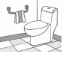 E. kitchen

八、根据图片和句意补全单词。(5分)

1. There is a s________ in my home(家). 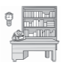

2. —Is the f________ in the kitchen? —Yes, it is. 

3. The keys are near the p________. 

4. She's in the s________. 

5. My glasses are on the t________. 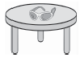

九、给图片选择正确的描述。(5分)

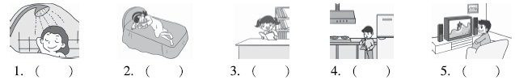

A. Go to the living room. Watch TV.

B. Go to the study. Read a book.

C. Go to the kitchen. Have a snack.

D. Go to the bedroom. Have a nap.

E. Go to the bathroom. Take a shower.

十、单项选择。(10分)

(　　) 1. —Is Lily in the living room?

—Yes, ________.

A. he is B. it is C. she is

(　　) 2. —________ is he?

—He's in the kitchen.

A. What B. Where C. Who

(　　) 3. Go to the________. Read a book.

A. living room B. study C. bathroom

(　　) 4. Look ________ that bedroom.

A. on B. at C. for

(　　) 5. —Where ________ my crayons?

—They're in your pencil box.

A. are B. is C. /

十一、按要求选出正确的一项。(10分)

(　　) 1. Shelly is in the living room. (对画线部分进行提问)

A. Where is Shelly? B. Who's Shelly?

(　　) 2. Is the bed in the living room? (作否定回答)

A. Yes, it is. B. No, it isn't.

(　　) 3. Are the candies in your schoolbag? (作肯定回答)

A. Yes, they are. B. Yes, it is.

(　　) 4. Is he in the kitchen? (作肯定回答)

A. No, he isn't. B. Yes, he is.

(　　) 5. John is in the bathroom. (改为一般疑问句)

A. John is in the bathroom? B. Is John in the bathroom?

十二、下面是小明和妈妈的对话，请你判断方框中的句子分别是谁说的，将序号填在相应的横线上。(10分)

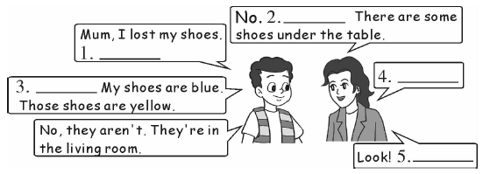

A. Those are not my shoes.

B. Do you see my shoes?

C. Are they in your bedroom?

D. Are they under the table?

E. Your shoes are under the chair.

十三、阅读短文，根据短文内容选择正确的答案。(10分)

Hello, I'm Jack. Look at the room. I have a bed in the bedroom. There is a picture on the wall. Look, the window is big and clean. The table is red. My books are on the table. My glasses are near the books, and my schoolbag is under the table.

(　　) 1. Is the bed in the bedroom?

A. Yes, it is. B. No, it isn't.

(　　) 2. Is the picture on the wall?

A. Yes, it is. B. No, it isn't.

(　　) 3. Where are the books?

A. They're under the table. B. They're on the table.

(　　) 4. Where are my glasses?

A. They're near the table. B. They're near the books.

(　　) 5. Is my schoolbag on the table?

A. Yes, it is. B. No, it isn't.

Unit 4达标测试卷

听力材料：

一、1. duck　2. use　3. fat　4. much　5. them

二、1. bed　2. find　3. sofa　4. table　5. living room

三、1. He is in the kitchen.

2. Go to the study. Read a book.

3. Put your book in the desk.

4. Go to the bedroom. Have a nap.

5. She is in the living room.

四、1. Is she in the kitchen?

2. Is it in your hand?

3. Where's my pen?

4. Are they near the window?

5. Is he in the study?

五、Tim has a cat. It's cute. Tim can't find the cat. Tim is in the living room. The cat is in the kitchen.

答案：

一、1. B　2. A　3. C　4. A　5. A

二、1. D　2. E　3. C　4. B　5. A

三、1. F　2. T　3. F　4. T　5. T

四、1. A　2. B　3. A　4. A　5. A

五、1. T　2. F　3. F　4. T　5. F

六、1. B　2. A　3. B　4. C　5. C

七、1. D　2. E　3. A　4. C　5. B

八、1. study　2. fridge　3. phone　4. sofa　5. table

九、1. E　2. D　3. B　4. C　5. A

十、1. C　点拨：关于女性单数第三人称的一般疑问句，肯定回答用“Yes, she is. ”。

2. B　点拨：对地点提问，特殊疑问词用Where。

3. B　点拨：读书的地点应该是在书房，其他地方可以读书，但不是最适合的地点。

4. B　点拨：look at 是固定搭配，指具体看某物。

5. A　点拨：对复数名词提问，be动词也要用复数形式。

十一、1. A　2. B　3. A　4. B　5. B

十二、1. B　2. D　3. A　4. C　5. E

点拨：第2题和第4题要根据上下文不能答反，第2题后面的句子提到了table，所以妈妈的问话，应该是关于桌子下有没有鞋的一般疑问句。而第4题根据后面儿子的答语可以分析出，应该问在哪个房间的一般疑问句。

十三、1. A　2. A　3. B　4. B　5. B