Unit 2达标测试卷
时间：40分钟 满分：100分
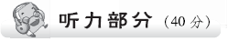
一、听录音，选出你听到的一项。(5分)
( ) 1. A. kite B. like C. cute
( ) 2. A. six B. ice C. nice
( ) 3. A. big B. pig C. bike
( ) 4. A. Chinese book B. schoolbag C. blue and white
( ) 5. A. in your desk B. under the desk C. on your English book
二、听录音，给图片排序，将其序号填在横线上。(5分)
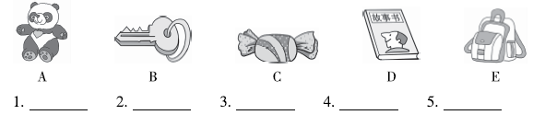
三、听录音，选出正确的图片。(10分)
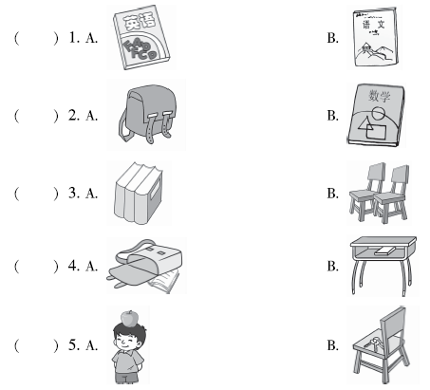
四、听录音，选择正确的答语。(10分)
( ) 1. A. It's black and white. B. It's a fat panda.
( ) 2. A. An English book and a maths book. B. In the desk.
( ) 3. A. May I see it? B. Two toys and a notebook.
( ) 4. A. Thank you very much. B. What colour is it?
( ) 5. A. Thank you very much. B. Good night.
五、听录音，根据你所听到的内容在表格中相应的位置打“√”。(10分)
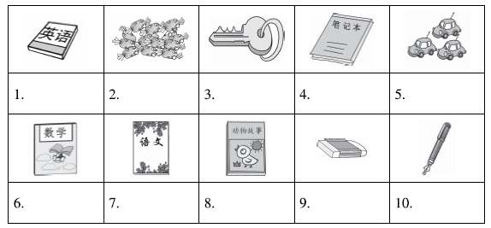
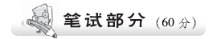
六、选出画线部分发音与其他两项不同的一项，将其序号填在题前括号内。(5分)
( ) 1. A. like B. it C. Chinese
( ) 2. A. kite B. this C. is
( ) 3. A. his B. nine C. fine
( ) 4. A. five B. fish C. in
( ) 5. A. English B. white C. window
七、读一读，选择相对应的图片。(5分)
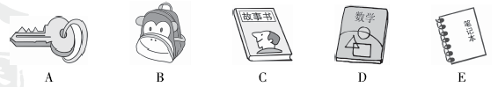
1. maths book ________ 2. storybook ________ 3. key ________
4. schoolbag ________ 5. notebook ________
八、看图，选词填空。(10分)
candies Chinese book toys key schoolbag
1. I lost my ________. 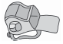
2. It's a ________. 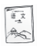
3. There are three ________ on the desk. 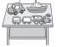
4. —What's in the schoolbag? 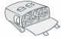
—Some ________.
5. Put the ________ in the pencil box. 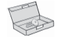
九、单项选择。(10分)
( ) 1. —________ colour is it?
—It's green.
A. What B. Where C. How
( ) 2. —________
—An English book, a maths book and three storybooks.
A. What colour is it? B. What's in it? C. Where is it?
( ) 3. I have ________ English book and ________ Chinese book.
A. an; a B. an; an C. a; an
( ) 4. —I lost my pen. —________
A. It's red. B. Here it is. C. Excuse me.
( ) 5. I have some ________ in my schoolbag.
A. candys B. toy C. candies
十、根据所给情景选择相应的句子。(10分)
( ) 1. 好朋友买了一个新书包，你想看看，可以说：
( ) 2. 同学丢了钢笔，你捡到了，为了确认是不是他的，你想问钢笔的颜色：
( ) 3. 同学的书包非常漂亮，你特别惊奇，你会说：
( ) 4. 妈妈问你的书包里有什么，她应该说：
( ) 5. 夸奖小动物可爱时，你会这样说：
A. What colour is it?
B. May I see it?
C. Wow! It's beautiful.
D. It's cute.
E. What's in it?
十一、给下列句子排序。(5分)
( ) Here it is.
( ) Thank you very much.
( ) I lost my schoolbag.
( ) What's in it?
( ) A Chinese book, a key and a pencil box.
十二、阅读短文，判断正(T)误(F)。(10分)
I have a new schoolbag. It's very big and beautiful. There is a fat panda on the schoolbag. It's cute. It's black and white. I like my schoolbag very much. I put an eraser in the pencil box. I put the pencil box in the schoolbag. I put the schoolbag in my desk. What's in the schoolbag? An English book, a maths book, three candies, a key and a storybook. My schoolbag is heavy.
( ) 1. My schoolbag is small and beautiful.
( ) 2. A cute panda is on the schoolbag.
( ) 3. I put an eraser under my desk.
( ) 4. Two keys are in my schoolbag.
( ) 5. My schoolbag is very heavy.
十三、段落仿写。(5分)
例： Sarah:
schoolbag, pink, big, English book, Chinese book, pencil box, eraser
Hello! I'm Sarah. I have a big schoolbag. It's pink. I have an English book, a Chinese book, a pencil box and an eraser in my schoolbag. I like my schoolbag very much.
Tom:
schoolbag, black and white, English book，maths book，three notebooks, two toys
_____________________________________________________________________
_____________________________________________________________________
_____________________________________________________________________
_____________________________________________________________________
_____________________________________________________________________
_____________________________________________________________________
_____________________________________________________________________

Unit 2达标测试卷
听力材料：
一、1. cute 2. six 3. bike 4. schoolbag 5. under the desk
二、1. candy 2. schoolbag 3. toy 4. key 5. storybook
三、1. English book 2. maths book 3. three books 4. in the desk 5. on the head
四、1. What colour is it?
2. What's in it?
3. I have a new notebook.
4. Here it is.
5. Good night.
五、Hello, my name is Tim. I have a new schoolbag. It's heavy. What's in it? Look, some candies. I like candies. This is my notebook. Here is my maths book. And that is the storybook. Can you see the pen? It's blue.
答案：
一、1. C 2. A 3. C 4. B 5. B
二、1. C 2. E 3. A 4. B 5. D
三、1. A 2. B 3. A 4. B 5. A
四、1. A 2. A 3. A 4. A 5. B
五、2. √ 4. √ 6. √ 8. √ 10. √
六、1. B 2. A 3. A 4. A 5. B
七、1. D 2. C 3. A 4. B 5. E
八、1. schoolbag 2. Chinese book 3. toys 4. candies 5. key
九、1. A 点拨：根据答句推断应该是询问颜色，所以用What。
2. B 点拨：询问“它里面有什么？”用What's in it?
3. A 点拨：考查冠词，在元音音素开头的单词前用an，辅音音素开头的单词前用a。
4. B 点拨：Here it is. 的意思是“给你。”
5. C 点拨：candy的复数形式为candies。
十、1. B 2. A 3. C 4. E 5. D
十一、4 5 1 2 3
十二、1. F 2. T 3. F 4. F 5. T
十三、Hello! I'm Tom. I have a new schoolbag. It's black and white. I have an English book, a maths book, three notebooks and two toys in my schoolbag. I like my schoolbag very much.

