Unit 4达标测试卷

时间：40分钟　满分：100分



一、根据所听顺序排序，将其序号按正确的顺序写入题前括号内。(5分)

例：(CBA)A. cow　 　　　　　　B. snow　　 　　　 　　C. how

(　　) 1. A. zoo B. too C. school

(　　) 2. A. good B. food C. goodbye

(　　) 3. A. book B. look C. balloon

(　　) 4. A. room B. noodles C. afternoon

(　　) 5. A. football B. foot C. cook

二、听录音，选择与所听内容相符的图片。(5分)

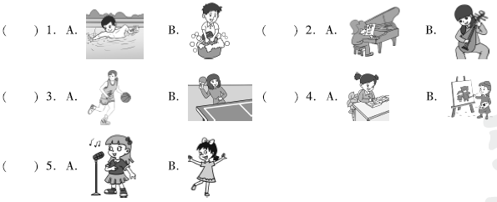三、听录音，判断下列图片与所听内容是(T)否(F)相符。(10分)

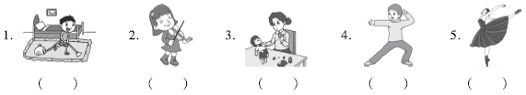四、听短文，在表格相应位置打√。(10分)

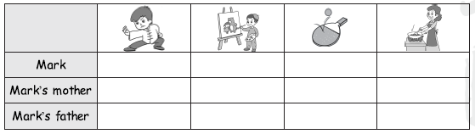



五、判断下列各项单词中画线部分发音是(T)否(F)相同。(5分)

(　　) 1. A. book B. foot (　　) 2. A. good B. food

(　　) 3. A. balloon B. afternoon (　　) 4. A. cook B. too

(　　) 5. A. zoo B. room

六、读一读，根据句意和图片提示写出单词，补全句子。(10分)

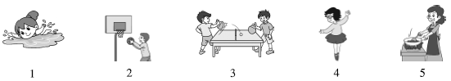1. In summer, we can ________ in the sea.

2. My friend Li Lei can play ________.

3. Dongdong can play ________ with his friend.

4. Susan likes to ________.

5. My mother can ________ delicious food.

七、读一读，选出与图片相匹配的短语。(5分)

(　　) 1.  A. sing songs B. speak English

(　　) 2.  A. have a party B. learn English

(　　) 3.  A. send emails B. read a story

(　　) 4.  A. draw cartoons B. write a story

(　　) 5. 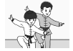 A. read books B. do kung fu

八、单项选择。(10分)

(　　) 1. They will go to the zoo ________ Sunday.

A. at B. next C. /

(　　) 2. What can you do ________ the party?

A. of B. with C. for

(　　) 3. They'll have ________ English party next Wednesday.

A. a B. an C. /

(　　) 4. I like reading books, ________ I don't like drawing pictures.

A. but B. so C. for

(　　) 5. I will send ________ email ________ my uncle.

A. an, to B. a, for C. a, at

(　　) 6. Can Lily ________ piano?

A. play B. plays C. play the

(　　) 7. Sally ________ Chinese in China.

A. want learn B. wants to learn C. want to learn

(　　) 8. I ________ do any kung fu, but I'd like to try.

A. can't B. can C. am not

(　　) 9. Danny can________ a kite.

A. fly B. flies C. flying

(　　) 10. ________ throw the paper into the lake.

A. Can B. Do C. Don't

九、选词填空。(5分)

some　any　want　want to　at

1. You can send an email ________ *104357@penpal. com*.

2. Would you like ________ juice?

3. I ________ a new English book.

4. Can John do ________ kung fu?

5. Does he ________ be our friend?

十、选择合适的句子补全对话。(10分)

(　　) 1. —Can Lily wash her clothes? —________

(　　) 2. —________　—Wonderful! I love parties.

(　　) 3. —________ —Yes，I can.

(　　) 4. —I can't speak Chinese. —________

(　　) 5. —________ —Amy can play the piano.

A. Can you clean the teacher's desk? B. We'll have a party next Friday.

C. Who can play the piano? D. Yes, she can.

E. No problem. I can help you.

十一、读一读，为下列句子排序。(5分)

(　　) What can you do at home?

(　　) I can, and I can cook.

(　　) I can clean my room. What about you?

(　　) I can clean the rooms, too. But I can't wash clothes.

(　　) Cool!

十二、阅读短文，完成任务。(10分) (建议用时：6分钟)

Welcome to our class. This is Lisa. She can play the erhu. She is very nice. This is Tom. He is strong. He likes playing sports. He can play football. This is Anna. She is hard­working. She can sing songs very well. This is John. He is clever. He can draw cartoons. I'm Sam. I can play the piano. Our class is very nice.

(一)根据短文内容，将人物与相应的活动连线。(5分)

1. Lisa　　　 　2. Tom　　　 　 3. Anna　　　 　 4. John　　　 　 5. Sam

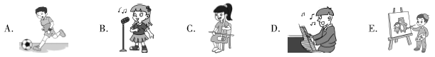(二)根据短文内容判断正(T)误(F)。(5分)

(　　) 6. Lisa is very clever. (　　) 7. Tom is strong.

(　　) 8. Anna is shy. (　　) 9. John is hard­working.

(　　) 10. Sam likes their class.

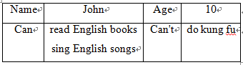十三、写作。(10分)

根据以下信息卡内容介绍John，

说明他能做哪些事情，不能做哪些事

情，可适当拓展，不少于6句。

_____________________________________________________________________

_____________________________________________________________________

_____________________________________________________________________

_____________________________________________________________________

听力材料：

一、例：how, snow, cow

1. zoo, school, too

2. food, goodbye, good

3. balloon, book, look

4. afternoon, noodles, room

5. foot, football, cook

二、1. John can wash his clothes.

2. Lisa can play the *pipa* very well.

3. Can your Chinese teacher play basketball?

4. Amy can draw pictures.

5. I can sing English songs very well.

三、1. **W:** John, can you clean your room?

**M:** Yes, I can.

2. **M:** Can Amy play the piano?

**W:** No, she can't.

3. **M:** What can you do, Lisa?

**W:** I can make a puppet.

4. **W:** Can you sing the birthday song?

**M:** Yes, I can.

5. **M:** Can Lily's sister dance?

**W:** Yes, she can.

四、**M:** Hello, I'm Mark. I'm a boy. I can draw cartoons and do some kung fu. My mother is kind. She can cook meals for us and play ping­pong. My father is an English teacher. He can play ping­pong, too. We are a happy family.

答案：

一、1. A C B　2. B C A　3. C A B　4. C B A 5. B A C

二、1. B　2. B　3. A　4. B　5. A

三、1. T　2. F　3. T　4. F　5. T

四、

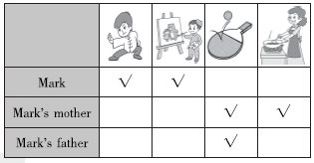

五、1. T　2. F　3. T　4. F　5. T

六、1. swim　2. basketball　3. ping­pong　4. dance 5. cook

七、1. A　2. B　3. A　4. A　5. B

八、1. B　点拨：will用于将来时，next Sunday表示“下周日”，将来的时间。

2. C　3. B　4. A

5. A　点拨：email为元音音素开头的名词，前面使用an。

6. C

7. B　点拨：Sally为单三，谓语动词应加­s。want to do sth. 想做某事。

8. A　9. A　10. C

九、1. at　2. some　3. want　4. any　5. want to

十、1. D　2. B　3. A　4. E　5. C

十一、1－4－2－3－5

十二、(一)1. C　2. A　3. B　4. E　5. D

(二)6. F　7. T　8. F　9. F　10. T

十三、范文：

John is my good friend. He is ten years old. He likes English. He can read English books. He can sing English songs. But he can't do any kung fu. I can do some kung fu. I can teach him!