Unit 4达标测试卷(A卷)

时间：40分钟　满分：100分

|  |  |  |  |  |  |  |  |  |  |  |  |  |  |
| --- | --- | --- | --- | --- | --- | --- | --- | --- | --- | --- | --- | --- | --- |
| 题　号 | 一 | 二 | 三 | 四 | 五 | 六 | 七 | 八 | 九 | 十 | 十一 | 十二 | 总　分 |
| 得　分 |  |  |  |  |  |  |  |  |  |  |  |  |  |



一、听录音, 选出你所听到的单词或短语。(每小题1分, 共5分)

(　　)1. A. three　　　　　 B. third　　　　　C. thirteen

(　　)2. A. fool B. fur C. fourth

(　　)3. A. kitten B. chicken C. Christmas

(　　)4. A. September B. special C. still

(　　)5. A. January 2nd B. June 12th C. July 20th

二、听录音, 选择与其相符的图片。(每小题1分, 共5分)

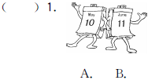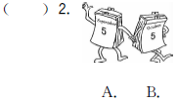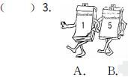

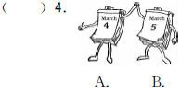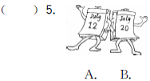

三、听录音, 判断所听内容与图意是否相符, 相符的在图片下的括号内打“√”, 不相符的打“×”。(每小题2分, 共10分)

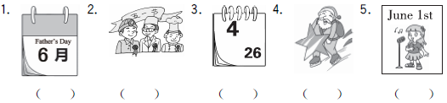

四、听短文, 根据所听短文内容, 选择正确答案。(每小题2分, 共10分)

(　　) 1. There are________ people in Mike's family.

A. six B. four C. five

(　　) 2. Mike's birthday is on________.

A. January 2nd B. January 8th C. August 16th

(　　) 3. There are________ birthdays in August.

A. five B. two C. three

(　　) 4. Mike's father's birthday is on________.

A. April 1st B. August 16th C. August 27th

(　　) 5. ________ is Mike's grandpa's birthday.

A. April Fool's Day B. Children's Day C. May Day



五、选出与所给单词同类的单词。(每小题1分, 共5分)

(　　) 1. ninth A. five B. eleventh C. thirteen

(　　) 2. eight A. twenty B. first C. second

(　　) 3. February A. Sunday B. Friday C. July

(　　) 4. mother A. maths B. music C. grandpa

(　　) 5. eat A. walk B. diary C. noise

六、下面的节日你一定熟悉吧！为下面的节日选择正确的日期。(每小题1分, 共5分)

(　　) 1. Teachers' Day A. June 1st

(　　) 2. China's National Day B. April 1st

(　　) 3. Children's Day C. September 10th

(　　) 4. New Year's Day D. October 1st

(　　) 5. April Fool's Day E. January 1st

七、用括号内所给数词的适当形式填空。(每小题2分, 共10分)

1. Sunday is the__________ (one) day of a week.

2. Today is his__________ (twelve) birthday.

3. My cat has__________ (two) new kittens.

4. My birthday is on July__________ (ten).

5. It's__________ (five) o'clock. Let's go home.

八、单项选择。(每小题2分, 共10分)

(　　) 1. February is the________ month of a year.

A. two B. second C. third

(　　) 2. The________ is on May 4th. I will sing an English song.

A. maths test B. sports meet C. singing contest

(　　) 3. The kittens are________ days old. They have white fur now.

A. six B. sixth C. 6th

(　　) 4. —Happy birthday, Mum!

—________

A. Cool! B. Thank you. C. Great!

(　　) 5. —When is your birthday, Sarah?

—My birthday is on________.

A. August 2th B. August 2nd C. August 2st

九、读句子, 选择与其相符的图片, 将其序号填在相应图片下面的括号内。(每小题2分, 共10分)

|  |
| --- |
| A. Christmas is on December 25th.  B. Mother's Day is on the second Sunday in May.  C. The school trip is on October 1st this year.  D. There is a birthday party for me today.  E. Tree Planting Day is on March 12th. We can plant trees. |

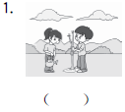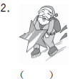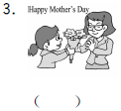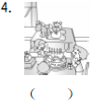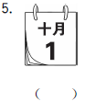

十、从方框中选出合适的选项补全对话。(每小题2分, 共10分)

Mike：Hello, Zhang Peng. 1. __________

Zhang Peng：I like winter best.

Mike：2. __________

Zhang Peng：Because my birthday is in winter.

Mike：3. __________

Zhang Peng：My birthday is on December 9th.

Mike：4. __________

Zhang Peng：I often have a birthday party with my friends.

Mike：Cool!

Zhang Peng：When is your birthday?

Mike：5. __________

Zhang Peng：Wow! That's May Day!

Mike：Yes!

|  |
| --- |
| A. When is your birthday? B. Why do you like winter? C. My birthday is on May 1st.  D. What do you often do on your birthday? E. Which season do you like best? |

十一、阅读短文, 根据短文内容回答问题。(每小题2分, 共10分) (建议用时：6分钟)

I have a big family. My grandpa's name is Harry. His birthday is on March 8th. My grandma's name is Helen. Her birthday is on June 6th. Now they're in England. My parents are in China. My father is Jeff and my mother's name is Jean. My father's birthday is on January 5th. My mother's birthday is on April 2nd. I have a sister. Her name is Kate. Her birthday is on October 4th. My name is Lily. I'm twelve. My birthday is on August 10th.

1. How many people are there in Lily's family?

________________________________________________________________________

2. When is Kate's birthday?

________________________________________________________________________

3. When is Lily's birthday?

________________________________________________________________________

4. When is Lily's mother's birthday?

________________________________________________________________________

5. Whose birthday is on June 6th?

________________________________________________________________________

十二、新型题)请根据信息卡的内容, 模仿范例进行仿写, 不少于四句话。(10分)

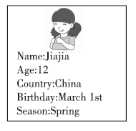

例：Look！This is Jiajia. She is a girl. She is twelve years old. She is from China. Her birthday is on March 1st. Spring is her favourite season.

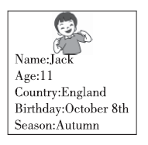

_______________________________________________

________________________________________________________________________

________________________________________________________________________

________________________________________________________________________

Unit 4达标测试卷(A卷)

听力原文：

一、1. third　2. fool　3. kitten　4. still　5. June 12th

二、1. My birthday is on May 10th.

2. Miss Chen's birthday is on October 5th.

3. The English test is on November 5th.

4. The school trip is on March 4th.

5. The maths test is on July 12th.

三、1. Mother's Day is on the second Sunday in May.

2. May Day is on May 1st.

3. Today is April 16th.

4. Easter is in March or April.

5. The singing contest is on June 1st.

四、M：My name is Mike. There are five people in my family. My birthday is on January 2nd. My mother's birthday is in January, too. It's on January 8th. There are two birthdays in August. My father's birthday is on August 16th. My grandma's birthday is on August 27th. When is my grandpa's birthday? His birthday is on April 1st, April Fool's Day. How funny!

答案：

一、1. B　2. A　3. A　4. C　5. B

二、1. A　2. B　3. B　4. A　5. A

三、1. ×　2. √　3. ×　4. ×　5. √

四、1. C　2. A　3. B　4. B　5. A

五、1. B　2. A　3. C　4. C　5. A

六、1. C　2. D　3. A　4. E　5. B

七、1. first　2. twelfth　3. two　4. tenth/10th　5. five

八、1. B 2. C [点拨] 由后句“我将唱首英语歌曲。”可知选C。

3. A　4. B

5. B [点拨] 本题考查日期表达法。首先月份无论在什么时候出现都大写第一个字母, 后面紧跟着序数词的缩写, second的缩写是2nd, 故选B。

九、1. E　2. A　3. B　4. D　5. C

十、1. E　2. B　3. A　4. D　5. C

十一、1. There are six people in her family.

2. Her birthday is on October 4th.

3. Her birthday is on August 10th.

4. Her birthday is on April 2nd.

5. Lily's grandma's.

十二、范文：

Look! This is Jack. He is a boy. He is eleven years old. He is from England. His birthday is on October 8th. Autumn is his favourite season.