Unit 6达标测试卷
时间：40分钟 满分：100分
一、听录音，选出你所听到的单词。(5分)
( ) 1. A. parents B. pear C. puppy
( ) 2. A. aunt B. uncle C. ant
( ) 3. A. father B. farmer C. grandfather
( ) 4. A. driver B. dinner C. doctor
( ) 5. A. brother B. basketball C. blackboard
二、听录音，判断图片与所听内容是否相符，相符写“T”，不相符写“F”。(5分)
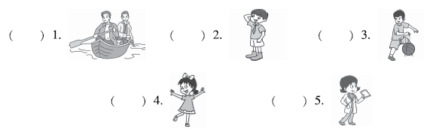
三、听录音，选择正确的图片。(10分)
( ) 1. He is a ________. A. B.
( ) 2. My ________ is a cook. A. B. 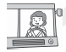
( ) 3. My brother is a ________. A. 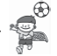 B.
( ) 4. Amy's ________ has short hair. A. B.
( ) 5. This is my ________. A. B. 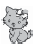
四、听录音，选出正确的答句。(10分)
( ) 1. A. Three. B. My father. C. My mother.
( ) 2. A. He is a student. B. Yes, he is. C. She is a student.
( ) 3. A. I'm a student. B. He is a student. C. She is a student.
( ) 4. A. Yes, he is. B. No, she isn't. C. Yes, they are.
( ) 5. A. Yes, I am. B. Yes, he is. C. Yes, she is.
五、听录音，在表格中正确的位置打“√”。(10分)
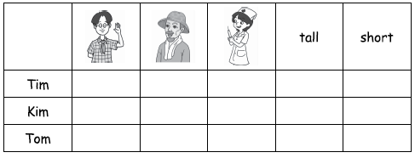
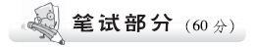
六、选出与其他画线部分发音不同的一项。(5分)
( ) 1. A. me B. he C. men
( ) 2. A. name B. bag C. apple
( ) 3. A. like B. his C. rice
( ) 4. A. dog B. hot C. nose
( ) 5. A. use B. cut C. us
七、根据图片写单词，补全句子。(5分)
1. His father is a ________.
2. Jack's grandpa is a ________.
3. She is my mother's sister. She is my ________.
4. Her sister is a ________.
5. My mother is a ________. 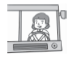
八、读一读，选择正确的词语补全句子。(5分)
A. people B. cook C. parents D. jobs E. football player
( ) 1. My mother and father are my ________.
( ) 2. I like football. I am a ________.
( ) 3. He can make(制作) good food. He is a ________.
( ) 4. Boys, girls, men and women are ________.
( ) 5. Teachers, doctors, drivers are ________.
九、单项选择。(10分)
( ) 1. My family has five ________.
A. man B. woman C. people
( ) 2. That man is ________ brother.
A. I B. Jack's C. he
( ) 3. ________ are there on the desk?
A. How many apples B. How much apples C. How many
( ) 4. What's ________ job?
A. your father B. your mother C. your uncle's
( ) 5. This is my little brother. ________ is a student.
A. He B. She C. I
十、给下列句子选出相应的问句或答语。(10分)
( ) 1. —________ —Four.
( ) 2. —What's your father's job?
—________
( ) 3. —What's your mother's job?
—________
( ) 4. —Is this your little brother?
—________
( ) 5. —Is your aunt a nurse?
—________
A. She is a driver. B. No, she isn't.
C. Yes, he is. D. He is a cook.
E. How many people are there in your family?
十一、读句子，为下列图片排序，将序号写入图下括号内。(10分)
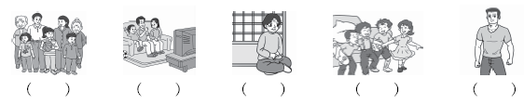1. There are three people in my family, my mother, my father and me.
2. These are my friends. We are students.
3. There are seven people in my family, my grandma, grandpa, mother, father, brother, little sister and me.
4. This is my uncle. He is tall and strong. He is a basketball player.
5. This is my grandma. She is friendly. I like her.
十二、阅读短文，选择正确的一项。(10分)
Hi, my name is Steven. I'm ten. I'm a boy. My father is a doctor. He is tall. My mother is a nurse. She has long hair. My sister is a teacher. She is quiet. She has glasses. My grandfather and grandmother have no job. I am a student. I'm tall and strong. I love my family.
( ) 1. There are ________ people in Steven's family.
A. five B. six C. four
( ) 2. Steven's father is ________.
A. tall B. a teacher C. quiet
( ) 3. ________ has long hair.
A. His father B. His mother C. His sister
( ) 4. ________ has no job.
A. His sister B. His parent C. His grandma
( ) 5. Steven is ________.
A. a boy B. a student C. Both A and B.
十三、假如你是汤姆，请根据提示写几句话介绍一下你和你的家人。不少于5句话。(5分)
Tom | tall | student
Father | tall and thin | doctor
Mother | short; long hair | nurse

_____________________________________________________________________
_____________________________________________________________________
_____________________________________________________________________
_____________________________________________________________________
_____________________________________________________________________
_______________________________________________________________________________________________________________________________________________________________________________________________________________
Unit 6达标测试卷
听力材料：
一、1. puppy 2. uncle 3. father 4. doctor 5. brother
二、1. They are my parents. 2. My cousin is a student.
3. His brother is a football player. 4. This is my baby brother.
5. My mother is a doctor.
三、1. He is a driver.
2. My uncle is a cook.
3. My brother is a basketball player.
4. Amy's father has short hair.
5. This is my little puppy.
四、1. How many people are there in your family?
2. Is your brother a student?
3. What's your sister's job?
4. Are your parents tall?
5. Is this your uncle?
五、M: I'm Tim. I'm a student. I'm ten. I'm tall. Kim is my sister. She is a nurse. She is short. Tom is my uncle. He is a farmer. There are many animals on the farm.
答案：
一、1. C 2. B 3. A 4. C 5. A
二、1. F 2. T 3. F 4. F 5. T
三、1. A 2. A 3. B 4. B 5. A
四、1. A 2. B 3. C 4. C 5. B
五、
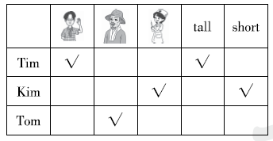

六、1. C 2. A 3. B 4. C 5. A
七、1. doctor 2. farmer 3. aunt 4. nurse 5. driver
八、1. C 2. E 3. B 4. A 5. D
九、1. C 点拨：five后应接复数名词。
2. B 点拨：此处应选择形容词性物主代词或名词所有格，B选项为名词所有格。
3. A 点拨：are匹配复数名词，how many搭配复数名词使用，询问数量。
4. C
5. A 点拨：男性，使用人称代词he来代替。
十、1. E 2. D 3. A 4. C 5. B
十一、3 1 5 2 4
十二、1. B 2. A 3. B 4. C 5. C
十三、 My name is Tom. I'm a student. I am tall. There are three people in my family. My father is a doctor. He is tall and thin. My mother is a nurse. She is short. She has long hair. I love my family.

