Unit 1达标测试卷

时间：40分钟　满分：100分



一、听录音，选出你听到的单词。(5分)

(　　) 1. A. cake B. cat (　　) 2. A. date B. dad

(　　) 3. A. hate B. hat (　　) 4. A. face B. fish

(　　) 5. A. name B. mum

二、听录音，选择与所听内容相符的图片。(5分)

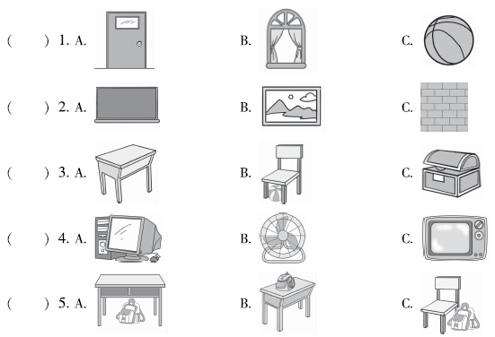

三、听录音，判断下列句子与所听内容是( √)否(×)相符。(10分)

(　　) 1. Look, this is our new school. (　　) 2. The picture is on the wall.

(　　) 3. The book is on the desk. (　　) 4. The pen is near the pencil.

(　　) 5. Let me clean the teacher's desk.

四、听录音，为下列图片排序。(10分)

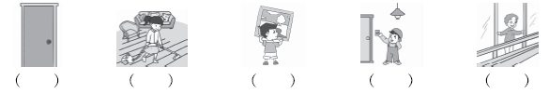

五、听录音，将相关联的两项连线。(10分)

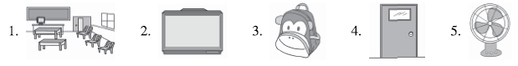

A. near the window B. under the desk　C. big and new　D. new and blue E. orange



六、判断下列单词中画线部分的发音是否相同，相同写“T”，不相同写“F”。(5分)

(　　) 1. make cake (　　) 2. cap apple (　　) 3. wall name

(　　) 4. hate classroom (　　) 5. what have

七、Danny给教室里的物品贴上了英文标签，请你帮他检查一下吧。对的在括号内打“√”，错的打“×”并在横线上改正。(5分)

例： floor ( × ) door　　　　1. 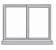wall (　　)________

2.  blackboard(　　)________ 3. light (　　)________

4.  picture (　　)________ 5. TV (　　)________

八、单项选择。(5分)

(　　) 1. We ________ a new school.

A. have B. has C. are

(　　) 2. ________ go to the new classroom.

A. Let B. Let's C. let me

(　　) 3. Let________ help you.

A. I B. we C. me

(　　) 4. —________ in your pencil box?

—Two pens and three pencils.

A. What's B. What C. Where are

(　　) 5. —________ is the crayon？—It's on the book.

A. What B. When C. Where

九、看图，判断句子与图片是否相符，相符的写“T”，不相符的写“F”。(5分)

(　　) 1. The picture is on the wall. 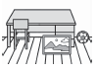

(　　) 2. The TV is on the table. 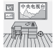

(　　) 3. The map is near the window. 

(　　) 4. The ball is under the chair. 

(　　) 5. There are four lights in the classroom. 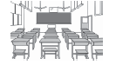

十、看图，把句子抄写在相应的四线三格上。(10分)

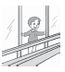 

 .

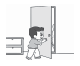 

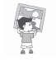 

 

Let me put up the picture.

Open the window.

Let me close the door.

Let us clean the classroom.

Let me turn on the light.

十一、选择正确的句子补全对话。(10分)

**A:** 1. ________ Do you see my pencil box?

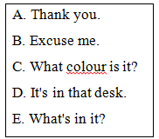**B:** 2. ________

**A:** It's blue and black.

**B:** 3. ________

**A:** Three pencils, a pen and a ruler.

**B:** Is that your pencil box? 4. ________

**A:** Yes, it is. 5. ________

**B:** You're welcome.

十二、阅读短文，填表格。(10分)

We have a new classroom. It's very big and beautiful. The walls are white and green. Two pictures and a map are on the walls. We have twenty－five desks and fifty chairs. They are yellow. Two blackboards are in the classroom. The teacher's desk is near the blackboard. It's big and orange. Some flowers are on the teacher's desk. Two books are on the desk, too. We have a new computer. It's on the teacher's desk, too. The teacher's desk is very big. We have six lights in the classroom. We clean our classroom every day. It's clean. We like our classroom.

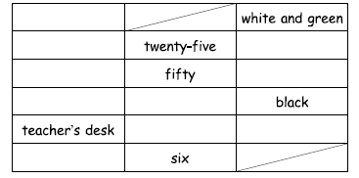

十三、看图，仿照例子写句子。(10分)

例：Look, this is our classroom.

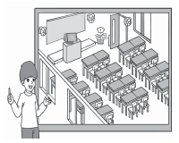Many desks are in the classroom.

The flower is near the door.

1.__________________________________________

2. __________________________________________

3.___________________________________________

4. __________________________________________

5. __________________________________________

Unit 1达标测试卷

听力材料：

一、1. cake　2. dad　3. hat　4. fish　5. name

二、1. A new door is in the classroom.

2. The picture is beautiful.

3. The ball is under the chair.

4. I have a new computer.

5. The bag is near the chair.

三、1. Look, this is my new classroom.

2. The picture is on the wall.

3. The book is in the desk.

4. The pen is near the pencil.

5. Let me clean the teacher's desk.

四、1. **W:** Let me clean the floor.

2. **M:** Let me put up the picture.

3. Open the window.

4. **M:** Let me clean the window.

5. Turn on the light.

五、　　Welcome to our new classroom. It's very big. Look, this is a TV in the classroom. It's near the window. A bag is under the desk. The door is orange. Two blue fans are in the classroom. They are new.

答案：

一、1. A　2. B　3. B　4. B　5. A

二、1. A　2. B　3. B　4. A　5. C

三、1. ×　2. √　3. ×　4. √　5. √

四、4　1　2　5　3

五、1—C　2—A　3—B　4—E　5—D

六、1. T　2. T　3. F　4. F　5. F

七、1. ×； window　2. ×； fan　3. √　4. √　5. ×； computer

八、1. A　点拨：句意为“我们有一所新学校。”We为第一人称复数，搭配have使用。

2. B　点拨：句意为“让我们去新教室吧。”Let's意为“让我们”，符合句意。

3. C　点拨：Let后用人称代词宾格形式。

4. A　点拨：根据答句可知在问铅笔盒里有什么，选择What's。

5. C　点拨：根据答句可知是在问位置，选择Where。

九、1. F　点拨：图中的画在地板上，而不是在墙上。

2. F　点拨：图中的电视在墙上，而不是在桌子上。

3. T

4. F　点拨：椅子下边有一只猴子，而不是球。

5. T

十、1. Open the window.

2. Let us clean the classroom.

3. Let me close the door.

4. Let me put up the picture.

5. Let me turn on the light.

十一、1. B　点拨：寻求别人帮助来寻找自己的铅笔盒，要先说Excuse me.

2. C　点拨：根据答句可以判断出在问铅笔盒的颜色。

3. E　点拨：根据答句可以判断出在问铅笔盒里有什么。

4. D　5. A

十二、

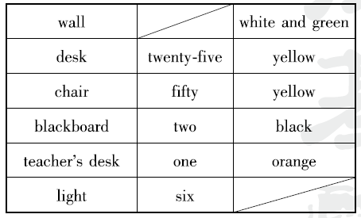

十三、1. Many chairs are in the classroom.

2. A blackboard is in the classroom.

3. A teacher's desk is in the classroom.

4. A computer is on the teacher's desk.

5. Some fans are on the walls.

(答案不唯一)