Unit 2达标测试卷
时间：40分钟 满分：100分

一、听录音，选出与所听内容相符的图片。(5分)
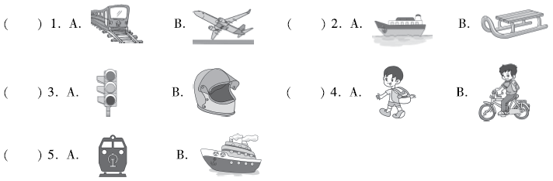二、听录音，选出你所听到的句子。(5分)
( ) 1. A. Some students usually come to school by bike.
B. Some students often come to school by bike.
( ) 2. A. Let's go to the science museum.
B. Let's go to the film museum.
( ) 3. A. How do you get to Canada from the USA?
B. How do we get to Canada from the USA?
( ) 4. A. Let me read the book for you.
B. Let's read a story for him.
( ) 5. A. You must wear a life jacket.
B. You must wear a helmet.
三、听录音，判断下列图片与所听内容是(T)否(F)相符。(10分)
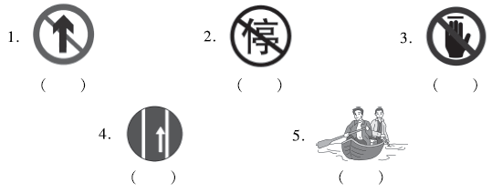
四、听录音，根据对话内容及问题选择正确的选项。(10分)
( ) 1. How does Mike get to the park?
A. By bus B. By bike. C. On foot.
( ) 2. Where is Peter?
A. He is in the park. B. He is in the cinema. C. He is at school.
( ) 3. How does Mike's mother go to work?
A. By bus. B. By bike. C. On foot.
( ) 4. How does Peter go to school?
A. By train. B. By subway. C. By bus.
( ) 5. How does Mike go to school?
A. On foot. B. By car. C. By train.
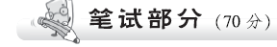
五、根据图片及首字母提示写出单词，补全句子。(5分)
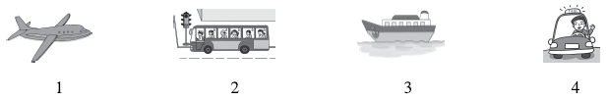
1. He goes to Shanghai by p________.
2. S________ down and s________ at a yellow light.
3. He goes to Dalian by s________.
4. They go to the park by t________.
六、根据图片选短语并用其适当形式填空。(5分)
look left traffic lights by sled by ferry don't touch
1. _________________ the door. 
2. _________________ before you cross the road. 
3. Some children in Sichuan go to school_______________. 

4. It snows a lot in Heilongjiang in winter.
Some children go to school_________________. 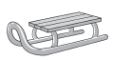
5. We must pay attention to the ______________. 
七、单项选择。(10分)
( ) 1. This is ________ Smith. She is our English teacher.
A. Mr B. Mrs C. /
( ) 2. You can cross the road ________ a green light.
A. at B. on C. of
( ) 3. ________ go at a yellow light.
A. Must B. No C. Don't
( ) 4. The subway is very ________， but the bike is very slow.
A. good B. fast C. slow
( ) 5. It's far from here. You can________ a bus to get there.
A. take B. by C. on
( ) 6. The gift is ________ my sister________ Canada.
A. of; at B. for; on C. from; in
( ) 7. Chinese food is different________ American food.
A. from B. with C. of
( ) 8. Don't ________ your child run on the bus.
A. letting B. let C. lets
( ) 9. We ________ go to school by bike. __________ we walk.
A. always; Often B. usually; Sometimes C. usually; Often
( ) 10. —________ do you go to Beijing?
—I often go there by train.
A. How B. Where C. What
八、给下列句子选择合适的图片。(10分)
( ) 1. In China, we use chopsticks to eat.
( ) 2. In China, we drive a car on the right side of the street.
( ) 3. Before crossing a road, you must look left first and then look right.
( ) 4. We can see a doubledecker on the street.
( ) 5. In the USA, people on bikes must wear a helmet.
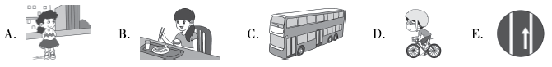
九、给下列句子选择合适的答语。(10分)
( ) 1. How do they go to the park?
( ) 2. How does your mother go to work?
( ) 3. How do you come to school?
( ) 4. What does it mean?
( ) 5. Where is the door of the bus？
A. She often goes to work by subway. B. They take the No. 50 bus.
C. Don't touch it. D. I usually come to school by bus.
E. It's on the left side of the bus.
十、选择正确的句子补全对话。(10分)
Mingming: Mum, let's go to Beijing. I want to see the Great Wall.
Mum: That's OK.
Mingming: Great! 1. ________
Mum: We can go by bus.
Mingming: A bus is slow. 2. ________
Mum: 3. ________ But it's too expensive. 4. ________
Mingming: A train is fast. And it's not expensive. 5. ________
Mum: OK.
A. What about a train? B. How can we get to Beijing?
C. Let's take a plane. D. Let's go by train.
E. A plane is fast.
十一、阅读短文，选择正确答案。(10分) (建议用时：5分钟)
It's Sunday today. Emily gets up at 7：30. She often gets up at 6：45. Today she doesn't go to school. In the morning, she goes shopping with her mother. They get there by bus. They buy some food. They take a taxi home. After lunch, she goes to the cinema with her friend. They live far from the cinema. They go there by bus. Then Emily walks to her grandmother's house. She has dinner with her grandmother and grandfather. Then she goes home by bus. What a happy and busy day!
( ) 1. Emily often gets up at________.
A. 7：30 B. 6：45 C. 7：00
( ) 2. Emily goes shopping ________ in the morning.
A. by bus B. by taxi C. on foot
( ) 3. Emily goes to the cinema with________ in the afternoon.
A. her mother B. her grandmother C. her friend
( ) 4. Emily goes to her grandmother's house________.
A. by bus B. on foot C. by taxi
( ) 5. Emily goes home________.
A. on foot B. by taxi C. by bus
十二、写作。(10分)
请根据以下提示写一写王明在北京的行程。
1. 王明和父母在周日乘火车去了北京。
2. 他们周一乘公共汽车去了长城(the Great Wall)。
3. 他们周二从宾馆(hotel)步行到了王府井大街(Wangfujing Street) 购物。
4. 他们周三乘坐火车回到了上海。
________________________________________________________________________
________________________________________________________________________
________________________________________________________________________
________________________________________________________________________________________________________________________________________________
________________________________________________________________________
________________________________________________________________________
听力材料：
一、1. They want to go to Beijing by train.
2. In Jiangxi, China, some children go to school by ferry.
3. You must pay attention to the traffic lights.
4. I usually go to school by bike.
5. They come to Shanghai by ship.
二、1. Some students usually come to school by bike.
2. Let's go to the film museum.
3. How do you get to Canada from the USA?
4. Let me read the book for you.
5. You must wear a helmet.
三、1. Don't go straight.
2. Please stop and wait.
3. Don't touch the door.
4. In the UK, people must drive on the left side of the road.
5. We sometimes go to school by sled.
四、Peter: Hello, Mike. Nice to see you.
Mike: Nice to see you, too，Peter.
Peter: How do you get here?
Mike: I come here on my bike. This park is near my home.
Peter: Who is that?
Mike: She is my mother. She comes here with me.
Peter: Does she go to work by bike, too?
Mike: No，she often goes to work by bus.
Peter: Oh，I usually go to school by bus, too. What about you, Mike?
Mike: I walk to school.
答案：
一、1. A 2. A 3. A 4. B 5. B
二、1. A 2. B 3. A 4. A 5. B
三、1. T 2. F 3. T 4. F 5. F
四、1. B 2. A 3. A 4. C 5. A
五、1. plane 2. Slow; stop 3. ship 4. taxi
六、1. Don't touch 2. Look left 3. by ferry 4. by sled 5. traffic lights
七、1. B 点拨：由第二句可知，英语老师为女性，所以此处选择B。
2. A 3. C 4. B
5. A 点拨：can后应接动词原形，by虽有“乘坐”的意思，但为介词。
6. C 点拨：from my sister意为“来自我姐姐”。在加拿大境内需使用介词in。
7. A 点拨：be different from 与……不同。
8. B 点拨：don't后接动词原形。
9. B 10. A
八、1. B 2. E 3. A 4. C 5. D
九、1. B 2. A 3. D 4. C 5. E
十、1. B 2. C 3. E 4. A 5. D
十一、1. B 2. A 3. C 4. B 5. C
十二、范文：
Wang Ming goes to Beijing with his parents. They get there by train on Sunday. They go to the Great Wall by bus on Monday. It's very long. They go to Wangfujing Street on foot on Tuesday. They shop for gifts there. They take a train home on Wednesday. They have a good trip.

