山东临沂市沂水县2016-2017学年度下学期六年级英语毕业测试题(PEP)
听力部分
Ⅰ.Listen and choose.（听录音，选出你所听到的句子中所包含的单词。）（每小题读两遍）
( )1.A.pilot B.polite C.plant
( )2.A.15kg B.50kg C.1.5m
( )3.A.fall B.feel C.fell
( )4.A.active B.angry C.afraid
( )5.A.drinking B.drink C.drank
( )6.A.skirt B.shirt C.shoes
( )7.A.this 8.these C.those
( )8.A.sunny B.snowy C.rainy
( )9.A.hall B.tall C.ball
( )10.A.rode B.ride C.read
Ⅱ.Listen and judge.（听录音，判断下列图片与所听内容是否相符。相符的在括号内 标“T”，不相符的标“F”。）（每小题读两遍）
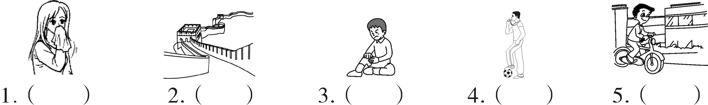
Ⅲ.Listen and choose.（听录音，选择正确的答语。）（每小题读两遍）
( )1.A.Yes,I did. B.Yes,he did. C.Yes,he does.
( )2.A.He works at sea. B.He is a worker. C.He goes to work by plane.
( )3.A.She is reading books. B.She reads books C.She likes reading books.
( )4.A.They go there by plane. B.They went there by plane. C.They went to a park.
( )5.A.It was sunny. B.It’s Thursday. C.It is hot.
Ⅳ.Listen and write．（听录音，写出句子中所缺的单词。）（每小题读三遍）
1.I with my parents last Sunday.
2.There no in our school last year.
3.Zhang Peng is and than Wu Yifan.
4.Please in the library.
5.Look!The rabbit is .The monkeys are .
笔试部分
V.Read and choose.（找出与所给单词画线部分发音相同的单词。）
( )1.look A.foot B.food C.school D.room
( )2.washed A.climbed B.cleaned C.stayed D.watched
( )3.thank A.these B.brother C.both D.with
( )4.tea A.bread B.meat C.heavy D.sweater
( )5.word A.horse B.short C.forty D.world
Ⅵ.Read and choose.（选择最佳答案，并将序号填在题前括号内。）
( )1.— is the hospital? —It’s next to the post office.
A.What B.Where C.When D.How
( )2.—Did you fishing yesterday? —No,I camping.
A.go,go B.went,go C.go,went D.went,went
( )3.Look!Liu Yun a book under a tree.
A.reads B.read C.reading D.is reading
( )4.谚语“问路总比迷路好。”用英语这样表达：
A.Think today and speak tomorrow.
B.All’s well that ends well.
C.Better to ask the way than go astray.
D.Let sleeping dogs lie.
( )5.Children’s Day is on .
A.July 1 st B.June 1 st C.October 1 st D.January l st
( )6.Before,I quiet.Now I very active.
A.am,am B.was,is C.am,was D.was,am
( )7.Chen Jie likes to music.
A.listen B.listening C.listened D.listens
( )8.— shoes are those? —They are Zhang Peng’s.
A.Who B.What C.Whose D.Where
( )9.—What did you do last night？—I did my homework and TV.
A.watch B.watched C.watches D.watching
( )10.—Is your father a postman? — .He is a fisherman.
A.Yes,he is B.Yes,he isn’t C.No,he doesn’t D.No,he isn’t
Ⅶ.Fill the blanks.（用括号内单词的适当形式填空。）
1.There are many (tomato) in this farm.
2.John is (thin) than his father.
3.Our classroom is on the (three) floor.
4.I (buy) some gifts for my friends last weekend.
5.Mike often (go) camping on the weekend.
Ⅷ.Read and write.（根据汉语提示，将下列句子补充完整，每空一词。）
1.Look!Mike is （打羽毛球）with his friend.
2.John （去游泳）last Sunday.
3.Turn left at the （电影院）.Then go （笔直的）.
4.Amy （待）at home and （睡觉）last Saturday.
5.I’m going to the （书店）and buy a new （词典）.
Ⅸ.Read and write.（根据要求，完成下列句子。）
1.Did they clean their room yesterday?（作否定回答）

2.He likes singing and doing kungfu.（就划线部分提问）

3.I’m going to have an art lesson.（就划线部分提问）

4. (. ) （连词成句）
feet
are
than
your
mine
bigger

5. (? ) （连词成句）
last
do
you
what
weekend
did

Ⅹ.Read and choose.（阅读短文，将正确答案序号填到括号里。）
The Road family often do housework together on the weekend.Pam often cleans bedrooms.Her father buys groceries(食品杂货) for the next week.Her mum washes the clothes. John,Pam’s brother,helps to cut grass in their garden.The Roads often ride a bike to the park nearby.In the park they can play basketball and football.They always have a good time there.
It is happy when a family works and plays together.
( )1.—How many people are there in the Road family? —
A.Two. B.Three. C.Four. D.Five.
( )2.The Road family likes to .
A.go on a picnic B.go shopping
C.have a rest D.go to the park
( )3.When the family work together,they feel .
A.tired B.happy C.angry D.sad
( )4. cuts the grass in the garden.
A.Father B.Mother C.Pam D.John
( )5.A good title(标题) for the passage is .
A.A family works and plays together B.Cleaning the rooms
C.A happy family D.Pam and her parents
Ⅺ.Read and judge.（阅读短文，判断正“T”，误“F”。）
Lucy and Lily are twins.They look the same.But they don’t like the same things. Lucy likes drawing cartoons,but Lily likes reading books.Yesterday Lily went to the bookstore,and Lucy went to the supermarket.Their parents took a trip last month.They bought some gifts for their daughters(女儿).They are going to Beijing next holiday.They are very excited.
( )l.Lucy likes reading books.
( )2.Their parents took a trip last year.
( )3.Lucy and Lily don’t like the same things.
( )4.Lily went to the supermarket yesterday.
( )5.Their parents are going to Beijing next holiday.
Ⅻ.Think and write.（想一想，写一写）
同学们，你们的小学生活即将结束，将要离开你们的母校，请你把你的
学校以前和现在的变化用英语记录下来吧。60-80词。

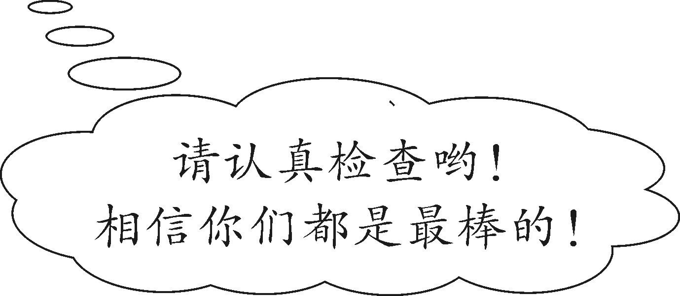
山东临沂市沂水县2016—2017学年度下学期六年级英语毕业测试卷（PEP）

笔试部分
V、1—5 ADCBD
VI、1—5 BCDCB 6—10 DBCBD
VII、1.tomatoes 2.thinner 3.third 4.bought 5.go
VIII、1.playing badminton 2.went swimming 3.cinema;straight 4.stayed;slept 5.bookstore;dictionary
IX、1.No,they didn’t.
2.What are his hobbies?
3.What are you going to do?
4.Your feet are bigger than mine.
5.What did you do last weekend?
X、1—5 CDBDC
XI、1—5 FFTFT
XII、
I’m 12 years old.I will go to the middle school.There wasn’t a library in our school then. But now there is a library in our school. It is next to my classroom. I often read books in it. The playground was old and small then.Now it is big and new.I like playing football with my friends in the playground.I will miss my school.

