玉林市2017年春季期小学学科综合素质调研检测
考点 考场 姓名___________ 考号
……………………………密………………………………………封…………………………………线……………………………
六年级英语试卷

(时间：60分钟 满分：100分）
Listening Part 听力部分（共20分）
一、听录音，选择适当的图画。（每小题1分，共5分）
你将听到五个句子，请根据句子意思，选择适当的图画选项，并将答案填在
各题的横线上。
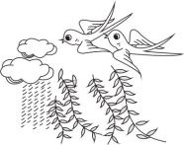
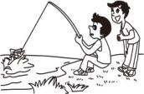
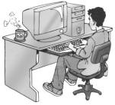
A. B. C.

D. E.

1.________ 2.________ 3.________ 4._______ 5.________
- 听录音，选答语。（每小题1分，共5分）
你将听到五个句子，请根据句子意思，选择正确的应答语。
( )6.A.They’re singing. B.They are my friends.
( )7.A.Yes, I did. B.No, she didn’t.
( )8.A.She is better now. B.She is in Beijing.
( )9.A.Thank you. B.Good idea.
( )10.A.You’re welcome. B.Oh, sorry.
- 听短文，选择正确的答案。（每小题2分，共10分）
你将听到一篇短文，请根据短文内容，选择正确的答案。短文读两遍。
( )11. I live in _________.
A.Canada B.Australia
( )12. I’ve got a __________.
A.sister B.brother
( )13. My mother teaches us ___________.
A.at home B.at school
( )14.We _________ in the afternoon.
A.go swimming B.go skating
( )15.I’m studying __________.
- Chinese B.French
Writing Part 笔试部分（共80分）
四、选出与中文意思相符的单词。（每小题1分，共10分)
( )16.黑色的 A.blue B.black C.brown
( )17. 打扫；清洁 A.call B.close C.clean
( )18.在……之间 A.before B.beside C.between
( )19.飞行(过去式) A.field B.flew C.flyed
( )20.谁的 A.whose B.who C.why
( )21.故事 A.shop B.stop C.story
( )22.卡片 A.car B.card C.candy
( )23.他（宾格） A.his B.him C.he
( )24.十 A.three B.two C.ten
( )25.高高地 A.high B.heavy C.healthy
五、在方框内找出与图片相对应的短语，并将答案填在各题的横线上。（每小题
2分，共 16 分）
A.eat noodles B.some ducks C.carry a bag D.half past nine
E.in the kitchen F.feel sad G.space travel H.sweep the floor

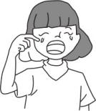
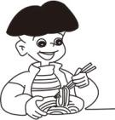
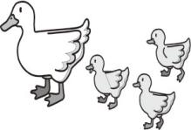
26. 27. 28. 29.

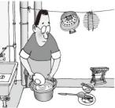
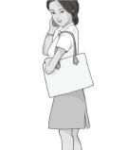
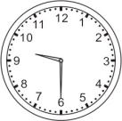
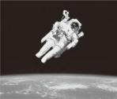
30. 31. 32. 33.

- _________ 27._________ 28._________ 29._________
30._________ 31._________ 32._________ 33._________
六、根据情景,选择最佳答案。（每小题1分，共10分）
( )34.你想了解朋友的爸爸是否喜欢听音乐，这样问：________
A.Does your father like singing a song?
B.Does your father like listening to music?
( )35.朋友问你，长城有多长，这样问：________
A.How long is the Great Wall? B.How big is the Great Wall?
( )36.你告诉朋友，上海有许多超市，这样说：________
A.There are lots of schools in Shanghai.
B.There are many supermarkets in Shanghai.
( )37.玲玲告诉你，她会用英语写故事，这样说：________
A.I can write emails in French. B.I can write stories in English.
( )38.老师告诉你，昆明位于中国的南部，这样说：________
A.Kunming is in the south of China.
B.Kunming is in the east of China.
( )39.过马路时，爸爸告诉你，交通牌示意不要右拐弯，这样说：_____
A.Don’t turn left here! B.Don’t turn right here!
( )40.奶奶告诉你，她在那时没有自行车，这样说：
A.I didn’t have a bus then. B.I didn’t have a bike then.
( )41.你告诉朋友，你将要去拜访在纽约的表妹，这样说：________
A.I will visit my cousin in New York.
B.I will go to New York with my cousin.
( )42.朋友告诉你，Daming昨天又饿又累，这样说：________
A.Daming was happy but tired yesterday.
B.Daming was hungry and tired yesterday.
( )43.在午休时，妈妈告诉你，请保持安静，这样说：________
A.Please be quiet. B.Please come back.
七、单项选择。（每小题2分，共20分）
( )44.I eat________ egg and ________ bread every morning.
A. an; a B.a; an C.an; some
( )45.________Saturday，I’ll go to the park.
A. On B. At C.In
( )46.Look! The horse is________.
A. runs B. runing C.running
( )47.In ________, he often walks in the snow.
A.summer B.autumn C.winter
( )48.My teacher ________ very young.
A.am B.is C.are
( )49.This farmer is deaf. He can’t ________.
A.see B.hear C.cry
( )50.—Have you got any stamps from the US? —Yes,_______.
A.I have B.I can C.I do
( )51.Simon _______ a book about science yesterday.
A.readed B.reads C.read
( )52.These are ________. They are small but clever.
A.monkeies B.monkeys C.monkey
( )53.Jack and Ben play basketball _________.
A.nice B.good C.well
八、从右侧找出相对应的句子补全对话。(每小题2分，共14分）
( )54.Will it be cloudy tomorrow? A. It’s red.
( )55.Good luck for the future. B. No, it won’t.
( )56.What colour is your coat? C. There are four.
( )57.How many people are there in your family? D. He lived in a village.
( )58.Can you help me? E. Thank you.
( )59.Where did your uncle live five years ago? F. Because it’s hot.
( )60.Why did the dog sit under the tree? G. No problem.
九、按要求完成下列句子。（每小题5分，共10分）
(正确抄写每小题2分，翻译每小题3分，共10分）
61.I want to go to Beijing.

______________________________________________________________
62.When are you going to eat?

______________________________________________________________

玉林市2017年春季期小学学科综合素质调研检测
笔试部分参考答案

四、16—20 BBCCBA 21—25 CBBCA
五、26—30 BABCB 31—33 DCE
六、34—38 BABBA 39—43 BBABA
七、44—48 AACCB 49—53 BACBC
八、54—58 BEACG 59—60 DF
九、61.我想要去北京。
62.你什么时候去吃饭？

