武江区期末教学目标检测
考点 考场 姓名___________ 考号
……………………………密………………………………………封…………………………………线……………………………
小学六年级英语试卷

(时间：60分钟 满分：100分）
Listening Part 听力部分（共40分）
一、听录音，选出你所听到的一项，并将其序号填在题前括号内。（10分）
( )1.A.hospital B.hotel C.hobby
( )2.A.subway B.bus C.ship
( )3.A.factory B.straight C.country
( )4.A.angry B.happy C.afraid
( )5.A.fisherman B.worker C.postman
( )6.A.science B.stay C.supermarket
( )7.A.tomorrow B.tonight C.next week
( )8.A.take a trip B.see a film C.visit grandparents
( )9.A.go straight B.turn right C.slow down
( )10.A.studies Chinese B.goes hiking C.does homework
- 听录音，根据你所听到的信息，用阿拉伯数字给下面的图片标上序号。（10分）
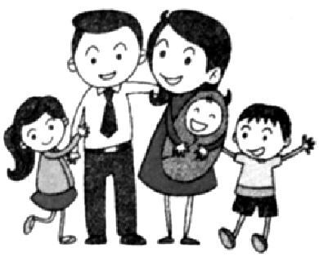
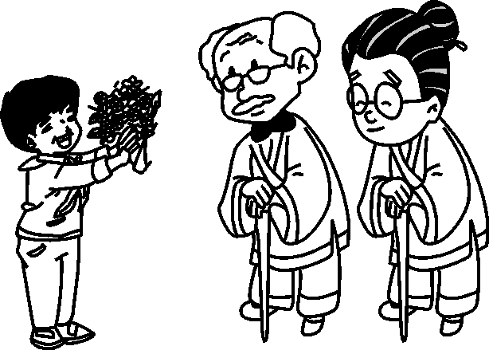
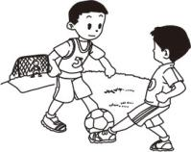
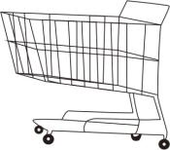
( ) ( ) ( ) ( ) ( )
- 听录音，根据你所听到的信息，选择合适的图片与下列人名配对，并将图片的序号填在括号内。（10分）
1.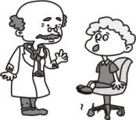 2.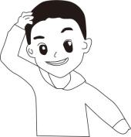 3.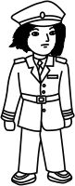 4.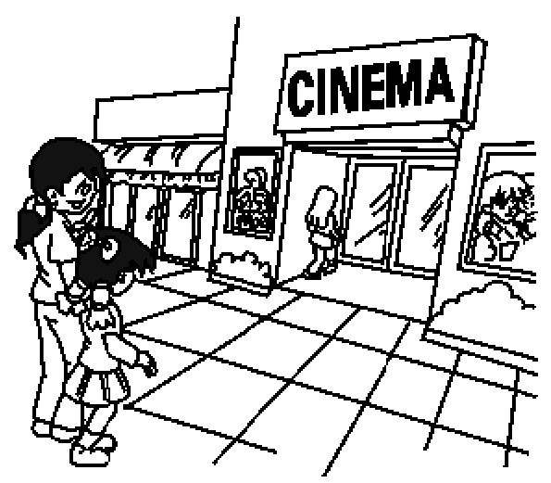 5.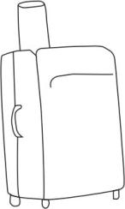
A B C D E
Chen Jie Sarah Mike Miss Li Oliver
( ) ( ) ( ) ( ) ( )

四、听录音，根据所听内容，从方框中选择正确的一项把句子补充完整，并将
其序号写在横线上。（10分）

A.on foot B.Where C.wear warm clothes D.hobbies E.likes
1. —What are Peter’s _________?
—He _________ reading stories.
2. —_________ are you going this weekend?
—I’m going to the bookstore.
3.I usually go to school _________.
4.Amy is cold. She should _________.

Writing Part 笔试部分（共60分）
五、从下列每组单词中找出与所给单词同类的一项，并将其序号填在题前括号内。（10分）
( )1.train A.school B.ship C.ask
( )2.go straight A. museum B.pen pal C.turn right
( )3.next week A.tomorrow B.wear C.country
( )4.worker A.pilot B.gym C.count
( )5.worried A.more B.afraid C.comic book
六、从方框中选择合适的单词或词组与下列图片配对，并将其正确地抄写在图片下面的四线格中。（10分）
turn left comic book do more exercise hospital pilot
by bus fisherman visit grandparents see a film angry

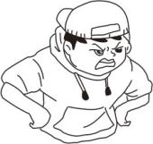
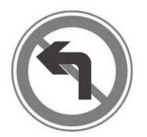

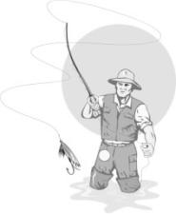
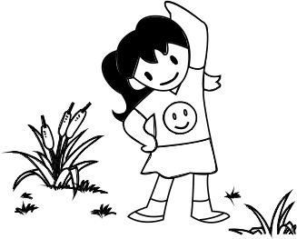

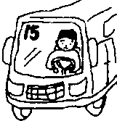
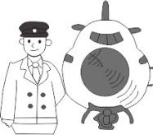
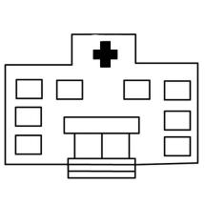
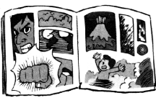

七、根据图片的意思，选择最合适的句子，并将其序号写在图片下方的括号内。（10分）
1. It’s cold today, you should wear warm clothes.
2. Don’t be angry. You should take a deep breath and count to ten.
3. I’m ill. I’m going to see a doctor.
4. Bingbing is happy.
5. Stop and wait at a red light.
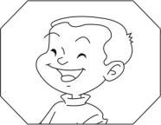
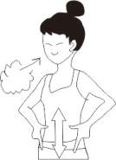
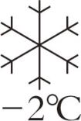
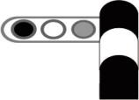

( ) ( ) ( ) ( ) ( )

八、选择正确的一项，把句子补充完整，并将其序号填在题前括号内。（10分）
( )1.Sarah _______ every weekend.
A. watch TV B. watches TV C. looks TV
( )2.—Where is the supermarket? —It’s _______ the hospital.
A. next to B. next C. behind to
( )3. Mr Lin likes ________ Chinese food.
A. cook B. cooking C. cooks
( )4.—What are you going to do tomorrow?
—I _____________ a film with my father.
A. see B. seeing C. am going to see
( )5.— ______ does your mother go to work? —By car.
A.How B. What C. Where
九、按要求答题。（10分）
(一）根据上下文提示，从方框中选择合适的单词把短文补充完整，并将其
序号填在横线上。（5分）
A.likes B.worker C.driver D.bike E.be

Hi, I’m Zhang Lin! Please come and meet my family! Look, this is a photo of my family. This is my father. He is tall. He is a ________. He drives the bus every day. This is my mother. She works in a factory. She is a ________. She goes to work by ________. Look at the tall boy. He is my brother. He ________ playing basketball. He is going to ________ a basketball player. The man and the woman are my uncle and aunt .They’re police officers. I’m a student. I can speak English well. I love my family.
- 阅读上面的短文，判断下列句子的意思是否与上文相符，相符的打“√”，不相符的打“×”。（5分）
( )1.Zhang Lin’s father is a driver.
( )2.Zhang Lin’s mother is a police officer.
( )3.Zhang Lin’s brother is going to be a basketball player.
( )4.Zhang Lin’s uncle and aunt are teachers.
( )5.Zhang Lin can speak English.
十、阅读理解。（10分）
Mike:What are you going to do this afternoon?
John:I’m going to visit my uncle.
Mike:How are you going to get there?
John:I’m going to get there by subway.
Mike:Where dose he live?
John:He lives next to the bookstore. Turn right at the crossing, and then go
straight. His home is on the right.
Mike:I’m going to the bookstore this afternoon. Let’s go together after lunch.
John:OK.

阅读上面的对话，根据对话的内容，选择恰当的一项把句子补充完整，并
将其序号填入题前括号内。
( )1. John is going to _________.
A. go hiking B.visit his uncle C. the bookstore
( )2. John’s uncle lives _________ the bookstore.
A.next to B. in front of C. behind
( )3. Mike is going to the _________.
A. post office B. bookstore C. uncle’s home
( )4.John is going by _________.
A. subway B.bus C. bike
( )5. Mike and John are going to go together _________.
A .tomorrow B. after lunch C. next week

十一、书面表达。（5分）

寒假就快到了，你有什么计划吗？请参考下列词汇，写一写你的寒假计划，要求不少于5句话（开头已给出，但不计入词数）。
参考词汇：read books, take a trip, see a film, do homework, clean my room, wash my clothes, go to the supermarket, visit my grandparents
Winter vacation（寒假） is coming. I’m going to study English. . ____________________________________________________________________________________________________________________________________________________________________________________________________________________________________________________________________________________
武江区2016-2017学年度第一学期期末教学目标检测
笔试部分参考答案

四、1.D;E 2.B 3.A 4.C
五、1—5 BCAAB
六、1.visit grandparents 2.turn left 3.angry 4.see a film
5.fisherman 6.do more exercise 7.hospital 8.pilot
9.by bus 10.comic book
七、4 1 5 3 2
八、1—5 BABCA
- CBDAE 1—5 √ × √ × √
- 1—5 BABAB
- （范文）
Winter vacation is coming. I’m going to study English. Because English is very important to us. And I will visit my grandparents with my parents. I love them so much. I’m also going to take a trip with my parents. Oh, what a rich and colourful winter vacation!

