江西南昌青云谱区2016-2017学年度毕业检测试卷
六年级（PEP）英语
（100分钟完成）
题号 | Ⅰ | Ⅱ | Ⅲ | Ⅳ | Ⅴ | 总分
满分值 | 30 | 25 | 15 | 20 | 10 | 100
实得分
听力部分 （30分）
Ⅰ.听力测试。（30分）
A.听对话，选图。从A、B两幅图画中选出与对话内容相符的图，将其填入括号 内，每段对话读两遍。本大题共10小题，每小题一分。（共10分）

B.听对话，选答案。请听七段对话，听完回答问题，从选项中选出与对话相符的一项，并填入括号中。每段对话读两遍，共七小题，每小题一分。（共7分）
( )1.A.worker B.fisherman C.scientist
( )2.A.15 B.50 C.55
( )3.A.bike B.bee C.buy
( )4.A.wash B.catch C.watch
( )5.A.play B.plant C.Plane
( )6.A.actor B.actress C.artist
( )7.A.October B.November C.December
C.听问句，选答语。请听五段对话，听完回答问题，从选项中选出与对话相符的答语，每段对话读两遍，每小题一分。（共5分）
( )1.A.I’m heavy. B.I’m 21 years old. C.I’m young.
( )2.A.He cleans the room. B.She cleans the room. C.I can clean the room.
( )3.A.I am fine. B.I am fifteen. C.I am five.
( )4.A.It’s blue. B.It’s a book. C.It’s a rabbit.
( )5.A.I often go by bus. B.I am going by bus. C.I went to school by bike.
D.听录音，完成短文。请听对话，并将所听内容填入空格中，每段对话读两遍。每小题1分。（每空只填一词，共8分）
Hello,I have a good .Her name is Lily.She is than me.she is 13, I’m 14.She is one year than me.She doing Kung fu.This weekend,We are to the post to buy stamps.We like making pen .We are very .
笔试部分 （70分）
Ⅱ.基础知识应用（25分）
A.选出划线部分读音与其余三个不同的单词。（共5分）
( )1.A.hand B.give C.map D.plan
( )2.A.went B.bed C.me D.get
( )3.A.heavy B.sleep C.weekend D.meet
( )4.A.car B.father C.warm D.hard
( )5.A.start B.car C.father D.swim
B.按要求选出相应的单词，并把它们填在横线上。（每个0.5分，共10分）
Yellow baseball basketball T-shirt green notebook volleyball
eraser blue hat pencil tennis coat soccer
black shoe ruler sock pen white

1.球类单词
2.颜色类单词
3.文具类单词
4.服装类单词
C.连词成句。（注意标点符号与大小写。每小题2分，共10分）
1.mine，is，picture，yellow，the.

2.to，Wanda，Park，get，I，can，how?

3.help，me，my，could，lessons，you，with?

4.tomorrow，are，where，they，going?

5.angry，cat，the，is，them，with.

Ⅲ.日常交际（15分）
A.从方框中选择正确的应答语。（每小题1分，共5分）
( )1.Do you have a good time?
( )2.When are you going to the bookstore?
A.He is 55 kg.
B.At 3:00 o’clock on Saturday.
C.Yes,we do.
D.By plane.
E.She works in a library.

( )3.How heavy is your brother?
( )4.Where does your sister work?
( )5.How do people go to Beijing?
B.根据所给的情景，选择合适的一项完成对话（其中有两个多余选项），并把相应选项
的字母标号写在题后的横线上。（每小题2分，共10分。）
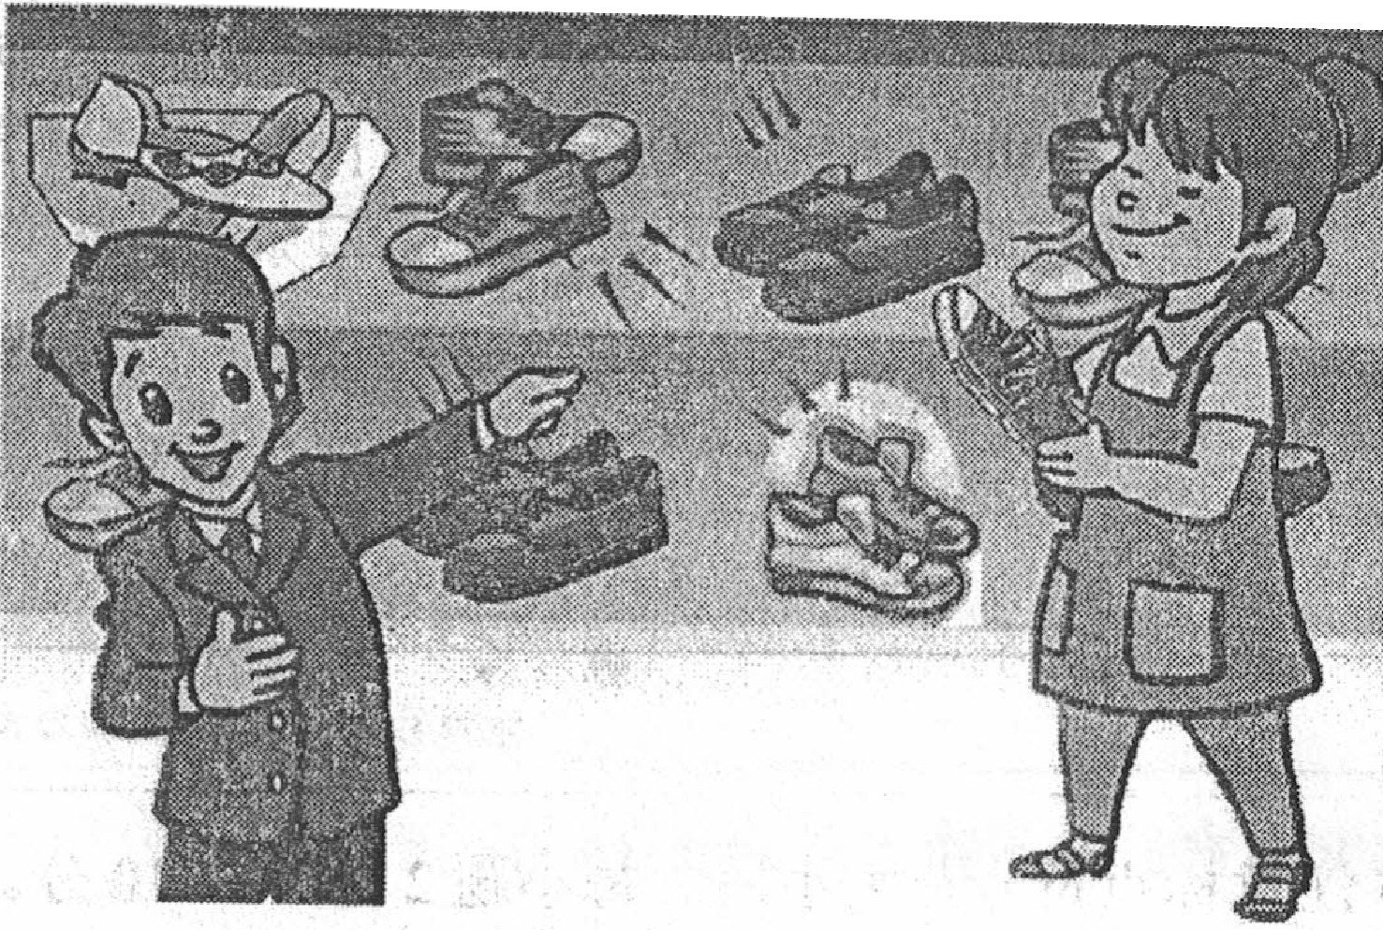

Saleswoman:Can I help you?
Bill:l.
A.Bye-bye.
B.It’s a black bag.
C.Great!
D.How are you?
E.Yes,I want to buy a pair of shoes.
F.Here is the money.
G.Red.

Saleswoman:What colour do you like?
Bill:2.
Saleswoman:How about this pair?
Bill:3. How much are they?
Saleswoman:20 yuan.
Bill:4. Bye-bye.
Saleswoman:5.
Ⅳ.阅读理解（每小题2分，共20分）
A
There is a girl.Her name is Cathrine.She has a cat.It’s an English cat.Her friends are Amy and Barbara.They have cats,too.They are Chinese cats.The English cat is four.The Chinese cats are both(都) two.They all like their cats.
Now they can’t see their cats.They think(认为) their cats are in the tree.They go there and carry(抱) them down.
根据短文内容，选择最佳选项。
( )1.Cathrine has a good cat.
A.English B.Chinese C.American D.Japanese
( )2.Cathrine has friends.
A.one B.two C.three D.four
( )3.The English cat is and the Chinese cats are .
A.two,two B.two,four C.four,two D.four,four
( )4.—Where are the cats? —They are .
A.in the tree B.on the floor C.behind them D.under the tree
( )5.Do they like their cats?
A.No,they don’t. B.Yes,they do. C.Yes,they don’t. D.No,they do.
B
One afternoon when the lessons are over,Peter and Paul do not go home.They stay at school to help their teacher.They work for an hour.
When the boys reach(到达) home,it is seven o’clock.It is dark outside,but there is light inside(在…里面) their home and the door is open.
“Who can it be?”says Peter,he smiles and says,“Come in! You don’t know me,but I am your father’s friend.He asks me to get some money for him.”The man does not see Paul.
Peter goes inside and begins talking to the man,but Paul does not.He quickly goes away to call a policeman.The policeman comes and catches(抓住) the man.
根据短文内容，选择最佳选项。
( )1.Peter and Paul stay at school .
A.until the school is over B.until seven o’clock
C.until eight o’clock D.for an hour
( )2.Their home is bright because .
A.it is still early B.their father is at home
C.it is dark outside D.a man is inside
( )3.Paul and Peter .
A.are helpful and clever B.are afraid of the man
C.are often late for school D.try to catch the man
( )4.Paul went away to .
A.call the police B.say to others
C.telephone their parents D.tell his friends
( )5.From the story we know .
A.the policeman knows the man is inside Paul’s home
B.Peter calls the policeman
C.Peter and Paul’s teacher needs help
D.their parents go shopping,but they don’t take enough money with them
Ⅴ.作文（共10分）
同学们，暑假就要到了，你一定做好自己的打算和计划了吧！快写下来和大家分享一下吧！要求：书写规范；时态正确；人称、句子结构准确；不少于60词。
Summer vacation is coming！I have a lot of plans.First

江西南昌青云谱区2016—2017学年度毕业检测试卷
六年级（PEP）英语

笔试部分
II、A 1—5 BCACD
B 1—5 1.baseball basketball volleyball tennis soccer
2.yellow green blue black white
3.notebook eraser pencil ruler pen
4.T-shirt hat coat shoe sock
C 1.The yellow picture is mine.
2. How can I get to Wanda Park?
3.Could you help me with my lessons?
4.Where are they going tomorrow?
5.The cat is angry with them.
III、A 1—5 CBAED
B 1—5 EGCFA
IV、A 1—5 ABCAB
B 1—5 DDAAC
V、
I plan to go to Beijing with my parents this summer vacation.We are going there by plane. We’ll visit the Great Wall, the History Museum and Tian’anmen Square.We’ll stay there for five days.I’m very excited.Second I will help my mother to do some housework.I’m helpful.

