湖北应城市2017年小学毕业会考
英 语 试 题（PEP）
(考试时间40分钟，试卷共100分)
题号 | 听力部分 |  |  | 笔试部分 |  |  |  |  |  | 总分
 | Ⅰ | Ⅱ | Ⅲ | Ⅳ | Ⅴ | Ⅵ | Ⅶ | Ⅷ | Ⅸ
得分
听力部分（40分）
Ⅰ.听音选词。选出你所听到的单词或词语。（10分）
（ ）1.A. thinner B.bigger C.heavier
（ ）2.A.dining hall B.hospital C.post office
（ ）3.A. Monday B.Wednesday C.Sunday
（ ）4.A. hamburger B.bread C.sandwich
（ ）5.A. hot B.cold C.warm
（ ）6.A. Jan.15 th B.Sept.12 th C.Dec.3 th
（ ）7.A. breakfast B.lunch C.dinner
（ ）8.A. go shopping B.go hiking C.go cycling
（ ）9.A. saw a film B.rode a bike C.hurt my foot
（ ）10.A.turn left B.go straight C.turn right
Ⅱ.听音选图。选出与你所听到内容相符的图片，将其字母编号填入题前括号内。（20分）

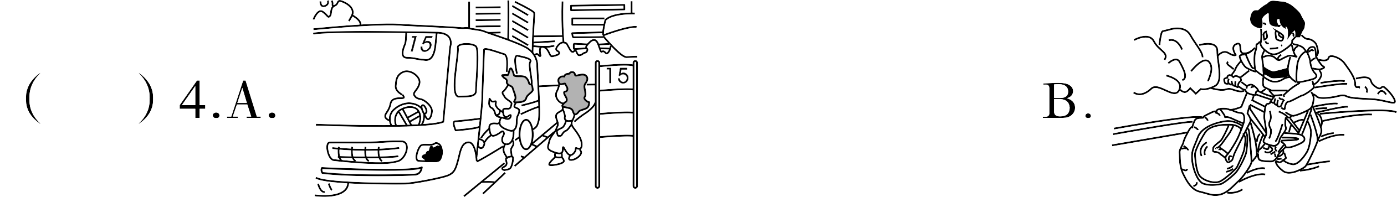

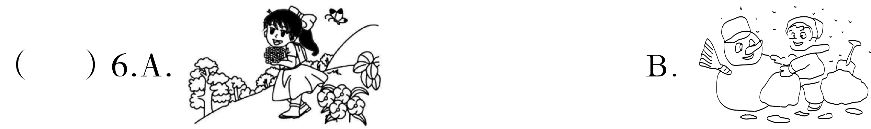

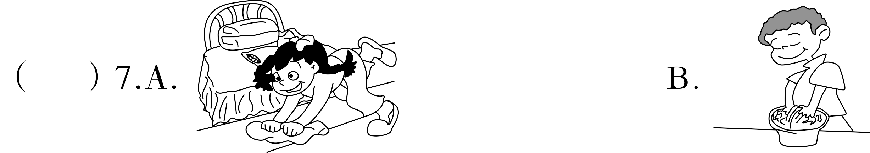

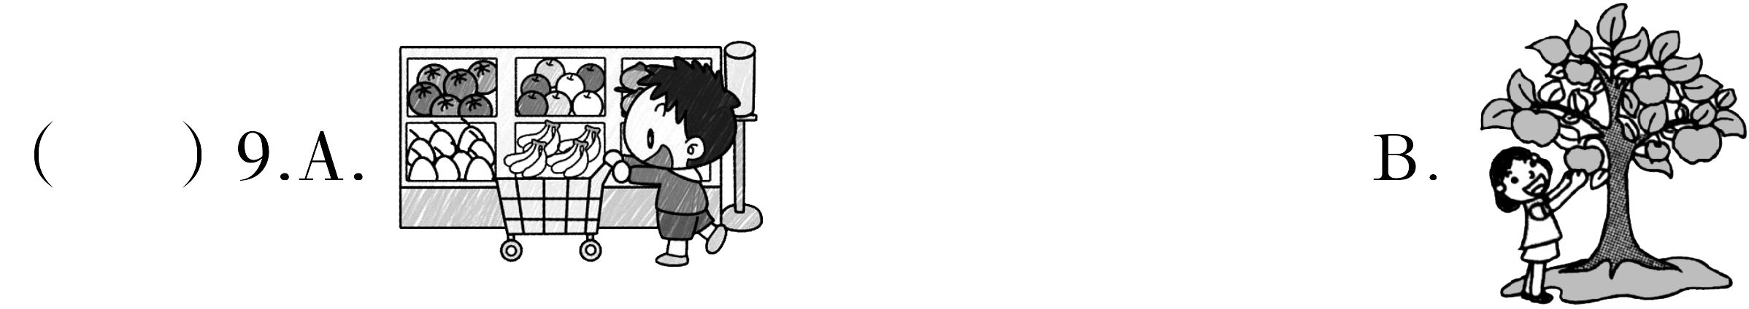

Ⅲ.听音排序。根据录音内容的先后顺序，用1-5给下列图片排序。（10分）
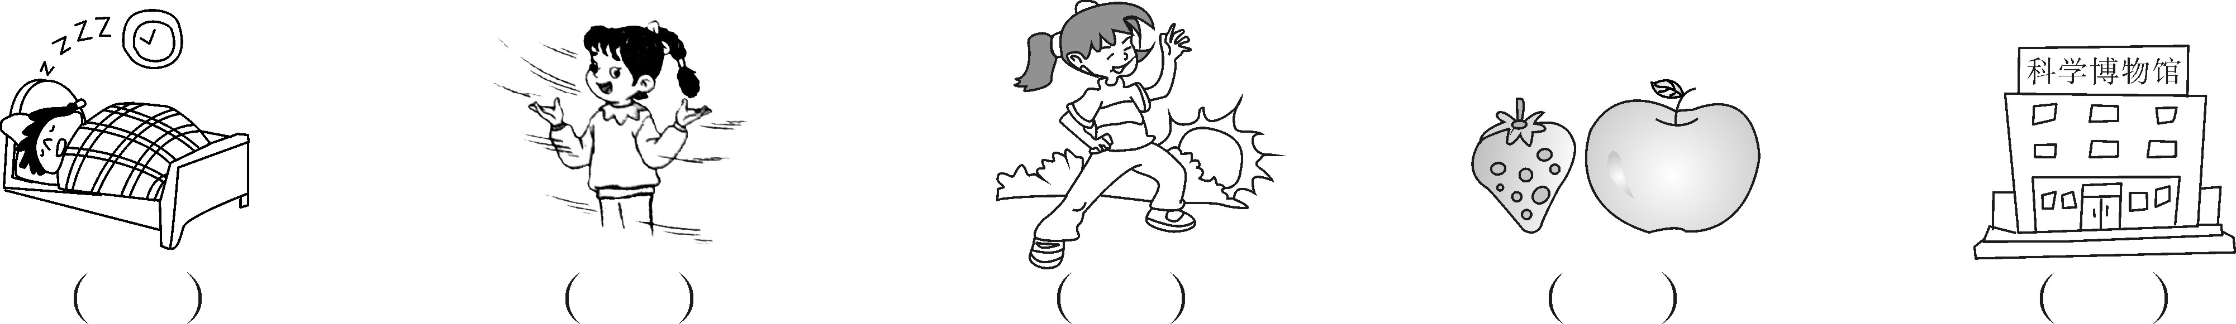
笔试部分（60分）
Ⅳ.从方框中选择合适的词或短语完成句子，将其字母编号填入题前括号内。（10分）
A.stayed at home B.taller C.gym D.businessman E.on foot
（ ）1.There was a in our school.We often played sports there before.
（ ）2.I and watched TV last weekend.
（ ）3.Mike is 1.68 metres.He is than me.
（ ）4.My home is not far from the school.So I usually go to school .
（ ）5.—What does your father do? —He is a .
Ⅴ.单项选择。（10分）
（ ）1.I can play football.But I can’t play piano.
A.the,the B.the,/ C./,the
（ ）2.—Is your mother?
—No,she isn’t.She is teacher.
A.her,my B.she,my C.she,I
（ ）3.There many trees in front of the river 10 years ago.
A.was B.were C.weren’t
（ ）4.March is the month of a year.
A.first B.second C.third
（ ）5.An elephant is usually than a dog.
A.heavier B.smaller C.shorter
（ ）6.Steven is going to some gifts for his friends this afternoon.
A.buy B.bought C.buys
（ ）7.There is a dance class Sundays 2 p.m.
A.in,on B.on,in C.on,at
（ ）8.—When did you go to Beijing? — .
A.Last Friday B.Tomorrow C.Next Friday
（ ）9.Jack is 11 years old.Sam is 14 years old.Jack is than Sam.
A.2 years older B.3 years younger C.3 years older
（ ）10.He books in the morning before.But now he often
in the evening.
A.readed,reads B.read,reads C.reads,reads
Ⅵ.根据问句或答语提示，连词成句。（注意首字母大写）（10分）
1.What are you going to buy?
going，a，buy，comic book，I，to，am(.)

2.teacher，your，is，father，a(?)

No,he isn’t.He is a doctor.
3.did，yesterday，where，go，you(?)

I went to a forest park.
4.you，how，are，heavy(?)

I am 50 kilograms.
5.film，you，a，night，see，did，last(?)

Yes,I did.
Ⅶ.从方框中找出下列问句相对应的答语，将其字母编号填入题前括号内。（10分）
（ ）1.When do you often get up?
A.It’s next to the park.
B.At seven o’ clock.
C.By taxi.
D.It’s windy and cool.
E.I like singing and dancing.
（ ）2.What’s the weather like today?
（ ）3.What are your hobbies?
（ ）4.How do we get there?
（ ）5.Where is the cinema?
Ⅷ.从方框中选择合适的句子完成对话，将其字母编号填在横线上。（10分）
A:Welcome to our shop.1.
A.How tall is your daughter?
B.How much is it?
C.What about this one?
D.Can I help you?
E.What colour does she like?
B:Yes.I want to buy a dress for my daughter(女儿).
A:2.
B:Red.
A:3.
B:Oh!It’s nice.But it looks a little small.Do you have a bigger one?
A:Of course.4.
B:About 1.4 metres.And she is thin.
A:I see.Is this one OK?
B:Yes,it’s just right.5.
A:It’s 80 yuan.
B:OK.I’ll take it.Here is the money.
Ⅸ.阅读理解。读短文，选择正确的选项。（10分）
Today was a sunny day.Wang Hao’s family went to the countryside.In the morning they rode bikes.Their dog,Huahua sat behind Wang Hao’s bike.That was fun!They took some beautiful pictures.They bought some fruit and had lunch in a small restaurant.After lunch,Wang Hao ate two ice creams and then he didn’t feel well.So they stayed in the hotel.Dad and Mum wanted to make Wang Hao happy.They told some funny stories. Wang Hao langhed and laughed.It was a bad day,but also a good day!
（ ）1.Wang Hao’s family went to .
A.his grandparents’ house B.a farm C.the countryside
（ ）2.They in the morning.
A.rode bikes B.climbed the mountain C.watched TV
（ ）3.Wang Hao ate and didn’t feel well.
A.some vegetables B.some ice cream C.some fruit
（ ）4.Wang Hao’s family stayed in the afternoon.
A.at home B.outside C.in the hotel
（ ）5.Dad and Mum to make Wang Hao happy.
A.told some funny stories B.made a play C.read a book

湖北应城市2017年小学毕业会考
英语试卷（PEP）

笔试部分
IV、1—5 CABED
V、1—5 CBBCA 6—10 ACABB
VI、1.I am going to buy a comic book. 2.Is your father a teacher? 3.Where did you go yesterday? 4.How heavy are you? 5.Did you see a film last night?
VII、1—5 BDECA
VIII、DECAB
IX、1—5 CABCA

