考点 考场 姓名___________ 考号
……………………………密………………………………………封…………………………………线……………………………
湖南岳阳2016年上学期期末考试题
六年级英语
（时间：60分钟 满分：100分）
Listening Part 听力部分（共40分）
一、根据你听到的十个句子，选出你所听到的单词。（10分)
( )1.A.left B.right C.straight
( )2.A.subway B.bus C.stop
( )3. A.tonight B.today C.tomorrow
( )4. A. angry B.happy C.sad
( )5. A. stronger B.shorter C.bigger
( )6. A.cleaned B.washed C.watched
( )7. A.grass B.gym C.go cycling
( )8. A. meter B.kilogram C.heavy
( )9. A. quiet B.active C.funny
( )10.A. Monday B.Tuesday C.Thursday
二、下面你将听到五段对话，请你根据录音内容，选择正确的图片。（10分)
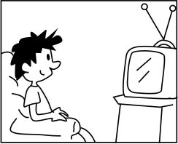
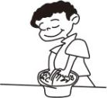
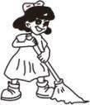
( )11.A. B. C.

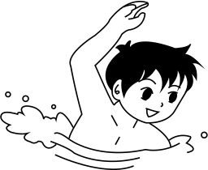
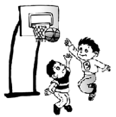
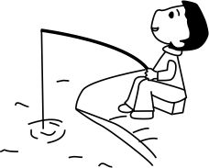
( )12.A. B. C.

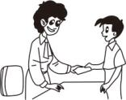
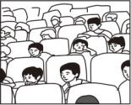
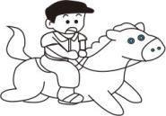
( )13.A. B. C.

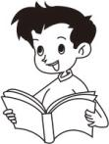
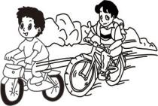
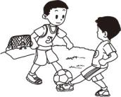
( )14.A. B. C.

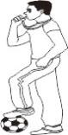
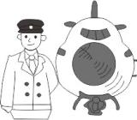
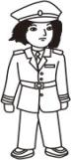
( )15.A. B. C.

三、下面你将听到五个问句，请从选项中选出能冋答该问题的答语。（10分)

( )16.A.I’m1.65m. B.I’m 48kg. C.Size 37.

( )17.A.I watched TV. B.It was great. C.Thanks.

( )18.A.See a film. B.No, he didn’t. C.It was funny.

( ) 19.A.He is a doctor. B.He goes to work on foot.
C.He works in a factory.
( ) 20.A.Mike. B.At 3:00 p.m. C.Our music room.

四、听短文，请根据录音内容，选择相应的选项。 （10分)
A.busy B.played computer C.cleaned my room
D.In the morning E.In the afternoon

Saturday was a 21 day for me. 22 , I got up early. Then I had breakfast. After that, I 23 . Next, I went fishing. 24 , I read a storybook. In the evening I 25 . Finally, I went to bed at 10:00p.m.

21.________ 22.________ 23.________ 24.________ 25.________

Writing Part 笔试部分（共60分）
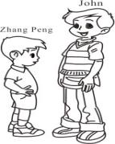
五、请根据图片或汉语提示完成下列句子。（10分)
26. Zhang Peng is ___________ than John.

- John____________last Sunday.

- Wu Yifan went to XinJiang and __________（寻找）his friends.

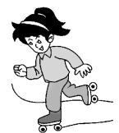
- I like winter, because I love to___________.

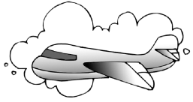
- I went to Canada by ______________.

- 请在A.B.C三个选项中选择正确答案完成句子，并将其序号填在题前的括号内。（10分)
( )31. —_______are you?
—I’m 1.65m.
A.How heavy B.How tall C. How many
( )32.Those shoes in the window ______ nice.
A.is B.an C. are
( )33.I stayed at home _______ your grandpa.
- about B.with C. in
( )34.Did you _______ pictures over your holidays?
A. take B.took C.taking
( )35.One day I’m_______ visit the moon.
A.go to B.going to C. goes to
- 请将每小题中的单词连接成一个没有错误的句子，并写在四线格上。（10分)
- both of us It’s than taller together (.)
_______________________________________
_______________________________________
_______________________________________
_______________________________________
- You do exercise more should (.)
_______________________________________
_______________________________________
_______________________________________
_______________________________________

- was library no There in my school (.)
_______________________________________
_______________________________________
_______________________________________
_______________________________________

- pay attention to must the traffic lights I (.)
_______________________________________
_______________________________________
_______________________________________
_______________________________________

- looks a mule like It (.)
_______________________________________
_______________________________________
_______________________________________
_______________________________________

八、给问句选择正确的答语，并将字母序号填在题前的括号内。（10分)
( )41.What happened? A.Yes, we did.
( )42.How did you go to the cinema? B.My mother.
( )43.Did you do anything else? C.I went there by subway.
( )44.Who did you go with last weekend? D.At 9:00 a.m.
( )45.When are you going to Children’s Center? E.I fell off my bike and hurt my foot.

九、请先阅读下面的短文，然后根据其内容，判断下列句子的对错，对的写“T”，
错的写“F”。（10分)
Dear friends,
It is time to leave our school.We are all going to middle school soon,so we will say
goodbye to each other. We are going to have a farewell party.You can bring your friends.
We will draw pictures and sing songs.We are going to give prizes for the best pictures.We are going to have cake,candy and juice,too. Have a good time!
Place: Our music room Time: Friday 3 p.m.
See you at the party!
( )46. This is a birthday party.
( )47. We can draw pictures and sing songs at the party.
( )48.You can’t bring your friends to the party.
( )49. The party is on Saturday 3 p.m.
( )50. We’ll have some delicious food at the party.
十、请先仔细阅读下面的短文，然后根据短文内容答题。（10分)
Hello! My name is Mike. I am an American boy.I’m 12 years old. I have a sister. She is two years younger than me .We study in Beijing. We usually go to school on foot.
My father and my mother are teachers. They work in a middle school. It’s very far. They go to work by subway. They work very hard. I love them.
Last weekend our family went to Mt. Tianshan, Xinjiang. We took many beautiful pictures and saw lots of grapes there. We couldn’t eat the grapes, because they won’t be ready till August. We were very happy.
（一）阅读短文，选择正确的答案。
( )51. How old is Mike’s sister ?
A.She is 12. B.She is 14. C. She is 10.
( )52.Is Mike an English boy?
A.Yes, he is. B.I don’t know. C.No, he isn’t.
( )53.How does he usually go to school ?
A.On foot. B.By bus. C.By subway.
（二）阅读短文，回答问题。
54.Where did Mike’s family go last weekend?
_______________________________________
55.What did they do in Xinjiang?
_______________________________________

湖南岳阳2016年上学期期末考试题
笔试部分参考答案

五、26.shorter 27.watched TV 28.look for 29.ice-skate 30.plane
六、31—35 BCBAB
七、36.It’s taller than both of us together.
37.You should do more exercise.
38.There was no library in my school.
39.I must pay attention to the traffic lights.
40.It looks like a mule.
八、41—45 ECABD
九、46—50 FTFFT
十、51—53 CCA
54.They went to Mt. Tianshan, Xinjiang.
55.They took many beautiful pictures and saw lots of grapes.

