湖南株洲芦淞区小学毕业水平测评卷
英语试卷
（时间：60分钟 满分：100分）

Listening Part 听力部分（共40分）
一、听音，写出你所听单词的第一个字母的大、小写。（6分）
考点 考场 姓名___________ 考号
……………………………线………………………………………封…………………………………密……………………………
1. 2. 3. 4. 5. 6.
二、听句子，用字母A-F给下列图片标号。（6分）
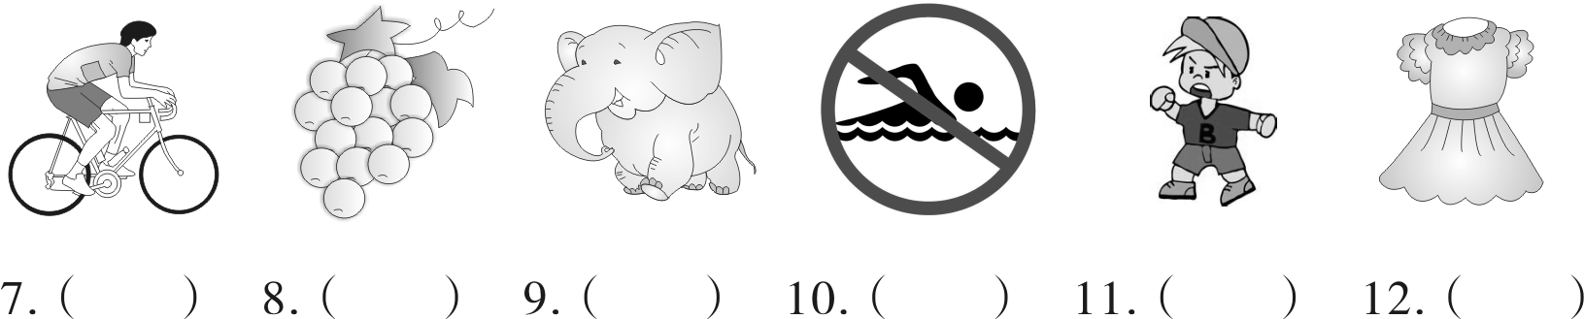

三、听句子，选择你所听到的内容。（6分）
（ ）13.A.hiking B.holiday C.heavy
（ ）14.A.best B.boat C.bed
（ ）15.A.sad B.cat C.tired
（ ）16.A.Chinese B.clean C.climb
（ ）17.A.uncle B.aunt C.doctor
（ ）18.A.party B.card C.hurt
四、听对话，选择正确的选项补全句子。（7分）
（ ）19.Peter’s weekend was . A.busy B.happy
（ ）20.John learned yesterday. A.music B.English
（ ）21.Mike is going to the . A.bookstore B.shoe shop
（ ）22.Sam is than Amy. A.shorter B.taller
（ ）23.Tim is . A.sleeping B.eating
（ ）24.Sarah did her homework on Sunday . A.morning B.afternoon
（ ）25.Linda went to Beijing by . A.bus B.plane
五、听对话，判断下列图片与所听内容是（T）否（F）相符。（5分）
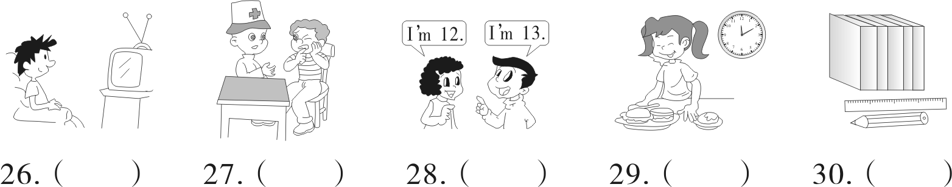

六、听长段对话，根据所听内容判断下列句子正误（T/F）。（5分）
（ ）31.Ben likes the white cat.
（ ）32.The black cat’s tail is 10 cm long.
（ ）33.The white cat is bigger and funnier.
（ ）34.The two cats are 50 yuan.
（ ）35.Ben and Mary can’t have the cats.
七、听录音，在横线上填出所缺的信息。（5分）

I was so happy last week.On Monday I went to a restaurant with Lisa.We ate (36) noodles and some fruit.On Tuesday I (37)
ping-pong.On Wednesday I went to a (38) with Jim.We (39)
many monkeys there.We took many pictures.On Thursday I went shopping.I bought a pretty dress.On (40) I went to Changsha.I had a good time last week.

Writing Part 笔试部分（共60分）
一、根据图片41-46和首字母提示，补全下列句子。（12分）
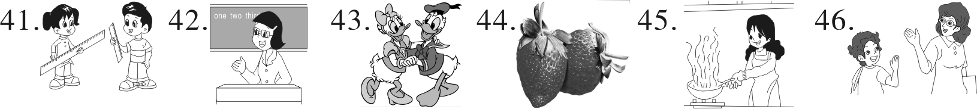

41.The girl’s ruler is l than the boy’s.
42.The woman is a teacher.She works in a s .
43.The two lovely ducks sang and d last night.
44.The strawberries are r .
45.Sarah is going to c dinner for us.
46.When(当……的时候) I see my teacher,I say “ ” to her.
二、读一读，判断下列句子的正（T）误（F）。（12分）
（ ）47.This is a 4-day trip.
（ ）48.Jim is going to Guangzhou in July.
（ ）49.Jim is going to Guangzhou with his grandparents.
（ ）50.Jim is going to Guangzhou by plane.
（ ）51.Jim is going to visit his parents.
（ ）52.Jim is going to Changlong Zoo.
Jim’s Trip Plan
Where to go:Guangzhou
When to go:July 5-10
Who to go with:parents
How to get there:by plane
What to do:visit Changlong Zoo
take pictures buy presents

三、读一读，选择最佳选项的编号填在题前的括号内。（7分）
Today is July 10th.It is Tom’s birthday.He is 12 years old.His friends,Sam and Mary 53 in his home. 54 parents buy him a big birthday cake.It’s 55 the table.Sam gives him a 56 ,because he likes music very much.Mary buys him a toy bear,because bear is his 57 animal.After dinner,they sing “ 58 ”song to him.Then they eat the birthday 59 .Tom likes the party.
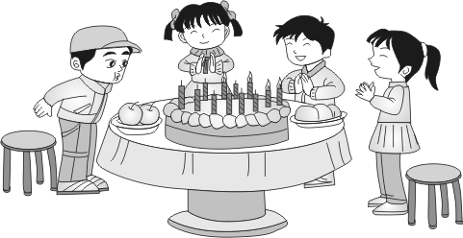
( )53.A.am B.are
( )54.A.His B.Her
( )55.A.on B.under
( )56.A.CD B.T-shirt
( )57.A.kind B.favorite
( )58.A.Good Morning B.Happy Birthday
( )59.A.card B.cake
四、读一读，将答句的编号写在相应问句前的括号内。（10分）
( )60.How many flowers do you have? A.It’s 100 yuan.
( )61.What time do you usually get up? B.It’s rainy.
( )62.How much is the T-shirt? C.She is my sister.
( )63.What’s the weather like today? D.I get up at 7:30.
( )64.Who’s that woman? E.I have 11 flowers.
五、读一读，根据短文内容回答下列问题。（8分）
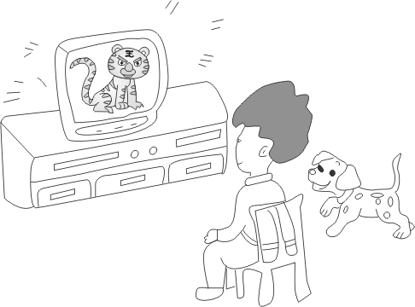
Jerry is a student.He has a pet dog,Tom.Tom is very cute.
Last night,Jerry and Tom were in the living room.Jerry fed(喂食) Tom with meat.After that he sat down on the floor and did his homework.Tom ate the meat and watched TV.When there was a big tiger on TV,Tom was excited.He barked(叫) at the tiger.Hada!He wanted to fight with the tiger!Jerry was happy.He said, “What a lovely dog!”
65.Is Jerry a student?
66.Where were Jerry and Tom last night?
67.What did Tom eat?
68.How did Tom feel when he saw the tiger?
六、连词成句。请给每个句子打上正确的标点哦！（6分）
69.do,Why,you,spring,like
70.has,eyes,He,big
71.did,you,What,do,yesterday
七、小练笔。Amy想要给她的全家福照片配上英文简介。请仔细观察照片。发挥想象，帮她简单介绍照片中的家人吧！至少要写5句话哦！（5分）

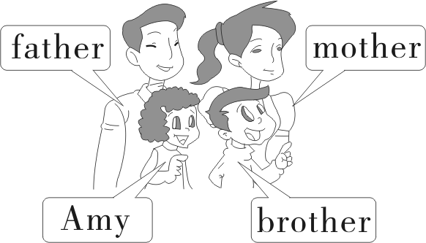
My name is Amy.This is my family.

湖南株洲芦淞区小学毕业水平测评卷
笔试部分参考答案

一、41.longer 42.school 43.danced 44.red 45.cook 46.Hello
二、47—51 FTFTF
三、53—57 BAAAB 58—59 BB
四、60—64 EDABC
五、65.Yes, he is.
66.They were in the living room.
67.He ate meat.
68.He was excited.
六、69.Why do you like spring?
70.He has big eyes.
71.What did you do yesterday?
七、作文略

